Supplementary Material

Supplementary Figures and Tables

Supplementary Figures

Supplementary Figure 1. Cs₃Cu₂Cl₅ NCs solution under ambient light and 254 nm UV light.
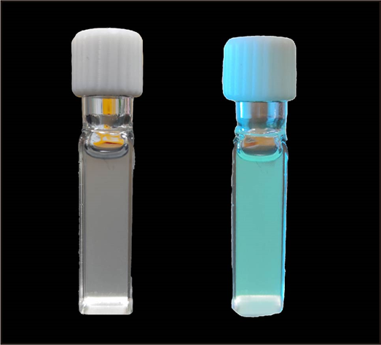

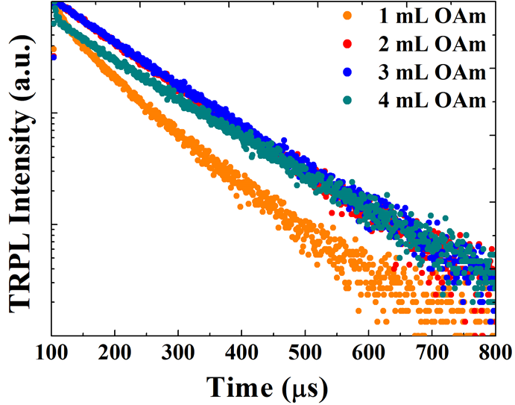
Supplementary Figure 2. Time-resolved PL (TRPL) decay spectra of NCs. The OAm-capped NCs show longer lifetime (from 77.8 μs to 119.8 μs) and single exponential decay.

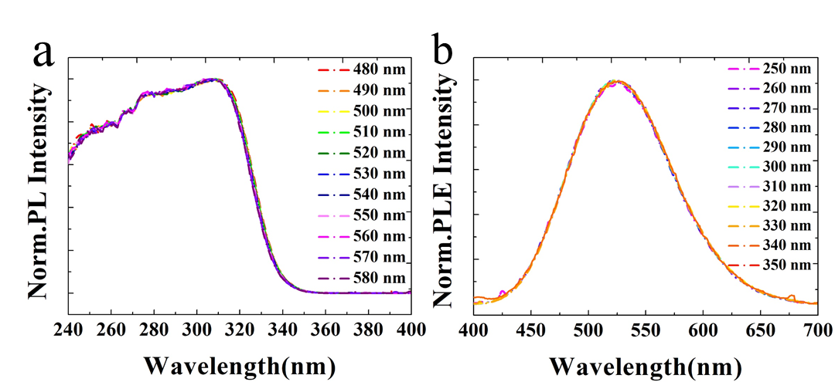
Supplementary Figure 3. a) PLE spectra and b) PL spectra of Cs₃Cu₂Cl₅ NCs measured at different emission and excitation wavelengths, respectively. The normalized PLE spectra showed the uniform shapes while the monitoring emission wavelength was changed from 480 to 580 nm. Equally, when the excitation wavelength altered from 250 to 340 nm, the normalized PL spectra represented the identical features.

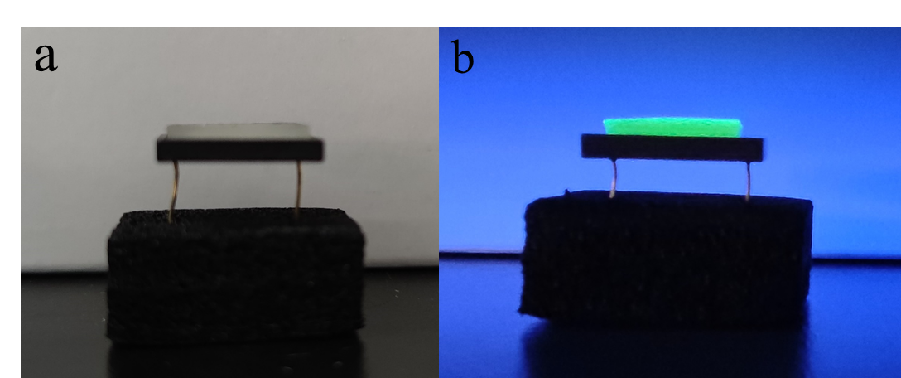
Supplementary Figure 4. The NCCFs coated Si photodiodes under a) ambient light and b) 254 nm UV light.

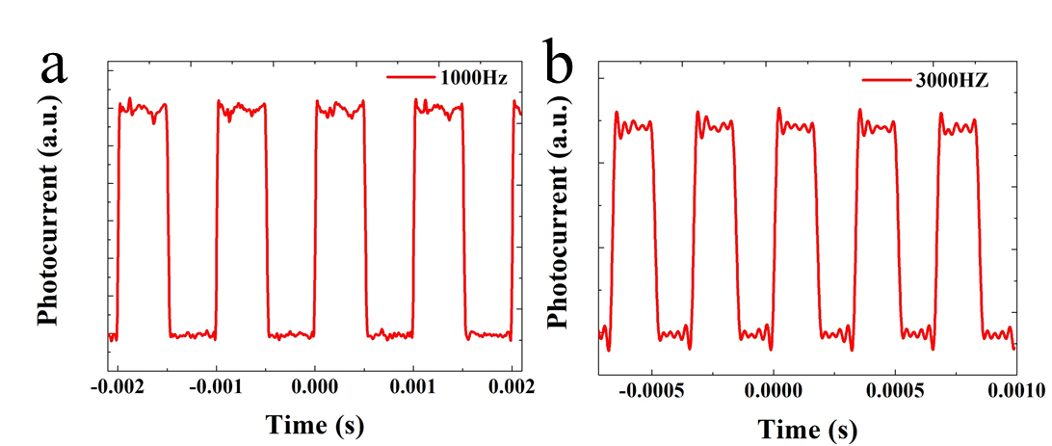
Supplementary Figure 5. Photoresponse characteristics of the NCCFs coated Si photodiodes to pulsed light irradiation at frequencies of a) 1000 Hz, b) 3000 Hz. It is obvious that the NCCFs coated Si photodetector can operate at a relatively wide frequency with outstanding stability and reproducibility.

Supplementary Tables
Table S1. Fitted PL lifetimes and radiative ($Γ_{rad}$) and nonradiative ($Γ_{non-rad}$) decay rates of different QDs.
sample | A₁ | $τ_{1}$ (ns) | A₂ | $τ_{2}$ (ns) | $τ_{ave}$ (µs) | $Γ_{rad}$ (ms⁻¹) | $Γ_{non-rad}$ (ms⁻¹)
1 mL OAm | 1913.4005 | 84256.556 | 1037.0352 | 16203.329 | 77.832 | 1.7987 | 11.049
2 mL OAm | 2960.8355 | 119769.24 | 0 | 0 | 119.8 | 5.767 | 2.582
3 mL OAm | 1484.36574 | 111796.549 | 1484.36574 | 111794.609 | 111.8 | 4.02 | 4.92
4 mL OAm | 2031.36187 | 117304.2047 | 917.41493 | 2913.14881 | 116.03 | 0.479 | 8.139
Time-resolved PL decay curves were fitted by a tri-exponential decay function of
$A\left(t\right)=A_{1}*e^{(-t/τ_{1)}}+{A_{2}*e}^{(-t/τ_{2)}}{+A}_{3}*e^{(-t/τ_{3)}}$ (1)
The average lifetime $τ_{ave}$ is
$τ_{ave}=\frac{A_{1}*τ_{1}^{2}+A_{2}*τ_{2}^{2}{+A}_{3}*τ_{3}^{2}}{A_{1}*τ_{1}+A_{2}*τ_{2}{+A}_{3}*τ_{3}}$ (2)
The average lifetime $τ_{ave}$ can also be calculated by
${ τ}_{ave}=\frac{1}{Γ_{rad}+Γ_{non-rad}}$ (3)
Considering PL QY can be calculated by
$QY=\frac{Γ_{rad}}{Γ_{rad}+Γ_{non-rad}}$ (4)
Thus, $Γ_{rad}$ and $Γ_{non-rad}$can be extracted by
$Γ_{rad}=\frac{QY}{{ τ}_{ave}}$ (5)
$Γ_{non-rad}=\frac{1-QY}{{ τ}_{ave}}$ (6)

