Supplementary Material



**Supplementary Figure 1**: Map of mean species richness for each route.



**Supplementary Figure 2:** Results of random forests predicting patterns of WE. A) Importance of each variable, B-F) response curves for the five most important predictor variables, with all other variables held at their means.



**Supplementary Figure 3:** Results of random forests predicting patterns of PD. A) Importance of each variable, B-F) response curves for the five most important predictor variables, with all other variables held at their means.



**Supplementary Figure 4**: Changes in overall annual means of PE, PD and WE that are attributable to changes in BBS representation through time. We computed the mean PE, PD and WE for each route across all years in which it was sampled. Then, for each year, we computed the mean of these route-level means for all routes sampled in that year. Thus, a high value in a year represents unusually large representation in the BBS data of regions that have high average values of that variable.

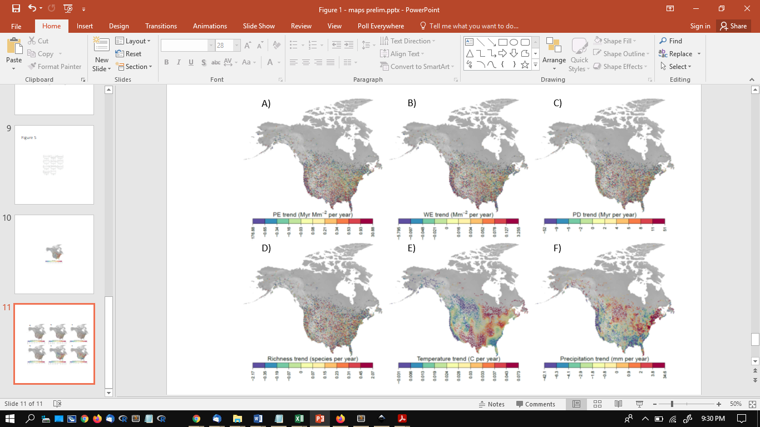

**Supplementary Figure 5:** Maps of trends in PE (A), WE (B), PD (C), species richness (D), temperature (E) and precipitation (F). These trends were estimating the linear regression slope for the relationship of year to the measured variable.