Supplementary data
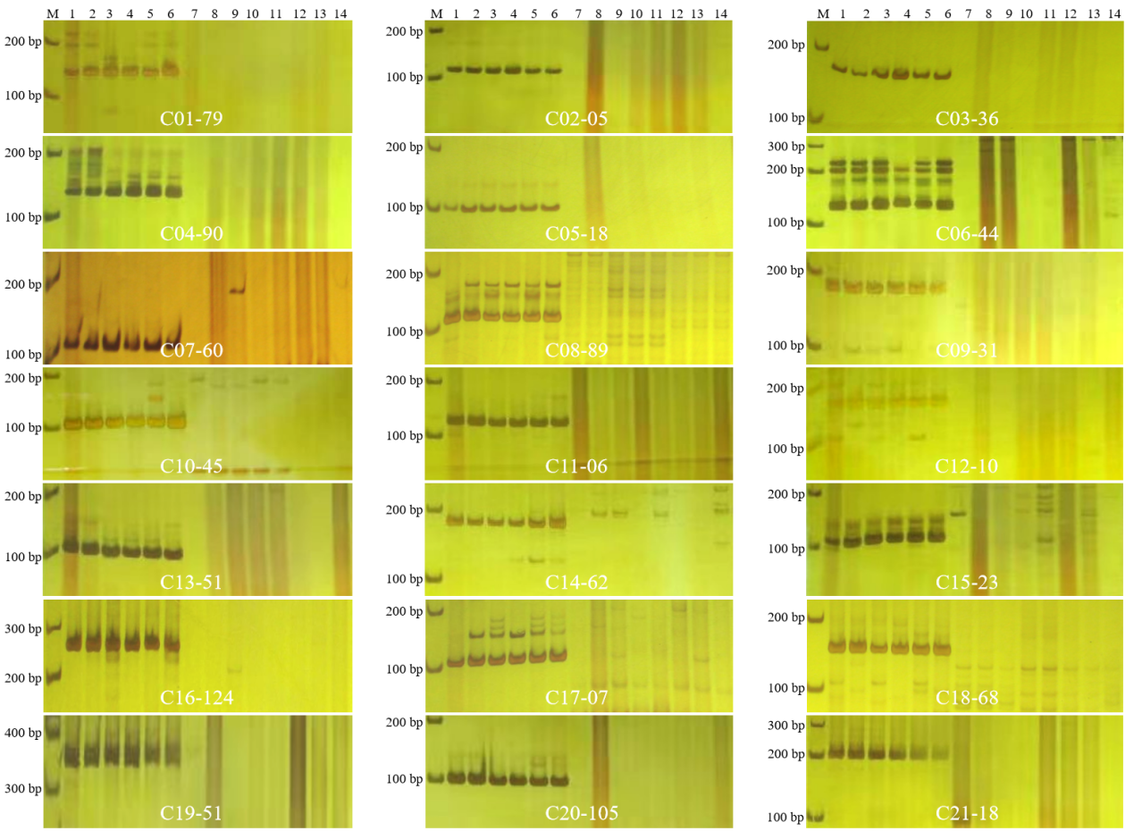
SUPPLEMENTARY FIGURE S1 | Polyacrylamide gel images showing amplification results of 21 Thi-specific markers on each Thi-chromosome in six Th. intermedium plants and eight wheat landraces. M: DNA ladder; C01-C21: markers for all 21 Th. intermedium chromosomes (1J-7St); 1-6: six Th. intermedium plants; 7-14: Chinese Spring, Shanglinxiaomai, Louguding, Xiaobaimang, Chadianhong, Jiangxizao, Lanhuamai, Motuoxiaomai.

