Supplementary Material
- SUPPLEMENTARY FIGURES

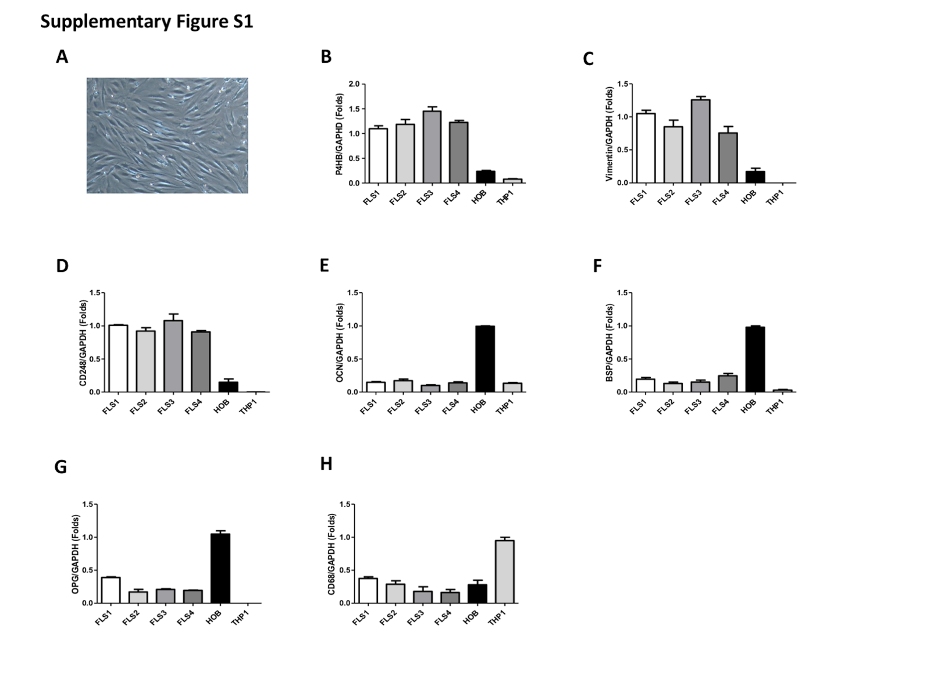

Figure S1. Characterization of FLS isolated from human synovial tissue. (A) A confluent monolayer of isolated FLS was grown at passage 2 and observed at 20X magnification. (B-D) mRNA expression levels of fibroblast specific markers such as prolyl 4 hydroxylase (P4HB), vimentin and CD248, (E-G), osteoblast-specific markers like osteocalcin (OCN), bone sialoprotein (BSP), and osteoprogrenin (OPG) and (H) monocyte specific marker CD68 were determined by real-time RT-PCR in FLS at passage 3, primary osteoblasts (HOB) and the monocyte cell line, THP 1. Data are shown as the mean ±SD. Similar results were obtained in three independent experiments.

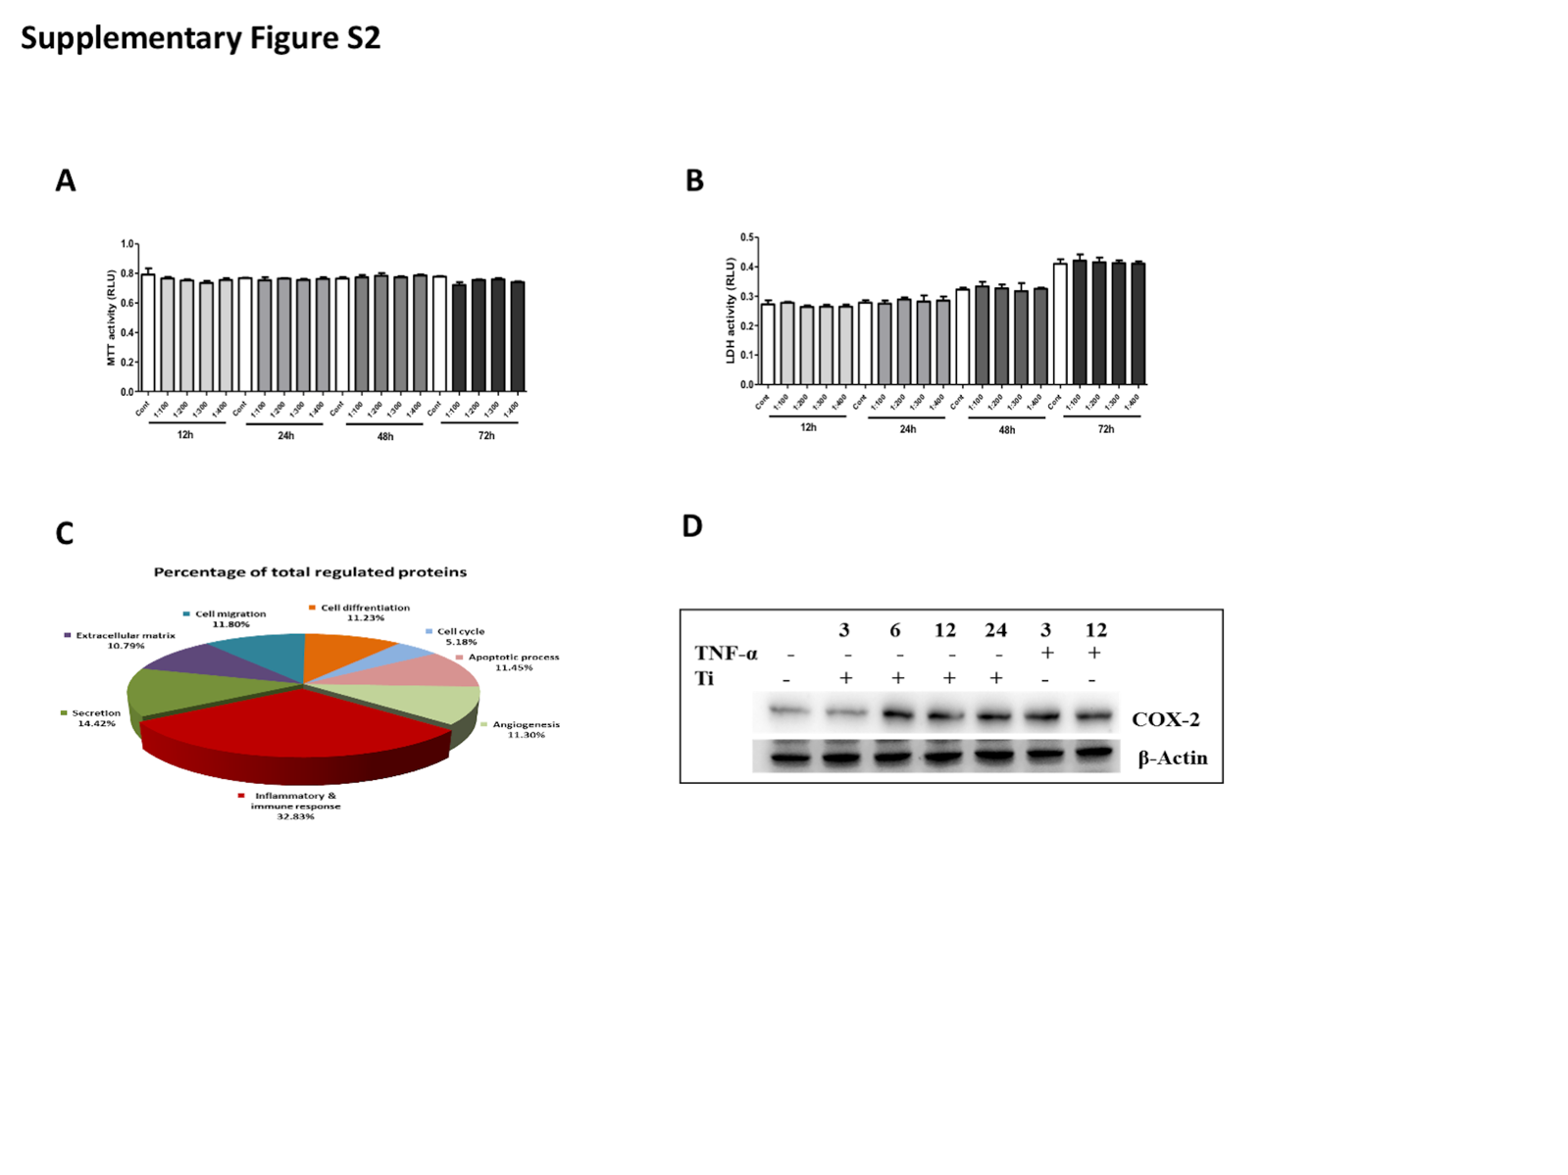
Figure S2. Effect of Ti particles on FLS. (A&B) Ratio (FLS to Ti particles) of 1:100-1:400 demonstrated no cell viability (MTT assay) and cytotoxic (LDH assay) effect on FLS until 72 h of treatment. (B) Secretory protein array analysis of Ti CM. Total secreted proteins in the Ti CM are grouped into 9 categories and depicted as a percentage of their ratio to Cont CM. (C) Ti particle treatment-induced COX-2 expression in a time-dependent manner (3, 6, 12, and 24 h). TNF-α was taken as a positive control. Similar results were obtained in three independent experiments.
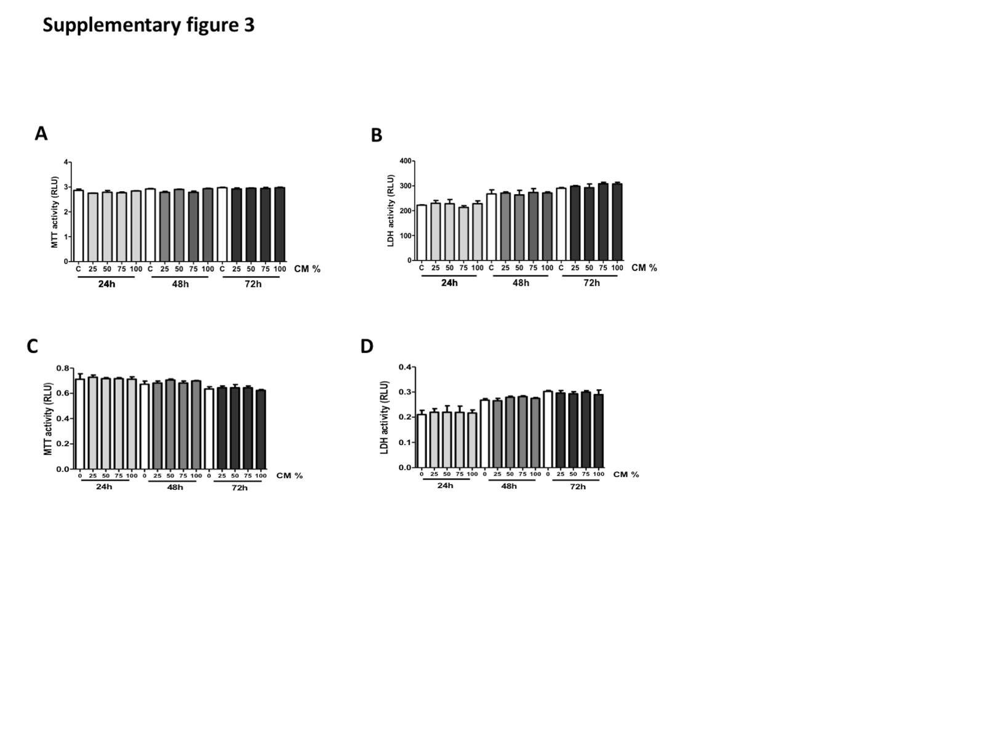
Figure S3. Effect of Ti particles on cell viability and cytotoxicity in Raw 264.7 cells and osteoblast cell (SaOS-2) (A&B) Ti CM treated to Raw 264.7 cells and (C&D) SaOS-2 cells at different percentages (25%-100%) demonstrated no cell viability (MTT assay) and cytotoxic (LDH assay) effect till 72 h of treatment. Similar results were obtained in three independent experiments.

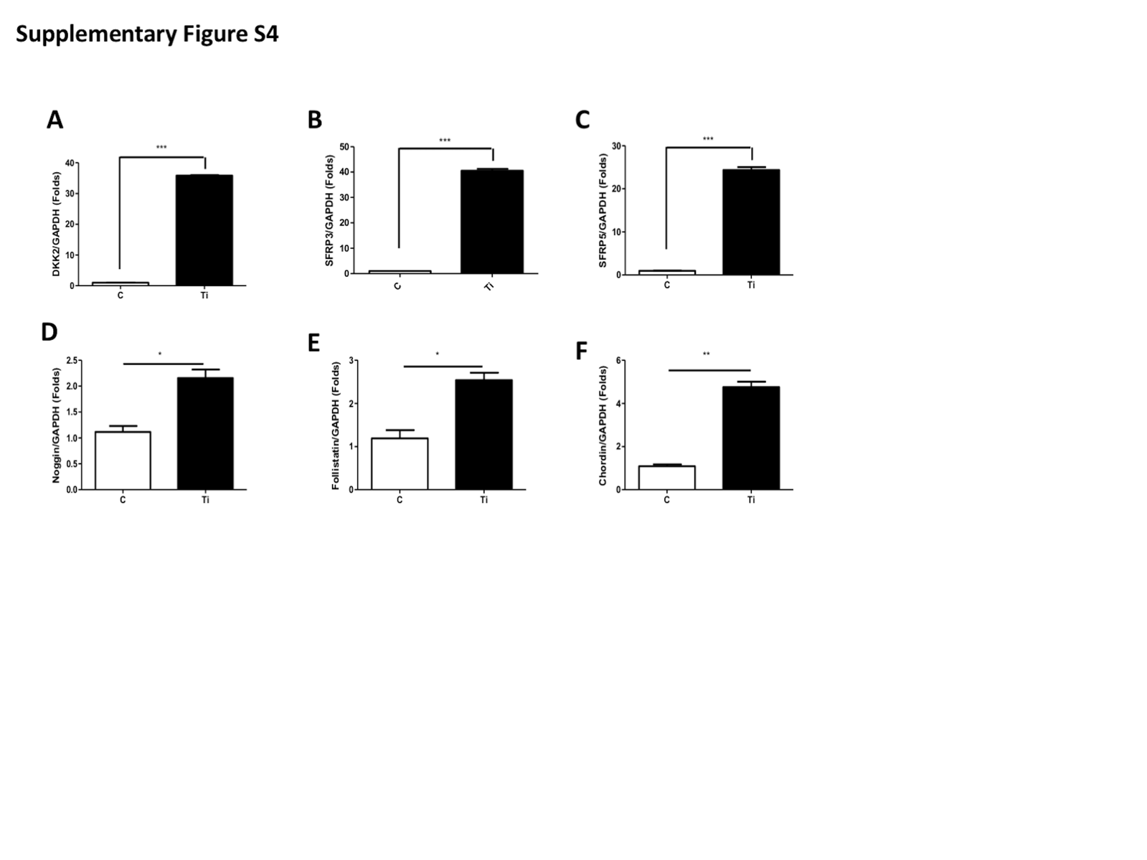
Figure S4. Ti particles induced the expression of WNT and BMP signaling antagonists in FLS. Treatment of Ti particle to FLS induced mRNA expression of WNT antagonist: (A) DKK2, (B) sFRP3, (C) sFRP5, and BMP signaling antagonist: (D) noggin, (E) chordin, and (F) follistatin. Similar results were obtained in three independent experiments. *P < 0.05, **P < 0.01, ***, P < 0.001 and ns (no significance) compared to the control.

