Supplementary Materials
Supplementary Table 1. Mean sea water temperature of the sampling site of last week from March to June of 2020. Average temperature was calculated with the temperature of last seven days of each month. Values represent the mean±SD. Last week’s average temperature was shown as abalone samples were collected in the last week of May and June. Raw data were taken from real-time environment fishery information system overview of National Institute of Fisheries Sciences (NIFS), Korea (http://www.nifs.go.kr/risa/risaInfo.risa).
 | Sea water temperature
Month | March  (March 25-31) | April  (April 24-30) | May  (May 25-31) | June  (June 24-30)
Temperature (°C) | 12.20±0.16 | 14.66±0.61 | 18.23±0.72 | 20.60±0.63

Supplementary Table 2. Mean values of water quality parameter of rearing tanks during 1st and 2nd experimental period. Values represent the mean±SD.
 | Mean values of water quality parameters
 | 1st Experiment | 2nd Experiment
Temperature (°C) | 18.08±0.32 | 21.02±0.16
Salinity (ppt) | 34.15±0.02 | 33.51±0.16
pH | 8.41±0.08 | 8.42±0.04
DO (ppm) | 6.22±0.32 | 6.09±0.31

Supplementary Table 3. Average shell length, shell height, and body weight of abalone used in the present study. Values represent the mean±SD (n=10).
 | Early breeding season |  |  | Peak breeding season
 | 14°C | 18°C | 22°C | 16°C | 21°C | 26°C
Shell length (mm) | 92.18±2.16 | 93.55±2.27 | 94.19±2.92 | 92.97±1.44 | 93.44±2.56 | 93.08±1.77
Shell width (mm) | 62.09±1.94 | 63.57±1.21 | 62.77±1.14 | 61.30±1.32 | 61.15±1.87 | 62.66±1.28
Shell height (mm) | 22.75±0.45 | 23.07±1.56 | 23.79±0.46 | 21.72±0.53 | 22.76±0.55 | 21.08±0.74
Body weight (mg) | 100.1±4.28 | 102.2±4.94 | 104.8±5.92 | 103.7±6.73 | 105.2±9.03 | 102.4±9.64

Supplementary Table 4. Changes in relative mRNA expression of Hdh-GnRH-like peptide in different ganglia of central nervous system and testis tissue of Pacific abalone exposed to different temperature for 3 and 7 days during early (experiment 1) and peak (experiment 2) breeding season. Values represent the mean±SD (n=3). Different letters in superscript indicates a significant difference among different temperature group (p < 0.05)
Early breeding season
 | IC  (18°C) |  | Day-3 |  |  |  |  |  | Day-7
 |  |  | 14°C |  | 18°C |  | 22°C |  | 14°C | 18°C |  | 22°C
CG | 2.41±0.31^{bcd} |  | 1.99±0.32de |  | 2.38±0.35^{bcd} |  | 2.64±0.32^{b} |  | 1.42±0.39^{f} | 2.42±0.39^{bcd} |  | 3.18±0.33ª
PPG | 0.59±0.07^{g} |  | 0.57±0.08^{g} |  | 0.60±0.08^{g} |  | 0.65±0.05^{g} |  | 0.60±0.10^{g} | 0.64±0.11^{g} |  | 0.76±0.07^{g}
BG | 0.54±0.08^{g} |  | 0.46±0.07^{g} |  | 0.52±0.08^{g} |  | 0.53±0.07^{g} |  | 0.43±0.06^{g} | 0.51±0.06^{g} |  | 0.59±0.07^{g}
Testis | 1.62±0.29^{ef} |  | 1.58±0.24^{ef} |  | 1.65±0.25^{ef} |  | 2.06±0.25^{cde} |  | 1.40±0.30^{f} | 1.76±0.28^{ef} |  | 2.52±0.33^{bc}
Peak breeding season
 |  | IC  (21°C) |  | Day-3 |  |  |  |  | Day-7
 |  |  |  | 16°C |  | 21°C |  | 26°C | 16°C |  | 21°C | 26°C
CG |  | 3.51±0.42ª |  | 2.25±0.23de |  | 3.54±0.35ª |  | 1.72±0.25^{ef} | 1.79±0.28^{ef} |  | 3.59±0.39ª | 1.23±0.26^{f}
PPG |  | 0.80±0.13^{g} |  | 0.75±0.08^{g} |  | 0.82±0.13^{g} |  | 0.68±0.09^{g} | 0.70±0.11^{g} |  | 0.85±0.09^{g} | 0.64±0.08^{g}
BG |  | 0.70±0.08^{g} |  | 0.68±0.08^{g} |  | 0.72±0.08^{g} |  | 0.62±0.06^{g} | 0.64±0.12g |  | 0.74±0.11^{g} | 0.61±0.10^{g}
Testis |  | 2.84±0.45^{bc} |  | 2.34±0.25^{cd} |  | 2.93±0.45^{b} |  | 1.68±0.37^{f} | 1.70±0.27^{ef} |  | 2.95±0.39^{b} | 1.21±0.31^{f}
IC: Initial control, CG: Cerebral ganglion, PPG: Pleuropedal ganglion, BG: Branchial ganglion

Supplementary Table 5. Changes in relative mRNA expression of Hdh-GnRH gene in different ganglia of central nervous system and testis tissue of Pacific abalone exposed to different temperature for 3 and 7 days during early (experiment 1) and peak (experiment 2) breeding season. Values represent the mean±SD (n=3). Different letters in superscript indicates a significant difference among different temperature group (p < 0.05)

Early breeding season
 | IC  (18°C) |  | Day-3 |  |  |  |  |  | Day-7
 |  |  | 14°C |  | 18°C |  | 22°C |  | 14°C | 18°C |  | 22°C
CG | 1.16±0.19^{h} |  | 1.04±0.11^{h} |  | 1.16±0.09^{h} |  | 1.27±0.21^{gh} |  | 1.00±0.13^{h} | 1.24±0.18^{gh} |  | 1.60±0.13e
PPG | 2.04±0.38^{c} |  | 1.80±0.18^{d} |  | 2.11±0.37^{bc} |  | 2.74±0.33^{ab} |  | 1.37±0.29f^{g} | 2.13±0.29^{bc} |  | 3.13±0.49ª
BG | 2.31±0.39^{b} |  | 1.99±0.32^{c} |  | 2.29±0.39^{b} |  | 2.55±0.27^{ab} |  | 1.34±0.29^{g} | 2.31±0.31^{b} |  | 2.77±0.50^{ab}
Testis | 1.71±0.23de |  | 1.52±0.28^{f} |  | 1.74±0.18^{d} |  | 2.05±0.26^{c} |  | 1.35±0.20^{g} | 1.77±0.25^{d} |  | 2.32±0.28^{b}
Peak breeding season
 |  | IC  (21°C) |  | Day-3 |  |  |  |  | Day-7
 |  |  |  | 16°C |  | 21°C |  | 26°C | 16°C |  | 21°C | 26°C
CG |  | 1.77±0.15^{f} |  | 1.46±0.17^{fg} |  | 1.78±0.19^{f} |  | 1.37±0.13^{g} | 1.40±0.13^{fg} |  | 1.75±0.19^{f} | 1.14±0.21^{g}
PPG |  | 3.39±0.56^{ab} |  | 2.28±0.43e |  | 3.30±0.45^{ab} |  | 1.74±0.53^{f} | 1.70±0.45^{f} |  | 3.62±0.37ª | 1.43±0.39^{fg}
BG |  | 2.93±0.30^{cd} |  | 2.11±0.40e |  | 2.88±0.31^{d} |  | 1.64±0.25^{f} | 1.67±0.35^{f} |  | 3.01±0.33^{bc} | 1.49±0.25^{fg}
Testis |  | 2.59±0.29de |  | 2.10±0.39e |  | 2.63±0.30de |  | 1.68±0.43^{f} | 1.88±0.43^{ef} |  | 2.62±0.28de | 1.09±0.32^{g}
IC: Initial control, CG: Cerebral ganglion, PPG: Pleuropedal ganglion, BG: Branchial ganglion

Supplementary Table 6. Changes in relative mRNA expression of Hdh-GnRH-R gene in different ganglia of central nervous system and testis tissue of Pacific abalone exposed to different temperature for 3 and 7 days during early (experiment 1) and peak (experiment 2) breeding season. Values represent the mean±SD (n=3). Different letters in superscript indicates a significant difference among different temperature group (p < 0.05)

Early breeding season
 | IC  (18°C) |  | Day-3 |  |  |  |  |  | Day-7
 |  |  | 14°C |  | 18°C |  | 22°C |  | 14°C | 18°C |  | 22°C
CG | 1.27±0.20^{fg} |  | 1.17±0.21^{fg} |  | 1.29±0.25^{fg} |  | 1.43±0.21^{f} |  | 0.91±0.14^{fg} | 1.33±0.21^{f} |  | 1.73±0.21^{ef}
PPG | 2.33±0.45^{c} |  | 2.07±0.35de |  | 2.39±0.25^{c} |  | 3.07±0.28^{ab} |  | 1.64±0.40^{ef} | 2.41±0.39^{c} |  | 3.44±0.29ª
BG | 0.70±0.05^{g} |  | 0.65±0.06^{g} |  | 0.69±0.11^{g} |  | 0.73±0.07^{g} |  | 0.65±0.05^{g} | 0.68±0.08^{g} |  | 0.76±0.06^{g}
Testis | 1.98±0.33e |  | 1.67±0.32^{ef} |  | 2.04±0.39e |  | 2.37±0.36^{c} |  | 1.35±0.39^{f} | 2.12±0.26de |  | 2.73±0.36^{bc}
Peak breeding season
 |  | IC  (21°C) |  | Day-3 |  |  |  |  | Day-7
 |  |  |  | 16°C |  | 21°C |  | 26°C | 16°C |  | 21°C | 26°C
CG |  | 2.10±0.16^{bc} |  | 1.39±0.28de |  | 2.15±0.19^{bc} |  | 1.19±0.25^{ef} | 1.19±0.22^{ef} |  | 2.18±0.22^{bc} | 1.07±0.21^{fg}
PPG |  | 3.59±0.37ª |  | 2.20±0.46^{bc} |  | 3.63±0.37ª |  | 1.84±0.38^{d} | 1.79±0.25de |  | 3.74±0.40ª | 1.42±0.25de
BG |  | 0.80±0.13^{fg} |  | 0.72±0.08^{g} |  | 0.80±0.13^{fg} |  | 0.67±0.08^{g} | 0.63±0.08^{g} |  | 0.81±0.11^{fg} | 0.62±0.10^{g}
Testis |  | 3.45±0.33ª |  | 2.59±0.45^{b} |  | 3.52±0.28ª |  | 2.25±0.30^{bc} | 2.02±0.36^{d} |  | 3.58±0.33ª | 1.73±0.33de
IC: Initial control, CG: Cerebral ganglion, PPG: Pleuropedal ganglion, BG: Branchial ganglion

Supplementary Table 7. Changes in relative mRNA expression of APGWamide gene in different ganglia of central nervous system and testis tissue of Pacific abalone exposed to different temperature for 3 and 7 days during early (experiment 1) and peak (experiment 2) breeding season. Values represent the mean±SD (n=3). Different letters in superscript indicates a significant difference among different temperature group (p < 0.05)
Early breeding season
 | IC  (18°C) |  | Day-3 |  |  |  |  |  | Day-7
 |  |  | 14°C |  | 18°C |  | 22°C |  | 14°C | 18°C |  | 22°C
CG | 0.92±0.15^{gh} |  | 0.86±0.12^{h} |  | 0.95±0.16^{gh} |  | 1.00±0.13^{g} |  | 0.83±0.12^{h} | 1.00±0.16^{g} |  | 1.16±0.09^{fg}
PPG | 1.76±0.31^{b} |  | 1.67±0.18^{c} |  | 1.80±0.37^{b} |  | 1.98±0.33^{ab} |  | 1.42±0.27e | 1.86±0.42^{b} |  | 2.32±0.29ª
BG | 1.29±0.18^{f} |  | 1.24±0.22^{f} |  | 1.33±0.21^{ef} |  | 1.46±0.19de |  | 1.20±0.23^{f} | 1.36±0.18^{ef} |  | 1.52±0.22^{d}
Testis | 1.71±0.22^{bc} |  | 1.36±0.19^{ef} |  | 1.75±0.23^{b} |  | 2.09±0.31^{ab} |  | 1.25±0.32^{f} | 1.80±0.23^{b} |  | 2.20±0.27^{ab}
Peak breeding season
 |  | IC  (21°C) |  | Day-3 |  |  |  |  | Day-7
 |  |  |  | 16°C |  | 21°C |  | 26°C | 16°C |  | 21°C | 26°C
CG |  | 1.27±0.16^{ef} |  | 1.15±0.20^{f} |  | 1.30±0.15^{ef} |  | 0.89±0.24^{g} | 1.12±0.20^{f} |  | 1.33±0.13^{ef} | 0.88±0.14^{g}
PPG |  | 3.30±0.39ª |  | 2.79±0.42^{b} |  | 3.30±0.37ª |  | 2.11±0.30^{bc} | 2.73±0.40^{b} |  | 3.38±0.40ª | 1.59±0.43^{cd}
BG |  | 2.14±0.25^{bc} |  | 2.00±0.30^{bc} |  | 2.17±0.26^{bc} |  | 1.96±0.31^{c} | 1.94±0.18^{c} |  | 2.19±0.25^{bc} | 1.87±0.21^{c}
Testis |  | 2.97±0.46ª |  | 2.23±0.37^{bc} |  | 2.99±0.32ª |  | 1.59±0.43^{cd} | 1.85±0.30^{c} |  | 3.03±0.36ª | 1.43±0.35^{d}
IC: Initial control, CG: Cerebral ganglion, PPG: Pleuropedal ganglion, BG: Branchial ganglion

Supplementary Table 8. Changes in relative mRNA expression of 5-HT_{hdh} gene in different ganglia of central nervous system and testis tissue of Pacific abalone exposed to different temperature for 3 and 7 days during early (experiment 1) and peak (experiment 2) breeding season. Values represent the mean±SD (n=3). Different letters in superscript indicates a significant difference among different temperature group (p < 0.05)
Early breeding season
 | IC  (18°C) |  | Day-3 |  |  |  |  |  | Day-7
 |  |  | 14°C |  | 18°C |  | 22°C |  | 14°C | 18°C |  | 22°C
CG | 0.82±0.16^{f} |  | 0.74±0.15^{f} |  | 0.85±0.16^{f} |  | 1.05±0.11^{ef} |  | 0.72±0.18^{g} | 0.87±0.11^{f} |  | 1.20±0.16e
PPG | 1.93±0.28^{bc} |  | 1.64±0.29^{d} |  | 1.92±0.21b^{c} |  | 2.36±0.28^{ab} |  | 1.58±0.36^{d} | 2.03±0.29b^{c} |  | 2.69±0.23ª
BG | 0.66±0.10^{g} |  | 0.63±0.08^{g} |  | 0.66±0.12^{g} |  | 0.66±0.09^{g} |  | 0.62±0.09^{g} | 0.68±0.08^{g} |  | 0.69±0.11^{g}
Testis | 1.60±0.19^{d} |  | 1.23±0.27e |  | 1.54±0.24^{d} |  | 1.88±0.22^{cd} |  | 1.12±0.27e | 1.54±0.21^{d} |  | 2.07±0.21^{bc}
Peak breeding season
 |  | IC  (21°C) |  | Day-3 |  |  |  |  | Day-7
 |  |  |  | 16°C |  | 21°C |  | 26°C | 16°C |  | 21°C | 26°C
CG |  | 1.28±0.20^{f} |  | 1.01±0.16^{fg} |  | 1.29±0.28^{f} |  | 1.47±0.22e | 0.87±0.18^{g} |  | 1.33±0.23^{f} | 1.68±0.11^{d}
PPG |  | 2.43±0.36^{c} |  | 2.13±0.33^{cd} |  | 2.43±0.37^{c} |  | 3.13±0.37^{b} | 1.69±0.32^{d} |  | 2.38±0.42^{c} | 3.99±0.45ª
BG |  | 0.78±0.13^{g} |  | 0.74±0.13^{g} |  | 0.77±0.13^{g} |  | 0.75±0.09^{g} | 0.72±0.11^{g} |  | 0.76±0.16^{g} | 0.68±0.14^{g}
Testis |  | 2.07±0.46^{cd} |  | 1.91±0.53^{cd} |  | 2.12±0.41^{cd} |  | 3.13±0.37^{b} | 1.62±0.37de |  | 2.05±0.48^{cd} | 3.55±0.37^{ab}
IC: Initial control, CG: Cerebral ganglion, PPG: Pleuropedal ganglion, BG: Branchial ganglion

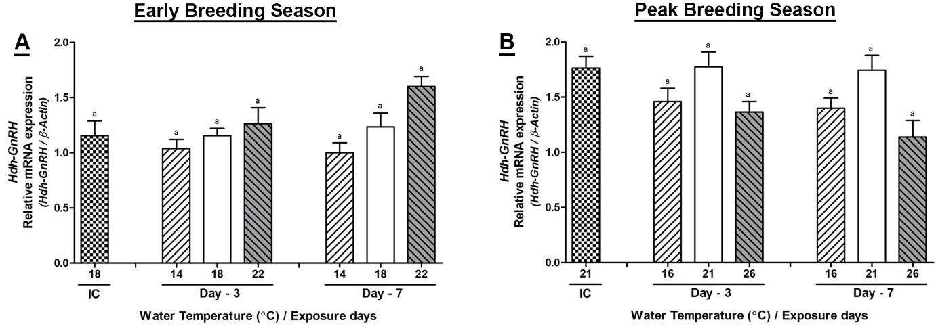
Supplementary Figure 1. Changes in relative mRNA expression of Hdh-GnRH in cerebral ganglion (CG) of male Pacific abalone during early (A) and peak (B) breeding seasons after exposure to thermal stress for 7 days. Before exposure to the target temperature of thermal stress, abalone were sampled to obtained reference values which served as initial control (IC). Values represent the mean ± SD (n = 10). Different letters on the bar indicate significant differences among different temperature groups (p < 0.05).

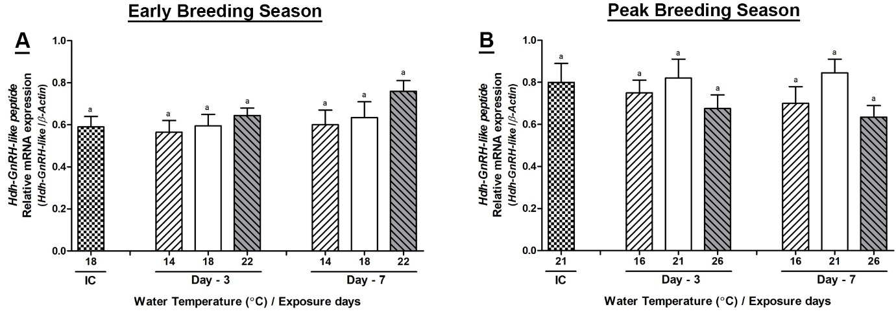
Supplementary Figure 2. Changes in relative mRNA expression of Hdh-GnRH-like peptide in pleuropedal ganglion (PPG) of male Pacific abalone during early (A) and peak (B) breeding seasons after exposure to thermal stress for 7 days. Before exposure to the target temperature of thermal stress, abalone were sampled to obtained reference values which served as initial control (IC). Values represent the mean ± SD (n = 10). Different letters on the bar indicate significant differences among different temperature groups (p < 0.05).

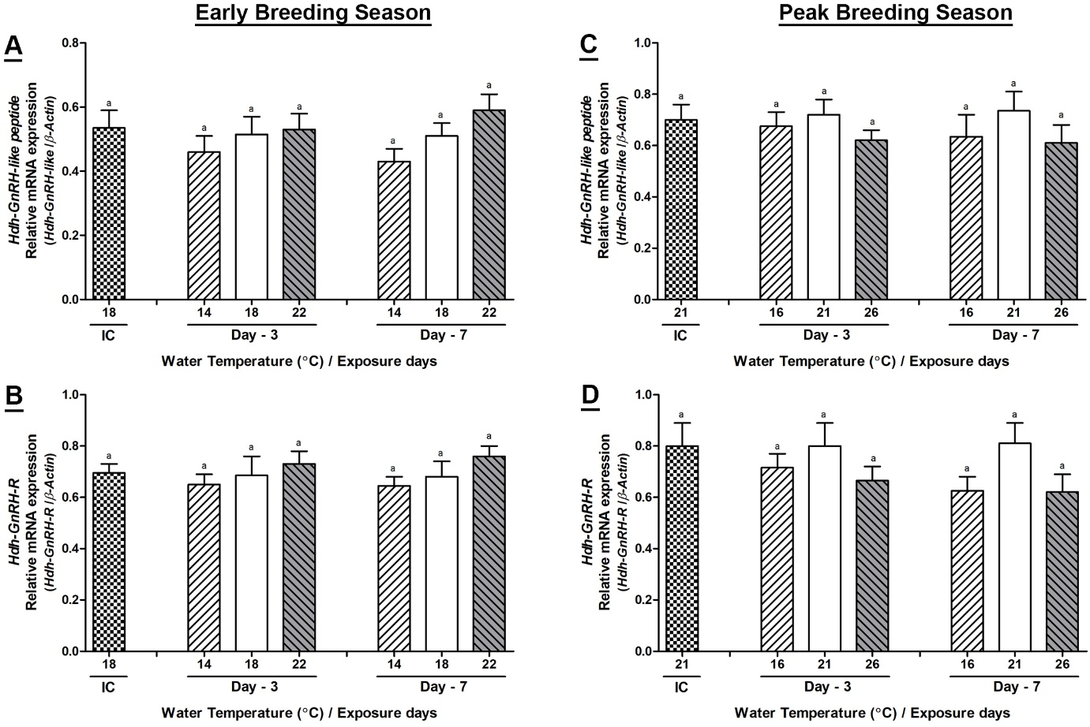
Supplementary Figure 3. Changes in relative mRNA expression of Hdh-GnRH-like peptide (A, C) and Hdh-GnRH-R (B, D) in branchial ganglion (BG) of male Pacific abalone during early and peak breeding seasons after exposure to thermal stress for 7 days. Before exposure to the target temperature of thermal stress, abalone were sampled to obtained reference values which served as initial control (IC). Values represent the mean ± SD (n = 10). Different letters on the bar indicate significant differences among different temperature groups (p < 0.05).
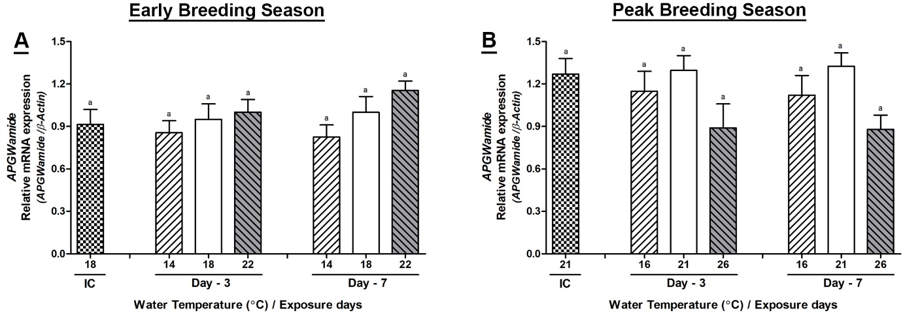
Supplementary Figure 4. Changes in relative mRNA expression of APGWamide in cerebral ganglion (CG) of male Pacific abalone during early (A) and peak (B) breeding seasons after exposure to thermal stress for 7 days. Before exposure to the target temperature of thermal stress, abalone were sampled to obtained reference values which served as initial control (IC). Values represent the mean ± SD (n = 10). Different letters on the bar indicate significant differences among different temperature groups (p < 0.05).

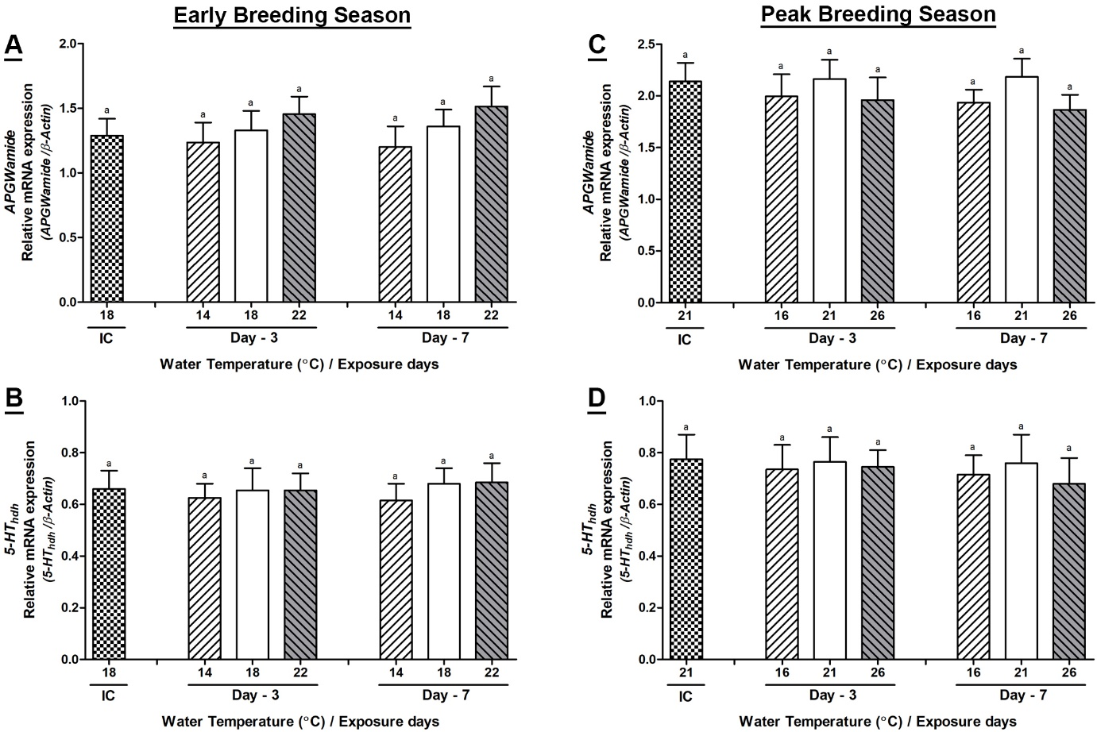
Supplementary Figure 5. Changes in relative mRNA expression of APGWamide (A, C) and 5-HT_{hdh} (B, D) in branchial ganglion (BG) of male Pacific abalone during early and peak breeding seasons after exposure to thermal stress for 7 days. Before exposure to the target temperature of thermal stress, abalone were sampled to obtained reference values which served as initial control (IC). Values represent the mean ± SD (n = 10). Different letters on the bar indicate significant differences among different temperature groups (p < 0.05).

