Abiraterone – Enzalutamide Data Sheet Results

75 patients with metastatic castrate resistant prostate cancer treated with abiraterone or enzalutamide between August, 2013 to Dec, 2019 at GVH.

Whole cohort results
- Abiraterone = 38 (Aug, 2013 – Dec 2019)
- Enzalutamide = 37 (July, 2015 to Dec, 2019)
- Median Age = 80 (61-94)
- ECOG
  - 0 = 2 (2.7%)
  - 1 = 29 (38.7%)
  - 2=27 (36.%)
  - 3 = 17 (22.7%)
- Risk Stratification
  - High = 54 (72%)
  - Low = 11 (14.7%)
  - Unknown = 10 (13.3%)
- Burden of Disease
  - High = 32 (42.7%)
    - Enza = 12
    - Abi = 20
  - Low = 43 (57.3%%)
    - Enza = 25
    - Abi = 18
- Visceral mets
  - Yes = 15 (20%)
  - No = 60 (80%)
- Prior Chemotherapy = 34 (45.3%)
  - Abiraterone – 20
  - Enzalutamide - 14
- Abiraterone group
  - Prior Enzalutamide 9
- Enzalutamide group
  - Prior Abiraterone 2

Response Rates:
- PSA Response rate Whole cohort – 41 (54%)
  - Abiraterone – 39.5 % (15)
  - Enzalutamide -70.3% (26)
Dose reduction
- Whole cohort – 18 (24 %)
  - Abiraterone – 5 (13.2%)
  - Enzalutamide – 13 (35.1%)
Dose interruption
- Whole cohort – 16 (21.3) %
  - Abiraterone – 8 (21.1%)
  - Enzalutamide – 8 (21.6%)

Median Follow up duration = 37 months

PSA PFS Whole Cohort = 6 months

Means and Medians for Survival Time
Meanª |  |  |  | Median
Estimate | Std. Error | 95% Confidence Interval |  | Estimate | Std. Error | 95% Confidence Interval
 |  | Lower Bound | Upper Bound |  |  | Lower Bound
10.463 | 1.399 | 7.722 | 13.204 | 6.000 | .787 | 4.457

Means and Medians for Survival Time
Medianª
95% Confidence Interval
Upper Bound
7.543

a. Estimation is limited to the largest survival time if it is censored.

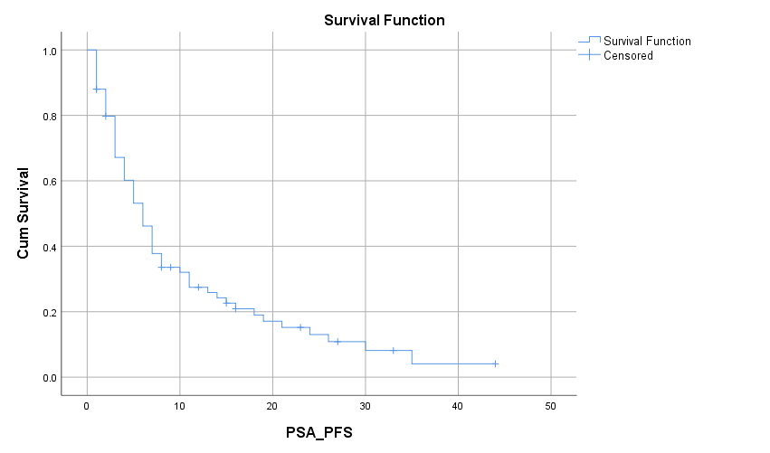

PSA PFS

Abi (5 months) vs Enza (7 months)

Means and Medians for Survival Time
Drug | Meanª |  |  |  | Median
 | Estimate | Std. Error | 95% Confidence Interval |  | Estimate | Std. Error
 |  |  | Lower Bound | Upper Bound
Abiraterone | 7.317 | 1.332 | 4.707 | 9.928 | 5.000 | .859
Enzalutamide | 13.938 | 2.482 | 9.074 | 18.803 | 7.000 | 1.168
Overall | 10.463 | 1.399 | 7.722 | 13.204 | 6.000 | .787

Means and Medians for Survival Time
Drug | Medianª
 | 95% Confidence Interval
 | Lower Bound | Upper Bound
Abiraterone | 3.317 | 6.683
Enzalutamide | 4.710 | 9.290
Overall | 4.457 | 7.543

a. Estimation is limited to the largest survival time if it is censored.

Overall Comparisons
 | Chi-Square | df | Sig.
Log Rank (Mantel-Cox) | 5.259 | 1 | .022

Test of equality of survival distributions for the different levels of Drug.

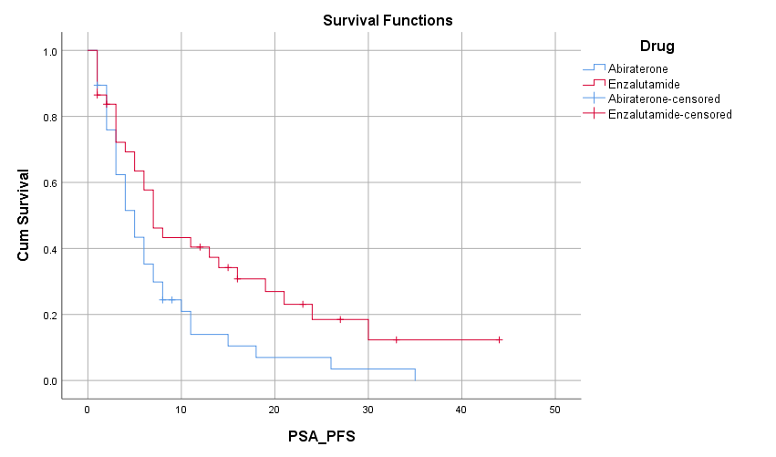

PSA PFS

High Burden (4 months) vs Low burden (7 months)

Means and Medians for Survival Time
Burden of Disease 1= High 2= Low | Meanª |  |  |  | Median
 | Estimate | Std. Error | 95% Confidence Interval |  | Estimate
 |  |  | Lower Bound | Upper Bound
High | 6.169 | .907 | 4.391 | 7.947 | 4.000
Low | 14.005 | 2.265 | 9.566 | 18.444 | 7.000
Overall | 10.463 | 1.399 | 7.722 | 13.204 | 6.000

Means and Medians for Survival Time
Burden of Disease 1= High 2= Low | Medianª
 | Std. Error | 95% Confidence Interval
 |  | Lower Bound | Upper Bound
High | 1.131 | 1.783 | 6.217
Low | 2.467 | 2.165 | 11.835
Overall | .787 | 4.457 | 7.543

a. Estimation is limited to the largest survival time if it is censored.

Overall Comparisons
 | Chi-Square | df | Sig.
Log Rank (Mantel-Cox) | 8.487 | 1 | .004

Test of equality of survival distributions for the different levels of Burden of Disease 1= High 2= Low.

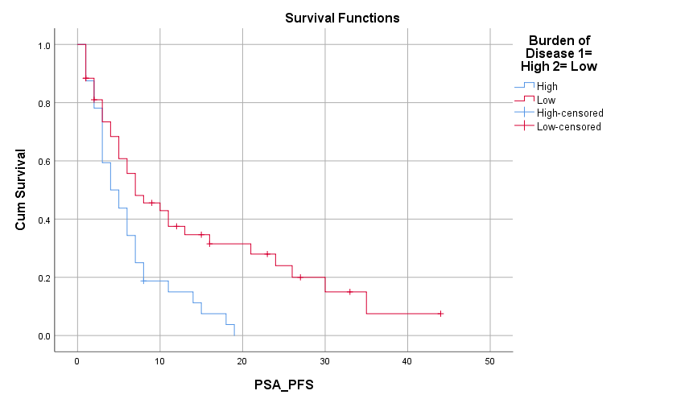

PSA PFS

No prior chemotherapy (7 months) vs prior chemotherapy (4 months)

Means and Medians for Survival Time
Prior Chemotherapy | Meanª |  |  |  | Median
 | Estimate | Std. Error | 95% Confidence Interval |  | Estimate | Std. Error
 |  |  | Lower Bound | Upper Bound
No prior chemotherapy | 11.532 | 1.863 | 7.881 | 15.183 | 7.000 | .896
Post chemotherapy | 8.732 | 1.822 | 5.160 | 12.304 | 4.000 | .926
Overall | 10.463 | 1.399 | 7.722 | 13.204 | 6.000 | .787

Means and Medians for Survival Time
Prior Chemotherapy | Medianª
 | 95% Confidence Interval
 | Lower Bound | Upper Bound
No prior chemotherapy | 5.243 | 8.757
Post chemotherapy | 2.185 | 5.815
Overall | 4.457 | 7.543

a. Estimation is limited to the largest survival time if it is censored.

Overall Comparisons
 | Chi-Square | df | Sig.
Log Rank (Mantel-Cox) | 1.406 | 1 | .236

Test of equality of survival distributions for the different levels of Prior Chemotherapy .

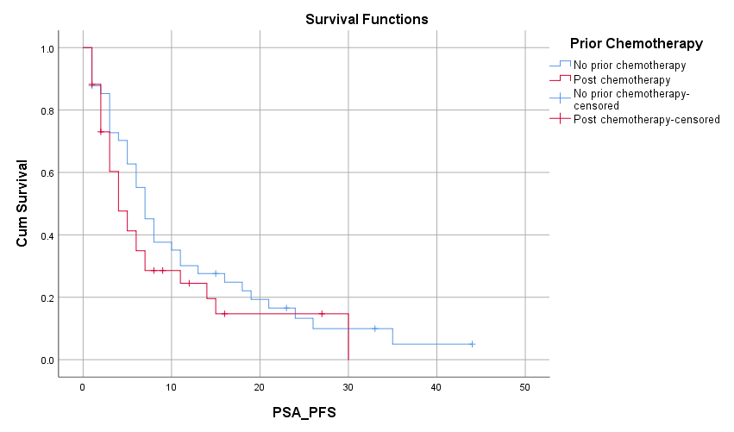

Means and Medians for Survival Time
Prior Chemotherapy | Drug | Median
 |  | Estimate | Std. Error | 95% Confidence Interval
 |  |  |  | Lower Bound | Upper Bound
No prior chemotherapy | Abiraterone | 7.000 | 1.346 | 4.363 | 9.637
 | Enzalutamide | 7.000 | 1.597 | 3.870 | 10.130
 | Overall | 7.000 | .896 | 5.243 | 8.757
Post chemotherapy | Abiraterone | 4.000 | .533 | 2.955 | 5.045
 | Enzalutamide | 7.000 | 1.657 | 3.751 | 10.249
 | Overall | 4.000 | .926 | 2.185 | 5.815
Overall | Overall | 6.000 | .787 | 4.457 | 7.543

a. Estimation is limited to the largest survival time if it is censored.

Overall Comparisonsª
 | Chi-Square | df | Sig.
Log Rank (Mantel-Cox) | 4.103 | 1 | .043

Test of equality of survival distributions for the different levels of Drug.ª
a. Adjusted for Prior Chemotherapy .

Stratum: PriorChemotherapy = No prior chemotherapy

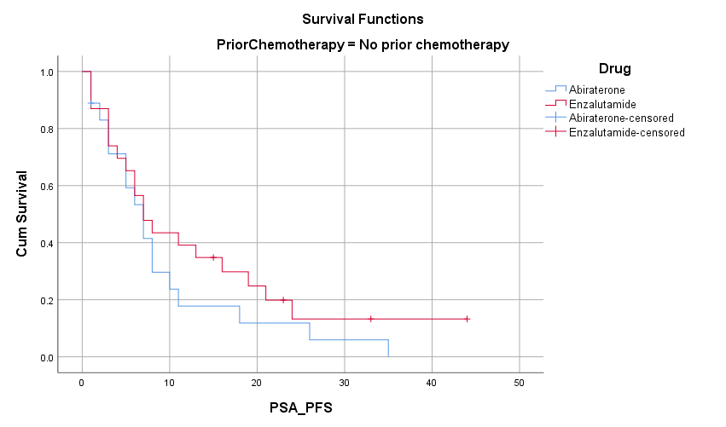

Stratum: PriorChemotherapy = Post chemotherapy

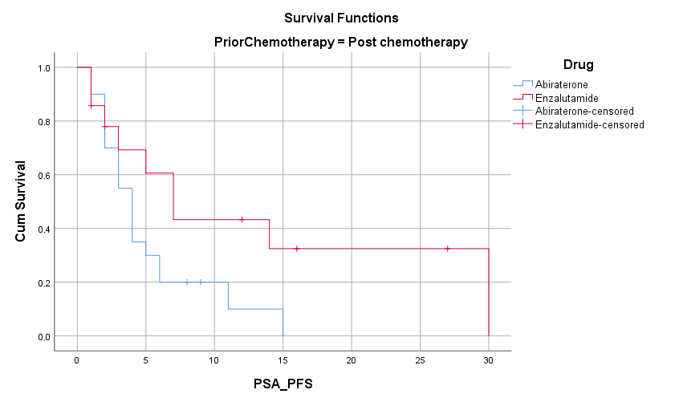
Radiologic PFS Whole Cohort = 7 months

Means and Medians for Survival Time
Meanª |  |  |  | Median
Estimate | Std. Error | 95% Confidence Interval |  | Estimate | Std. Error | 95% Confidence Interval
 |  | Lower Bound | Upper Bound |  |  | Lower Bound
11.085 | 1.417 | 8.308 | 13.863 | 7.000 | .835 | 5.363

Means and Medians for Survival Time
Medianª
95% Confidence Interval
Upper Bound
8.637

a. Estimation is limited to the largest survival time if it is censored.

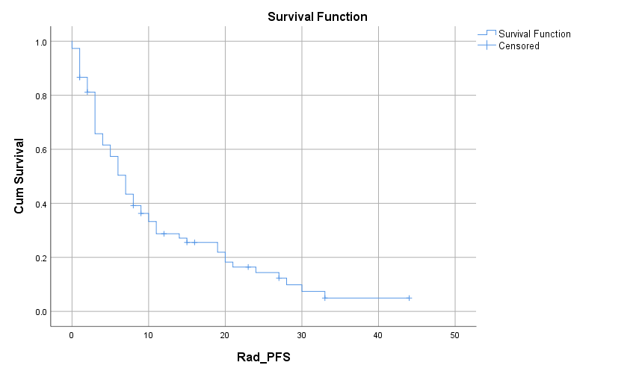

Radiologic PFS

Abi (5 months) vs Enza (7 months)

Means and Medians for Survival Time
Drug | Meanª |  |  |  | Median
 | Estimate | Std. Error | 95% Confidence Interval |  | Estimate | Std. Error
 |  |  | Lower Bound | Upper Bound
Abiraterone | 7.933 | 1.281 | 5.423 | 10.443 | 5.000 | 1.515
Enzalutamide | 14.504 | 2.505 | 9.593 | 19.414 | 7.000 | 1.748
Overall | 11.085 | 1.417 | 8.308 | 13.863 | 7.000 | .835

Means and Medians for Survival Time
Drug | Medianª
 | 95% Confidence Interval
 | Lower Bound | Upper Bound
Abiraterone | 2.030 | 7.970
Enzalutamide | 3.573 | 10.427
Overall | 5.363 | 8.637

a. Estimation is limited to the largest survival time if it is censored.

Overall Comparisons
 | Chi-Square | df | Sig.
Log Rank (Mantel-Cox) | 4.416 | 1 | .036

Test of equality of survival distributions for the different levels of Drug.

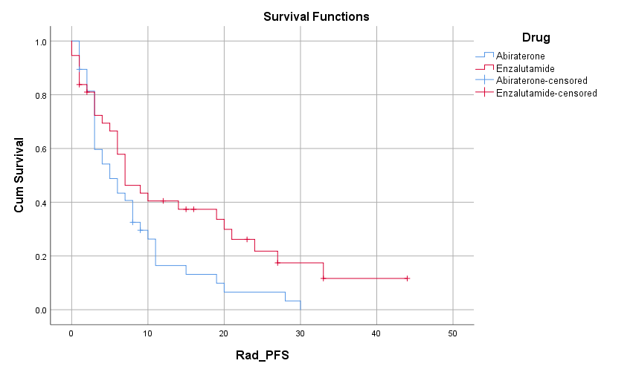

Radiologic PFS

No prior chemotherapy (7 months) vs prior chemotherapy (6 months)

Means and Medians for Survival Time
Prior Chemotherapy | Meanª |  |  |  | Median
 | Estimate | Std. Error | 95% Confidence Interval |  | Estimate | Std. Error
 |  |  | Lower Bound | Upper Bound
No prior chemotherapy | 11.538 | 1.910 | 7.795 | 15.281 | 7.000 | 1.047
Post chemotherapy | 10.319 | 1.983 | 6.433 | 14.206 | 6.000 | 1.667
Overall | 11.085 | 1.417 | 8.308 | 13.863 | 7.000 | .835

Means and Medians for Survival Time
Prior Chemotherapy | Medianª
 | 95% Confidence Interval
 | Lower Bound | Upper Bound
No prior chemotherapy | 4.947 | 9.053
Post chemotherapy | 2.732 | 9.268
Overall | 5.363 | 8.637

a. Estimation is limited to the largest survival time if it is censored.

Overall Comparisons
 | Chi-Square | df | Sig.
Log Rank (Mantel-Cox) | .195 | 1 | .659

Test of equality of survival distributions for the different levels of Prior Chemotherapy .

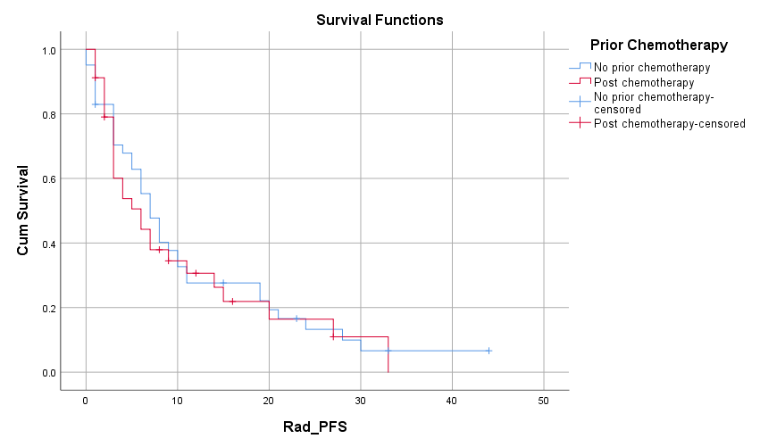

Means and Medians for Survival Time
Prior Chemotherapy | Drug | Median
 |  | Estimate | Std. Error | 95% Confidence Interval
 |  |  |  | Lower Bound | Upper Bound
No prior chemotherapy | Abiraterone | 8.000 | .673 | 6.681 | 9.319
 | Enzalutamide | 6.000 | .958 | 4.122 | 7.878
 | Overall | 7.000 | 1.047 | 4.947 | 9.053
Post chemotherapy | Abiraterone | 3.000 | .639 | 1.748 | 4.252
 | Enzalutamide | 14.000 | 5.501 | 3.218 | 24.782
 | Overall | 6.000 | 1.667 | 2.732 | 9.268
Overall | Overall | 7.000 | .835 | 5.363 | 8.637

a. Estimation is limited to the largest survival time if it is censored.

Overall Comparisonsª
 | Chi-Square | df | Sig.
Log Rank (Mantel-Cox) | 3.670 | 1 | .055

Test of equality of survival distributions for the different levels of Drug.ª
a. Adjusted for Prior Chemotherapy .

Stratum: PriorChemotherapy = No prior chemotherapy

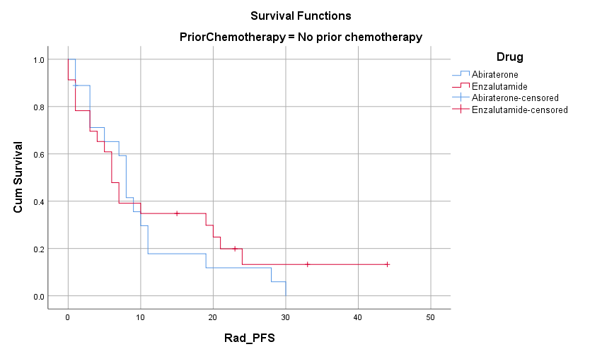

Stratum: PriorChemotherapy = Post chemotherapy

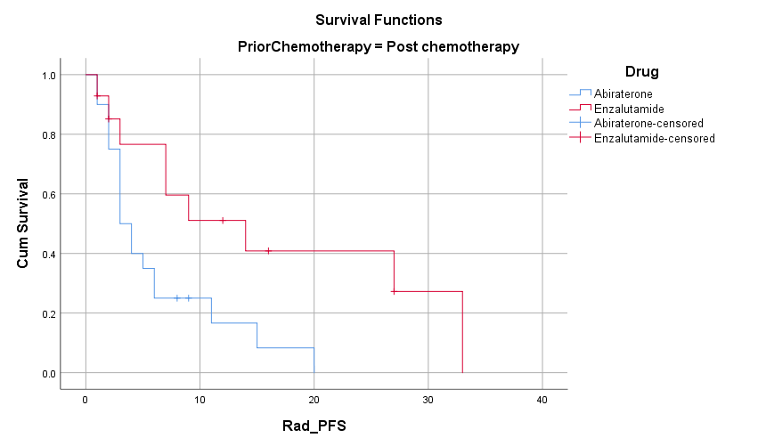

Radiologic PFS

High Burden (6 months) vs Low burden (8 months)

Means and Medians for Survival Time
Burden of Disease 1= High 2= Low | Meanª |  |  |  | Median
 | Estimate | Std. Error | 95% Confidence Interval |  | Estimate
 |  |  | Lower Bound | Upper Bound
High | 7.719 | 1.209 | 5.349 | 10.088 | 6.000
Low | 14.047 | 2.317 | 9.506 | 18.588 | 8.000
Overall | 11.085 | 1.417 | 8.308 | 13.863 | 7.000

Means and Medians for Survival Time
Burden of Disease 1= High 2= Low | Medianª
 | Std. Error | 95% Confidence Interval
 |  | Lower Bound | Upper Bound
High | 1.111 | 3.822 | 8.178
Low | 1.742 | 4.586 | 11.414
Overall | .835 | 5.363 | 8.637

a. Estimation is limited to the largest survival time if it is censored.

Overall Comparisons
 | Chi-Square | df | Sig.
Log Rank (Mantel-Cox) | 5.072 | 1 | .024

Test of equality of survival distributions for the different levels of Burden of Disease 1= High 2= Low.

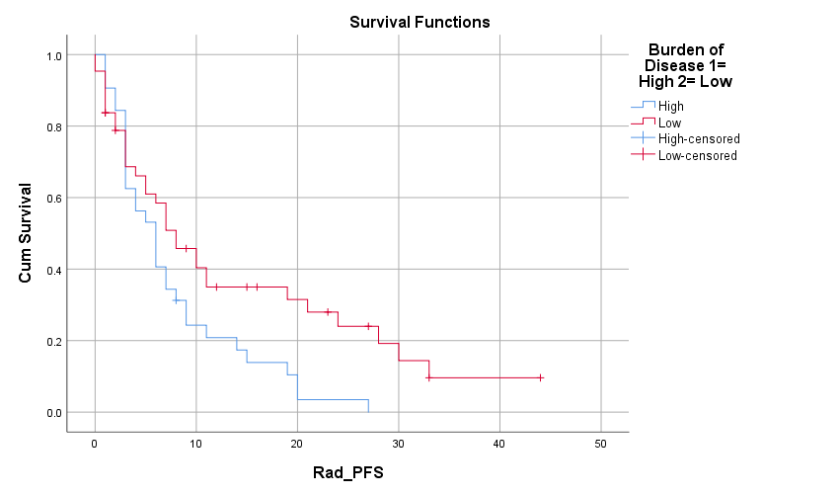

Overall Survival Whole Cohort = 24 months

Means and Medians for Survival Time
Meanª |  |  |  | Median
Estimate | Std. Error | 95% Confidence Interval |  | Estimate | Std. Error | 95% Confidence Interval
 |  | Lower Bound | Upper Bound |  |  | Lower Bound
23.018 | 2.116 | 18.870 | 27.166 | 24.000 | 4.347 | 15.480

Means and Medians for Survival Time
Medianª
95% Confidence Interval
Upper Bound
32.520

a. Estimation is limited to the largest survival time if it is censored.

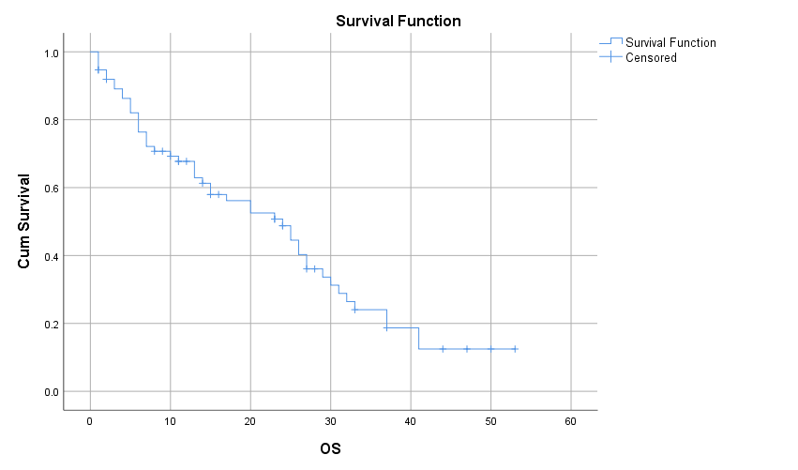

Overall Survival

Abi (13 months) Vs Enza (30 months)

Means and Medians for Survival Time
Drug | Meanª |  |  |  | Median
 | Estimate | Std. Error | 95% Confidence Interval |  | Estimate | Std. Error
 |  |  | Lower Bound | Upper Bound
Abiraterone | 16.197 | 2.455 | 11.385 | 21.009 | 13.000 | 2.586
Enzalutamide | 29.790 | 2.978 | 23.953 | 35.627 | 30.000 | 2.611
Overall | 23.018 | 2.116 | 18.870 | 27.166 | 24.000 | 4.347

Means and Medians for Survival Time
Drug | Medianª
 | 95% Confidence Interval
 | Lower Bound | Upper Bound
Abiraterone | 7.931 | 18.069
Enzalutamide | 24.883 | 35.117
Overall | 15.480 | 32.520

a. Estimation is limited to the largest survival time if it is censored.

Overall Comparisons
 | Chi-Square | df | Sig.
Log Rank (Mantel-Cox) | 10.270 | 1 | .001

Test of equality of survival distributions for the different levels of Drug.

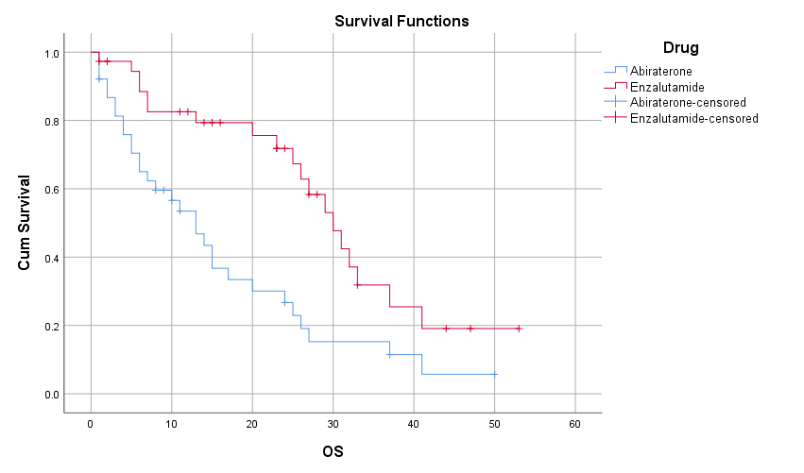

Overall Survival

No prior chemotherapy (26 months) Vs prior chemotherapy (17 months)

Means and Medians for Survival Time
Prior Chemotherapy | Meanª |  |  |  | Median
 | Estimate | Std. Error | 95% Confidence Interval |  | Estimate | Std. Error
 |  |  | Lower Bound | Upper Bound
No prior chemotherapy | 24.762 | 2.686 | 19.497 | 30.027 | 26.000 | 3.888
Post chemotherapy | 19.900 | 3.102 | 13.819 | 25.981 | 17.000 | 7.010
Overall | 23.018 | 2.116 | 18.870 | 27.166 | 24.000 | 4.347

Means and Medians for Survival Time
Prior Chemotherapy | Medianª
 | 95% Confidence Interval
 | Lower Bound | Upper Bound
No prior chemotherapy | 18.379 | 33.621
Post chemotherapy | 3.261 | 30.739
Overall | 15.480 | 32.520

a. Estimation is limited to the largest survival time if it is censored.

Overall Comparisons
 | Chi-Square | df | Sig.
Log Rank (Mantel-Cox) | 1.037 | 1 | .308

Test of equality of survival distributions for the different levels of Prior Chemotherapy .

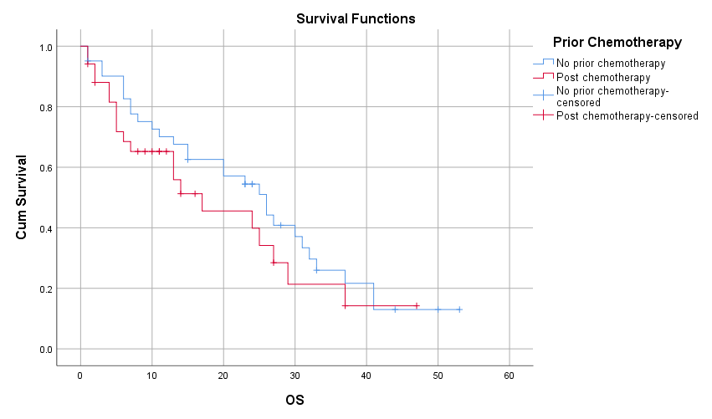

Means and Medians for Survival Time
Prior Chemotherapy | Drug | Median
 |  | Estimate | Std. Error | 95% Confidence Interval
 |  |  |  | Lower Bound | Upper Bound
No prior chemotherapy | Abiraterone | 15.000 | 2.699 | 9.710 | 20.290
 | Enzalutamide | 30.000 | 3.402 | 23.331 | 36.669
 | Overall | 26.000 | 3.888 | 18.379 | 33.621
Post chemotherapy | Abiraterone | 7.000 | 5.870 | .000 | 18.505
 | Enzalutamide | 29.000 | 3.949 | 21.261 | 36.739
 | Overall | 17.000 | 7.010 | 3.261 | 30.739
Overall | Overall | 24.000 | 4.347 | 15.480 | 32.520

a. Estimation is limited to the largest survival time if it is censored.

Overall Comparisonsª
 | Chi-Square | df | Sig.
Log Rank (Mantel-Cox) | 9.146 | 1 | .002

Test of equality of survival distributions for the different levels of Drug.ª
a. Adjusted for Prior Chemotherapy .
Stratum: PriorChemotherapy = No prior chemotherapy

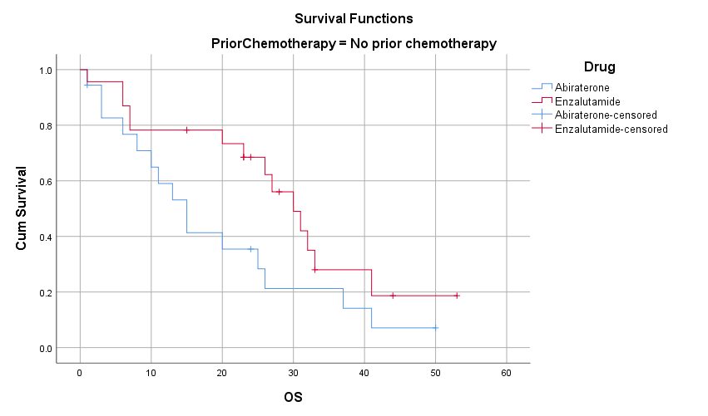
Stratum: PriorChemotherapy = Post chemotherapy

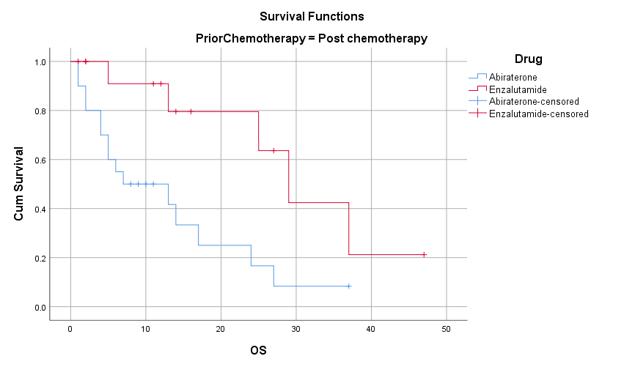

Overall Survival

High burden (15 months) Vs Low burden (26 months)

Means and Medians for Survival Time
Burden of Disease 1= High 2= Low | Meanª |  |  |  | Median
 | Estimate | Std. Error | 95% Confidence Interval |  | Estimate
 |  |  | Lower Bound | Upper Bound
High | 19.274 | 3.006 | 13.383 | 25.166 | 15.000
Low | 25.694 | 2.743 | 20.317 | 31.071 | 26.000
Overall | 23.018 | 2.116 | 18.870 | 27.166 | 24.000

Means and Medians for Survival Time
Burden of Disease 1= High 2= Low | Medianª
 | Std. Error | 95% Confidence Interval
 |  | Lower Bound | Upper Bound
High | 4.656 | 5.874 | 24.126
Low | 1.765 | 22.540 | 29.460
Overall | 4.347 | 15.480 | 32.520

a. Estimation is limited to the largest survival time if it is censored.

Overall Comparisons
 | Chi-Square | df | Sig.
Log Rank (Mantel-Cox) | 2.558 | 1 | .110

Test of equality of survival distributions for the different levels of Burden of Disease 1= High 2= Low.

