Supplemental Material for LOA et al. 31-03-2021

Table S1. Q-sample comprised of a set of statements, grouped by thematic area, proposed to characterize cocoa cultivation in both countries
Thematic area | N | Statement
Landscape configuration | S1 | In your country cocoa cultivation has a role as a deforestation agent
 | S2 | In your country cocoa has a role as a reforestation agent
 | S3 | "lack of secure rights to (titles) land” in rural areas of your country influences cocoa as reforestation/deforestation...
 | S4 | “Bureaucracy to cut/harvest” timber trees in rural areas of your country can influence cocoa being an agent of reforestation/deforestation?
 | S5 | The “price/value of land” in rural areas of your country can influence whether cocoa is an agent of reforestation/deforestation?
 | S6 | The relative economic weight” of cocoa in the agricultural matrix of cocoa in your country
Management and Commercialization model | S7 | The minimum size of area cultivated in your country has a potential effect on the role that cocoa plays as an agent of deforestation/reforestation?
 | S8 | The “low productivity (less than 400 kg/ha)” of cocoa can have a potential effect on the role that the crop plays in your country as an agent of deforestation/reforestation?
 | S9 | ...“SAF-Cacao typology” promoted by agroforestry projects in your country has a potential effect on the role that cacao plays as an agent of deforestation/reforestation?
 | S10 | ...“genetic composition (clones/varieties)” of the cocoa grown in your country/zone has any effect on the role of the crop as an agent of deforestation/reforestation?
 | S11 | ... “profitability of cocoa” in the growing areas of your country has an effect on the role that cocoa plays as an agent of deforestation/reforestation
 | S12 | the “degree of diversification” of the farms (several crops/practices on the same farm) have a potential effect on the role that cocoa plays in your country/zone as an agent of deforestation/reforestation?
 | S13 | ...“plantation age / productive status of cocoa plantations”
 | S14 | the “lack of links/marketing channels” for SAF-Cacao by-products (fruits, wood, firewood, fibers) influences the role of the crop as an agent of deforestation/reforestation?
Knowledge, Skills & abilities | S15 | the “level of technical knowledge” of the staff of the cocoa projects in your country/zone has a potential effect on the role that the crop plays as an agent of deforestation/reforestation?
 | S16 | the “level of research/experimentation” in cocoa in your country/zone has any effect on the role that the crop plays as an agent of deforestation/reforestation?
 | S17 | the predominant “agricultural extension model” in the cocoa projects in your country/zone has any effect on the role of the crop as an agent of deforestation/reforestation?
 | S18 | the existence of “a national cocoa plan/program/strategy” in your country/zone has a potential effect on the role that the crop plays as a deforestation/reforestation agenda?
 | S19 | the age of the cocoa producers in your country/zone influences the role that the crop plays as an agent of deforestation/reforestation?
Governance | S20 | the existence of “certification or environmental labels” in cocoa influences whether the crop is seen as an agent of deforestation/reforestation in your country?
 | S21 | the existence of “payment for environmental services” initiatives have a potential effect on the role of crops in your country/zone as an agent of deforestation/reforestation?
 | S22 | the “Absence/Weakness of the Legal Framework” in your country may have an effect on the role of cocoa as an agent of deforestation/reforestation?
 | S23 | the political “level of influence” exercised by the cocoa union/chain in your country has a potential effect on the role of the crop as an agent of deforestation/reforestation?
 | S24 | the “fluctuation of grain prices” at the international level has any effect on the role that cocoa plays in your country/zone as an agent of reforestation/deforestation?
 | S25 | the “existence of private investors” in your country/zone may influence the role of cocoa as an agent of deforestation/reforestation?
Social Networking | S26 | the degree of “organization/association” of cocoa producers in your country/zone has some potential effect on the role of the crop as an agent of deforestation/reforestation
 | S27 | Consortia/PPP/Networks between cocoa organizations in your country have some potential effect on the role of cocoa as an agent of deforestation/reforestation
 | S28 | "Safe market access (future purchases) has any effect on the role of the crop as an agent of deforestation/reforestation?
Infrastructure | S29 | “Closeness of the cacao Farms” to the road in your country/zone has some effect on the role of the crop as an agent of
 | S30 | "Access to grain collection/transformation centers" has any effect on the role of the crop as an agent of deforestation/reforestation?
 | S31 | the presence of "Financial Services in the cocoa-producing areas can motivate the role of cocoa as an agent of deforestation/reforestation?"

Table S2. Factor matrix with defining sorts flagged for Nicaragua.

No. | Respondent | F1 | F2 | F3 | F4
1 | Private landowner | -0.0884 | 0.411 | 0.7857X | 0.0328
2 | Research/Academia | 0.2313 | -0.0269 | 0.812X | 0.0989
3 | International NGO | 0.12 | -0.0145 | 0.0278 | 0.7646X
4 | Exporter | 0.5671X | 0.4805 | 0.0442 | 0.1602
5 | Government | 0.4642 | 0.6796X | 0.1395 | -0.2928
6 | Local NGO | 0.4937 | -0.0588 | 0.6486X | 0.0532
7 | Local NGO | 0.576X | 0.0507 | 0.303 | 0.3301
8 | Private landowner | 0.42 | 0.0602 | 0.282 | 0.488
9 | International NGO | -0.0378 | 0.5705X | 0.472 | 0.2966
10 | Farmer´s representative | 0.7082X | 0.2267 | -0.0892 | 0.3628
11 | International NGO | 0.1298 | 0.1733 | 0.2174 | 0.5668X
12 | Private landowner | 0.3368 | 0.7035X | 0.2433 | 0.2693
13 | International NGO | 0.1792 | 0.4499 | -0.2346 | 0.5739X
14 | Farmer´s representative | 0.8936 | 0.0054 | 0.1753 | 0.055
15 | Independent consultant | 0.1086 | 0.4929 | 0.083 | 0.2845
16 | Independent consultant | -0.0898 | 0.756 | -0.049 | -0.0051
% Explained Variance |  | 18 | 17 | 15 | 13

F1: Factor 1; F2: Factor 2; F3: Factor 3; F4: Factor 4. The defining sorts are bolded and flagged with an X.

Table S3. Factor matrix with defining sorts flagged for Peru.

No | Respondent | F1 | F2 | F3 | F4
1 | Exporter | 0.3158 | 0.3351 | 0.2822 | -0.1709
2 | International Research/Academia | 0.8745X | 0.0409 | -0.0725 | 0.0082
3 | Exporter | 0.6793X | 0.172 | -0.2238 | 0.2578
4 | Industry | -0.1319 | -0.1211 | -0.0944 | 0.8174X
5 | Government | 0.6008X | -0.0474 | 0.2581 | -0.011
6 | Independent Consultant | 0.7082X | 0.2138 | 0.0798 | -0.1906
7 | National Research/Academia | 0.0131 | -0.0663 | 0.7425X | -0.11
8 | Local NGO | 0.7074X | 0.139 | 0.0624 | 0.0909
9 | International NGO | 0.701X | 0.2056 | -0.0558 | 0.1979
10 | Private landowner | 0.1327 | 0.8335X | -0.0283 | 0.0991
11 | International NGO | 0.1705 | 0.7484X | -0.1994 | -0.2216
12 | International Organization Development | 0.1191 | -0.1744 | 0.7241X | 0.3944
13 | Government | 0.6245X | -0.4456 | 0.0378 | -0.2147
14 | Exporter | 0.4028 | 0.1019 | 0.1171 | 0.4773X
15 | Farmer´s organization representative | 0.5939X | -0.3782 | 0.4047 | -0.0514
16 | Independent Consultant | 0.3168 | -0.423 | -0.5257 | 0.2088
17 | Private landowner | 0.679X | -0.4314 | -0.1584 | -0.2289
% Explained Variance |  | 28 | 13 | 11 | 9

F1: Factor 1; F2: Factor 2; F3: Factor 3; F4: Factor 4. The defining sorts are bolded and flagged with an X.

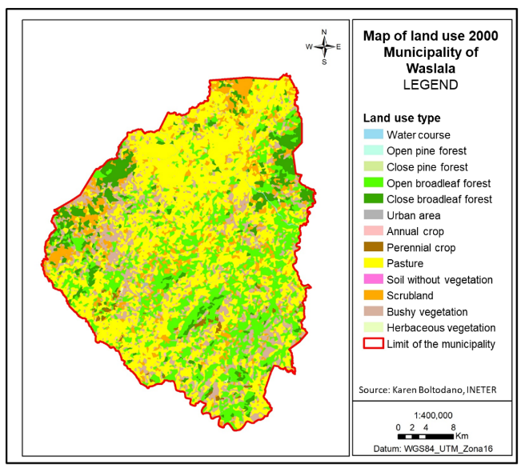

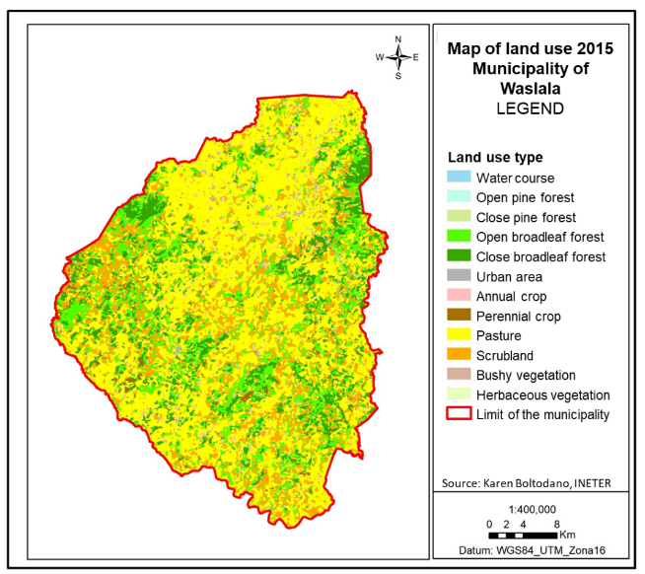

Figure S1. Land-use change map between 2000-2015 in the municipality of Waslala, Nicaragua.

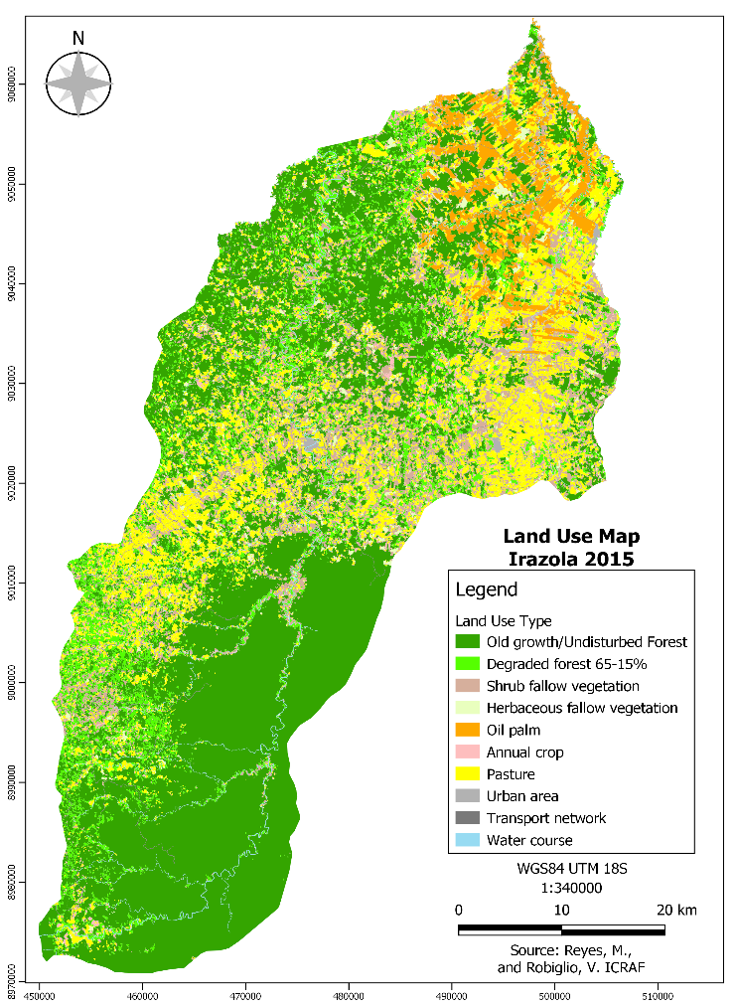
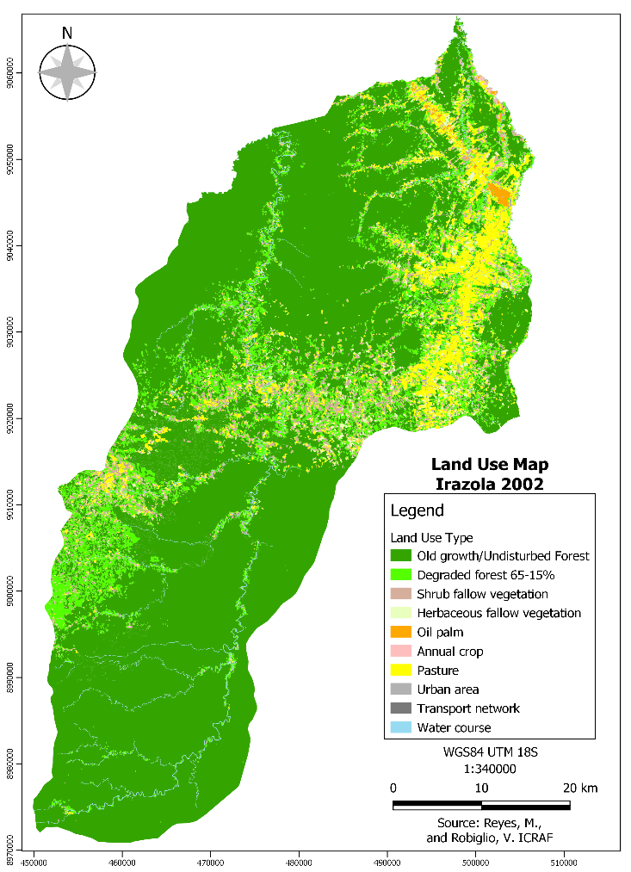

Figure S2. Land-use change map between 2002-2015 in the district of Irazola, Ucayali, Peru.

Table S6. Media outlook linking cocoa cultivation to deforestation and reforestation collected for Nicaragua and Peru (before/after 2010).

For the construction of the Media Outlook, we decided to use the Google search engine, specifically for news, using the following periods: before 2010 and after 2010. The keywords we used were cocoa deforestation Nicaragua, cocoa reforestation Nicaragua, and the same for Peru, only changing the name of the country. Results for Nicaragua and Peru are given next:

Table X. Google search outputs for the construction of the Media Outlook in Nicaragua.

 | Before 2010 | After 2010
Deforestation | In the media, it was not possible to find any article linking cocoa cultivation to deforestation. The media outlook shows how deforestation is linked to other reasons. A few articles hold illegal mining and lack of regulation responsive for deforestation.  Deforestation AND Nicaragua (Before 2010)  The key world “cocoa” was excluded from the research as it gave no results associated with “deforestation” and “Nicaragua”.  114 hits in Google | More information links deforestation to illegal mining, fires, overpopulation, lack of national regulations.  Deforestation AND Nicaragua (After 2010)  The key world “cocoa” was excluded from the research as it gave no results associated with “deforestation” and “Nicaragua”.  186 hits in Google
Reforestation | A few studies show how cocoa in agroforestry system could help reforesting. Most of the studies emerge from national and international scientific institutes.  Cacao AND Reforestation AND Nicaragua (Before 2010)  113 hits in Google | Cocoa as a driver for reforestation comes real and is more widely documented in the media. The media Outlook shows how big projects and companies contribute to reforesting with cocoa in AFS.  Cacao AND Reforestation AND Nicaragua (Before 2010)  159 hits in Google

Table X. Nicaragua’s media outlook online references.

 | Before 2010 | After 2010
Deforestation | 1991  https://www.envio.org.ni/articulo/2852 | 2016  https://raleighnicaragua.ong/blog/blog_post/deforestacion-y-el-yaraje-deforestation-and-el-yaraje/
 | 2007  https://conbio.onlinelibrary.wiley.com/doi/abs/10.1111/j.1523-1739.2007.00793.x | 2021  https://insightcrime.org/news/analysis/deforestation-mining-impunity-nicaragua/
Reforestation | 2008  http://web.mit.edu/~jjay/Public/papers/InnovationsForHealthyValueChainsv15.pdf | 2019  https://cacaooro.com/sustainability/
 | 1995  https://www.jstor.org/stable/3986580?seq=1 | 2018  http://www.marena.gob.ni/Enderedd/wp-content/uploads/Fases/13.%20Estrategia%20Nacional%20ENDE%20(English).pdf
 | 2003  https://issuu.com/simas/docs/revista_enlace_cacao | 2019  https://orochocolate.com/cacao-reforestation/
 | 2009  https://www.librosymanualesdeagronomia.com/guia-tecnologica-del-cultivo-de-cacao/ | 2020  https://www.rikolto.org/en/project/cocoa-waslala-nicaragua-project-ended
 | 2010  https://cenida.una.edu.ni/relectronicos/REF01M547.pdf | 2012  https://www.worldcoo.com/blog/en/cocoa-the-nicaraguan-hope/
2020
https://mlr.com.ni/wp-content/uploads/2020/12/VCS-MLR-Joint-Project-Description-Monitoring-Report-final-Draft-22-10-2020.pdf

Table X. Google search outputs for the construction of the Media Outlook in Peru.

 | Before 2010 | After 2010
Deforestation | At the beginning of the 90's the media was focus on the growing drug trade and terrorism; however, it was known that since the 70’s, deforestation in the Peruvian amazon was led by agricultural intensification specially of coffee and coca.  Cacao AND Deforestation AND Peru (Before 2010)  127 hits in Google | After the drug crisis, the presence of national authorities elucidated the presence of big cocoa producers that were “illegally” destroying the forest and establishing their plantations.  Cacao AND Deforestation AND Peru (After 2010)  149 hits in Google
Reforestation | Some reforestation projects with cocoa started to emerge, led by studies that show how cocoa in agroforestry system could help reforesting. Most these studies emerge from international scientific institutes.  Cacao AND Reforestation AND Peru (Before 2010)  138 hits in Google | Same that in Nicaragua, cocoa AFS was rapidly started to be recognized as a driver for reforestation more widely and it was documented in the media. The media Outlook shows how big projects and companies contribute to reforesting with cocoa in AFS.  Cacao AND Reforestation AND Peru (Before 2010)  172 hits in Google

Table X. Peru’s media outlook references.
 | Before 2010 | After 2010
Deforestation | 1992  https://www.unodc.org/unodc/en/data-and-analysis/bulletin/bulletin_1992-01-01_2_page006.html | 2015  https://www.wri.org/blog/2015/06/zooming-sustainable-cocoa-producer-destroys-pristine-forest-peru
 | 2005  https://books.google.co.cr/books?id=A2qHCgAAQBAJ&pg=PA64&lpg=PA64&dq=cacao+reforestation++deforestation+peru&source=bl&ots=YeAtrQO3fD&sig=ACfU3U0to6qyY3zHn73i7B8N7ikHBvaTIA&hl=es&sa=X&ved=2ahUKEwjnxc2Zr6vvAhXBrVkKHSaqAgI4MhDoATAIegQIDxAD#v=onepage&q=cacao%20reforestation%20%20deforestation%20peru&f=false | 2016  https://news.mongabay.com/2015/01/company-chops-down-rainforest-to-produce-sustainable-chocolate/
Reforestation | 1998  https://agritrop.cirad.fr/390123/1/document_390123.pdf | 2012  https://www.ecotierra.co/commodities
 | 2005  http://www.asb.cgiar.org/PDFwebdocs/White_et_al_2005_ASB-Peru.pdf | 2013  https://growahead.org/give-trees-peru/
 | 2006  https://www.therawchocolatecompany.com/pages/tree-planting | 2015  https://www.businesswire.com/news/home/20160419005633/en/Alter-Eco-Unveils-Annual-Full-Circle-Sustainability-Social-Impact-Report
 | 2008  https://www.purprojet.com/project/alto-huayabamba/ | 2020  https://onetreeplanted.org/blogs/stories/peruvian-amazon-agroforestry

