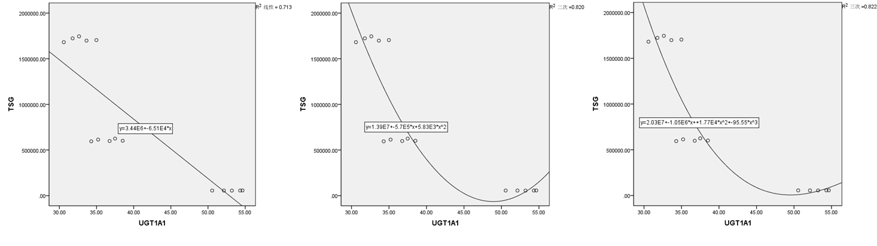
Supplementary Figure 1 The correlation between the expression level of UGT1A1 and the AUC of phase II metabolites of TSG (p<0.01)

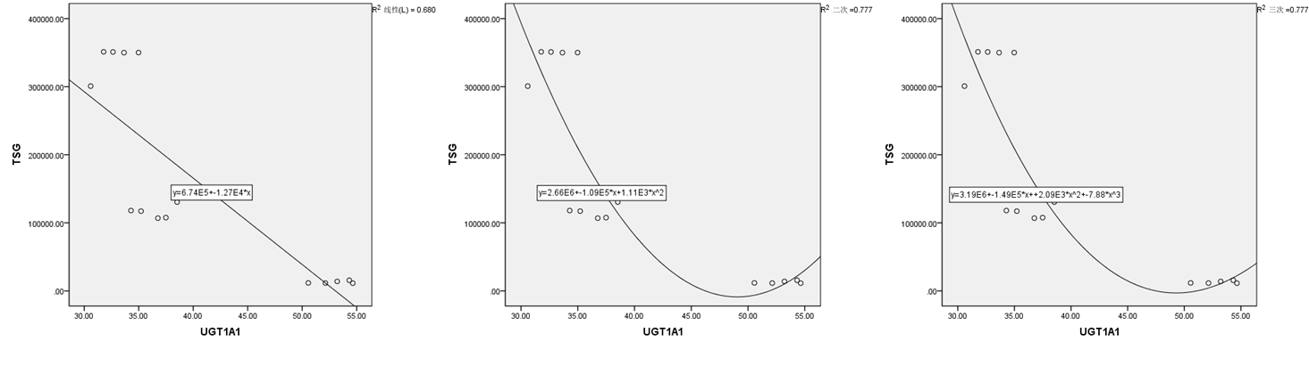
Supplementary Figure 2 The correlation between the expression level of UGT1A1 and the AUC of TSG (p<0.01)

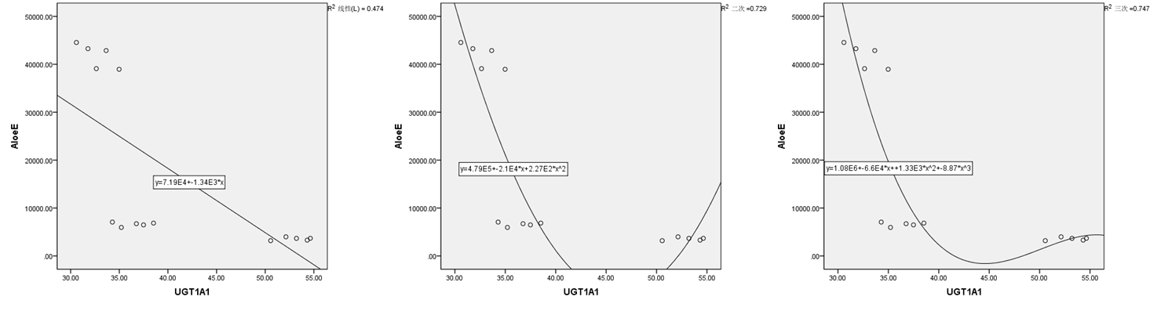Supplementary Figure 3 The correlation between the expression level of UGT1A1 and the AUC of aloe-emodin (p<0.01)

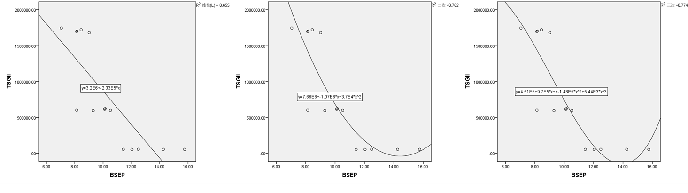Supplementary Figure 4 The correlation between the expression level of BSEP and the AUC of phase II metabolites of TSG (p<0.01)

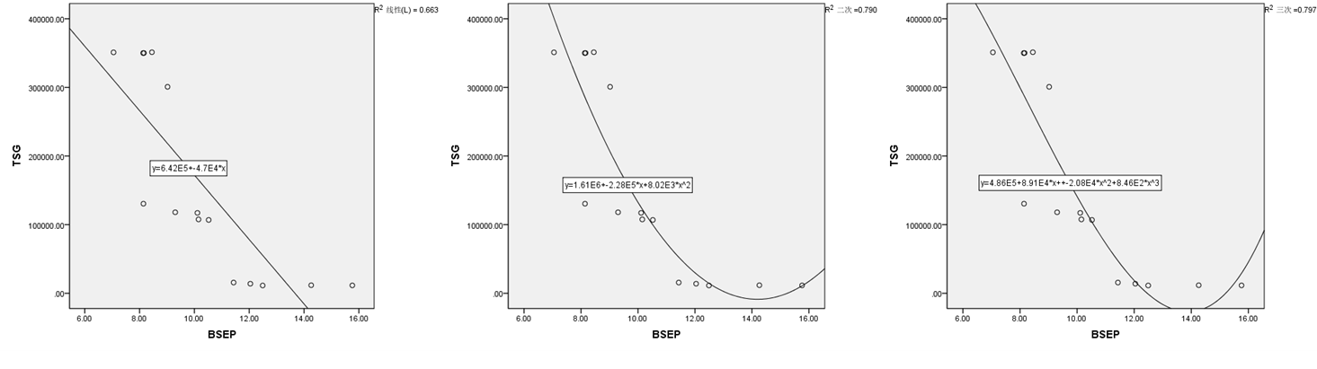Supplementary Figure 5 The correlation between the expression level of BSEP and the AUC of TSG (p<0.01)

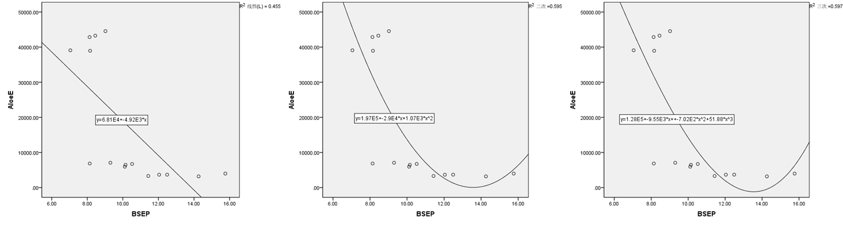
Supplementary Figure 6 The correlation between the expression level of BSEP and the AUC of aloe-emodin (p<0.01)

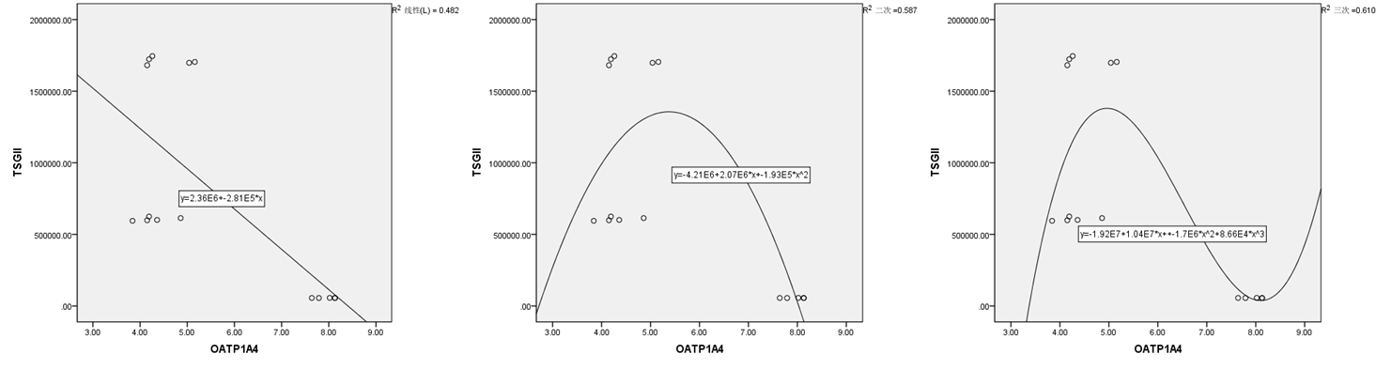
Supplementary Figure 7 The correlation between the expression level of OATP1A4 and the AUC of phase II metabolites of TSG (p<0.01)

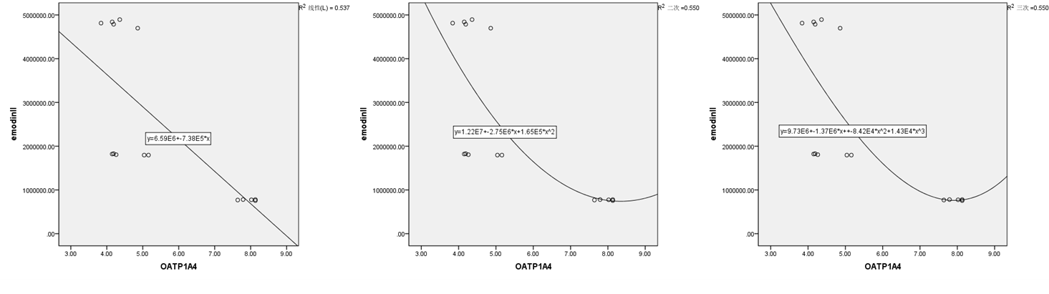
Supplementary Figure 8 The correlation between the expression level of OATP1A4 and the AUC of phase II metabolites of emodin (p<0.01)

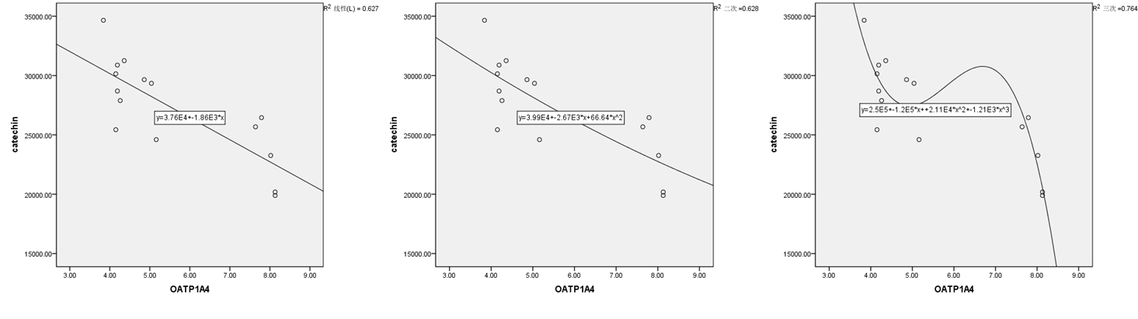
Supplementary Figure 9 The correlation between the expression level of OATP1A4 and the AUC of phase II metabolites of catechin (p<0.01)

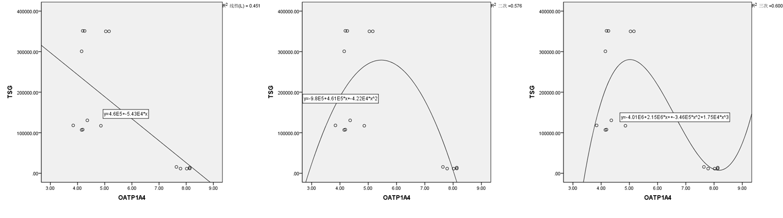
Supplementary Figure 10 The correlation between the expression level of OATP1A4 and the AUC of TSG (p<0.05)

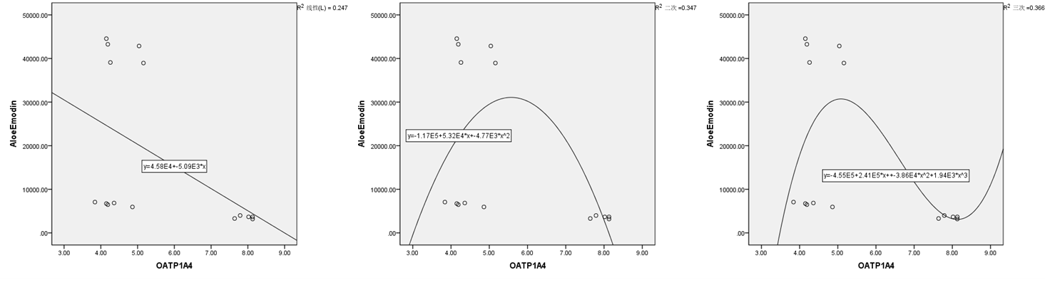
Supplementary Figure 11 The correlation between the expression level of OATP1A4 and the AUC of aloe-emodin (p<0.01)

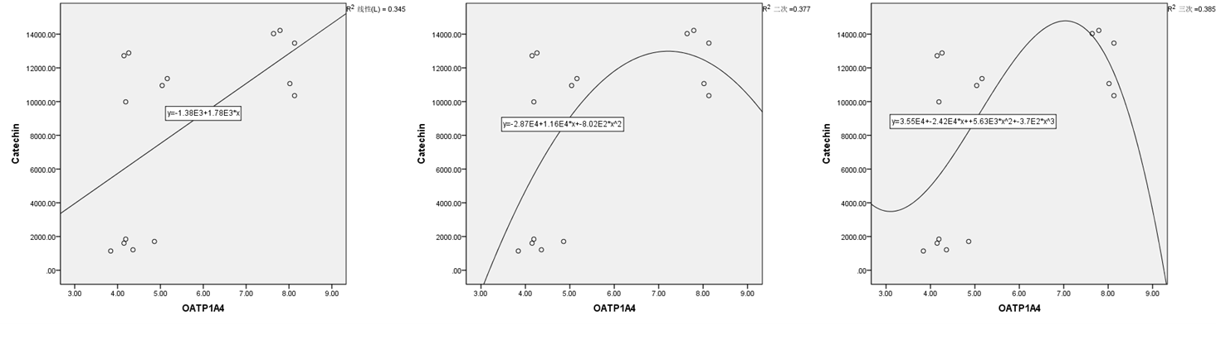
Supplementary Figure 12 The correlation between the expression level of OATP1A4 and the AUC of catechin (p<0.05)

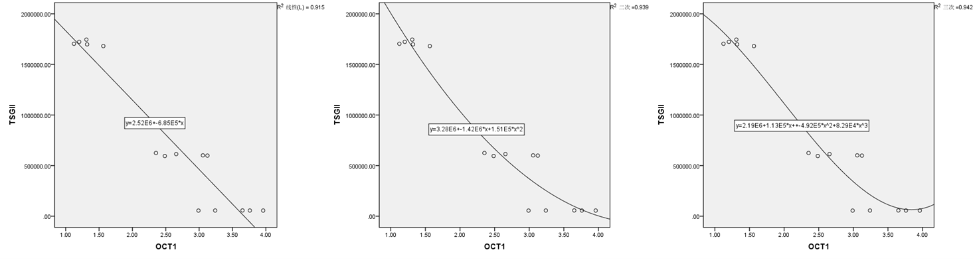
Supplementary Figure 13 The correlation between the expression level of OCT1 and the AUC of phase II metabolites of TSG (p<0.01)

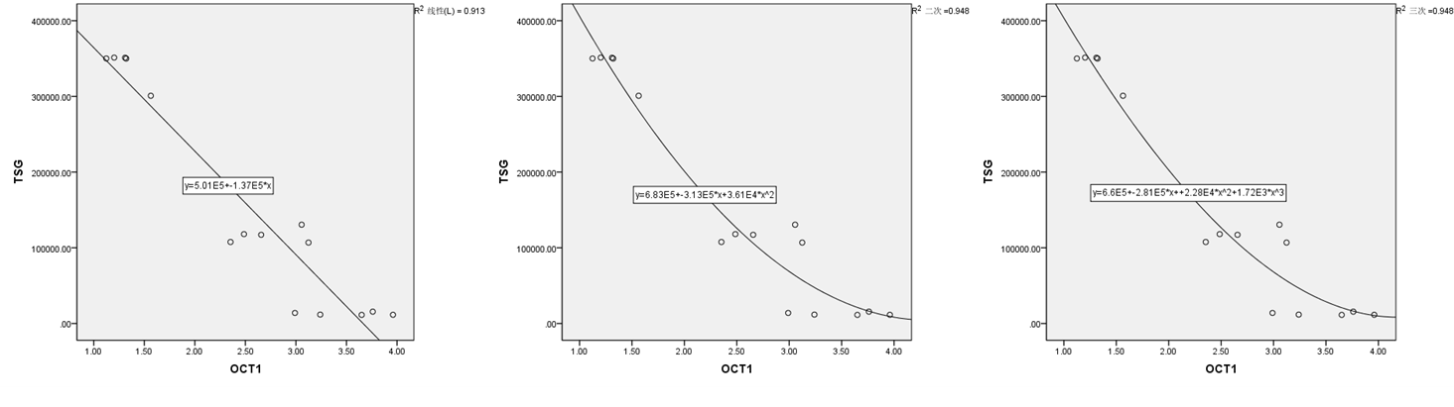
Supplementary Figure 14The correlation between the expression level of OCT1 and the AUC of TSG (p<0.01)

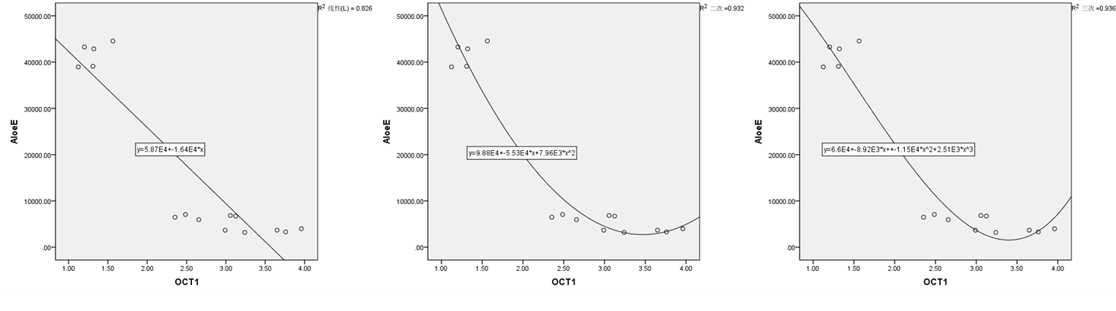
Supplementary Figure 15 The correlation between the expression level of OCT1 and the AUC of aloe-emodin (p<0.01)

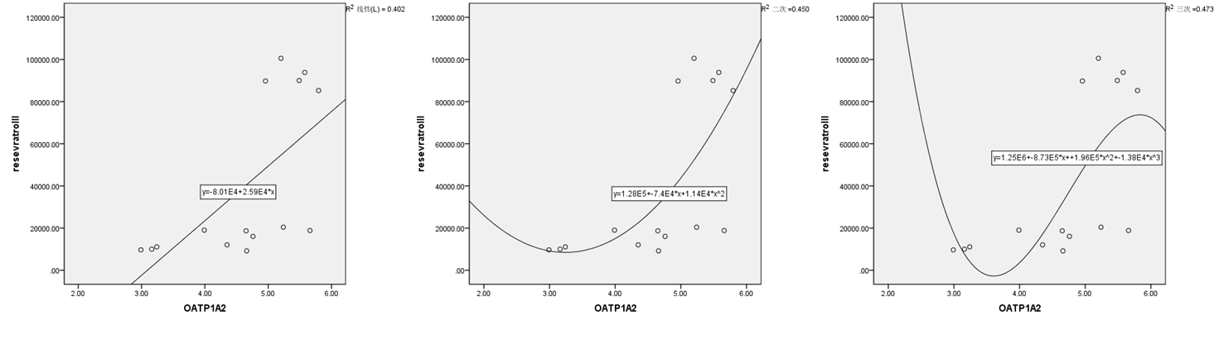
Supplementary Figure 16 The correlation between the expression level of OATP1A2 and the AUC of phase II metabolites of resveratrol (p<0.01)

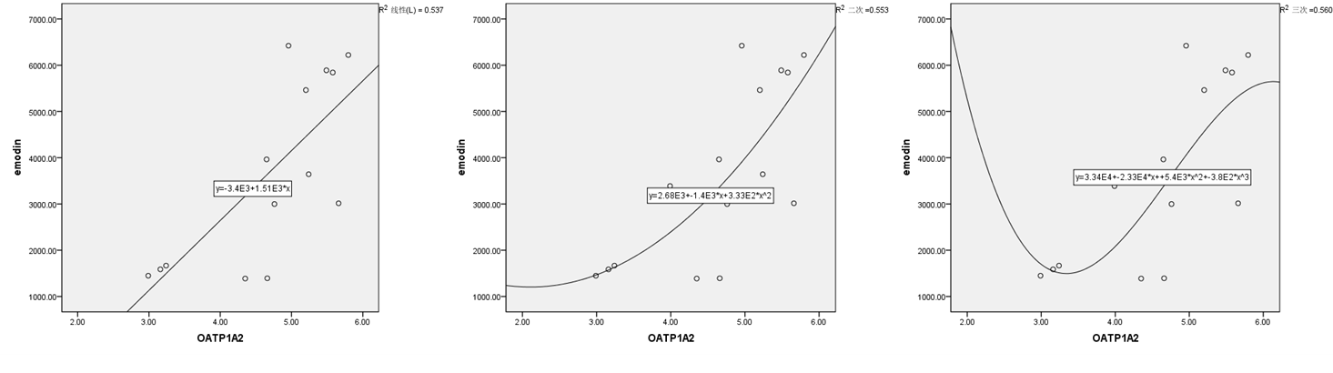
Supplementary Figure 17 The correlation between the expression level of OATP1A2 and the AUC of emodin (p<0.01)

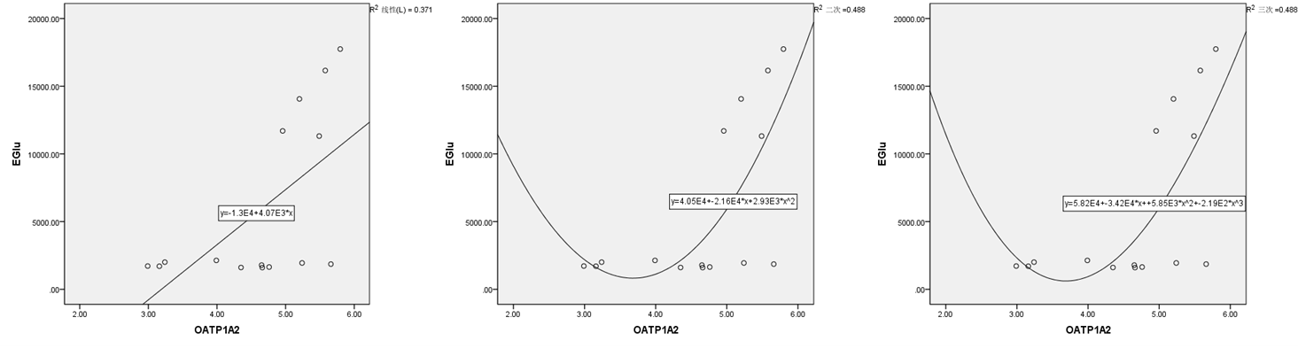
Supplementary Figure 18 The correlation between the expression level of OATP1A2 and the AUC of E-Glu (p<0.05)

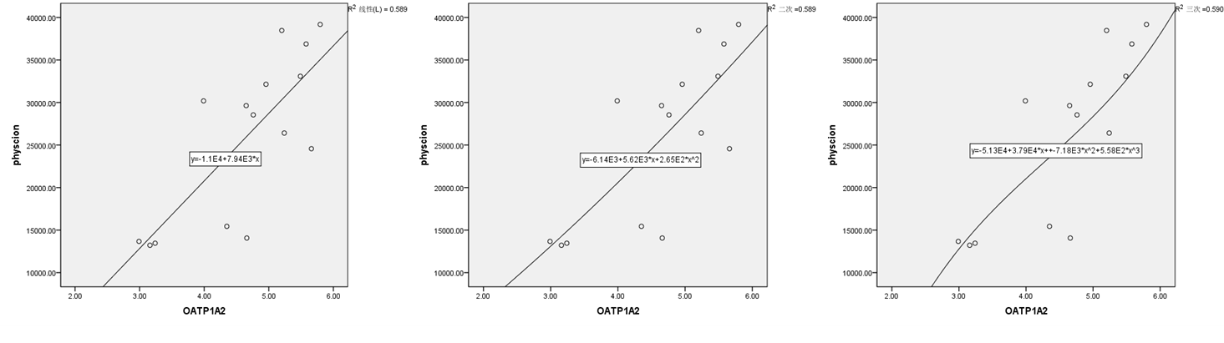
Supplementary Figure 19 The correlation between the expression level of OATP1A2 and the AUC of physcion (p<0.01)

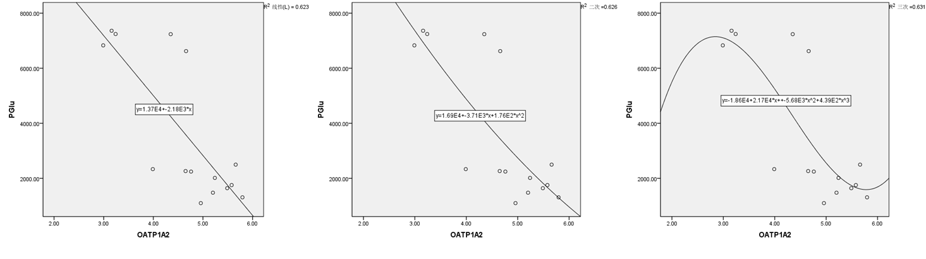Supplementary Figure 20 The correlation between the expression level of OATP1A2 and the AUC of P-Glu (p<0.01)

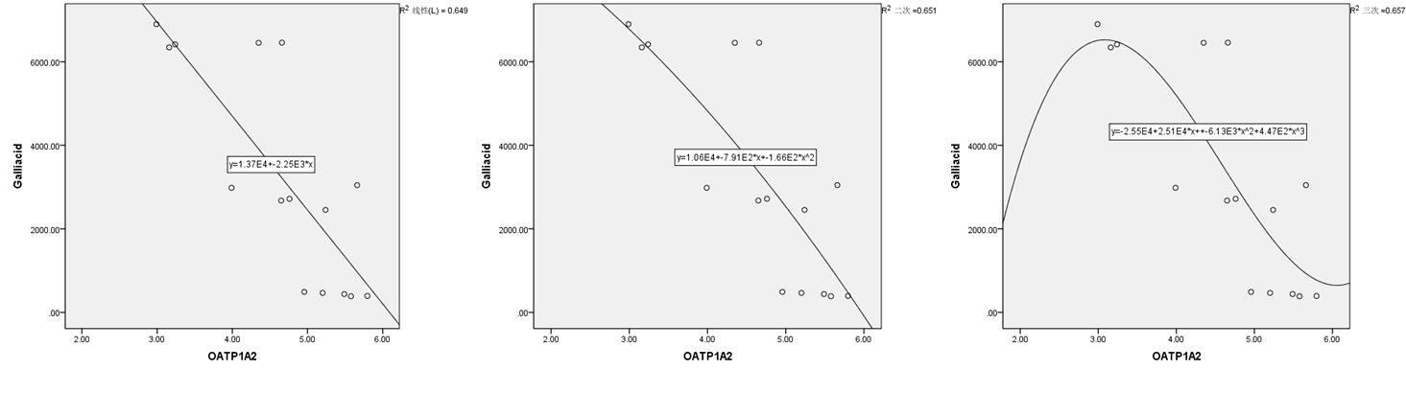Supplementary Figure 21 The correlation between the expression level of OATP1A2 and the AUC of gallic acid (p<0.01)

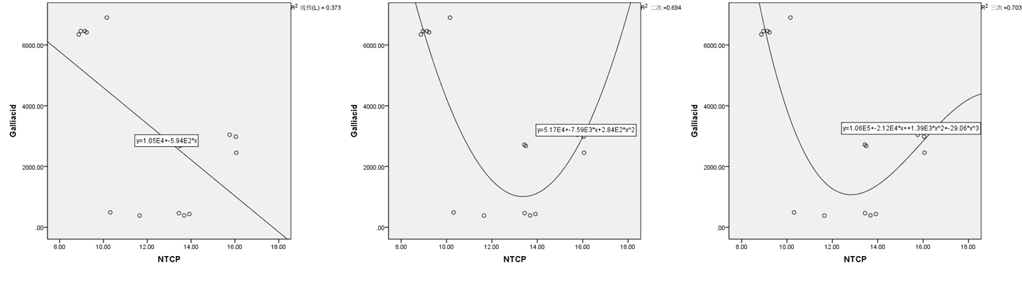Supplementary Figure 22 The correlation between the expression level of NTCP and the AUC of gallic acid (p<0.05)

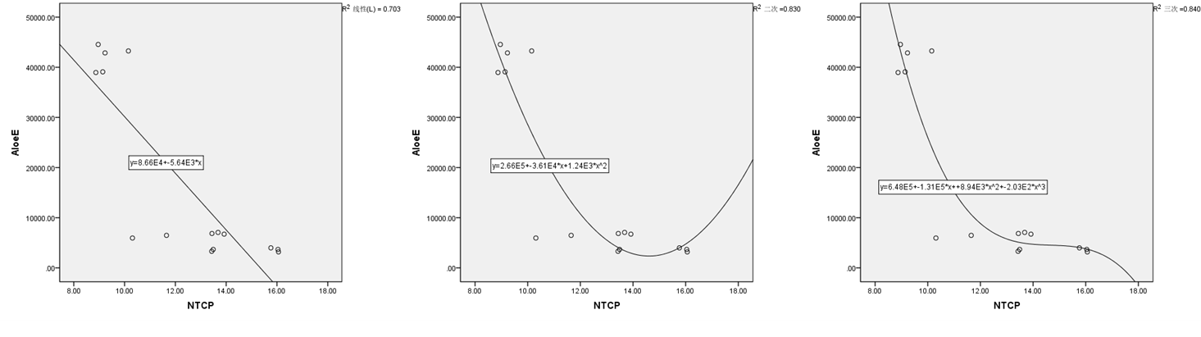Supplementary Figure 23 The correlation between the expression level of NTCP and the AUC of aloe-emodin (p<0.01)

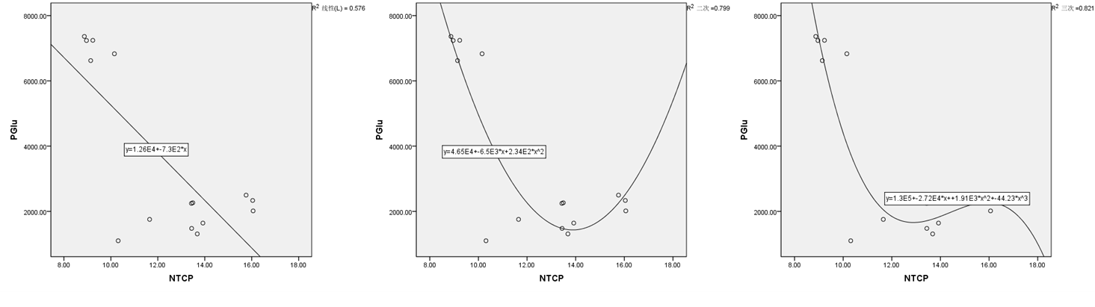
Supplementary Figure 24 The correlation between the expression level of NTCP and the AUC of P-Glu (p<0.05)

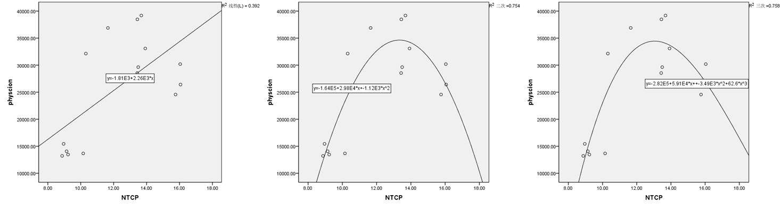
Supplementary Figure 25 The correlation between the expression level of NTCP and the AUC of physcion (p<0.05)

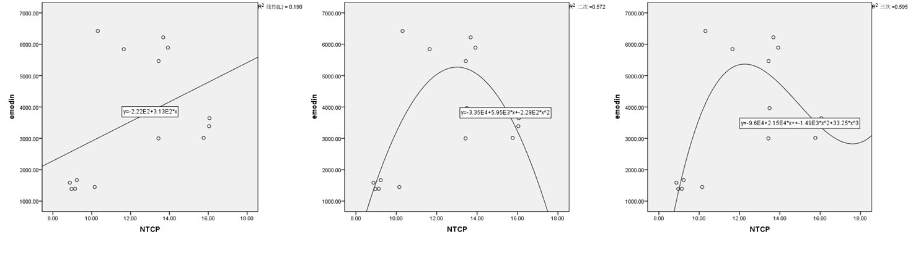Supplementary Figure 26 The correlation between the expression level of NTCP and the AUC of emodin (p<0.05)

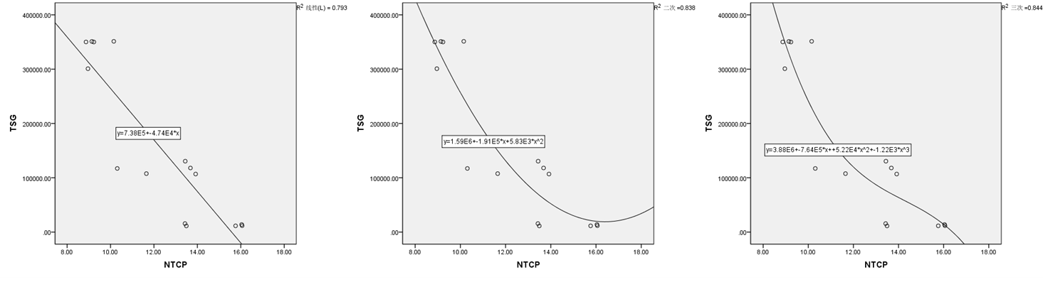
Supplementary Figure 27 The correlation between the expression level of NTCP and the AUC of TSG (p<0.01)

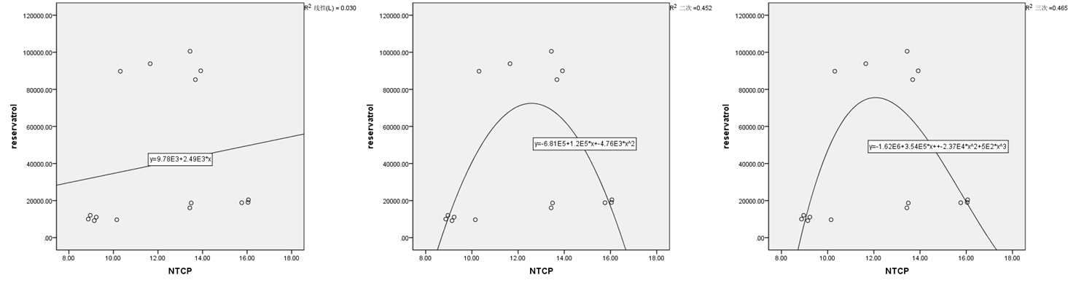
Supplementary Figure 28 The correlation between the expression level of NTCP and the AUC of phase II metabolites of resveratrol (p<0.05)

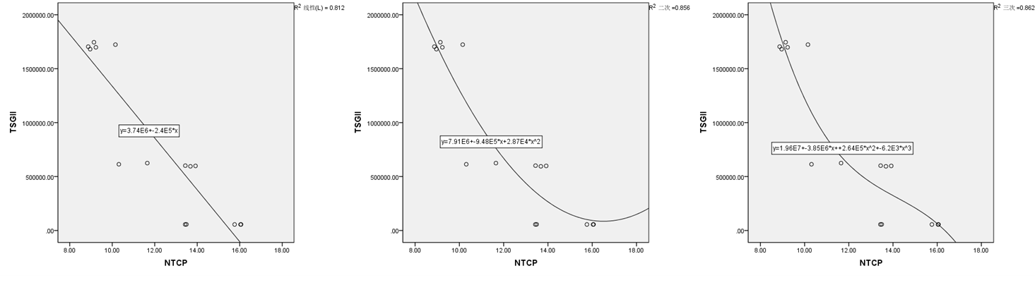
Supplementary Figure 29 The correlation between the expression level of NTCP and the AUC of phase II metabolites of TSG (p<0.01)

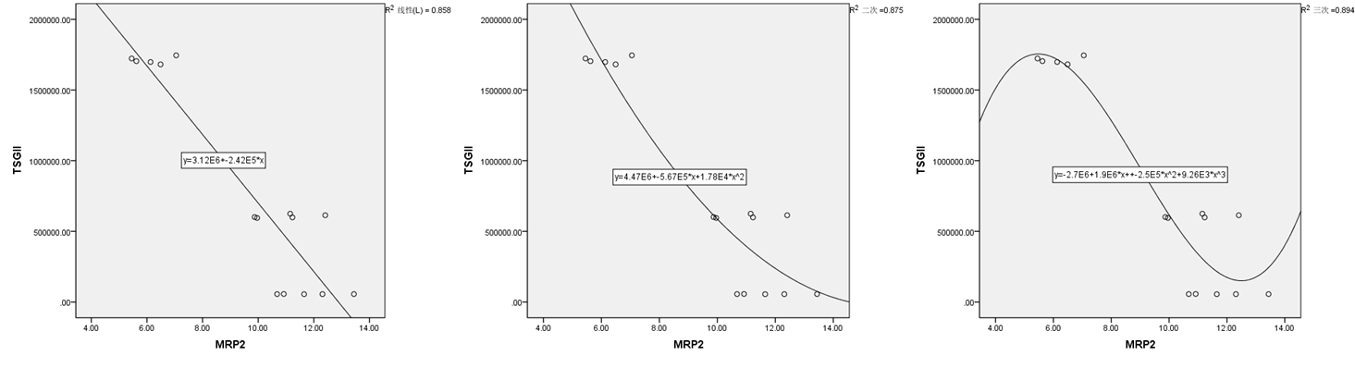
Supplementary Figure 30 The correlation between the expression level of MRP2 and the AUC of phase II metabolites of TSG (p<0.01)

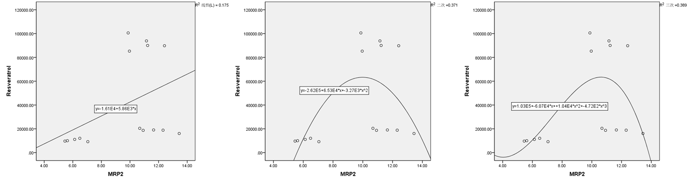
Supplementary Figure 31 The correlation between the expression level of MRP2 and the AUC of phase II metabolites of resveratrol (p<0.05)

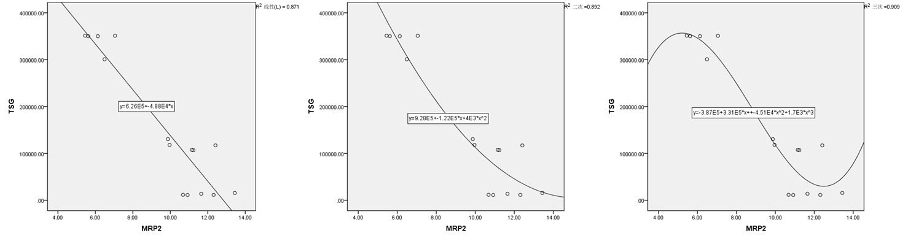
Supplementary Figure 32 The correlation between the expression level of MRP2 and the AUC of TSG (p<0.01)

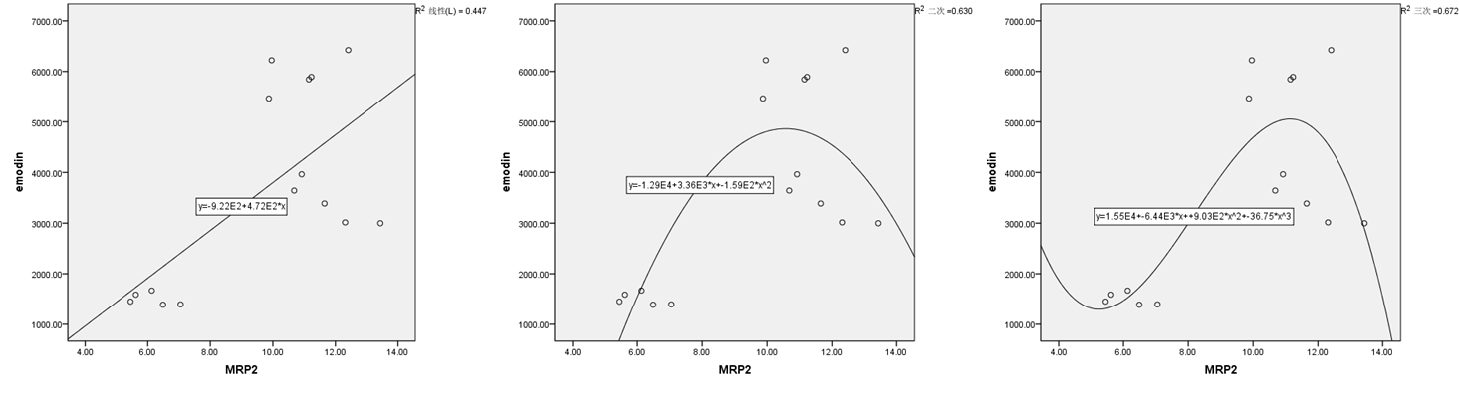Supplementary Figure 33 The correlation between the expression level of MRP2 and the AUC of emodin (p<0.05)

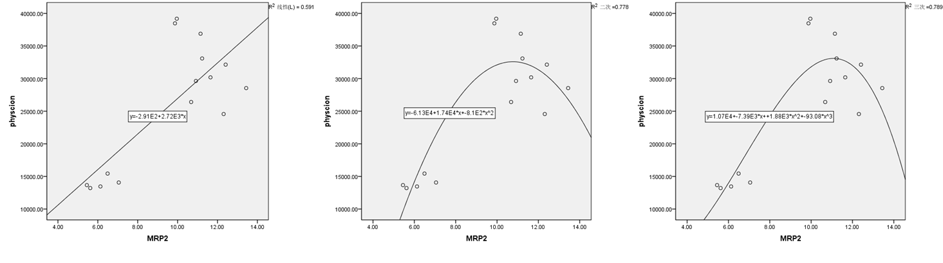
Supplementary Figure 34 The correlation between the expression level of MRP2 and the AUC of physcion (p<0.05)

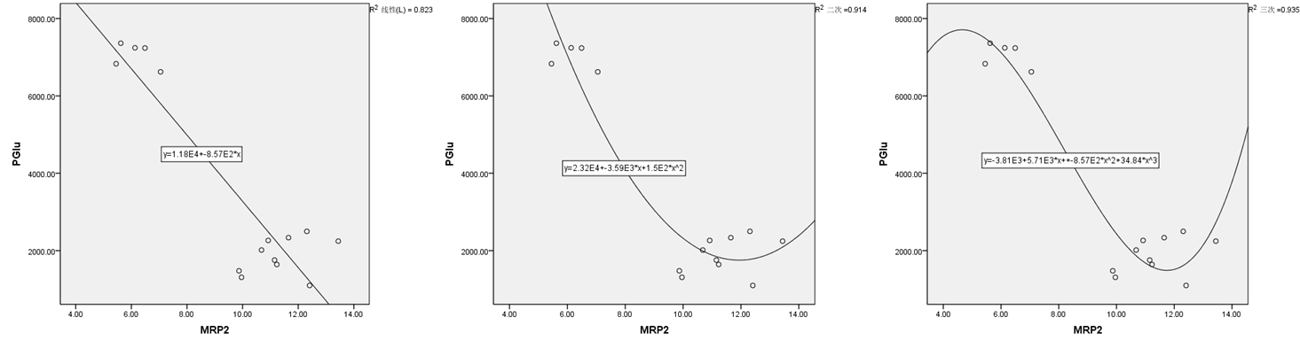Supplementary Figure 35 The correlation between the expression level of MRP2 and the AUC of P-Glu (p<0.05)

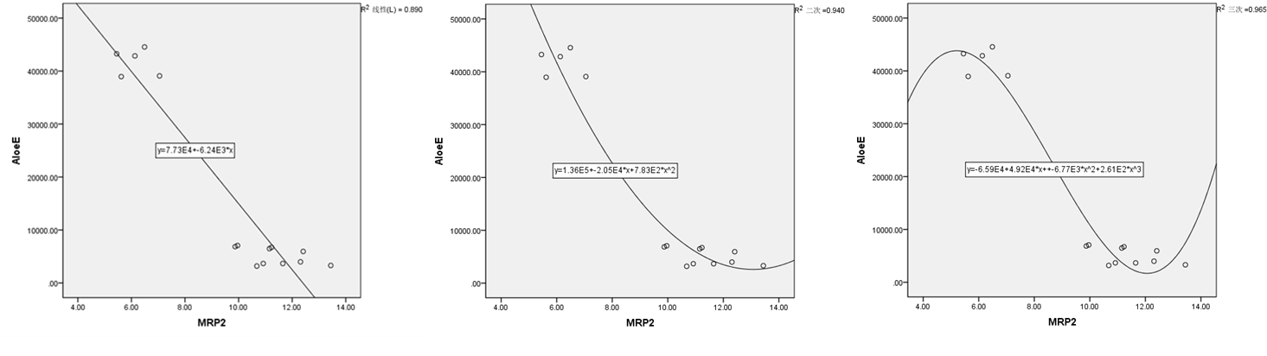Supplementary Figure 36 The correlation between the expression level of MRP2 and the AUC of aloe-emodin (p<0.01)

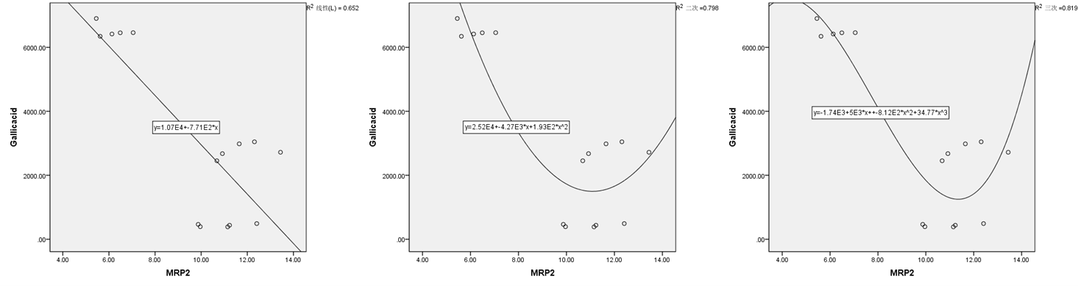
Supplementary Figure 37 The correlation between the expression level of MRP2 and the AUC of gallic acid (p<0.05)

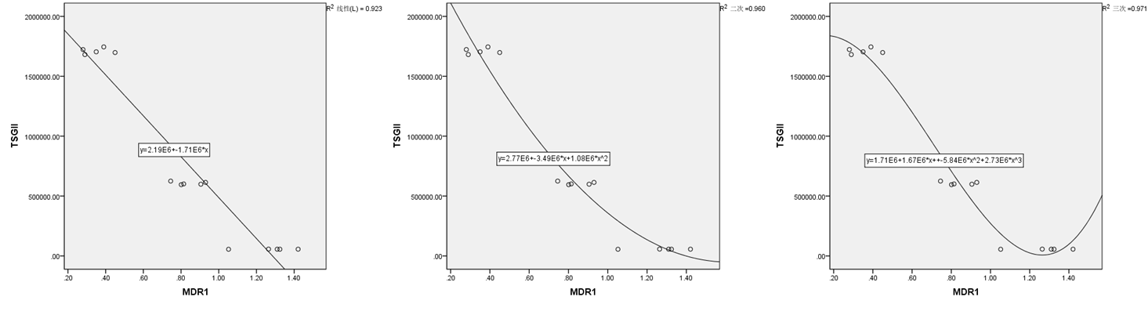
Supplementary Figure 38 The correlation between the expression level of MDR1 and the AUC of phase II metabolites of TSG (p<0.01)

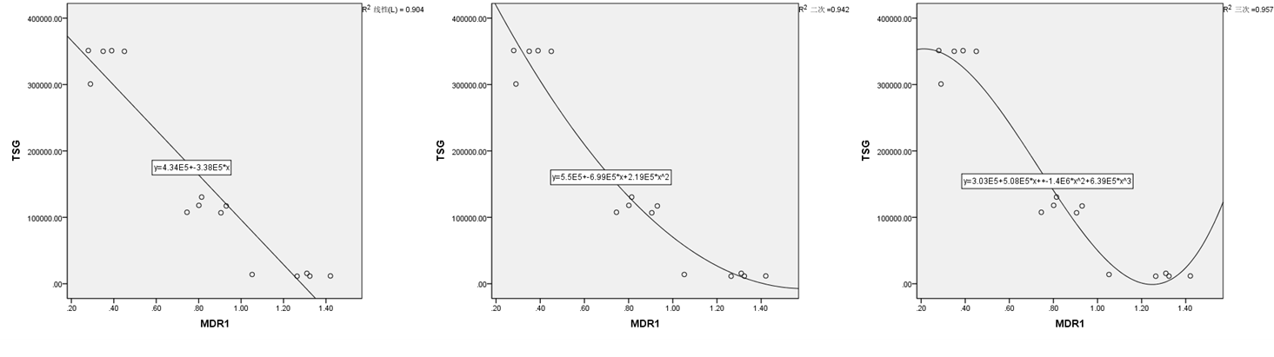
Supplementary Figure 39 The correlation between the expression level of MDR1 and the AUC of TSG (p<0.01)

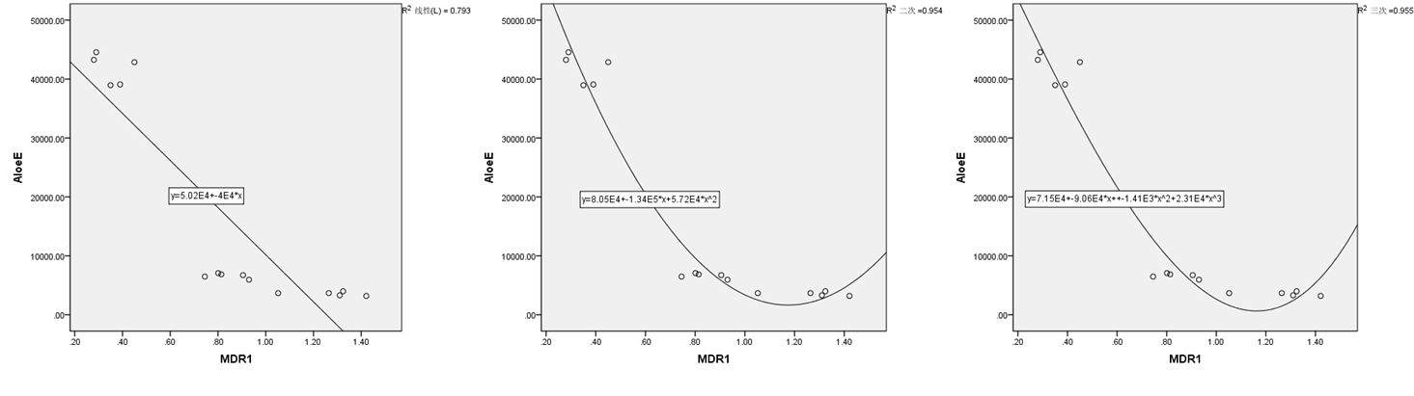
Supplementary Figure 40 The correlation between the expression level of MDR1 and the AUC of aloe-emodin (p<0.01)

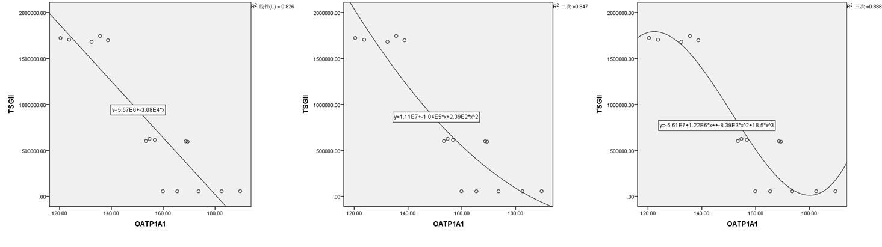Supplementary Figure 41 The correlation between the expression level of OATP1A1 and the AUC of phase of metabolites of TSG (p<0.01)

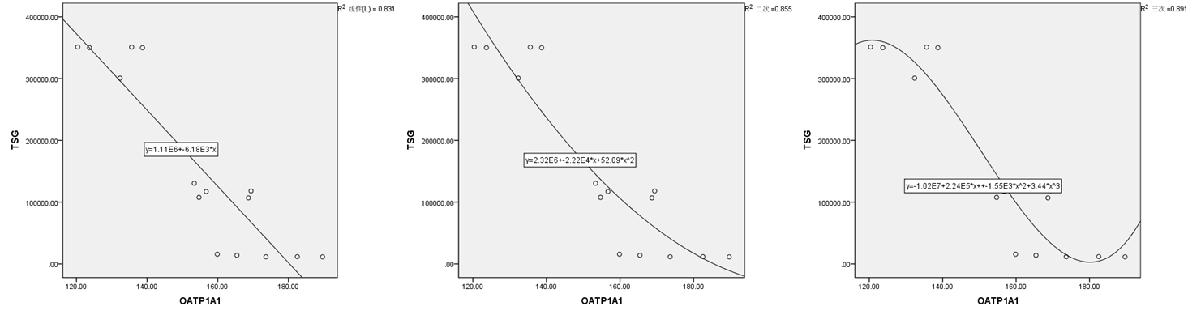Supplementary Figure 42 The correlation between the expression level of OATP1A1 and the AUC of TSG (p<0.01)

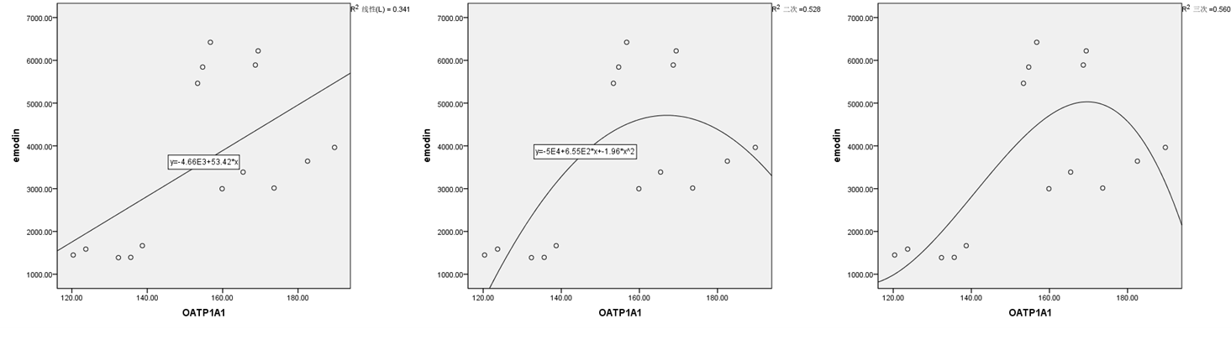
Supplementary Figure 43 The correlation between the expression level of OATP1A1 and the AUC of emodin (p<0.05)

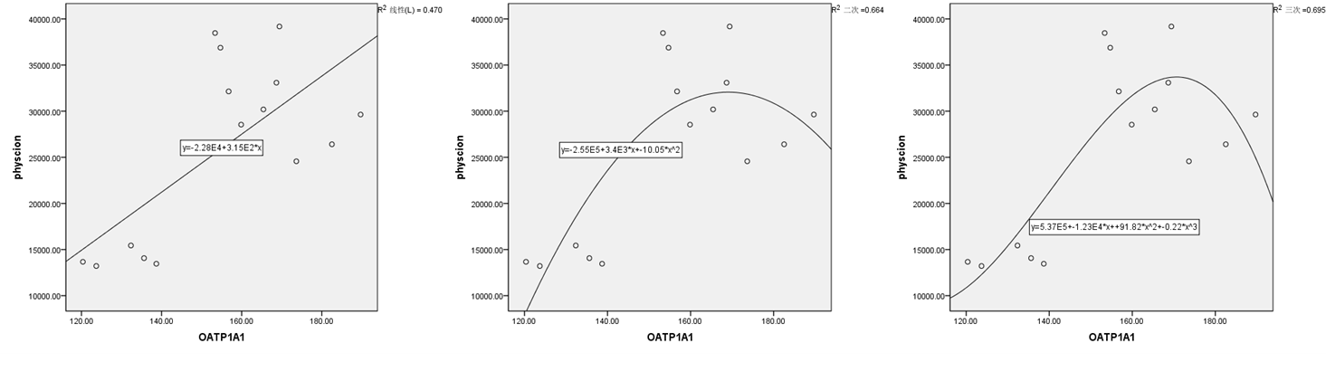
Supplementary Figure 44 The correlation between the expression level of OATP1A1 and the AUC of physcion (p<0.05)

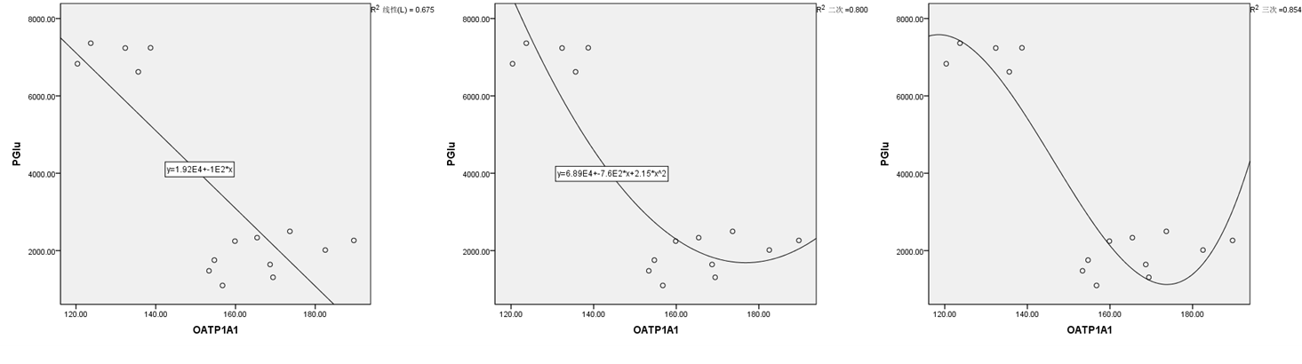

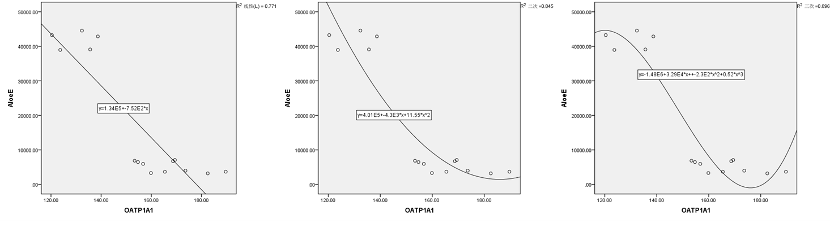
Supplementary Figure 46 The correlation between the expression level of OATP1A1 and the AUC of aloe-emodin (p<0.01)

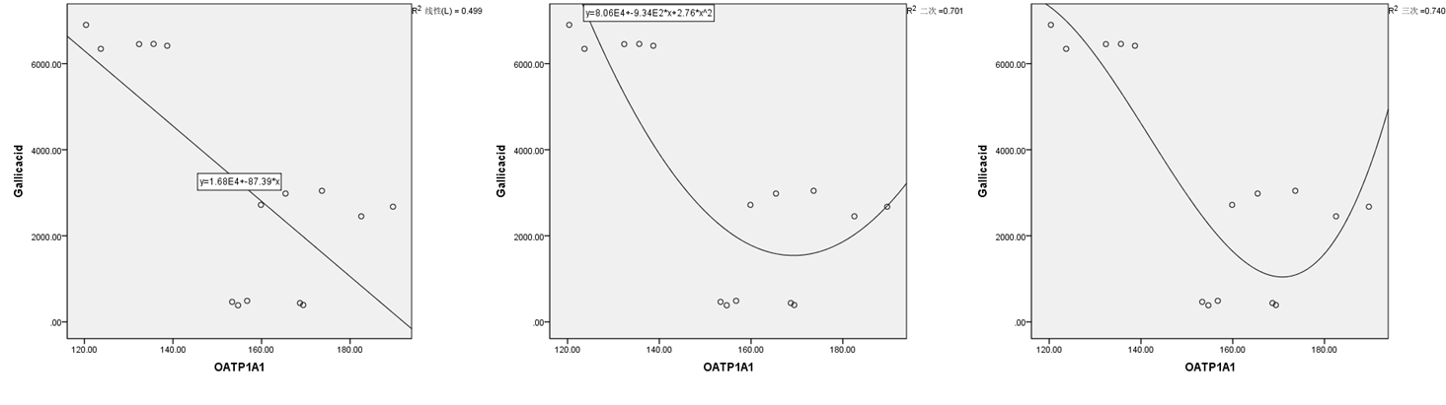Supplementary Figure 47 The correlation between the expression level of OATP1A1 and the AUC of gallic acid (p<0.05)

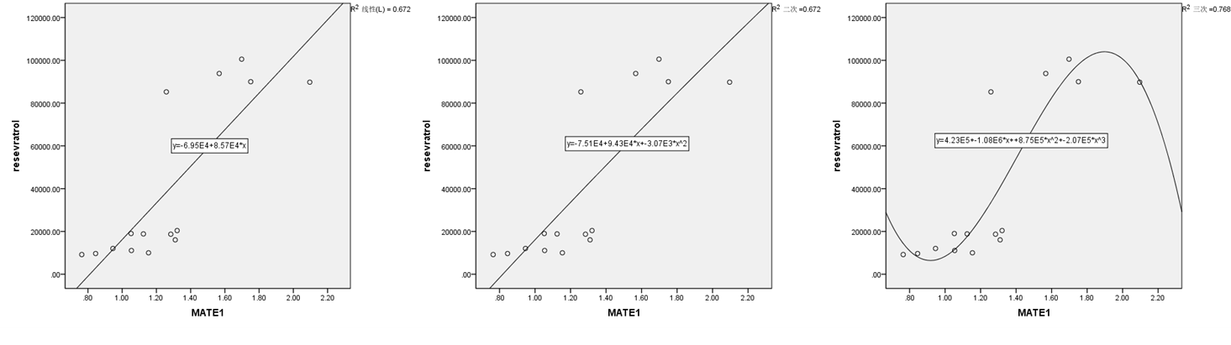Supplementary Figure 48 The correlation between the expression level of MATE1 and the AUC of phase II metabolites of resveratrol (p<0.01)

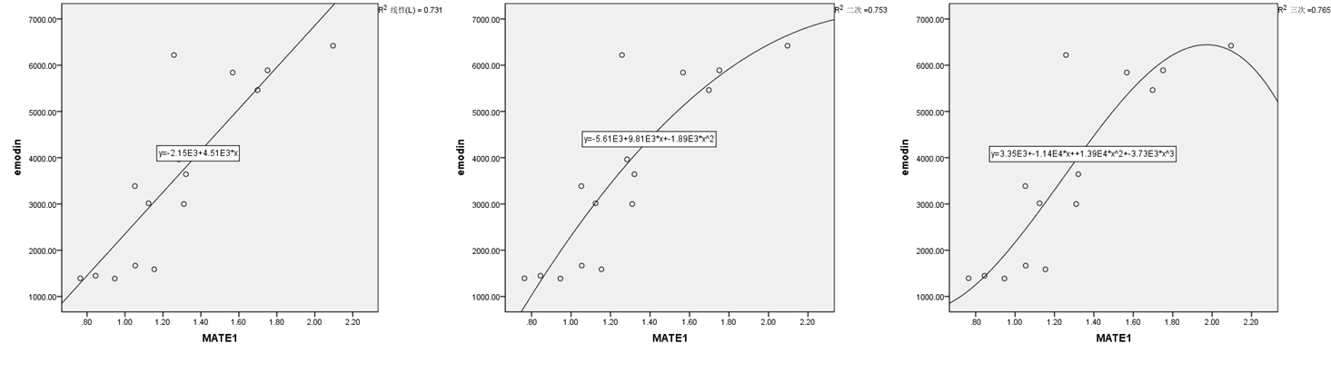Supplementary Figure 49 The correlation between the expression level of MATE1 and the AUC of emodin (p<0.01)

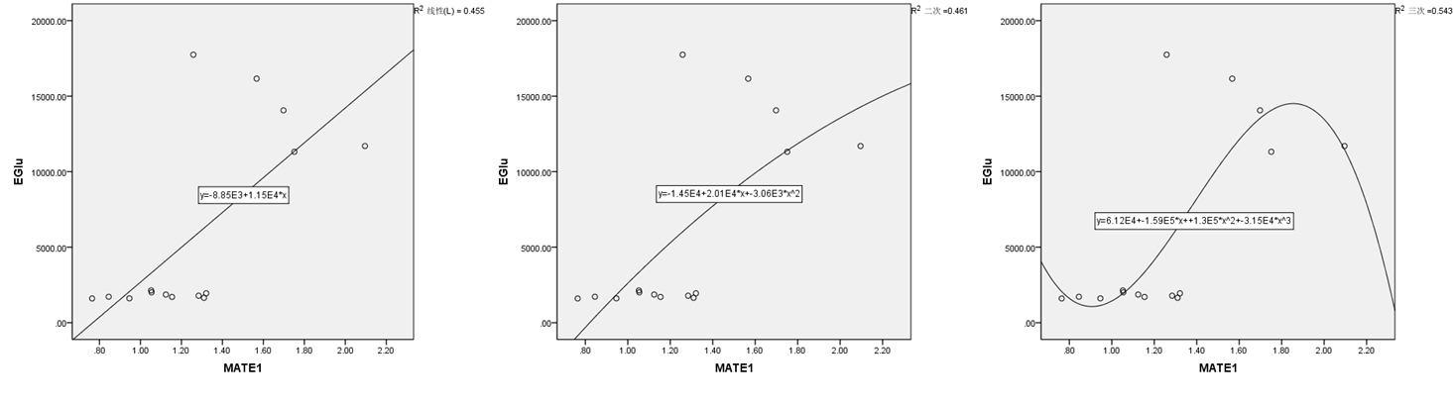
Supplementary Figure 50 The correlation between the expression level of MATE1 and the AUC of E-Glu (p<0.05)

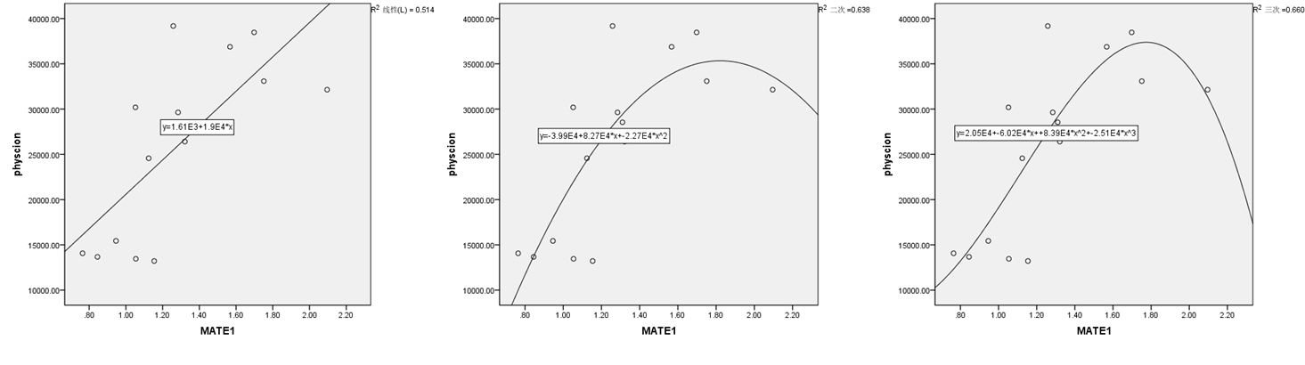Supplementary Figure 51 The correlation between the expression level of MATE1 and the AUC of physcion (p<0.01)

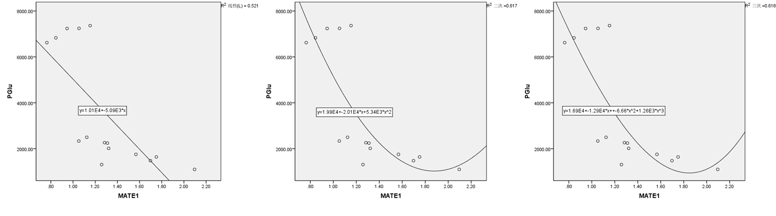Supplementary Figure 52 The correlation between the expression level of MATE1 and the AUC of P-Glu (p<0.01)

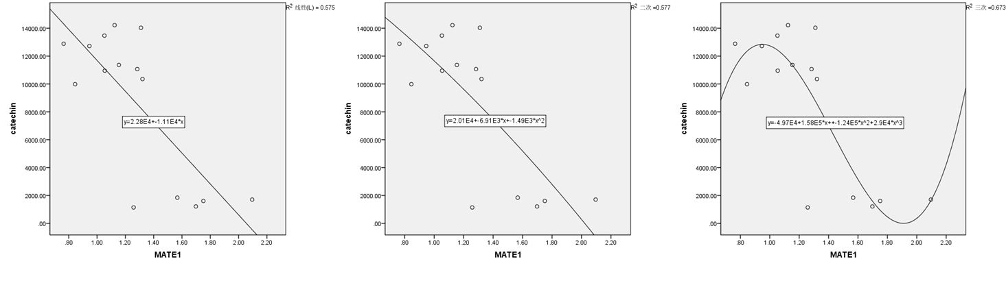Supplementary Figure 53 The correlation between the expression level of MATE1 and the AUC of catechin (p<0.05)

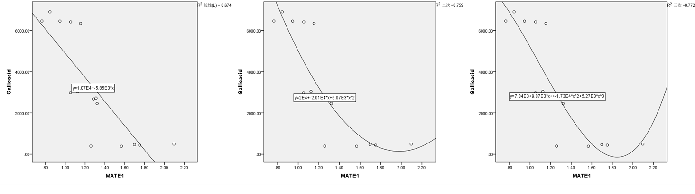
Supplementary Figure 54 The correlation between the expression level of MATE1 and the AUC of gallic acid (p<0.01)

