Supplementary Material

Supplementary Tables
Table S1. Summary of donor information
No. | Patient ID | Age | Sex
1 | 2016152 | 73 | Female | Female Average  Age: 72.0
2 | 2018917 | 70 | Female
3 | 20-0810-006 | 73 | Female
4 | 2012529 | 69 | Male | Male Ave  Age: 69.3
5 | 2012473 | 70 | Male
6 | 20-0818-006 | 69 | Male

Full name | Gene | Protein
Ribosomal protein L13a | RPL13a | RPL13A
Collagen type II alpha 1 chain | COL2 | COL2
Aggrecan | ACAN | ACAN
SRY-Box transcription factor 9 | SOX9 | SOX9
Matrix metallopeptidase 13 | MMP13 | MMP13
Matrix metallopeptidase 1 | MMP1 | MMP1
Collagen type X | COL10 | COL10
Interleukin 6 | IL6 | IL-6
Interleukin 8 | IL8 | IL-8
Cyclin-dependent kinase inhibitor 2A | CDKN2A | p16
Cyclin-dependent kinase inhibitor 1A | CDKN1A | p21
Tumor antigen p53 | TP53 | p53
Lysosomal-associated membrane protein 1 | LAMP1 | LAMP1
Microtubule-associated proteins 1A/1B light chain 3B | LC3B | LC3B
PTEN-induced kinase 1 | PINK1 | PINK1
Parkin | PARK2 | Parkin
Mitogen-activated protein kinase 1/2 | p-ERK1/2 | p-ERK1/2
Nuclear factor kappa-light-chain-enhancer of activated B cells | NF-kB1 | NF-kB p65
Caspase 3 | CASP3 | CASP3
BCL2-associated X protein | BAX | BAX
Nuclear factor erythroid 2-related factor 2 | NRF2 | NRF2
A disintegrin and metalloproteinase with thrombospondin motifs 5 | ADAMTS5 | ADAMTS5
Translocase of outer mitochondrial membrane 20 | TOMM20 | TOM20
Glyceraldehyde 3-phosphate dehydrogenase | GAPDH | GAPDH

Table S2. Full name and abbreviation of gene and protein
Table S3. Primer sequences used for qRT-PCR.

Gene | Forward primer (5’->3’) | Reverse primer (5’->3’)
RPL13a | CATAGGAAGCTGGGAGCAAG | GCCCTCCAATCAGTCTTCTG
COL2A1 | GGATGGCTGCACGAAACATACCGG | CAAGAAGCAGACCGGCCCTATG
ACAN | AGTCACACCTGAGCAGCATC | AGTTCTCAAATTGCATGGGGTGTC
SOX9 | GGCGGAGGAAGTCGGTGAAGAA | GCTCATGCCGGAGGAGGAGTGT
MMP13 | ATGCAGTCTTTCTTCGGCTTAG | ATGCCATCGTGAAGTCTGGT
MMP1 | AAAATTACACGCCAGATTTGCC | GGTGTGACATTACTCCAGAGTTG
COL10 | CCCTCTTGTTAGTGCCAACC | AGATTCCAGTCCTTGGGTCA
ALP | ATCTTTGGTCTGGCCCCCATG | AGTCCACCATGGAGACATTCTCTC
OCN | TCACACTCCTCGCCCTATTG | GAAGAGGAAAGAAGGGTGCC
OPN | TCACCAGTCTGATGAGTCTCACCATTC | TAGCATCAGGGTACTGGATGTCAGGTC
IL-6 | ACTCACCTCTTCAGAACGAATTG | CCATCTTTGGAAGGTTCAGGTTG
IL-8 | ACTGAGAGTGATTGAGAGTGGAC | AACCCTCTGCACCCAGTTTTC
CDKN2A | CTACTGAGGAGCCAGCGTCT | CTGCCCATCATCATGACCT
CDKN1A | AGTGGAATTAGCCCTCAGCA | CATGGTCCCTGGGTTCTTC
TP53 | GCCCAACAACACCAGCTCCT | CCTGGGCATCCTTGAGTTCC
ADAMTS5 | GAACATCGACCAACTCTACTCCG | CAATGCCCACCGAACCATCT
NF-kB1 | AACAGAGAGGATTTCGTTTCCG | TTTGACCTGAGGGTAAGACTTCT

Table S4. Information of primary antibodies used in this study

Antibody | Company | Catalog number | Dilution
p21 | Abcam | ab218311 | IHC: 1:200; WB: 1:1000
p16 | Abcam | ab108349 | IHC: 1:100; WB: 1:1000
COL2A1 | Thermal Fisher | MA5-12789 | IHC: 1:100; WB: 1:100
ACAN | Abcam | ab3778 | WB: 1:100
SOX9 | Cell Signaling | D8G8H | WB: 1:1000
LAMP1 | Thermal Fisher | PA1-654A | IHC: 1:50; WB: 1:500
LC3B | Novus Biologicals | NB100-2220 | IHC: 1:200; WB: 1:1000
PINK1 | MyBioSource | MBS3215961 | WB: 1:1000
Parkin | Thermal Fisher | PA513399 | WB: 1:1000
NRF2 | Novus Biologicals | NBP1-32822 | WB: 1:1000
NF-κB p65 | Thermal Fisher | PA5-16545 | WB: 1:200
BAX | Novus Biologicals | NB100-56095 | WB 1:1000
p-Erk1/2 | Thermal Fisher | PA5-13036 | WB 1:1000
CASP3 | Abcam | ab32042 | WB 1:500
MMP13 | Abcam | ab39012 | WB 1:1000
TOM20 | MyBioSource | MBS820677 | IF: 1:200; WB 1:1000
p53 | Abcam | ab26 | WB 1:500
GAPDH | Cell signaling | 5174 | WB: 1:1000
Universal Kit | Vector | PK6200 | -
Mouse IgG | Invitrogen | 31450 | 1:1000
Rabbit IgG | Healthcare | NA934-1ML | 1:1000

Figure S1
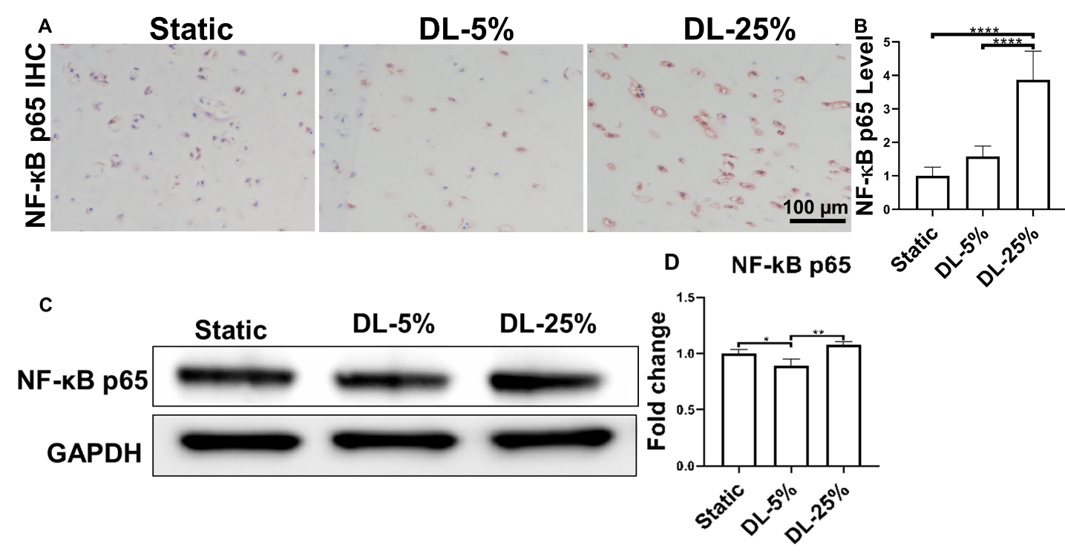
Figure S1. (A) NF-кB p65 IHC for samples from different groups. Scale bar: 100 µm. (B) Based on staining density, the level of NF-кB p65 were semi-quantitated using the ImageJ. (C) Representative western blot to assess the levels of NF-кB p65. (D) Semi-quantitative analysis of NF-кB p65protein level. N= 3. *, p<0.05; **, p<0.01; ****, p<0.0001.

Figure S2
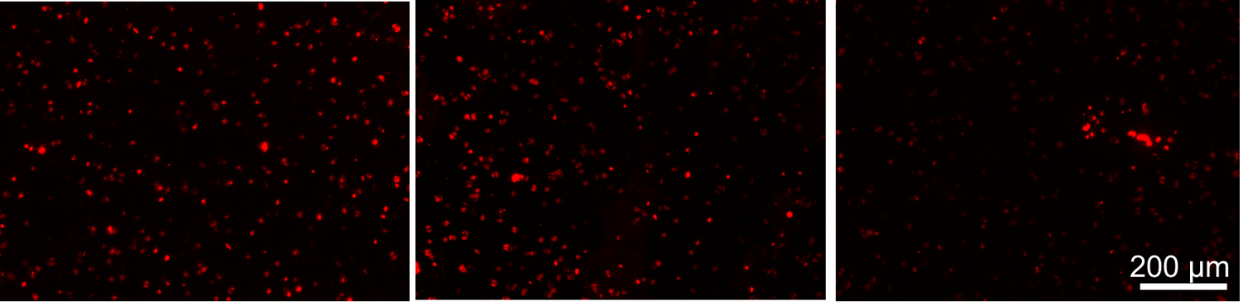
Figure S2. JC-1 immunofluorescence staining for samples from different groups. Scale bar: 100 µm.

Figure S3
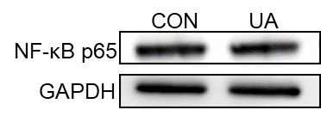
Figure S3. Representative western blot to assess the levels of NF-кB p65. CON: samples subjected to 25% strain loading; UA: samples subjected to 25% strain loading together with UA treatment (10 µM).

