Figure S1. Population coverage by the final set of epitopes.

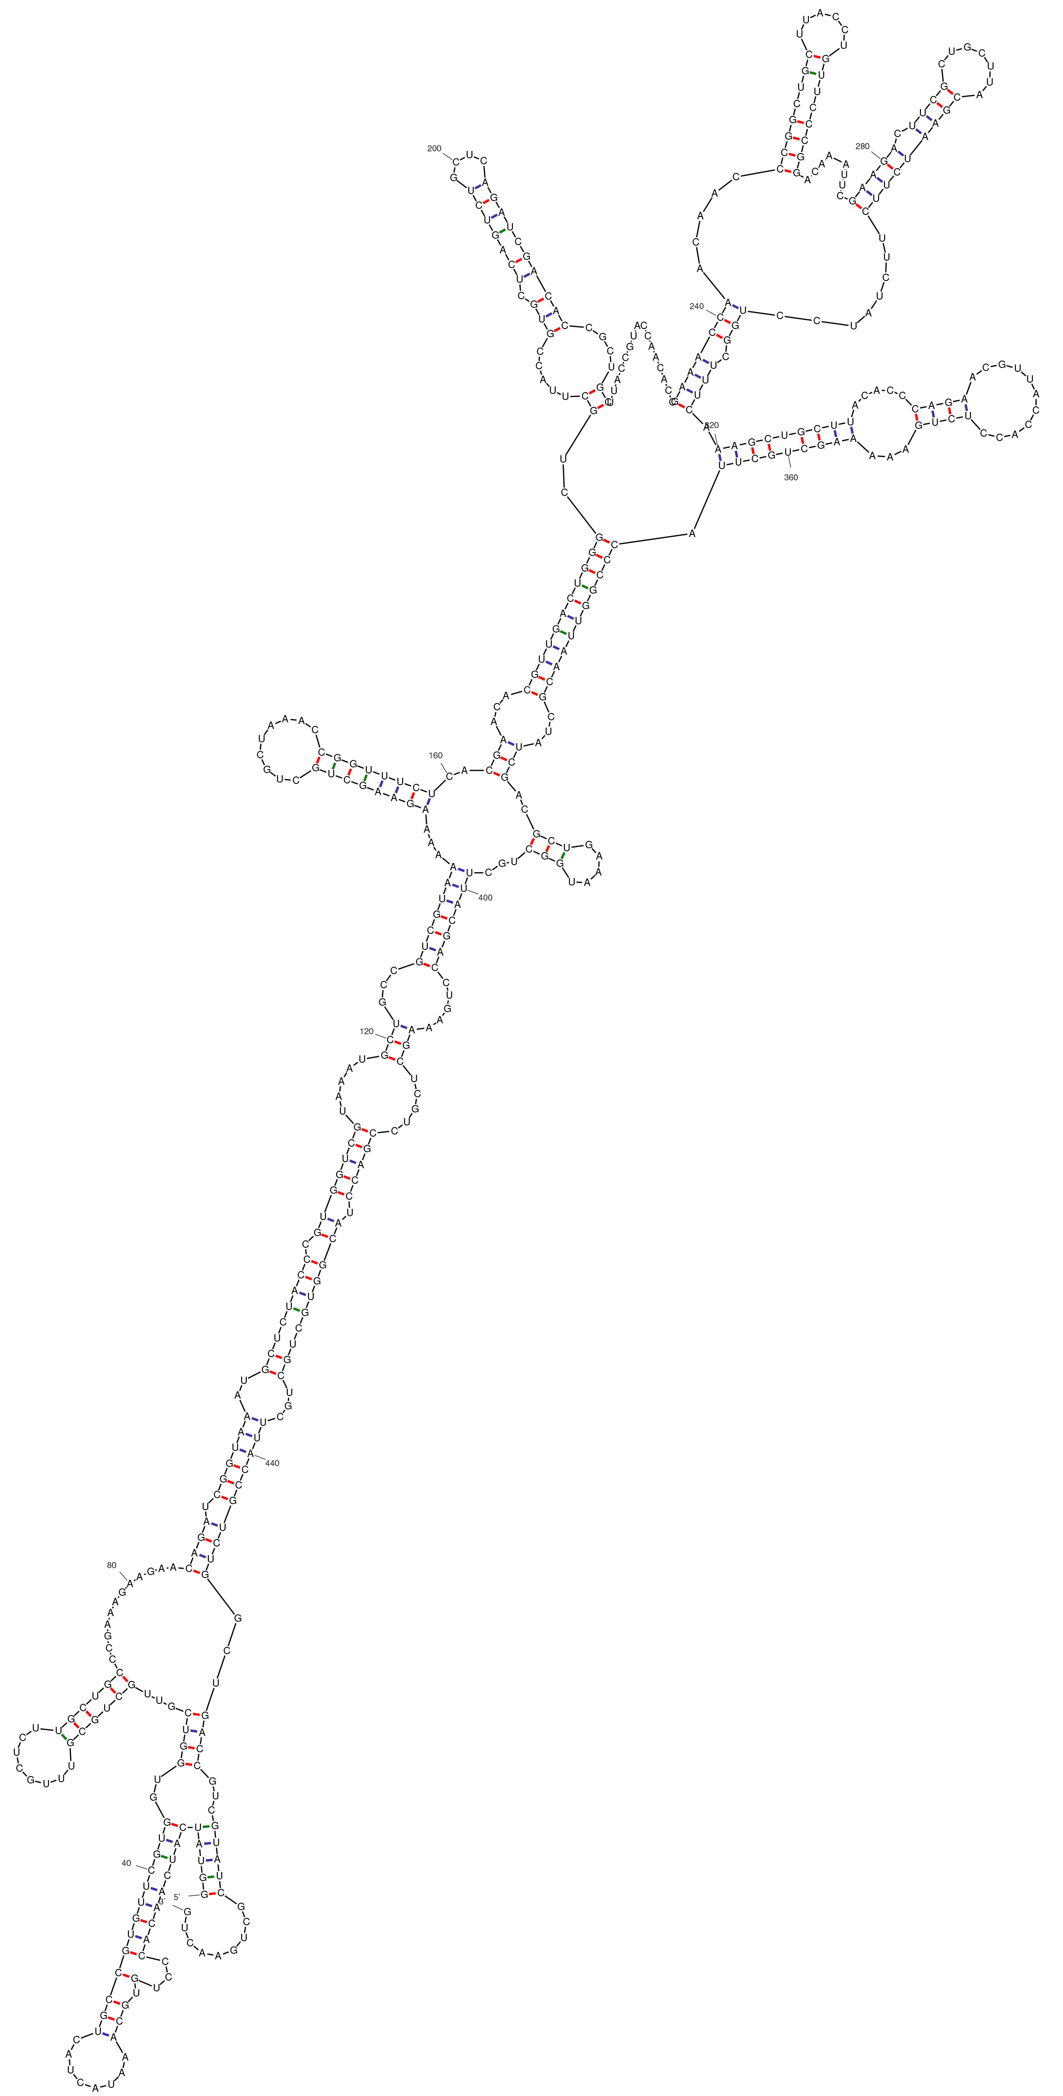
Figure S2. Secondary structure of MEV optimized sequence mRNA
Table S1. MEV refined models prioritized based on the lowest galaxy energy. Structural statistics of the initial unrefined model is also given.

Model | RMSD | MolProbity | Clash score | Poor rotamers | Rama favored | GALAXY energy
Initial | 0 | 3.522 | 145.6 | 2.4 | 87.7 | 12203.27
MODEL 1 | 4.214 | 1.266 | 1.9 | 0 | 95.5 | -3151.35
MODEL 2 | 4.372 | 1.523 | 3.4 | 0 | 94.2 | -3105.52
MODEL 3 | 0.99 | 1.248 | 1.5 | 0 | 94.8 | -3096.46
MODEL 4 | 3.931 | 1.356 | 3 | 0 | 96.1 | -3090.16
MODEL 5 | 1.007 | 1.029 | 0.4 | 0 | 94.2 | -3080.71
MODEL 6 | 3.478 | 1.448 | 3 | 0 | 94.8 | -3079.82
MODEL 7 | 3.911 | 1.475 | 2.6 | 0 | 93.5 | -3071.57
MODEL 8 | 3.556 | 1.361 | 2.3 | 0 | 94.8 | -3067.26
MODEL 9 | 4.264 | 1.522 | 3.8 | 0 | 94.8 | -3062.72
MODEL 10 | 3.945 | 1.407 | 2.6 | 0 | 94.8 | -3060.87

Table S2. TLR2 refined PatchDock complexes.
Rank | Solution Number | Global Energy | Attractive VdW | Repulsive VdW | ACE | HB
 |  | ↓
1 | 5 | -14.33 | -42.75 | 32.11 | 7.58 | -5.46
2 | 8 | -4.04 | -3.91 | 0.82 | 2.10 | -2.24
3 | 3 | 2.66 | -24.16 | 11.24 | 10.72 | -1.19
4 | 7 | 12.10 | -13.47 | 5.18 | 3.53 | -1.93
5 | 2 | 29.00 | -1.54 | 0.00 | 2.89 | 0.00
6 | 1 | 38.81 | -9.70 | 3.68 | 8.76 | -1.25
7 | 9 | 67.52 | -30.98 | 36.81 | 15.76 | -3.34
8 | 6 | 70.90 | -15.52 | 92.10 | 7.00 | -1.08
9 | 4 | 195.27 | -18.64 | 213.18 | 15.43 | -0.79
10 | 10 | 3930.96 | -41.19 | 4906.37 | 5.16 | -6.42
*VdW (van der Waals), ACE (Atomic Contact Energy), HB (Hydrogen Bonding).

Table S3. TLR3 refined PatchDock complexes.
Rank | Solution Number | Global Energy | Attractive VdW | Repulsive VdW | ACE | HB
 |  | ↓
1 | 9 | -6.95 | -7.70 | 1.50 | -2.47 | 0.00
2 | 7 | -4.70 | -26.88 | 4.98 | 10.51 | -2.81
3 | 4 | -3.59 | -38.77 | 16.29 | 14.37 | -1.89
4 | 8 | -3.13 | -8.60 | 4.06 | 2.02 | -2.74
5 | 3 | 5.60 | -2.68 | 0.79 | 2.12 | 0.00
6 | 6 | 13.68 | -26.63 | 28.19 | 13.63 | -4.19
7 | 2 | 22.90 | -13.65 | 18.59 | 9.08 | -2.32
8 | 10 | 29.81 | -23.23 | 12.66 | 2.17 | -1.56
9 | 5 | 34.06 | -5.68 | 9.45 | 6.89 | -0.35
10 | 1 | 43.55 | -13.42 | 1.99 | 9.81 | -3.96
*VdW (van der Waals), ACE (Atomic Contact Energy), HB (Hydrogen Bonding).

Table S4. List of hotspot residues in MMGBSA and MMPBSA
MEV-TLR2
MMGBSA |  |  |  |  |  | MMPBSA
Total Energy |  | Sidechain Energy |  | Backbone Energy |  | Total Energy |  | Sidechain Energy |  | Backbone Energy
Ser33 | -5.4 | Ser33 | -4.4 | Ser33 | -1.0 | Ser33 | -6.7 | Ser33 | -5.7 | Ser33 | -1.0
Ser56 | -6.7 | Ser56 | -5.7 | Ser56 | -1.0 | Ser56 | -7.1 | Ser56 | -7.0 | Ser56 | -0.1
Lys55 | -2.7 | Lys55 | -2.0 | Lys55 | -0.7 | Lys55 | -4.8 | Lys55 | -3.8 | Lys55 | -1.0
Gln79 | -7.1 | Gln79 | -5.8 | Gln79 | -1.3 | Gln79 | -3.8 | Gln79 | -3.5 | Gln79 | -0.3
Gln152 | -3.4 | Gln152 | -2.9 | Gln152 | -0.5 | Gln152 | -1.9 | Gln152 | -1.5 | Gln152 | -0.4
Asn177 | -8.4 | Asn177 | -7.4 | Asn177 | -1.0 | Asn177 | -7.5 | Asn177 | -7.0 | Asn177 | -0.5
Val80 | -2.4 | Val80 | -2.2 | Val80 | -0.2 | Val80 | -8.4 | Val80 | -7.4 | Val80 | -1.0
Gly344 | -9.4 | Gly344 | -8.7 | Gly344 | -0.7 | Gly344 | -5.9 | Gly344 | -3.9 | Gly344 | -2.0
Asn345 | -1.4 | Asn345 | -1.2 | Asn345 | -0.2 | Asn345 | -4.8 | Asn345 | -3.8 | Asn345 | -1.0
Arg422 | -1.9 | Arg422 | -1.7 | Arg422 | -0.7 | Arg422 | -3.8 | Arg422 | -3.2 | Arg422 | -0.6
Tyr483 | -4.7 | Tyr483 | -4.0 | Tyr483 | -0.7 | Tyr483 | -6.4 | Tyr483 | -5.4 | Tyr483 | -1.0
Val503 | -4.1 | Val503 | -3.1 | Val503 | -1.1 | Val503 | -5.7 | Val503 | -5.0 | Val503 | -0.7
Lys505 | -4.8 | Lys505 | -3.7 | Lys505 | -1.1 | Arg422 | -5.9 | Arg422 | -4.9 | Arg422 | -1.0
Arg507 | -6.1 | Arg507 | -6.0 | Arg507 | -6.0
Val556 | -5.7 | Val556 | -5.1 | Val556 | -0.6
Asp557 | -2.7 | Asp557 | -2.0 | Asp557 | -0.7
Glu629 | -1.8 | Glu629 | -1.3 | Glu629 | -0.5
MEV-TLR3
MMGBSA |  |  |  |  |  | MMPBSA
Total Energy |  | Sidechain Energy |  | Backbone Energy |  | Total Energy |  | Sidechain Energy |  | Backbone Energy
Hie3 | -2.85 | Val1 | -1.84 | Hie3 | -1.61 | Arg454 | -8.09 | Val1 | -1.79 | Hie3 | -1.43
Val5 | -1.15 | Hie3 | -1.24 | Thr137 | 0.00 | Arg453 | -7.83 | Asp7 | -1.88 | Leu175 | 0.00
Asp7 | -2.49 | Val5 | -1.14 | Cys187 | 0.00 | Arg704 | -6.13 | Arg453 | -7.35 | Glu628 | -1.61
Leu135 | 0.00 | Asp7 | -2.25 | Hie189 | 0.00 | Arg646 | -6.05 | Arg454 | -7.80 | Thr629 | -2.26
Asn143 | 0.00 | Lys60 | 0.00 | Asn218 | 0.00 | Glu722 | -5.65 | Phe609 | -1.04
Ala190 | 0.00 | Val115 | 0.00 | Trp244 | 0.00 | Lys637 | -4.09 | Phe622 | -2.73
Ser207 | 0.00 | Val139 | 0.00 | Thr248 | 0.00 | Lys679 | -3.57 | Asn627 | -1.05
Asn236 | 0.00 | Ser159 | 0.00 | Ser315 | 0.00 | Thr629 | -3.21 | Lys637 | -3.74
Thr237 | 0.00 | Ser207 | 0.00 | Ser368 | 0.00 | Tyr638 | -3.14 | Tyr638 | -2.37
Leu242 | 0.00 | Leu247 | 0.00 | Asp390 | 0.00 | Lys720 | -3.01 | Val642 | -1.31
Met249 | 0.00 | Trp267 | 0.00 | Ala514 | 0.00 | Phe622 | -2.78 | Arg646 | -6.44
Ala266 | 0.00 | Ser286 | 0.00 | Glu628 | -1.01 | Asp7 | -2.26 | Val649 | -1.19
Gly291 | 0.00 | Cys321 | 0.00 | Cys686 | -1.44 | Hie3 | -2.08 | Lys679 | -3.38
Ser337 | 0.00 | Leu343 | 0.00 |  |  | Val743 | -1.71 | Trp688 | -1.35
Leu343 | 0.00 | Ser372 | 0.00 |  |  | Phe721 | -1.52 | Arg704 | -5.87
Asp390 | 0.00 | Leu374 | 0.00 |  |  | Val642 | -1.45 | Lys720 | -3.29
Arg453 | -5.83 | Gly414 | 0.00 |  |  | Trp688 | -1.39 | Phe721 | -1.67
Arg454 | -5.91 | Gly419 | 0.00 |  |  | Val649 | -1.39 | Glu722 | -5.53
Ser463 | 0.00 | Ala442 | 0.00 |  |  | Thr744 | -1.33 | Val743 | -1.37
Thr603 | -2.01 | Arg453 | -5.71 |  |  | Hie683 | -1.23 | Thr744 | -1.13
Phe609 | -1.15 | Arg454 | -6.04 |  |  | Cys686 | -1.11
Ile619 | -1.06 | Pro543 | 0.00 |  |  | Gln694 | -1.11
Phe622 | -3.47 | Thr603 | -2.13 |  |  | Arg692 | -1.10
Asn627 | -1.04 | Phe609 | -1.21 |  |  | Val5 | -1.07
Glu628 | -1.03 | Ile619 | -1.25 |  |  | Phe609 | -1.06
Thr629 | -1.31 | Phe622 | -3.57 |  |  | Gly136 | 0.00
Thr634 | -2.18 | Asn627 | -1.33 |  |  | Ile387 | 0.00
Lys637 | -2.06 | Thr634 | -1.89
Tyr638 | -3.80 | Lys637 | -2.53
Arg641 | -1.92 | Tyr638 | -3.35
Val642 | -1.72 | Arg641 | -2.12
Arg646 | -5.03 | Val642 | -1.55
Val649 | -1.50 | Arg646 | -5.63
Lys679 | -2.72 | Val649 | -1.38
Hie683 | -1.40 | Lys679 | -2.83
Cys686 | -2.32 | Hie683 | -1.35
Trp688 | -2.95 | Trp688 | -2.96
Gln694 | -1.67 | Gln694 | -1.53
Arg704 | -5.84 | Arg704 | -6.02
Lys720 | -1.06 | Lys720 | -2.36
Phe721 | -1.24 | Phe721 | -1.37
Glu722 | -6.29 | Glu722 | -6.22
Val743 | -2.01 | Val743 | -1.62
Thr744 | -1.11 | Thr744 | -1.15

