Supplementary Material

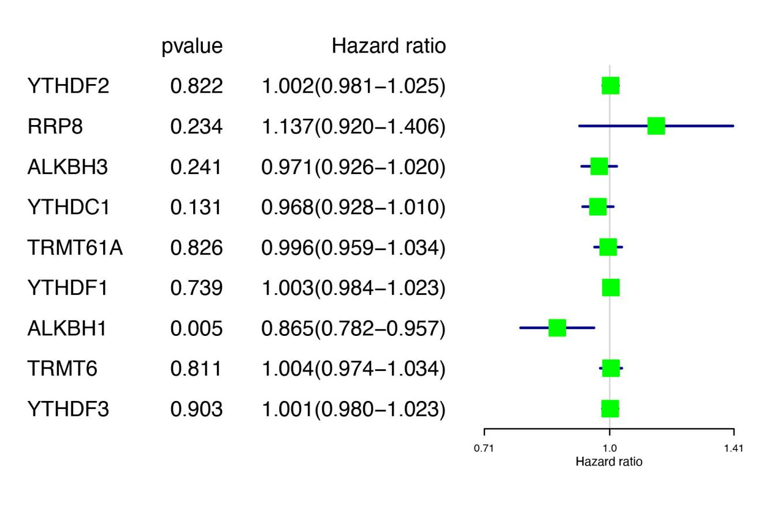

Supplementary Figure 1.Univariate analysis of the m1A regulators.

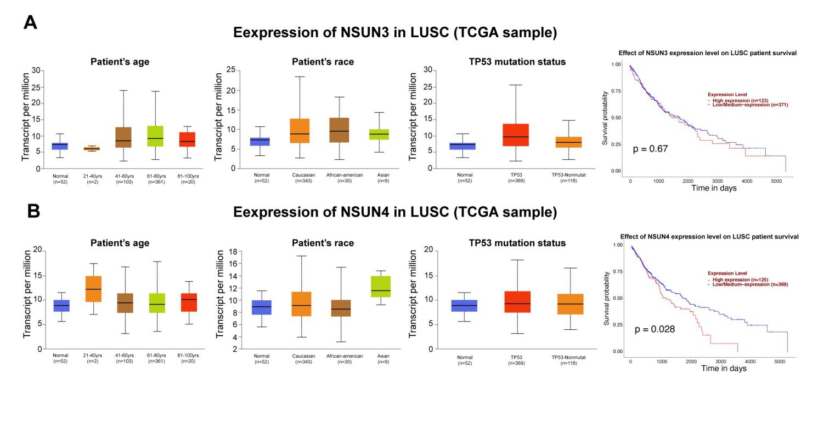
Supplementary Figure 2. Association between NSUN3 and NSUN4 expression and clinicopathological parameters in patients with LUSC (UALCAN). (A) Expression of NSUN3 in normal and LUSC tissues based on patients’age, patients’race, TP53 mutation status and the effect of NSUN3 expression level on LUSC patient survival. (B)Expression of NSUN4 in normal and LUSC tissues based on patients’age, patients’race, TP53 mutation status and the effect of NSUN4 expression level on LUSC patient survival.

m5C regulators | Expression level |  | Log₂FC | P-velue
 | Control | Lung squamous cell carcinoma
NSUN6 | 2.814363978 | 1.890451627 | 0.574077989 | 2.21E-09
NSUN5 | 9.864093955 | 4.445676881 | 1.149783446 | 4.76E-22
ALYREF | 61.61679417 | 21.84867147 | 1.495778065 | 2.14E-28
DNMT1 | 13.53670915 | 6.223152033 | 1.121159657 | 4.39E-19
DNMT3B | 2.626512853 | 0.369784646 | 2.828391415 | 2.48E-28
TET2 | 2.260273452 | 1.952009713 | 0.211537092 | 0.108861824
NSUN2 | 25.62473515 | 9.365234208 | 1.452150114 | 1.52E-27
TRDMT1 | 0.553026007 | 0.806736038 | -0.544749377 | 2.98E-12
NSUN7 | 1.212726379 | 1.664010999 | -0.45641089 | 5.84E-05
DNMT3A | 5.31402955 | 2.228390934 | 1.253803899 | 2.29E-21
YBX1 | 306.4194176 | 191.2191892 | 0.680280415 | 2.19E-14
NSUN4 | 3.472517601 | 3.014368051 | 0.204126428 | 0.009378237
NSUN3 | 2.813874394 | 1.774022785 | 0.665533391 | 1.71E-05
m1A regulators | Expression level |  | Log₂FC | P-velue
 | Control | Lung squamous cell carcinoma
YTHDF2 | 20.06925851 | 22.70893909 | 0.178272993 | 0.015230462
RRP8 | 2.520220612 | 2.487262063 | -0.018991507 | 0.231224929
ALKBH3 | 6.590550061 | 8.464055095 | 0.360950138 | 1.30E-06
YTHDC1 | 10.31424837 | 11.25122384 | 0.125443246 | 0.136582582
TRMT61A | 5.066602347 | 8.162574477 | 0.688005647 | 4.82E-11
YTHDF1 | 16.33556984 | 24.86300239 | 0.605983741 | 2.22E-19
ALKBH1 | 3.429169224 | 4.373833307 | 0.351039137 | 2.34E-05
TRMT6 | 4.327496857 | 10.6748966 | 1.302617418 | 2.03E-26
YTHDF3 | 12.41726282 | 13.73406175 | 0.145411165 | 0.113716289

Supplementary table 1. Differentially expressed genes of m5C regulators and m1A regulators in TCGA database.

m5C regulators | Expression level |  | Log₂FC | P-velue
 | Control | Lung squamous cell carcinoma
NSUN6 | 0.718730601813954 | 0.47312067 | -0.603242922224121 | 0.003521824
NSUN5 | 0.441173229 | 0.884361942 | 1.003291693 | 5.46E-08
DNMT1 | 0.3210398 | 1.348059147 | 2.070059731 | 2.29E-12
DNMT3B | 0.240107082 | 1.975161041 | 3.040220426 | 1.53E-11
TET2 | 0.594225406 | 0.529351069 | -0.166785446 | 0.252692693
NSUN2 | 0.362320102 | 1.087323095 | 1.58544394 | 1.08E-10
TRDMT1 | 0.692257856 | 0.440014016 | -0.653760042 | 2.32E-05
NSUN7 | 1.251178417 | 0.465565566 | -1.426231268 | 0.003953887
DNMT3A | 0.53057849 | 0.80960557 | 0.609653025 | 0.00020959
YBX1 | 0.471794345 | 0.898300462 | 0.929039949 | 5.08E-06
NSUN4 | 0.491446849 | 0.691430759 | 0.492549388 | 0.000750519
NSUN3 | 0.504331081 | 0.73954819 | 0.552273019 | 0.003011694

Supplementary table 2. Differentially expressed genes of m5C regulators in GEO database

