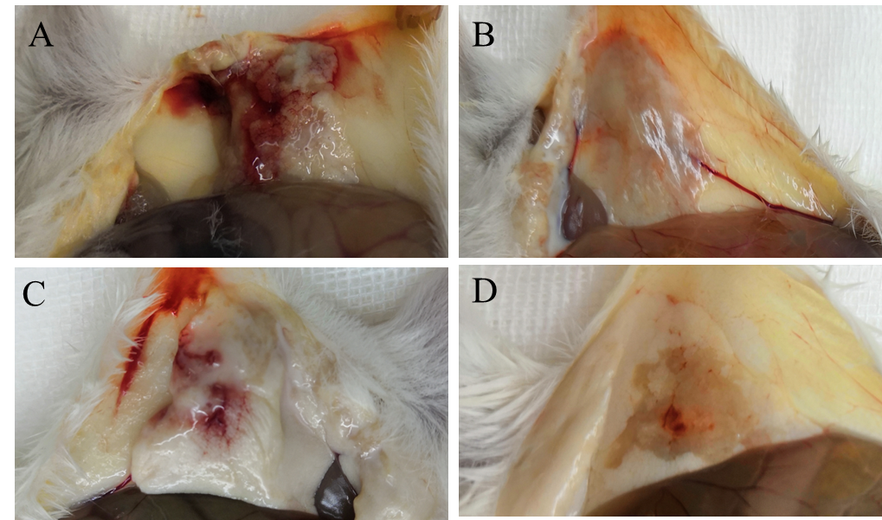

Figure S1. PAJD-1 reduced P. aeruginosa-induced mammary gland lesions of mice. After 24 h, the mammary glands of mice were photographed. Mice were infected with P. aeruginosa PAmas5 strains and treated with (C) PAJD-1 and (D) ceftiofur sodium. Mice were treated with PBS after infection as (A) a medium-treated group. (B) An uninfected mouse served as a positive control.

Table S1 Identification of P. aeruginosa PAmas-1 by the VITEK 2 system
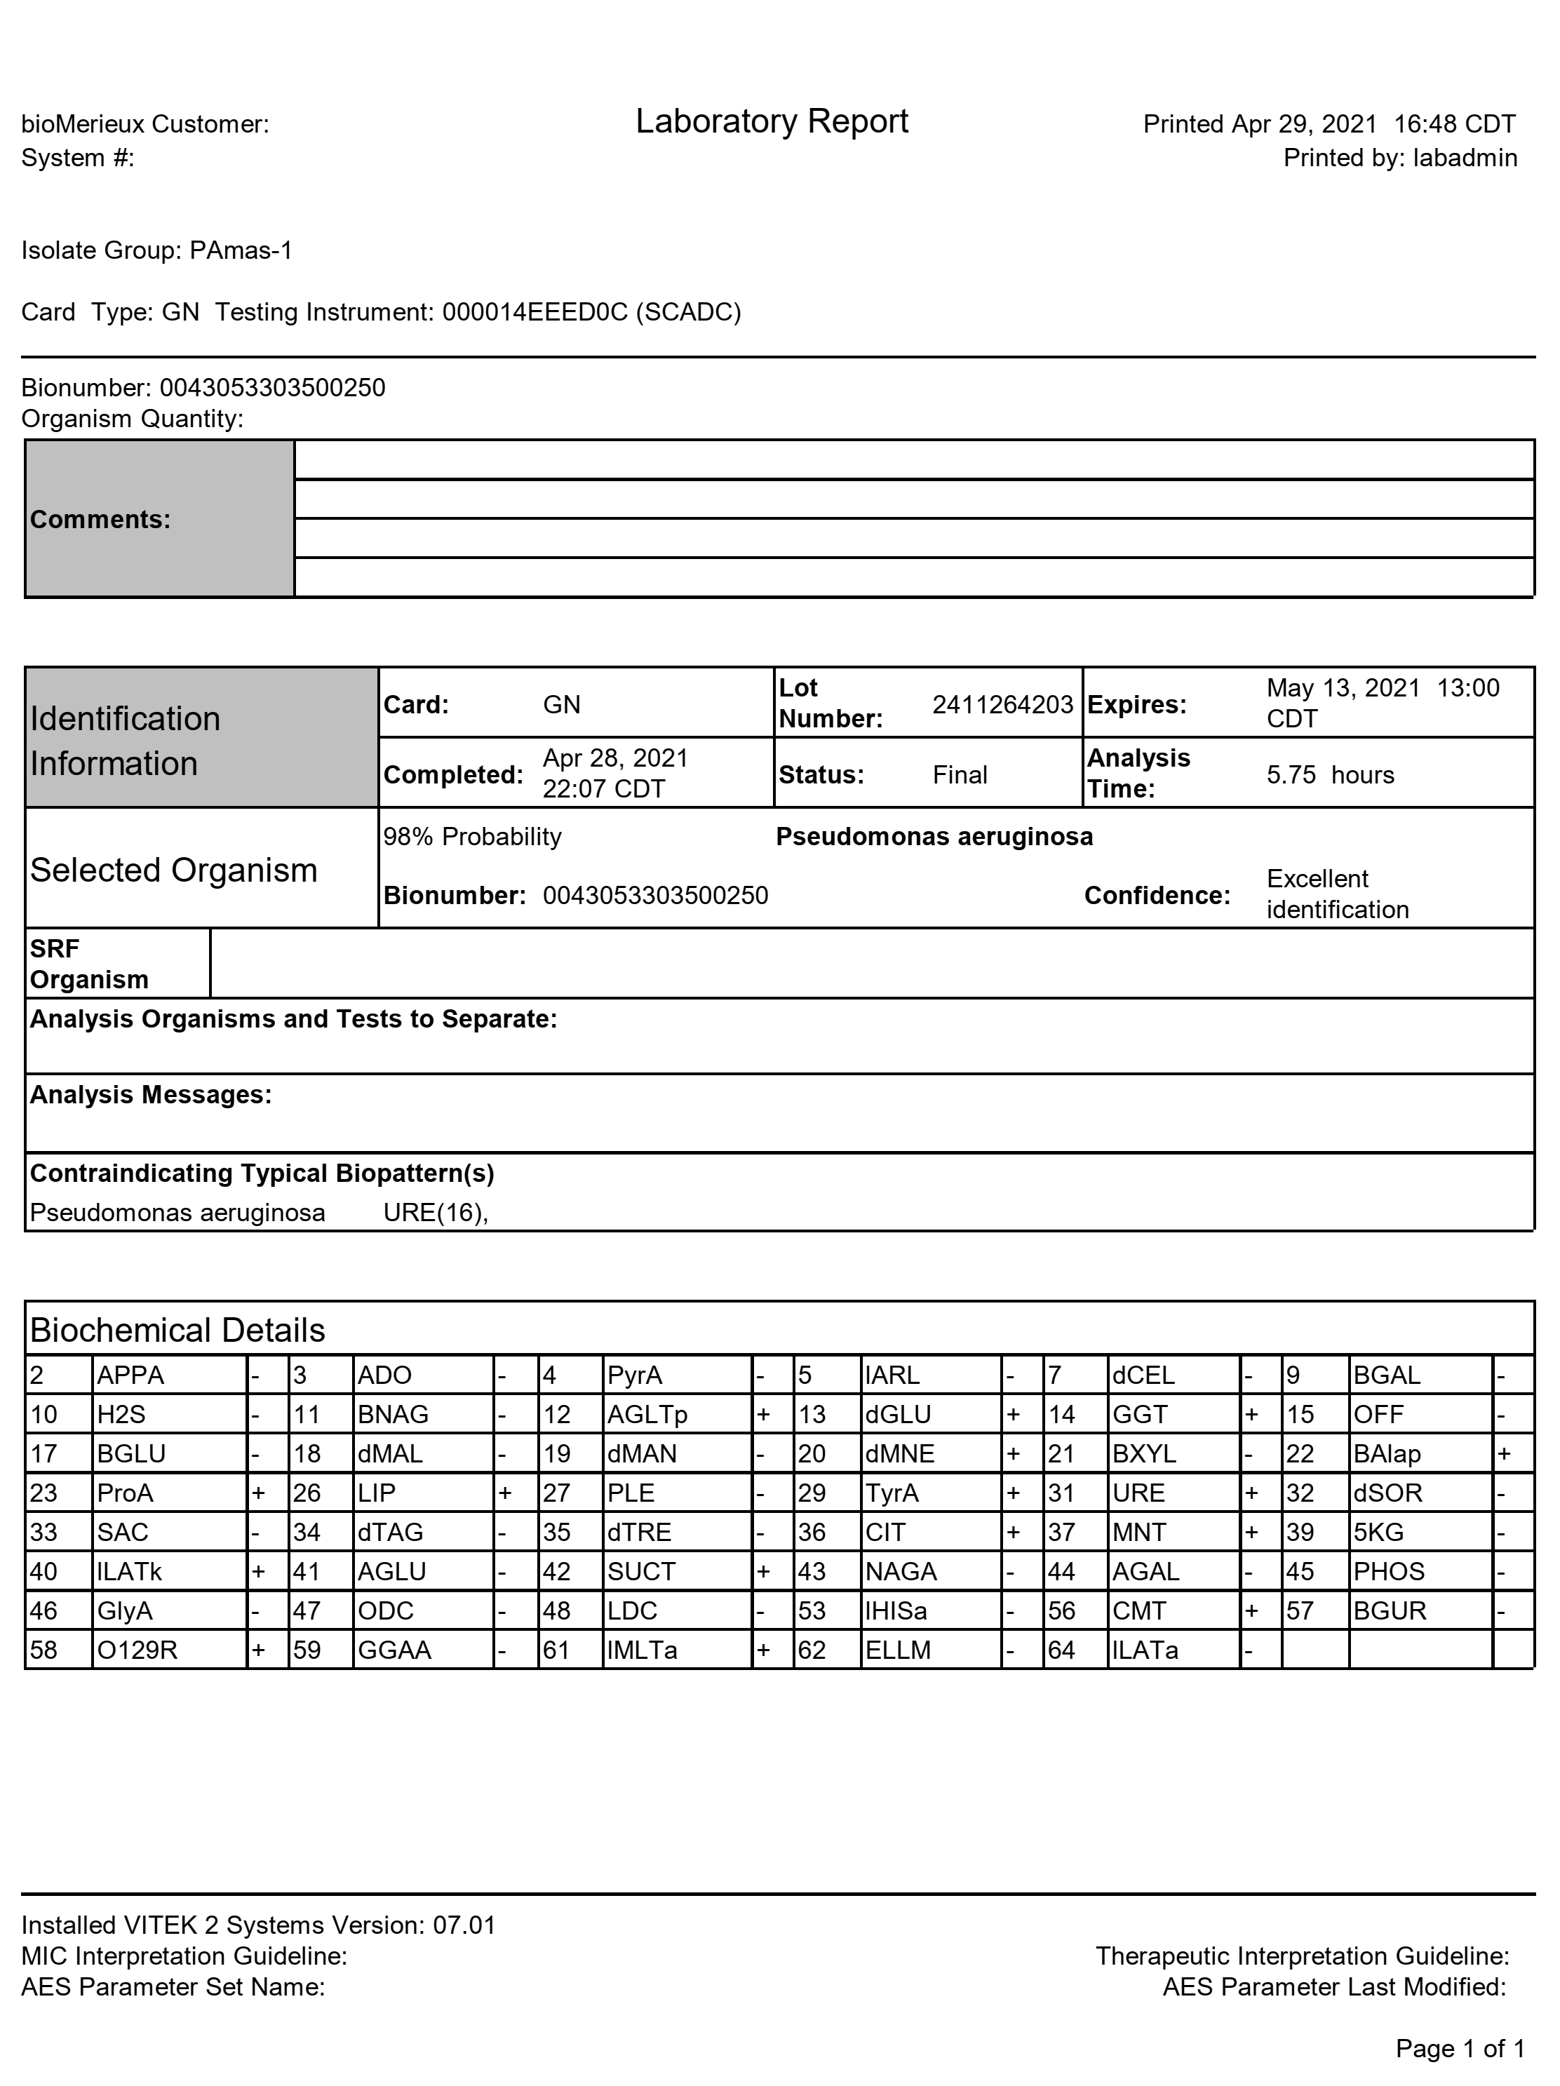

Table S2 Identification of P. aeruginosa PAmas-2 by the VITEK 2 system
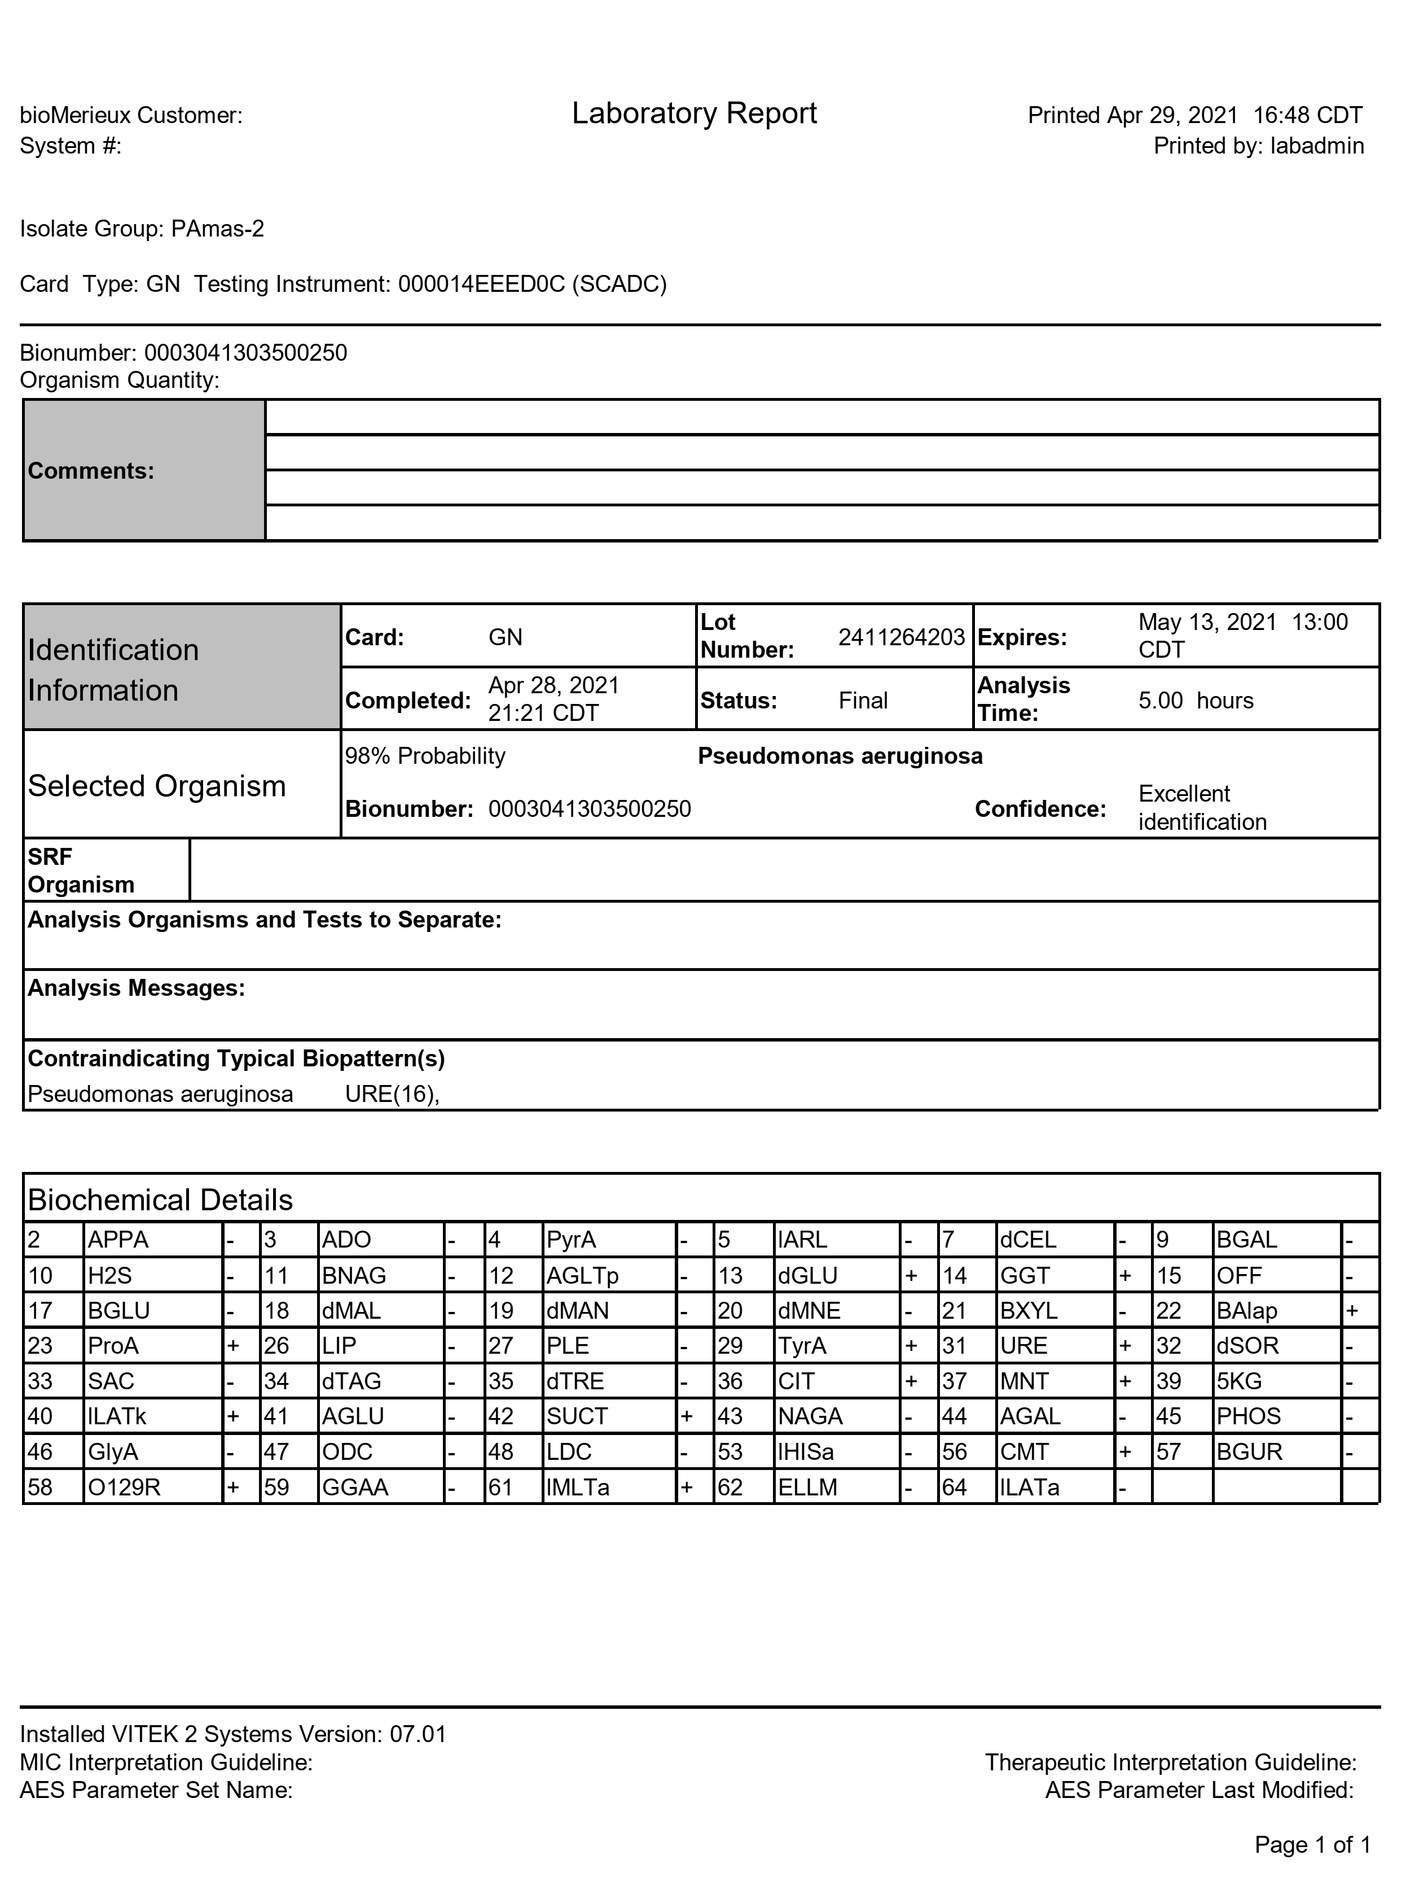

Table S3 Identification of P. aeruginosa PAmas-3 by the VITEK 2 system
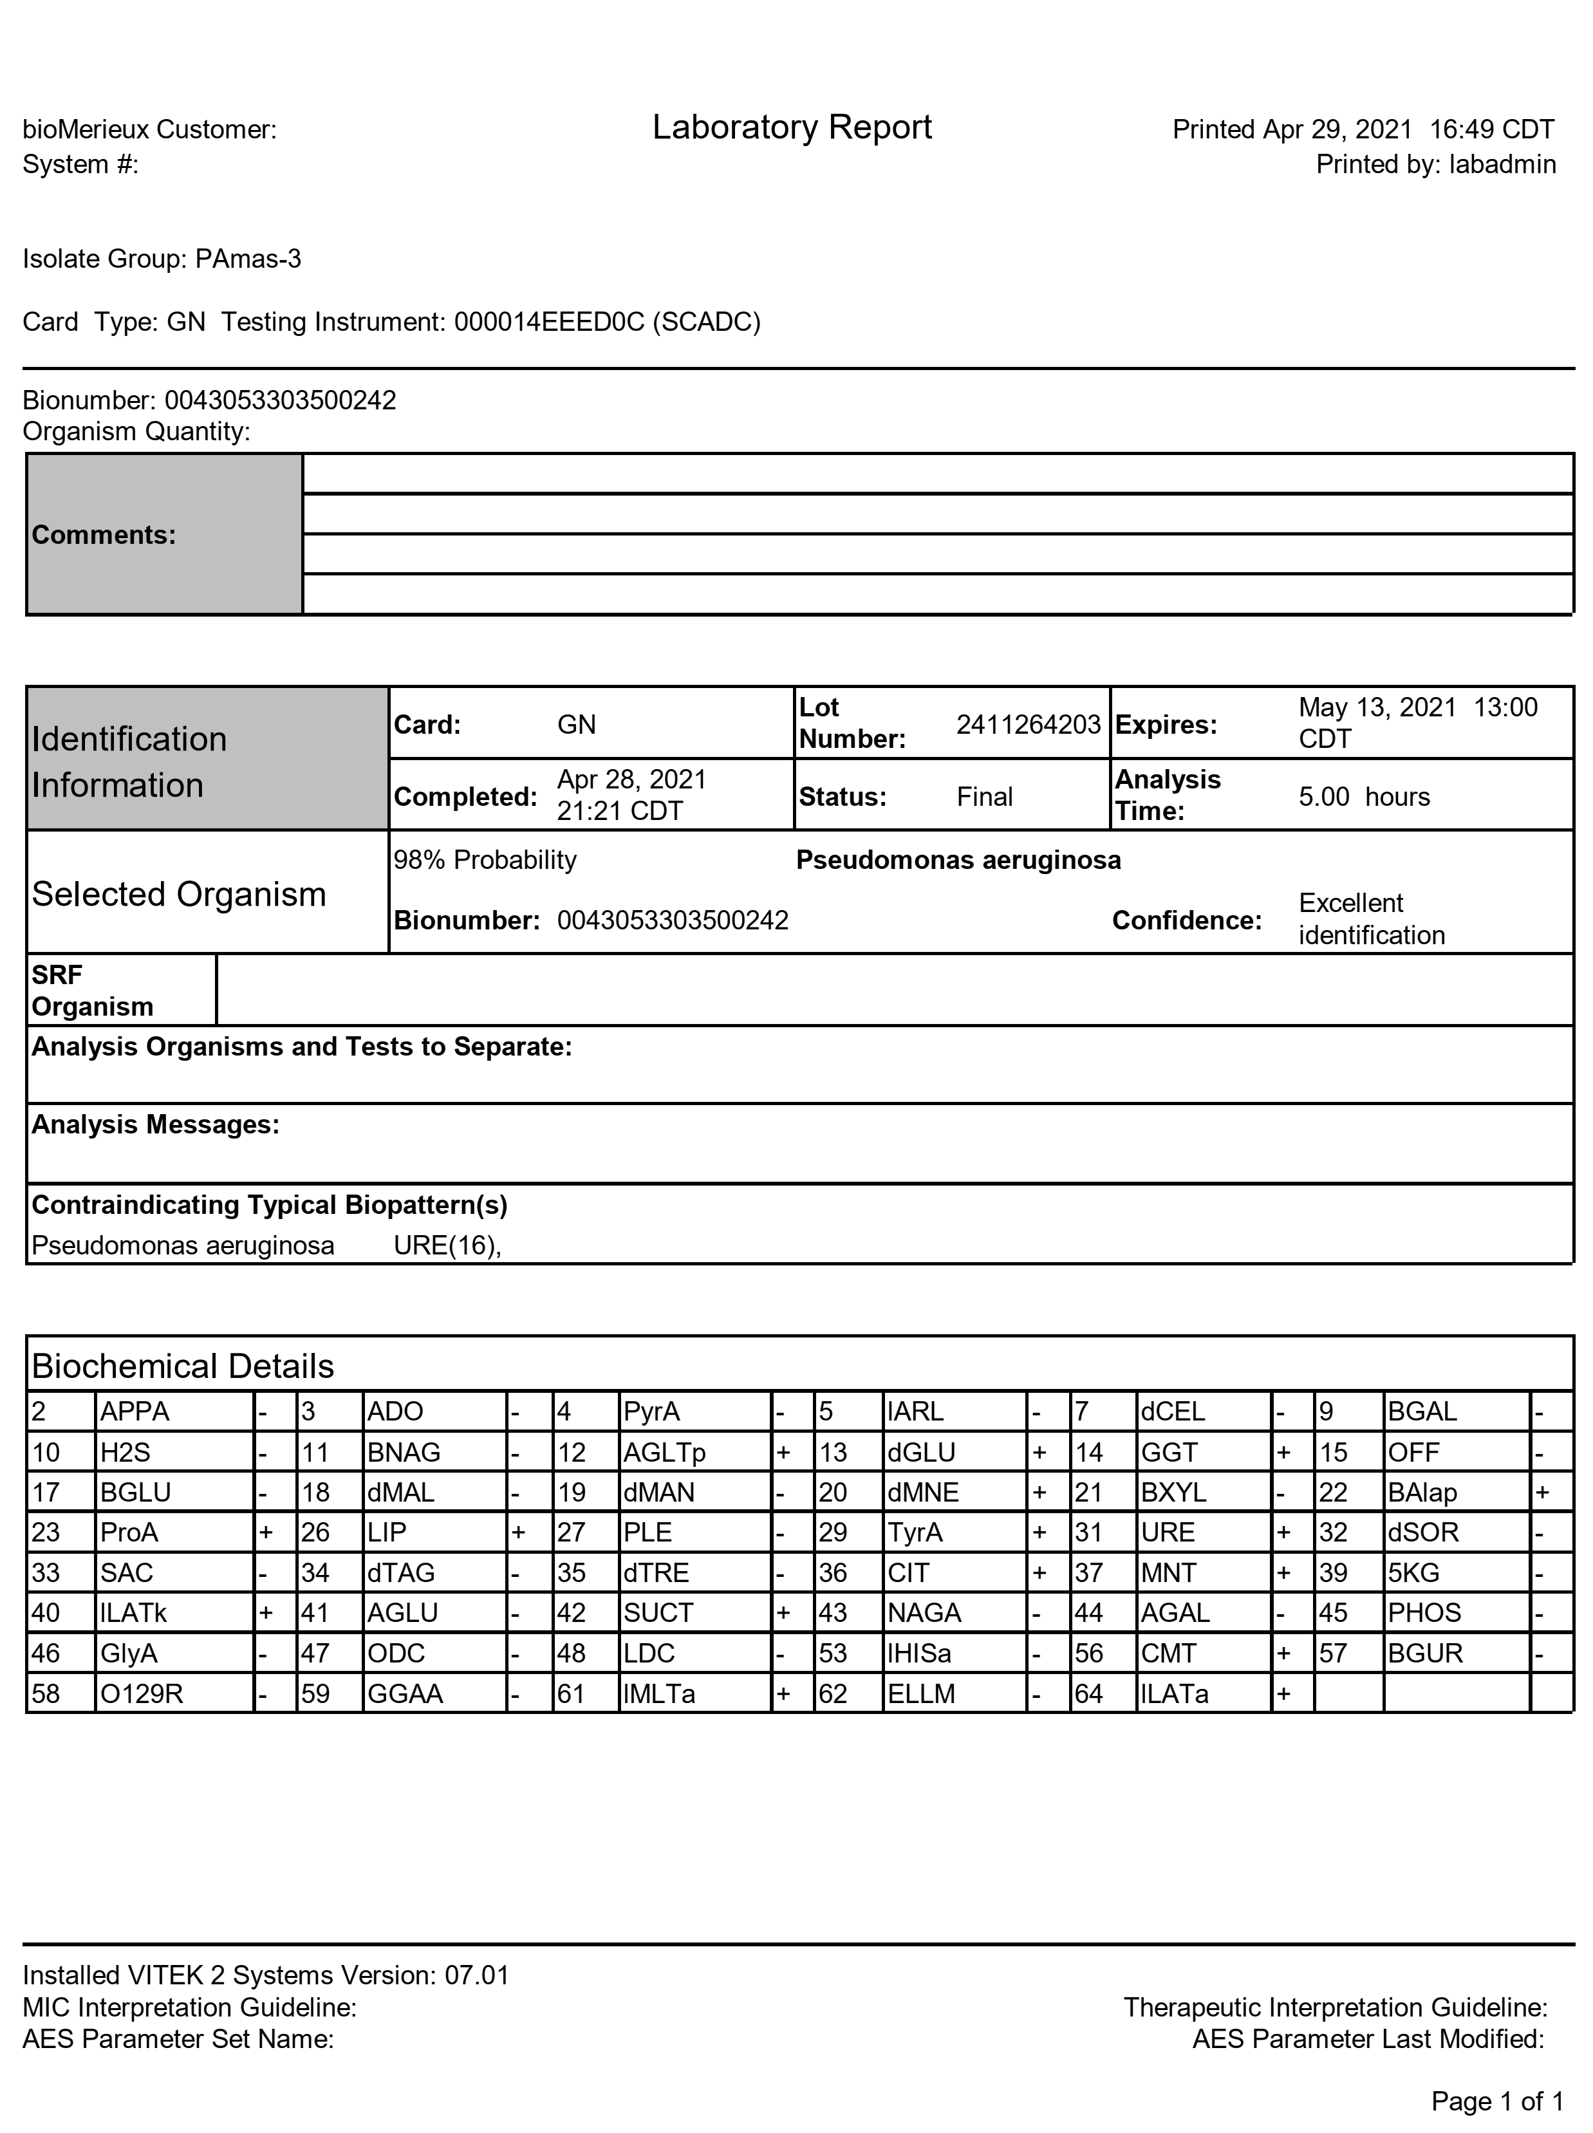

Table S4 Identification of P. aeruginosa PAmas-4 by the VITEK 2 system
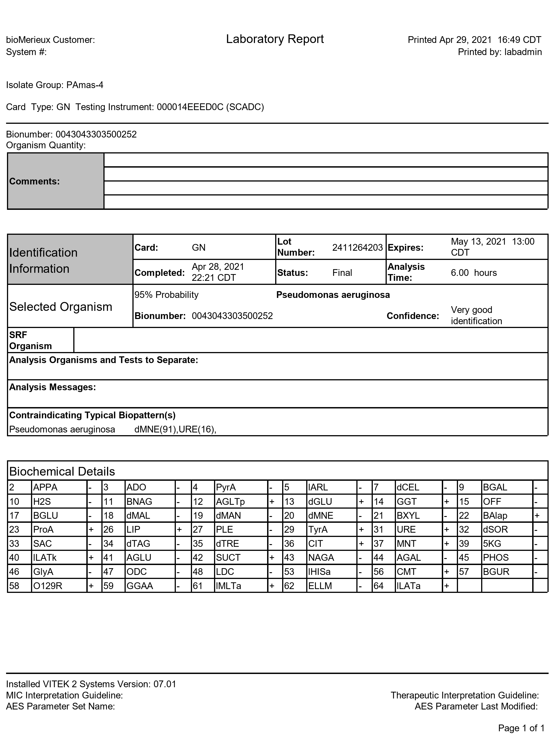

Table S5 Identification of P. aeruginosa PAmas-5 by the VITEK 2 system
