Supplementary Material

**Supplementary Table 1.** The mean of RMSLE of the cases adding one more scale in addition to the original scale of 0~250 cm/s2.

|  |  |
| --- | --- |
| Combination  of Scales* | RMSLE |
| E | 0.6439 |
| A + E | 0.6176 |
| B + E | 0.6111 |
| C + E | 0.6239 |
| D + E | 0.6291 |
| A’ + E | 0.5429 |
| B’ + E | 0.5302 |
| C’ + E | 0.5427 |

* Scale A: 0~2.5 cm/s2; Scale B: 0~8 cm/s2; Scale C: 0~25 cm/s2; Scale D: 0~80 cm/s2; Scale E: 0~250 cm/s2; Scale A’: 0~1 gal/Hz; Scale B’: 0~20 gal/Hz; Scale C’: 0~40 gal/Hz.

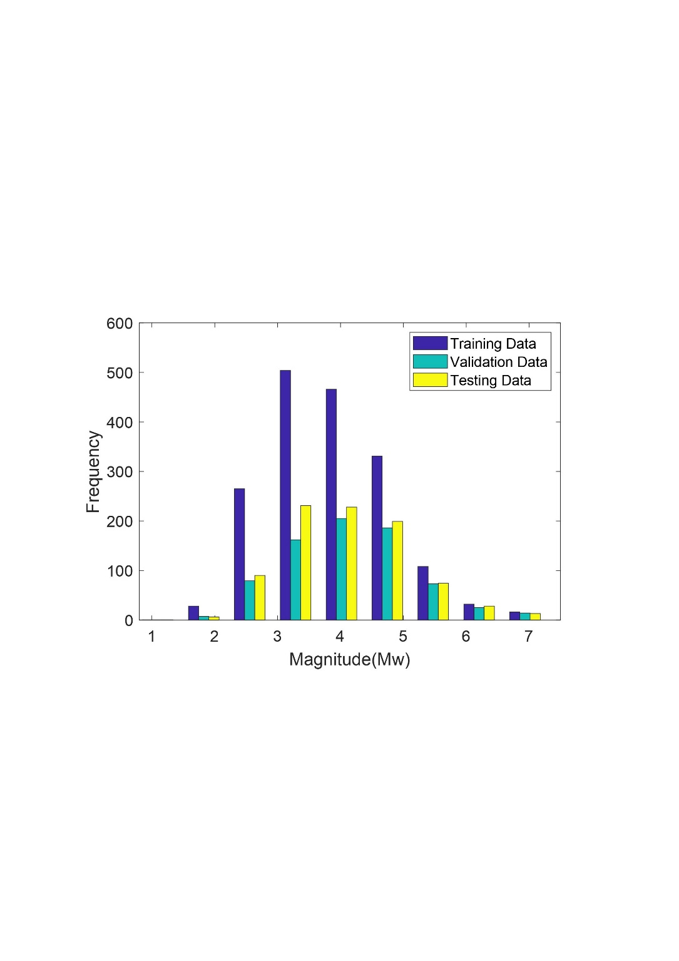

**Supplementary Figure 1.** The frequency of the magnitude for training, validation, and testing datasets.



**Supplementary Figure 2.** The magnitude vs. hypocentral distance of the T-data.

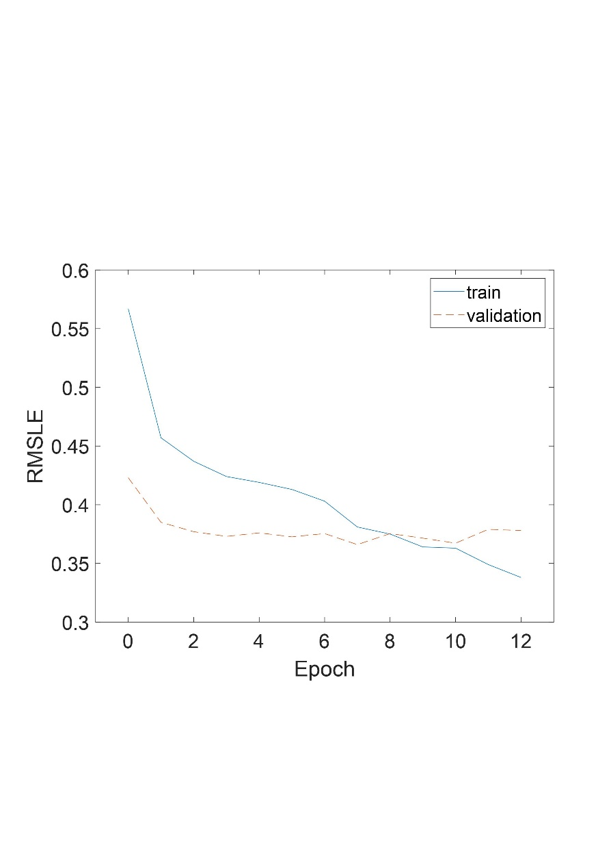

**Supplementary Figure 3.** The typical training process stops at epoch 12 because the loss of the validation dataset was larger than the one of the training dataset for five epochs successively.