Supplementary Material

Supplementary Figures
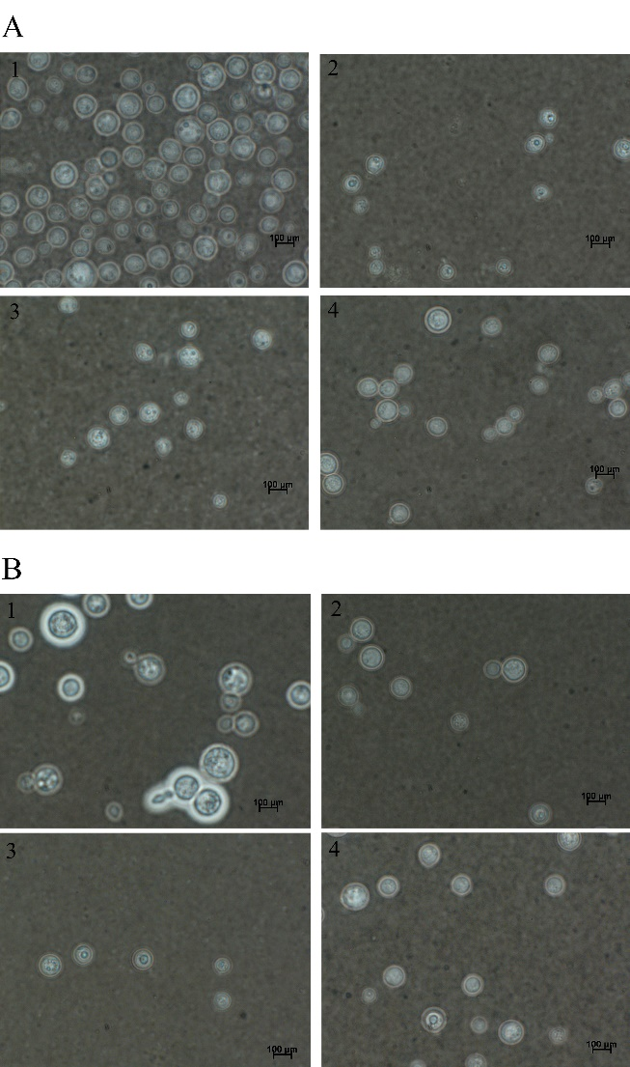

Supplementary Figure 1. Effect of ethyl acetate fraction (EAF) of P. pluviosa bark and amphotericin B (AmB) alone or combined on capsule and cell size of C. neoformans ATCC 66031 (A) and C. neoformans CN12 (B). Yeast cells were negatively stained with Chinese ink and visualized by light microscopy. (A1 and B1) untreated cells; (A2) EAF MIC 1000.0 µg/mL; (B2) EAF MIC 125 µg/mL; (A3 and B3) AmB MIC (0.125 µg/mL); (A4 and B4) EAF combined with AmB (3.9/0.003 µg/mL).

Supplementary Tables

Supplementary Table 1: Effect of ethyl acetate fraction (EAF) of P. pluviosa and amphotericin B (AmB) alone or combined on 48 h-biofilm of Cryptococcus neoformans.
Treatment (µg/mL) | Isolates
 | ATCC 66031 | CN12
Untreated control | 0.759 ± 0.017 | 0.424 ± 0.094
EAF
1000 | 0.189 ± 0.008 | 0.401 ± 0.101
500 | 0.218 ± 0.010 | 0.224 ± 0.094
250 | 0.258 ± 0.026 | 0.355 ± 0.005
125 | 0.300 ± 0.010 | 0.356 ± 0.089
62.5 | 0.371 ± 0.012 | 0.345 ± 0.003
31.2 | 0.495 ± 0.021 | 0.380 ± 0.101
AmB
16 | 0.035 ± 0.003 | 0.022 ± 0.004
8 | 0.066 ± 0.021 | 0.014 ± 0.002
4 | 0.109 ± 0.042 | 0.035 ± 0.016
2 | 0.119 ± 0.049 | 0.053 ± 0.006
1 | 0.126 ± 0.011 | 0.067 ± 0.024
0,5 | 0.146 ± 0.024 | 0.164 ± 0.020
EAF/AmB
62.5/1 | 0.096 ± 0.038 | 0.015 ± 0.004
31.2/0.062 | 0.134 ± 0.062 | 0.030 ± 0.009
15.6/0.031 | 0.146 ± 0.007 | 0.059 ± 0.022
7.8/0.015 | 0.135 ± 0.018 | 0.023 ± 0.013
3.9/0.007 | 0.144 ± 0.013 | 0.037 ± 0.031
1.9/0.003 | 0.168 ± 0.039 | 0.126 ± 0.095

Metabolic activity of sessile cells was assessed by the MTT reduction method after 48 h incubation at 37 °C with different concentrations of EAF and AmB alone or combined. Values were expressed in optical density (O. D.) and are mean ± standard deviation of two experiments in quintuplicate and were analyzed by one way ANOVA. Negative control (without biofilm) was subtracted from all O.D. values to eliminate the background staining interference.

