Supplementary Material

Supplementary Figures and Tables

Supplementary Figures
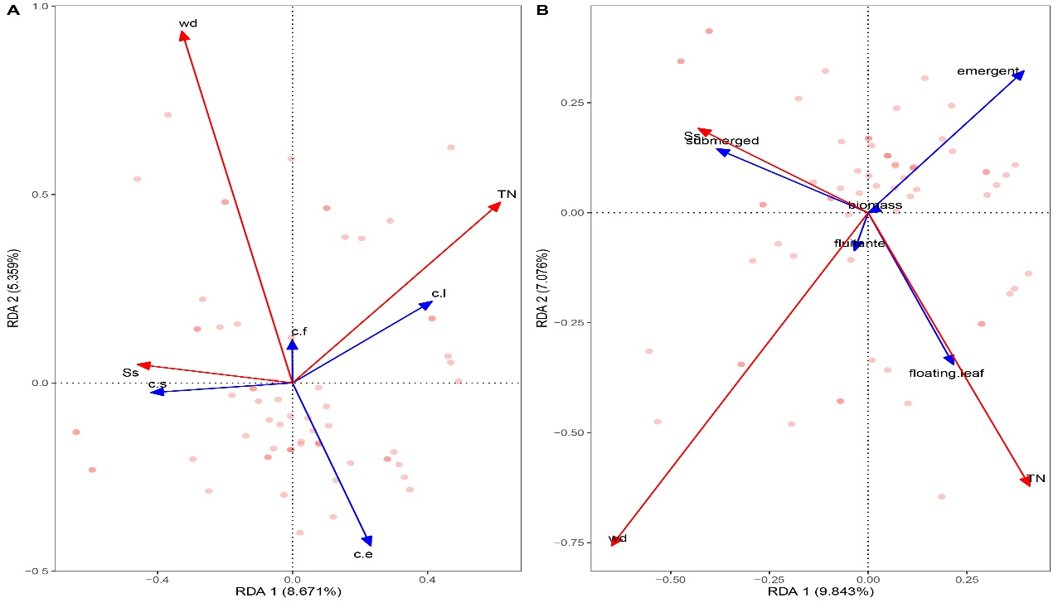
Supplementary Figure 1. Redundancy analysis ordination diagram of environmental factors and (A) coverage, (B) biomass of four lifeform aquatic plants. TN, WD, SS mean total nitrogen concentration, water depth, suspended solid respectively. And c.s, c.l, c.f, c.e mean coverage of submerged, floating-leaved, free floating and emergent plants.

Supplementary Tables

Supplementary Table 1. List of the species and lifeform of aquatic macrophytes.

 | Family | Genus | Species | Abbreviation
Submerged species | Ceratophyllaceae | Ceratophyllum | Ceratophyllum demersum | CD
 | Haloragidaceae | Myriophyllum | Myriophyllum spicatum | MS
 | Najadaceae | Najas | Najas marina | NM1
 | Najadaceae | Najas | Najas minor | NM2
 | Hydrocharitaceae | Ottelia | Ottelia alismoides | OA
 | Hydrocharitaceae | Vallisneria | Vallisneria natans | VN
 | Hydrocharitaceae | Hydrilla | Hydrilla verticillata | HV
 | Potamogetonaceae | Potamogeton | Potamogeton crispus | PC
 | Potamogetonaceae | Potamogeton | Potamogeton maackianus | PM1
 | Potamogetonaceae | Potamogeton | Potamogeton malaianus | PM2
 | Lentibulariaceae | Utricularia | Utricularia vulgaris | UV
 | Characeae | Chara | Chara sp. | CV
Floating-leaved species | Nymphaeaceae | Euryale | Euryale ferox | EF
 | Nymphaeaceae | Nelumbo | Nelumbo nucifera | NN1
 | Gentianaceae | Nymphoides | Nymphoides indica | NI
 | Gentianaceae | Nymphoides | Nymphoides peltata | NP
 | Pedaliaceae | Trapella | Trapella sinensis | TS
 | Trapaceae | Trapa | Trapa sp. | TN
 | Nymphaeaceae | Nelumbo | Nelumbo sp.2 | NN2
Free-floating species | Pontederiaceae | Eichhornia | Eichhornia crassipes | EC
 | Salviniaceae | Salvinia | Salvinia natans | SN
Emergent species | Amaranthaceae | Alternanthera | Alternanthera philoxeroides | AP
 | Cyperaceae | Scirpus | Scirpus yagara | SY
 | Cyperaceae | Heleocharis | Heleocharis dulcis | HD
 | Cyperaceae | Heleocharis | Eleocharis yokoscensis | EY
 | Gramineae | Leersia | Leersia hexandra | LH
 | Gramineae | Phragmites | Phragmites australis | PA
 | Gramineae | Gramineae | Gramineae sp.1 | P1
 | Gramineae | Gramineae | Gramineae sp.2 | P2
 | Polygonaceae | Polygonum | Polygonum sp. | PH
 | Alismataceae | Sagittaria | Sagittaria sp. | ST
 | Typhaceae | Typha | Typha orientalis | TO
 | Gramineae | Zizania | Zizania latifolia | ZL

Supplementary Table 2. The extreme value and mean of the physico-chemical parameters and nutrition level monitored in Liangzi Lake

 | T (℃) | DO  (mg·L⁻¹) |  | Cond  (us·cm⁻¹) |  | TDS | SAL |  | pH | Turb  (NTU) | SS  (mg·L⁻¹) | TN  (mg·L⁻¹) |  |  | TP  (mg·L⁻¹) |  | Kd
Maximum | 36.3 |  | 14.84 |  | 200.2 | 109.85 |  | 0.08 | 9.75 | 101 | 77 | 1.05 |  | 0.06 |  | 10.68
Minimum | 30 |  | 2.29 |  | 157.3 | 86.45 |  | 0.06 | 7.3 | 4.88 | 0 |  | 0.363 | 0.005 |  | 0.77
Mean | 32.9 |  | 7.83 |  | 170.2 | 96.47 |  | 0.07 | 8.61 | 21.37 | 24 |  | 0.554 | 0.024 |  | 3.33

Supplementary Method
Full results for DI models comparing the contribution of species identity and interspecific interactions to BPR patterns in aquatic macrophyte communities.

M0: Null model
Table 1 ANOVA table for M0
 | Df | Sum Sq | Mean Sq | F value | P
M | 1 | 1036386 | 1036386 | 10.426 | 0.0018
Residuals | 76 | 7554699 | 99404

Table 2 Parameter estimates for M0
 | Estimate | Std. Error | t value | P
Intercept | 16.384 | 115.133 | 0.142 | 0.8872
M | 3.591 | 1.112 | 3.229 | 0.0018

M1: Species identity model
Table 3 Parameter estimates for M1
 | Estimate | Std. Error | t value | P
PM2 | 53.9 | 99.61 | 0.541 | 0.5911
VN | -280.4 | 102.8 | -2.728 | 0.0091
NP | -119.5 | 160.4 | -0.745 | 0.46
HV | -152.4 | 140.4 | -1.085 | 0.2837
NM1 | -286.7 | 154.3 | -1.858 | 0.0697
MS | 13.17 | 85.44 | 0.154 | 0.8782
PA | 40.88 | 197 | 0.208 | 0.8365
CD | 213.5 | 127.5 | 1.674 | 0.1011
ZL | 924.6 | 195.8 | 4.723 | <0.001
PH | 483.5 | 190.6 | 2.537 | 0.0147
NM2 | -385 | 163.7 | -2.351 | 0.0232
PC | -4954 | 8723 | -0.568 | 0.5729
TN | 119.6 | 180.1 | 0.664 | 0.5102
NI | -226.3 | 154.4 | -1.466 | 0.1497
NN1 | -55.95 | 635.5 | -0.088 | 0.9302
TS | -448.6 | 287.4 | -1.561 | 0.1255
EF | -924.7 | 1783 | -0.519 | 0.6066
PM1 | -2017 | 17400 | -0.116 | 0.9082
TO | 1606 | 721 | 2.227 | 0.031
HD | 361.5 | 490.8 | 0.737 | 0.4651
SY | -18530 | 22930 | -0.808 | 0.4233
LH | -4690 | 4295 | -1.092 | 0.2807
UV | 98610 | 114700 | 0.86 | 0.3944
ST | -1352 | 5217 | -0.259 | 0.7967
P1 | 6563 | 4983 | 1.317 | 0.1945
AP | -1001 | 1745 | -0.574 | 0.569
NN2 | 106600 | 23970 | 4.448 | <0.001
EC | 1114 | 357.6 | 3.115 | 0.0032
CV | 358.9 | 4480 | 0.08 | 0.9365
OA | -1104 | 1629 | -0.678 | 0.5015
EY | -2731 | 4018 | -0.68 | 0.5003
P2 | -2308 | 2351 | -0.982 | 0.3316
M | 4.181 | 0.8189 | 5.105 | <0.001
Abbreviations are as in Supplementary Tables 1

M2: Species identity model with all pairwise interactions
Table 4 Parameter estimates for M2
 | Estimate | Std. Error | t value | P
PM2 | -71.59700818 | 261.465 | -0.27383 | 0.8099
VN | -74968.69356 | 47436.73 | -1.58039 | 0.2548
NP | 18802544467 | 1.17E+10 | 1.601935 | 0.2503
HV | -9258.974891 | 5140.912 | -1.80104 | 0.2135
NM1 | 830495.2579 | 817101.4 | 1.016392 | 0.4164
MS | -292.2492056 | 238.9885 | -1.22286 | 0.3459
PA | 0.900303902 | 280.289 | 0.003212 | 0.9977
CD | 3.907568124 | 277.564 | 0.014078 | 0.99
ZL | 7024993.064 | 4272702 | 1.644157 | 0.2419
PH | 143.15326 | 379.474 | 0.377241 | 0.7423
NM2 | -11866855.64 | 7426362 | -1.59794 | 0.2512
PC | -9147372745 | 5.69E+09 | -1.60658 | 0.2494
TN | -17563.64963 | 34575.26 | -0.50798 | 0.6619
NI | -3224943.594 | 1965321 | -1.64092 | 0.2425
NN1 | -1519.161186 | 149127.1 | -0.01019 | 0.9928
TS | -466187750.1 | 2.91E+08 | -1.60192 | 0.2503
EF | -7.41834E+12 | 4.63E+12 | -1.60239 | 0.2502
PM1 | 41337512441 | 2.58E+10 | 1.601544 | 0.2504
TO | -73931390.32 | 44945961 | -1.6449 | 0.2417
HD | -72899749863 | 4.55E+10 | -1.60204 | 0.2503
SY | 2.28991E+12 | 1.43E+12 | 1.601998 | 0.2503
LH | -16953557028 | 1.05E+10 | -1.60708 | 0.2493
UV | -1.14496E+13 | 7.15E+12 | -1.602 | 0.2503
ST | 5.40459E+11 | 3.37E+11 | 1.60215 | 0.2503
P1 | -48187294852 | 3.01E+10 | -1.60012 | 0.2507
AP | -8.13142E+12 | 5.07E+12 | -1.60239 | 0.2502
NN2 | 1017922.95 | 3290966 | 0.309308 | 0.7863
EC | 8.56684E+11 | 5.35E+11 | 1.602397 | 0.2502
CV | -7.69577E+11 | 4.81E+11 | -1.60146 | 0.2504
OA | 7.03835E+14 | 4.39E+14 | 1.603018 | 0.2501
EY | 14366553.14 | 8728007 | 1.646029 | 0.2415
P2 | 1.56031E+14 | 9.74E+13 | 1.602352 | 0.2502
M | 8.521722195 | 3.550088 | 2.400426 | 0.1384
PM2*VN | 77748.27701 | 53659.34 | 1.448923 | 0.2844
PM2*NP | 1.53802E+11 | 9.6E+10 | 1.601937 | 0.2503
PM2*HV | 11444.85768 | 7060.832 | 1.620894 | 0.2465
PM2*NM1 | 590118354 | 3.59E+08 | 1.645339 | 0.2416
PM2*MS | -29533.031 | 33925.89 | -0.87052 | 0.4758
PM2*CD | -64831.7419 | 37372.49 | -1.73475 | 0.2249
PM2*ZL | -639226000.4 | 3.89E+08 | -1.64406 | 0.2419
PM2*PH | 1.3402E+13 | 8.05E+12 | 1.664392 | 0.2379
PM2*NM2 | -1.06709E+11 | 6.68E+10 | -1.59847 | 0.2510
PM2*PC | 6.89739E+12 | 4.3E+12 | 1.6022 | 0.2503
PM2*TN | 1.06659E+11 | 6.67E+10 | 1.598471 | 0.251
PM2*NI | 32248332.52 | 19656132 | 1.640625 | 0.2426
PM2*NN1 | -3.27384E+14 | 2.04E+14 | -1.60239 | 0.2502
PM2*TS | -7.94568E+17 | 4.96E+17 | -1.60236 | 0.2502
PM2*TO | 303194367.1 | 1.84E+08 | 1.644308 | 0.2418
PM2*CV | -8.65445E+15 | 5.4E+15 | -1.60302 | 0.2501
VN*VP | -1.74686E+12 | 1.09E+12 | -1.60194 | 0.2503
VN*HV | 260372.6628 | 178105.8 | 1.461899 | 0.2813
VN*NM1 | -8669418.401 | 5452911 | -1.58987 | 0.2528
VN*MS | 4982562.405 | 3086027 | 1.614555 | 0.2478
VN*CD | 66688.98237 | 45940.47 | 1.451639 | 0.2837
VN*ZL | 1.57748E+16 | 9.84E+15 | 1.602352 | 0.2502
VN*PH | -1.32951E+11 | 7.99E+10 | -1.66488 | 0.2379
VN*NM2 | 16172166.34 | 10144038 | 1.594253 | 0.2519
VN*PC | -1.10961E+12 | 6.9E+11 | -1.60809 | 0.2491
VN*TN | 596307.7186 | 347736.9 | 1.714824 | 0.2285
VN*NI | 22617541162 | 1.41E+10 | 1.608072 | 0.2491
VN*NN1 | 3.27093E+14 | 2.04E+14 | 1.602392 | 0.2502
VN*P2 | -1.60711E+16 | 1E+16 | -1.60235 | 0.2502
NP*HV | 1.74787E+12 | 1.09E+12 | 1.602084 | 0.2503
NP*NM1 | -2.15294E+12 | 1.34E+12 | -1.60208 | 0.2503
NP*MS | -1.70995E+11 | 1.07E+11 | -1.60188 | 0.2503
NP*PH | -3.27792E+13 | 2.05E+13 | -1.60239 | 0.2502
HV*NM1 | -898038.2457 | 4444833 | -0.20204 | 0.8586
HV*MS | 12772.51177 | 6517.145 | 1.959832 | 0.1891
HV*CD | 784604.3635 | 1554029 | 0.504884 | 0.6638
HV*NM2 | 1198483796 | 7.5E+08 | 1.597814 | 0.2512
HV*PC | 66081755826 | 4.11E+10 | 1.608747 | 0.2489
NM1*MS | 76458563.3 | 45777581 | 1.670219 | 0.2368
NM1*NM2 | -263410262 | 1.63E+08 | -1.61932 | 0.2468
NM1*TN | -6676570.909 | 6983370 | -0.95607 | 0.4399
MS*CD | -674.5724513 | 2048.288 | -0.32933 | 0.7732
MS*NM2 | 22211292.55 | 13903005 | 1.597589 | 0.2512
Abbreviations are as in Supplementary Tables 1

M3: Species identity model with average pairwise interactions
Table 5 Parameter estimates for M3
 | Estimate | Std. Error | t value | P
PM2 | 62.88 | 99.23 | 0.634 | 0.5296
VN | -254 | 104.3 | -2.435 | 0.019
NP | -67.5 | 164.7 | -0.41 | 0.6838
HV | -134.2 | 140.3 | -0.956 | 0.3441
NM1 | -269.8 | 153.9 | -1.753 | 0.0866
MS | 24.59 | 85.38 | 0.288 | 0.7747
PA | 66.31 | 196.7 | 0.337 | 0.7377
CD | 219.6 | 126.8 | 1.732 | 0.0903
ZL | 905.4 | 195.1 | 4.641 | <0.001
PH | 464 | 190 | 2.443 | 0.0187
NM2 | -342.6 | 166.1 | -2.062 | 0.0451
PC | -2590 | 8869 | -0.292 | 0.7717
TN | 161.1 | 182 | 0.885 | 0.3809
NI | -187.3 | 156.6 | -1.197 | 0.2379
NN1 | 52.96 | 637.4 | 0.083 | 0.9342
TS | -371.7 | 292 | -1.273 | 0.2098
EF | -870.3 | 1772 | -0.491 | 0.6258
PM1 | 8.87 | 17360 | 0.001 | 0.9996
TO | 1835 | 739.3 | 2.482 | 0.017
HD | 433.9 | 491 | 0.884 | 0.3817
SY | -16270 | 22860 | -0.712 | 0.4804
LH | -4885 | 4271 | -1.144 | 0.2588
UV | 87550 | 114300 | 0.766 | 0.4477
ST | -180.8 | 5267 | -0.034 | 0.9728
P1 | 6793 | 4955 | 1.371 | 0.1774
AP | -750.1 | 1745 | -0.43 | 0.6694
NN2 | 102100 | 24080 | 4.243 | <0.001
EC | 1106 | 355.4 | 3.113 | 0.0032
CV | 1790 | 4595 | 0.39 | 0.6987
OA | -1339 | 1629 | -0.822 | 0.4155
EY | -2880 | 3995 | -0.721 | 0.4747
P2 | -1503 | 2423 | -0.621 | 0.5381
M | 4.426 | 0.8368 | 5.289 | <0.001
PPsum | -322.4 | 256.6 | -1.256 | 0.2157
Abbreviations are as in Supplementary Tables 1; PPsum is the sum of pairwise interactions.

