Supplementary Material

Supplementary Figures and Tables
Supplementary Figure 1. Structure diagram of glucosamine hydrochloride used in this study.
Supplementary Table 1. The primer sequence used for RT-qPCR.

Supplementary Figure
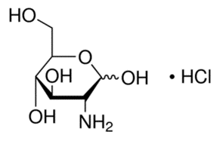
Supplementary Figure 1. Structure diagram of glucosamine hydrochloride used in this study.

Supplementary Table
Table 1. The primer sequence used for RT-PCR
Name | Forward primer | Reverse primer
IL-1β | CGACAAAATACCTGTGGCCT | TTCTTTGGGTATTGCTTGGG
IL-6 | GAAACCGCTATGAAGTTCCTCTCTG | TGTTGGGAGTGGTATCCTCTGTGA
MCP-1 | GGGATCATCTTGCTGGTGAA | AGGTCCCTGTCATGCTTCTG
PPARγ | TCGCTGATGCACTGCCTATG | GAGAGGTCCACAGAGCTGATT
CD11c | ACGTCAGTACAAGGAGATGTTGGA | ATCCTATTGCAGAATGCTTCTTTACC
β-Actin | AGGTGACAGCATTGCTTCTG | GCTGCCTCAACACCTCAAC

