Supplementary Material
Supplementary Figure 1. Expression of two lncRNAs with no significance in 44 SLE patients and 24 healthy controls. A. Expression of lncRNA ENST00000625135 has in two groups (p=0.1822). B. Expression of lncRNA MSTRG.44469.23 has no significance in two groups (p=0.4286).
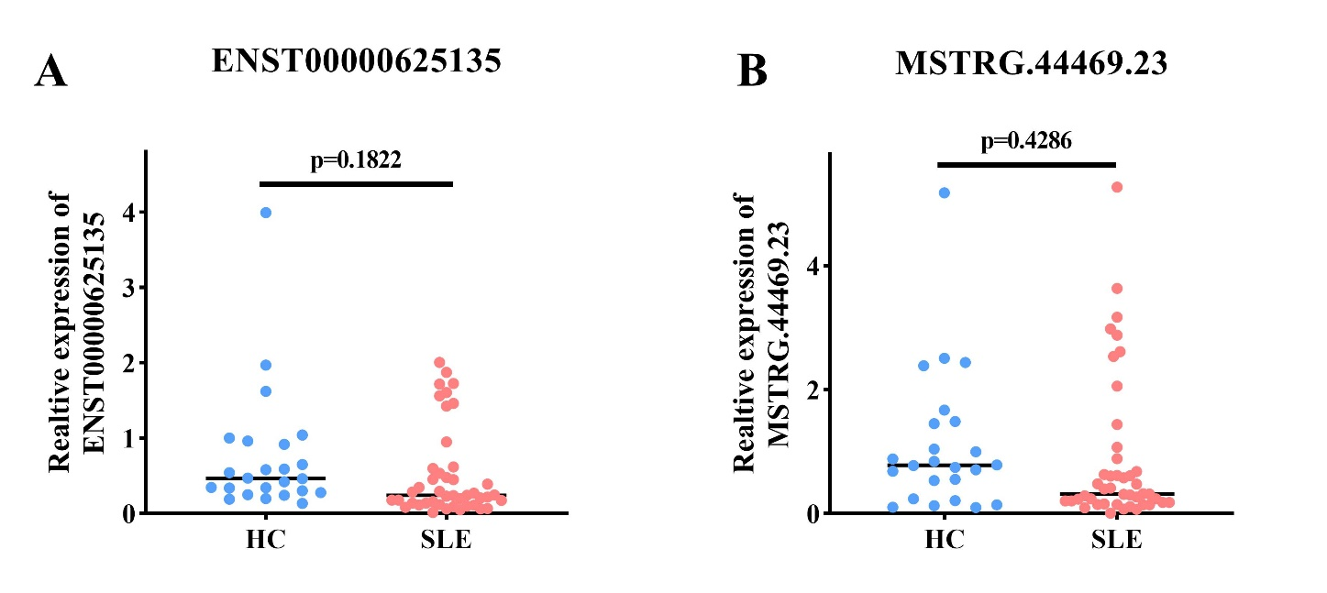
Supplementary Figure 2. Expression of LMBRD2 and its correlation with NONHSAT101022.2.
A. Expression of LMBRD2 in 77 SLE patients and 24 healthy controls (p=0.0017). B. Correlation of NONHSAT101022.2 and its target gene LMBRD2 (r = 0.5793, p < 0.0001)
