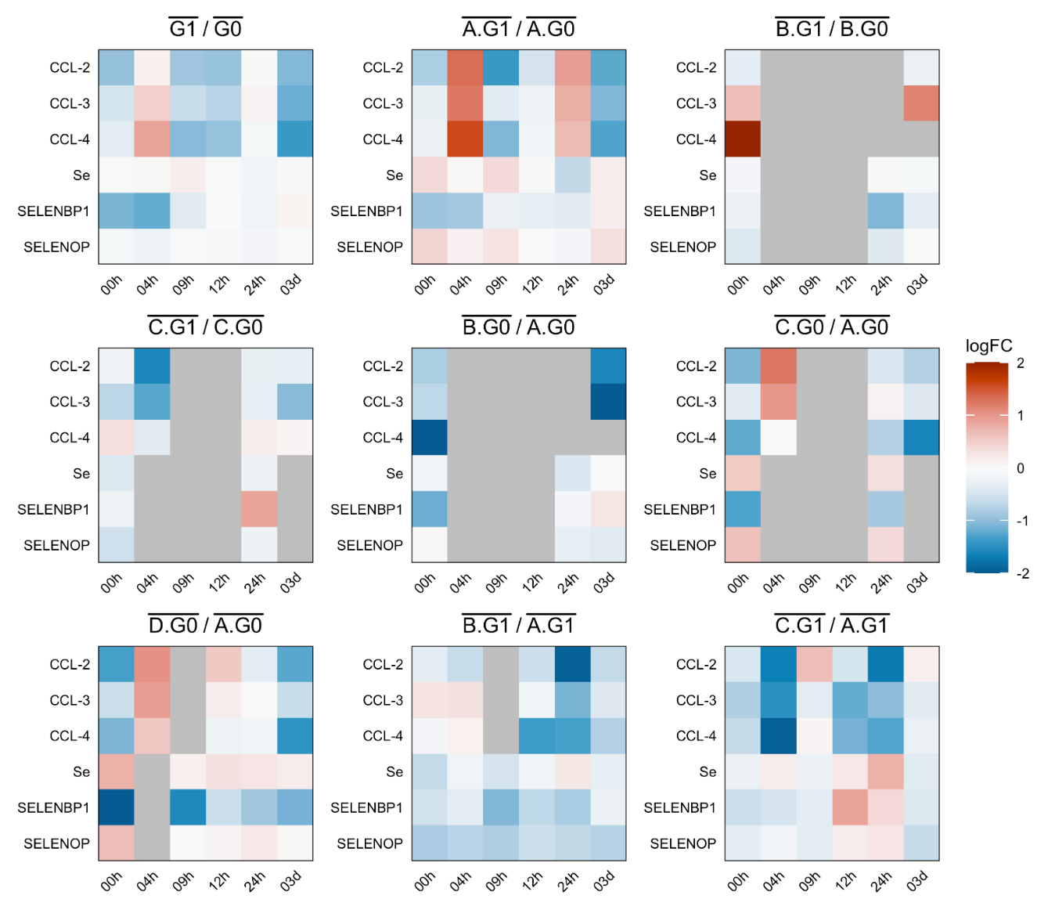
Suppl. Fig. 1. Trace element and cytokine dynamics. Heatmap values correspond to cytokine, trace element levels and associated protein concentrations averaged across replicates for each point in time, and z-normalized within each panel (comparison of AIS groups); missing values are shown in grey. Rows correspond to the analytes; columns correspond to 6 points in time from admission (00h) to 3 days after (03d) the injury.

