Geographical differentiation YEAR 2008

- All 5 countries (1-AT (Austria), 2-RO (Romania), 3-SI (Slovenia), 4-ME (Montenegro), 5-AR (Argentina))
84.1% initial classification, 79.5% cross-validation

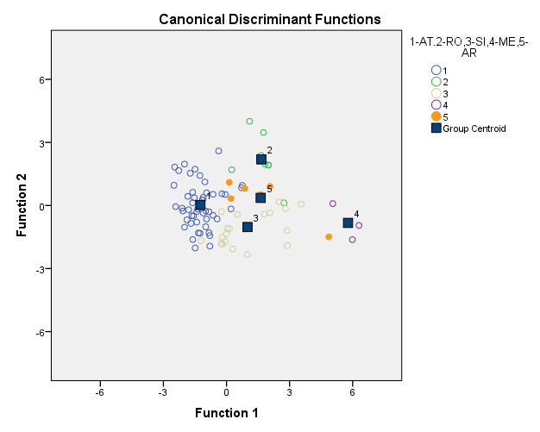

Classification Results^{a,c}
 |  | 1-AT.2-RO,3-SI,4-ME,5-AR | Predicted Group Membership |  |  |  |  | Total
 |  |  | 1 | 2 | 3 | 4 | 5
Original | Count | 1 | 46 | 1 | 1 | 0 | 2 | 50
 |  | 2 | 0 | 8 | 0 | 0 | 1 | 9
 |  | 3 | 2 | 0 | 12 | 0 | 6 | 20
 |  | 4 | 0 | 0 | 0 | 3 | 0 | 3
 |  | 5 | 0 | 0 | 0 | 1 | 5 | 6
 | % | 1 | 92.0 | 2.0 | 2.0 | .0 | 4.0 | 100.0
 |  | 2 | .0 | 88.9 | .0 | .0 | 11.1 | 100.0
 |  | 3 | 10.0 | .0 | 60.0 | .0 | 30.0 | 100.0
 |  | 4 | .0 | .0 | .0 | 100.0 | .0 | 100.0
 |  | 5 | .0 | .0 | .0 | 16.7 | 83.3 | 100.0
Cross-validated^{b} | Count | 1 | 45 | 1 | 2 | 0 | 2 | 50
 |  | 2 | 0 | 8 | 0 | 0 | 1 | 9
 |  | 3 | 2 | 0 | 11 | 0 | 7 | 20
 |  | 4 | 0 | 0 | 0 | 3 | 0 | 3
 |  | 5 | 2 | 0 | 0 | 1 | 3 | 6
 | % | 1 | 90.0 | 2.0 | 4.0 | .0 | 4.0 | 100.0
 |  | 2 | .0 | 88.9 | .0 | .0 | 11.1 | 100.0
 |  | 3 | 10.0 | .0 | 55.0 | .0 | 35.0 | 100.0
 |  | 4 | .0 | .0 | .0 | 100.0 | .0 | 100.0
 |  | 5 | 33.3 | .0 | .0 | 16.7 | 50.0 | 100.0
a. 84.1% of original grouped cases correctly classified.
b. Cross validation is done only for those cases in the analysis. In cross validation, each case is classified by the functions derived from all cases other than that case
c. 79.5% of cross-validated grouped cases correctly classified.

- 4 Countries (without AR)

89% initial classification, 87.8% cross-validation

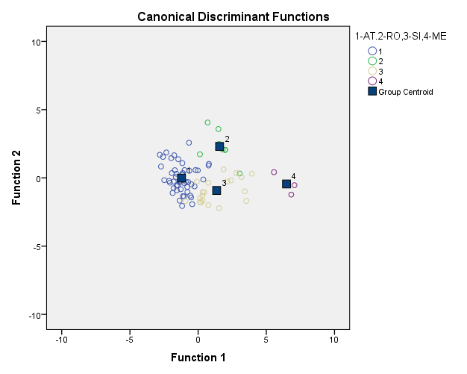

Classification Results^{a,c}
 |  | 1-AT.2-RO,3-SI,4-ME | Predicted Group Membership |  |  |  | Total
 |  |  | 1 | 2 | 3 | 4
Original | Count | 1 | 45 | 3 | 2 | 0 | 50
 |  | 2 | 0 | 8 | 1 | 0 | 9
 |  | 3 | 2 | 0 | 17 | 1 | 20
 |  | 4 | 0 | 0 | 0 | 3 | 3
 | % | 1 | 90.0 | 6.0 | 4.0 | .0 | 100.0
 |  | 2 | .0 | 88.9 | 11.1 | .0 | 100.0
 |  | 3 | 10.0 | .0 | 85.0 | 5.0 | 100.0
 |  | 4 | .0 | .0 | .0 | 100.0 | 100.0
Cross-validated^{b} | Count | 1 | 45 | 3 | 2 | 0 | 50
 |  | 2 | 0 | 8 | 1 | 0 | 9
 |  | 3 | 2 | 1 | 16 | 1 | 20
 |  | 4 | 0 | 0 | 0 | 3 | 3
 | % | 1 | 90.0 | 6.0 | 4.0 | .0 | 100.0
 |  | 2 | .0 | 88.9 | 11.1 | .0 | 100.0
 |  | 3 | 10.0 | 5.0 | 80.0 | 5.0 | 100.0
 |  | 4 | .0 | .0 | .0 | 100.0 | 100.0
a. 89.0% of original grouped cases correctly classified.
b. Cross validation is done only for those cases in the analysis. In cross validation, each case is classified by the functions derived from all cases other than that case.
c. 87.8% of cross-validated grouped cases correctly classified.

- 3 Countries (without AR and ME)

89.9% initial classification, 88.6% cross-validation

Classification Results^{a,c}
 |  | 1-AT.2-RO,3-SI | Predicted Group Membership |  |  | Total
 |  |  | 1 | 2 | 3
Original | Count | 1 | 45 | 3 | 2 | 50
 |  | 2 | 0 | 8 | 1 | 9
 |  | 3 | 2 | 0 | 18 | 20
 | % | 1 | 90.0 | 6.0 | 4.0 | 100.0
 |  | 2 | .0 | 88.9 | 11.1 | 100.0
 |  | 3 | 10.0 | .0 | 90.0 | 100.0
Cross-validated^{b} | Count | 1 | 45 | 3 | 2 | 50
 |  | 2 | 0 | 8 | 1 | 9
 |  | 3 | 2 | 1 | 17 | 20
 | % | 1 | 90.0 | 6.0 | 4.0 | 100.0
 |  | 2 | .0 | 88.9 | 11.1 | 100.0
 |  | 3 | 10.0 | 5.0 | 85.0 | 100.0
a. 89.9% of original grouped cases correctly classified.
b. Cross validation is done only for those cases in the analysis. In cross validation, each case is classified by the functions derived from all cases other than that case.
c. 88.6% of cross-validated grouped cases correctly classified.

Geographical differentiation Year 2009

- All 5 countries (1-AT, 2-RO, 3-SI, 4-ME, 5-AR)
56.4 % initial classification, 54.3% cross-validation
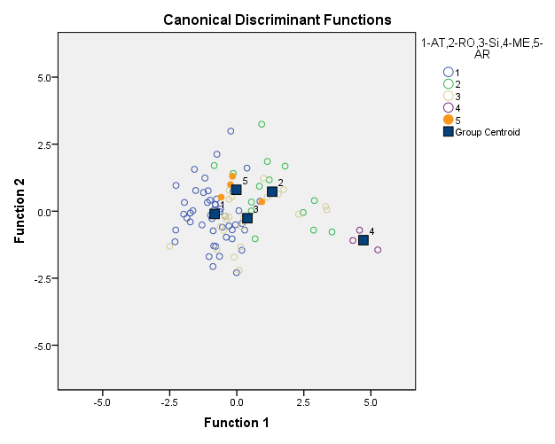

Classification Results^{a,c}
 |  | 1-AT,2-RO,3-Si,4-ME,5-AR | Predicted Group Membership |  |  |  |  | Total
 |  |  | 1 | 2 | 3 | 4 | 5
Original | Count | 1 | 34 | 1 | 8 | 0 | 7 | 50
 |  | 2 | 0 | 7 | 3 | 2 | 2 | 14
 |  | 3 | 7 | 5 | 5 | 2 | 3 | 22
 |  | 4 | 0 | 0 | 0 | 3 | 0 | 3
 |  | 5 | 0 | 1 | 0 | 0 | 4 | 5
 | % | 1 | 68.0 | 2.0 | 16.0 | .0 | 14.0 | 100.0
 |  | 2 | .0 | 50.0 | 21.4 | 14.3 | 14.3 | 100.0
 |  | 3 | 31.8 | 22.7 | 22.7 | 9.1 | 13.6 | 100.0
 |  | 4 | .0 | .0 | .0 | 100.0 | .0 | 100.0
 |  | 5 | .0 | 20.0 | .0 | .0 | 80.0 | 100.0
Cross-validated^{b} | Count | 1 | 34 | 1 | 8 | 0 | 7 | 50
 |  | 2 | 0 | 6 | 3 | 2 | 3 | 14
 |  | 3 | 7 | 5 | 5 | 2 | 3 | 22
 |  | 4 | 0 | 0 | 0 | 3 | 0 | 3
 |  | 5 | 1 | 1 | 0 | 0 | 3 | 5
 | % | 1 | 68.0 | 2.0 | 16.0 | .0 | 14.0 | 100.0
 |  | 2 | .0 | 42.9 | 21.4 | 14.3 | 21.4 | 100.0
 |  | 3 | 31.8 | 22.7 | 22.7 | 9.1 | 13.6 | 100.0
 |  | 4 | .0 | .0 | .0 | 100.0 | .0 | 100.0
 |  | 5 | 20.0 | 20.0 | .0 | .0 | 60.0 | 100.0
a. 56.4% of original grouped cases correctly classified.
b. Cross validation is done only for those cases in the analysis. In cross validation, each case is classified by the functions derived from all cases other than that case.
c. 54.3% of cross-validated grouped cases correctly classified.

- 4 Countries (without AR)

60.7% initial classification, 59.6% cross-validation
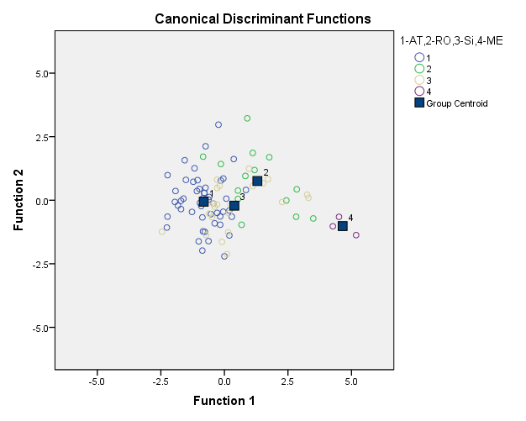

Classification Results^{a,c}
 |  | 1-AT,2-RO,3-Si,4-ME | Predicted Group Membership |  |  |  | Total
 |  |  | 1 | 2 | 3 | 4
Original | Count | 1 | 38 | 3 | 9 | 0 | 50
 |  | 2 | 1 | 8 | 3 | 2 | 14
 |  | 3 | 10 | 5 | 5 | 2 | 22
 |  | 4 | 0 | 0 | 0 | 3 | 3
 | % | 1 | 76.0 | 6.0 | 18.0 | .0 | 100.0
 |  | 2 | 7.1 | 57.1 | 21.4 | 14.3 | 100.0
 |  | 3 | 45.5 | 22.7 | 22.7 | 9.1 | 100.0
 |  | 4 | .0 | .0 | .0 | 100.0 | 100.0
Cross-validated^{b} | Count | 1 | 38 | 3 | 9 | 0 | 50
 |  | 2 | 2 | 7 | 3 | 2 | 14
 |  | 3 | 10 | 5 | 5 | 2 | 22
 |  | 4 | 0 | 0 | 0 | 3 | 3
 | % | 1 | 76.0 | 6.0 | 18.0 | .0 | 100.0
 |  | 2 | 14.3 | 50.0 | 21.4 | 14.3 | 100.0
 |  | 3 | 45.5 | 22.7 | 22.7 | 9.1 | 100.0
 |  | 4 | .0 | .0 | .0 | 100.0 | 100.0
a. 60.7% of original grouped cases correctly classified.
b. Cross validation is done only for those cases in the analysis. In cross validation, each case is classified by the functions derived from all cases other than that case.
c. 59.6% of cross-validated grouped cases correctly classified.

- 3 Countries (without AR and ME)

62.8% initial classification, 62.8% cross-validation

Classification Results^{a,c}
 |  | 1-AT,2-RO,3-Si,4-ME | Predicted Group Membership |  |  | Total
 |  |  | 1 | 2 | 3
Original | Count | 1 | 40 | 2 | 8 | 50
 |  | 2 | 0 | 9 | 5 | 14
 |  | 3 | 10 | 7 | 5 | 22
 | % | 1 | 80.0 | 4.0 | 16.0 | 100.0
 |  | 2 | .0 | 64.3 | 35.7 | 100.0
 |  | 3 | 45.5 | 31.8 | 22.7 | 100.0
Cross-validated^{b} | Count | 1 | 40 | 2 | 8 | 50
 |  | 2 | 0 | 9 | 5 | 14
 |  | 3 | 10 | 7 | 5 | 22
 | % | 1 | 80.0 | 4.0 | 16.0 | 100.0
 |  | 2 | .0 | 64.3 | 35.7 | 100.0
 |  | 3 | 45.5 | 31.8 | 22.7 | 100.0
a. 62.8% of original grouped cases correctly classified.
b. Cross validation is done only for those cases in the analysis. In cross validation, each case is classified by the functions derived from all cases other than that case.
c. 62.8% of cross-validated grouped cases correctly classified.

Geographical differentiation - years 2008+2009

- All 5 countries (1-AT, 2-RO, 3-SI, 4-ME, 5-AR)
67.0 % initial classification, 65.4% cross-validation
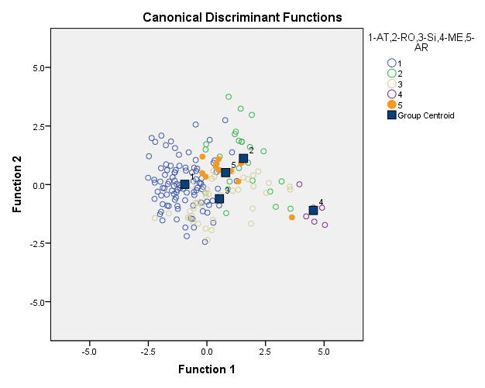

Classification Results^{a,c}
 |  | 1-AT,2-RO,3-Si,4-ME,5-AR | Predicted Group Membership |  |  |  |  | Total
 |  |  | 1.00 | 2.00 | 3.00 | 4.00 | 5.00
Original | Count | 1.00 | 75 | 2 | 16 | 0 | 7 | 100
 |  | 2.00 | 0 | 14 | 2 | 3 | 4 | 23
 |  | 3.00 | 9 | 7 | 19 | 2 | 5 | 42
 |  | 4.00 | 0 | 0 | 0 | 6 | 0 | 6
 |  | 5.00 | 1 | 1 | 0 | 1 | 8 | 11
 | % | 1.00 | 75.0 | 2.0 | 16.0 | .0 | 7.0 | 100.0
 |  | 2.00 | .0 | 60.9 | 8.7 | 13.0 | 17.4 | 100.0
 |  | 3.00 | 21.4 | 16.7 | 45.2 | 4.8 | 11.9 | 100.0
 |  | 4.00 | .0 | .0 | .0 | 100.0 | .0 | 100.0
 |  | 5.00 | 9.1 | 9.1 | .0 | 9.1 | 72.7 | 100.0
Cross-validated^{b} | Count | 1.00 | 75 | 2 | 16 | 0 | 7 | 100
 |  | 2.00 | 0 | 14 | 2 | 3 | 4 | 23
 |  | 3.00 | 10 | 7 | 17 | 2 | 6 | 42
 |  | 4.00 | 0 | 0 | 0 | 6 | 0 | 6
 |  | 5.00 | 2 | 1 | 0 | 1 | 7 | 11
 | % | 1.00 | 75.0 | 2.0 | 16.0 | .0 | 7.0 | 100.0
 |  | 2.00 | .0 | 60.9 | 8.7 | 13.0 | 17.4 | 100.0
 |  | 3.00 | 23.8 | 16.7 | 40.5 | 4.8 | 14.3 | 100.0
 |  | 4.00 | .0 | .0 | .0 | 100.0 | .0 | 100.0
 |  | 5.00 | 18.2 | 9.1 | .0 | 9.1 | 63.6 | 100.0
a. 67.0% of original grouped cases correctly classified.
b. Cross validation is done only for those cases in the analysis. In cross validation, each case is classified by the functions derived from all cases other than that case.
c. 65.4% of cross-validated grouped cases correctly classified.

Vintage differentiation 2008 vs 2009

- All samples

63.7 % initial classification, 63.2% cross-validation

Classification Results^{a,c}
 |  | 1-2008,2-2009 | Predicted Group Membership |  | Total
 |  |  | 1.00 | 2.00
Original | Count | 1.00 | 54 | 40 | 94
 |  | 2.00 | 26 | 62 | 88
 | % | 1.00 | 57.4 | 42.6 | 100.0
 |  | 2.00 | 29.5 | 70.5 | 100.0
Cross-validated^{b} | Count | 1.00 | 53 | 41 | 94
 |  | 2.00 | 26 | 62 | 88
 | % | 1.00 | 56.4 | 43.6 | 100.0
 |  | 2.00 | 29.5 | 70.5 | 100.0
a. 63.7% of original grouped cases correctly classified.
b. Cross validation is done only for those cases in the analysis. In cross validation, each case is classified by the functions derived from all cases other than that case.
c. 63.2% of cross-validated grouped cases correctly classified.

- Austrian samples

68.5 % initial classification, 68.5% cross-validation

Classification Results^{a,c}
 |  | 1-2008,2-2009 | Predicted Group Membership |  | Total
 |  |  | 1.00 | 2.00
Original | Count | 1.00 | 57 | 29 | 86
 |  | 2.00 | 23 | 56 | 79
 | % | 1.00 | 66.3 | 33.7 | 100.0
 |  | 2.00 | 29.1 | 70.9 | 100.0
Cross-validated^{b} | Count | 1.00 | 57 | 29 | 86
 |  | 2.00 | 23 | 56 | 79
 | % | 1.00 | 66.3 | 33.7 | 100.0
 |  | 2.00 | 29.1 | 70.9 | 100.0
a. 68.5% of original grouped cases correctly classified.
b. Cross validation is done only for those cases in the analysis. In cross validation, each case is classified by the functions derived from all cases other than that case.
c. 68.5% of cross-validated grouped cases correctly classified.

3.Slovenian samples

80 % initial classification, 79% cross-validation

Classification Results^{a,c}
 |  | 1-2008,2-2009 | Predicted Group Membership |  | Total
 |  |  | 1.00 | 2.00
Original | Count | 1.00 | 39 | 11 | 50
 |  | 2.00 | 9 | 41 | 50
 | % | 1.00 | 78.0 | 22.0 | 100.0
 |  | 2.00 | 18.0 | 82.0 | 100.0
Cross-validated^{b} | Count | 1.00 | 39 | 11 | 50
 |  | 2.00 | 10 | 40 | 50
 | % | 1.00 | 78.0 | 22.0 | 100.0
 |  | 2.00 | 20.0 | 80.0 | 100.0
a. 80.0% of original grouped cases correctly classified.
b. Cross validation is done only for those cases in the analysis. In cross validation, each case is classified by the functions derived from all cases other than that case.
c. 79.0% of cross-validated grouped cases correctly classified.

