Supplement: OPLS-DA of wine samples among individual investigated countries

Austria-Slovenia:
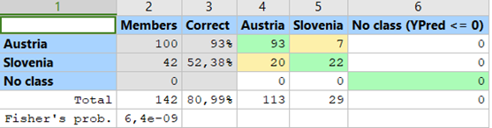
Austria-Romania:
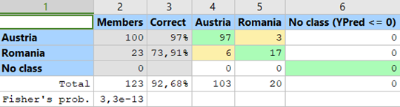
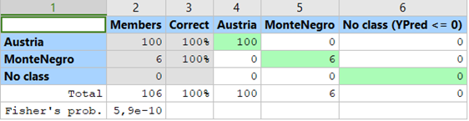
Austria-Montenegro:

Austria-Argentina:
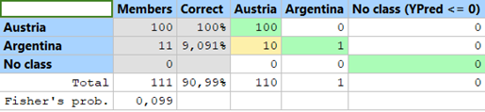
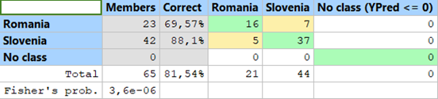
Romania-Slovenia:

Slovenia-Montenegro:
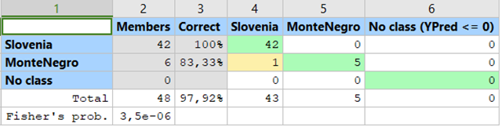

Slovenia-Argentina:
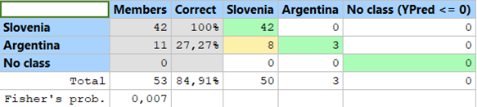
Romania-Montenegro:
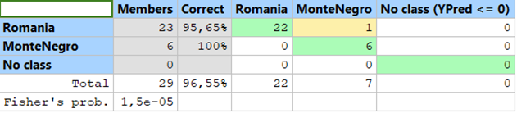
Romania-Argentina:
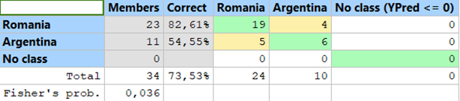
Montenegro-Argentina:
