Supplementary Material

Supplementary Figures and References

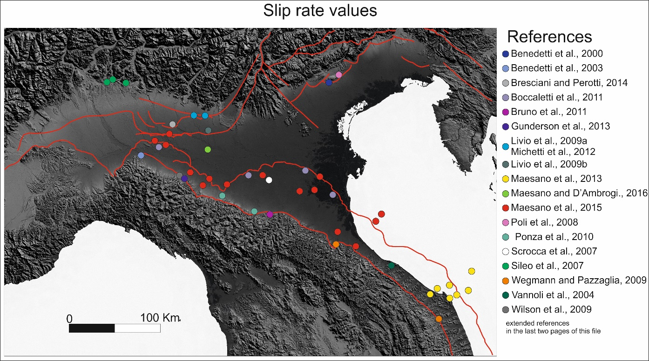
Supplementary Figure 1.
Po Plain and Northern Adriatic Sea slip rates.Red lines are the main tectonic lineaments, colored circles show the location of the slip rate datasets available in literature (see Supplementary References).

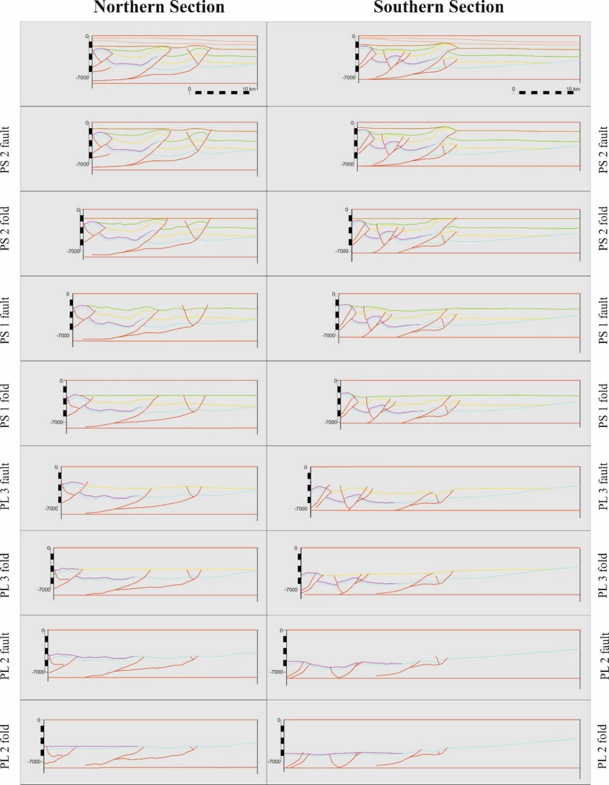
Supplementary Figure 2.
Main steps of the regional cross sections’ restoration process. Colors are the same as those in figures 6, 7, and 8 of the article. The terms “fault” and “fold” near the passages indicate the restoration of the shortening associated to either fault displacement or to folding, respectively.

a
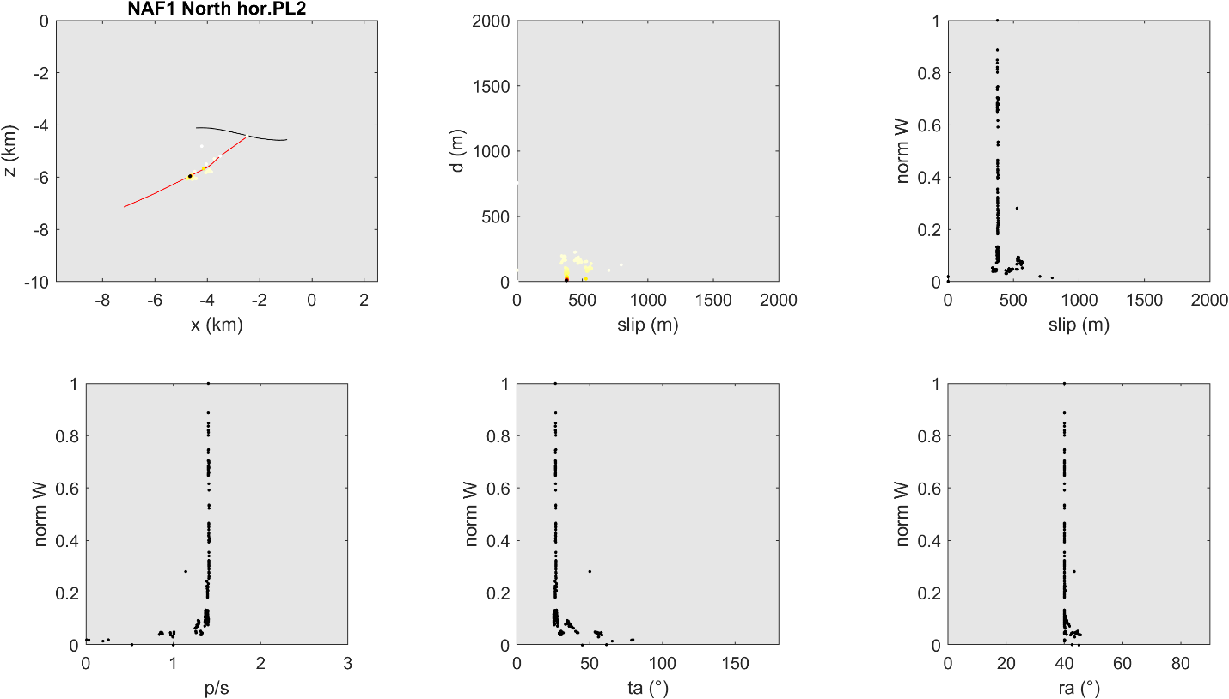

b
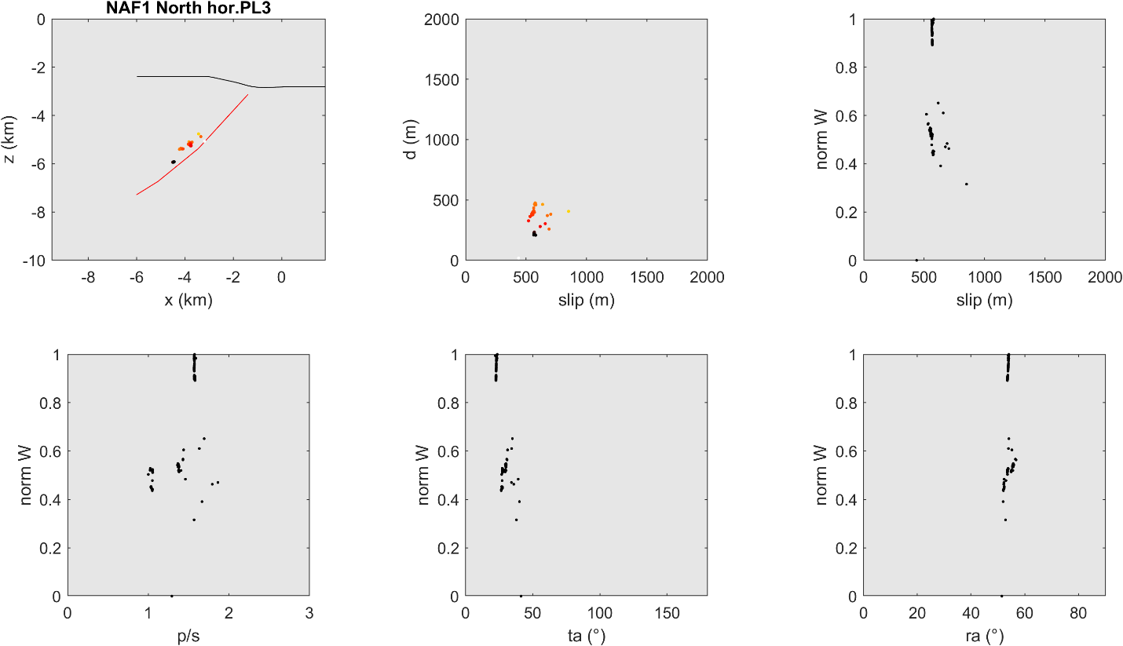
c
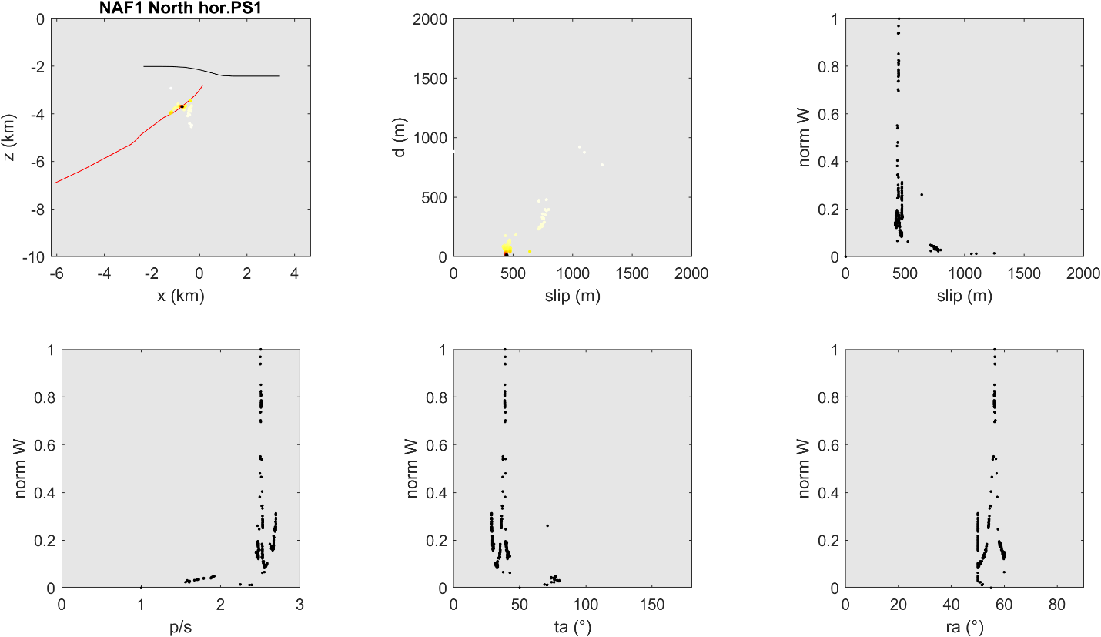
d
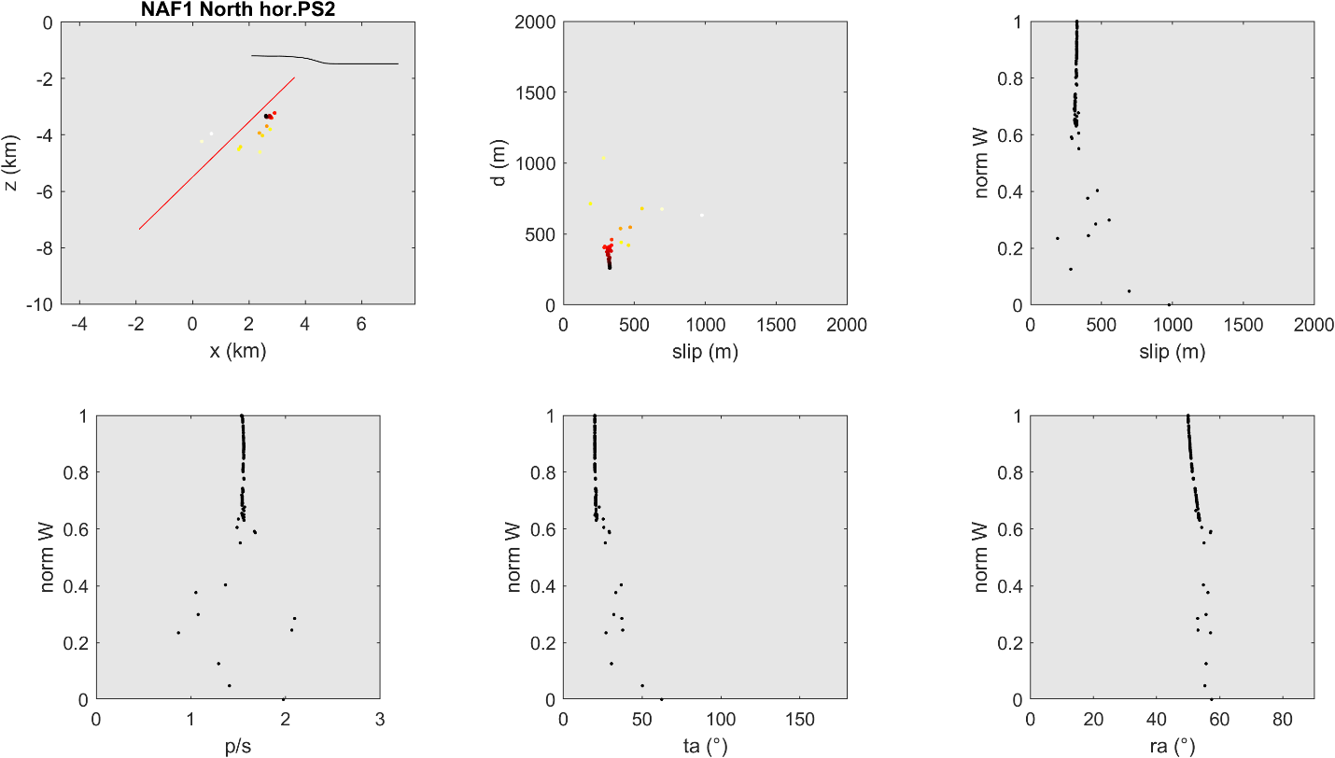

e
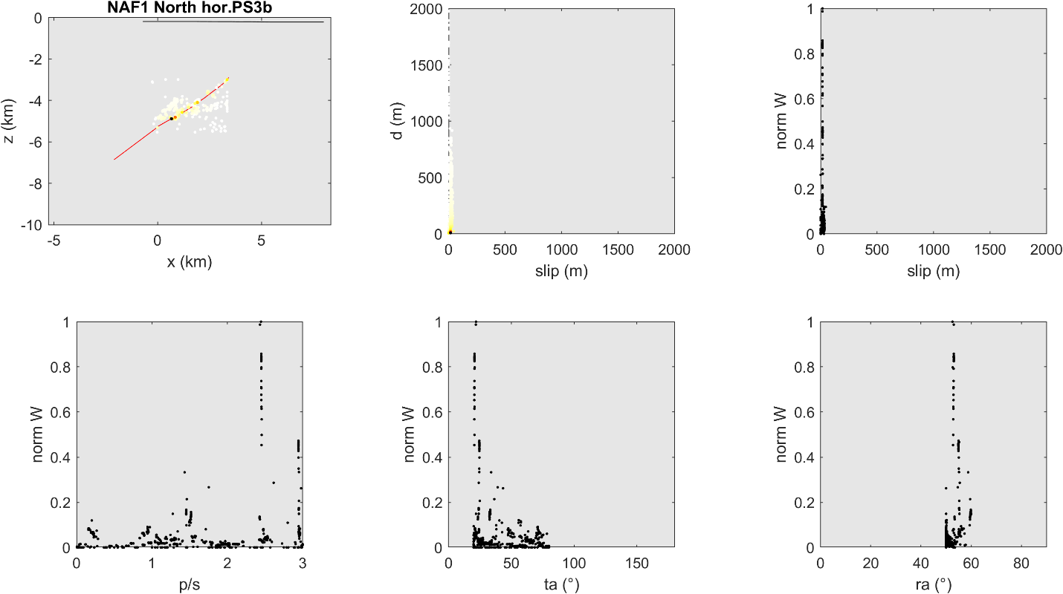
f
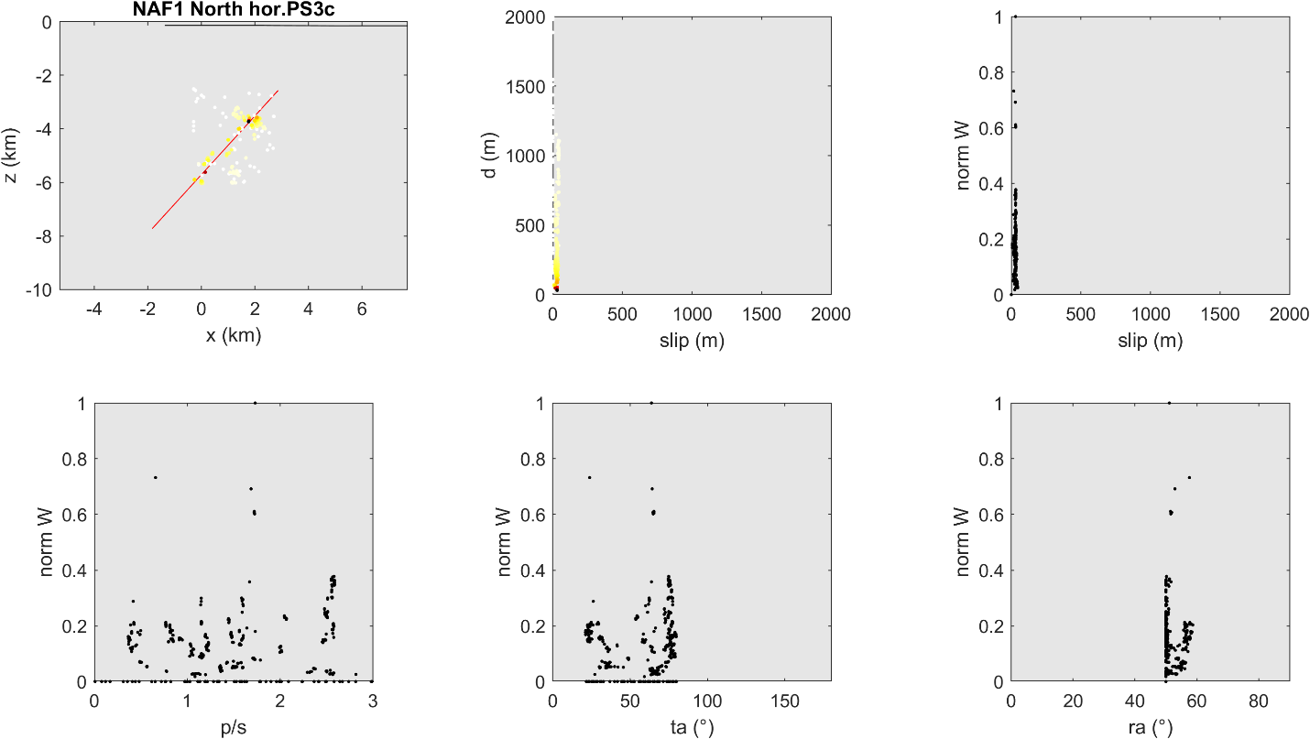

g
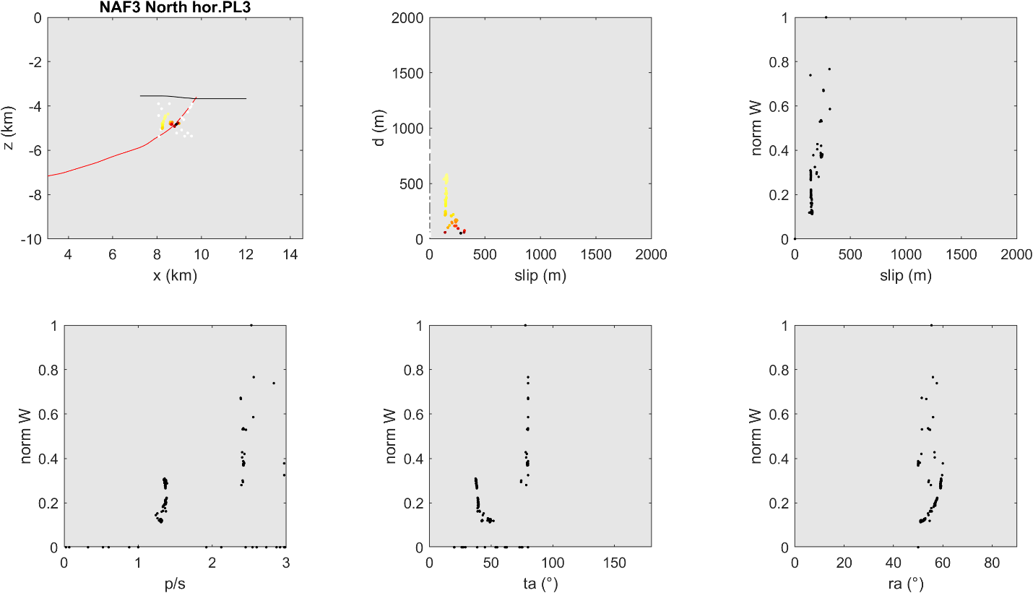
h
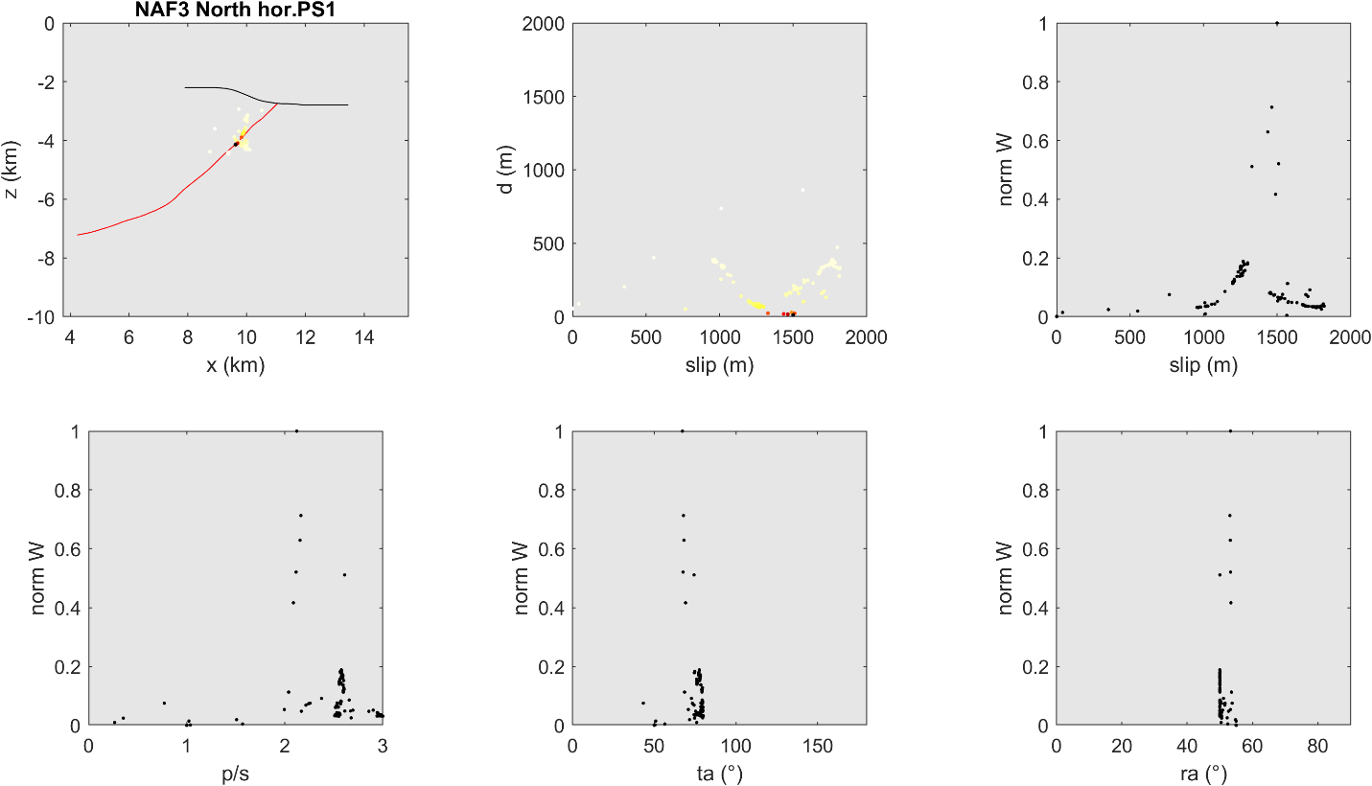

i
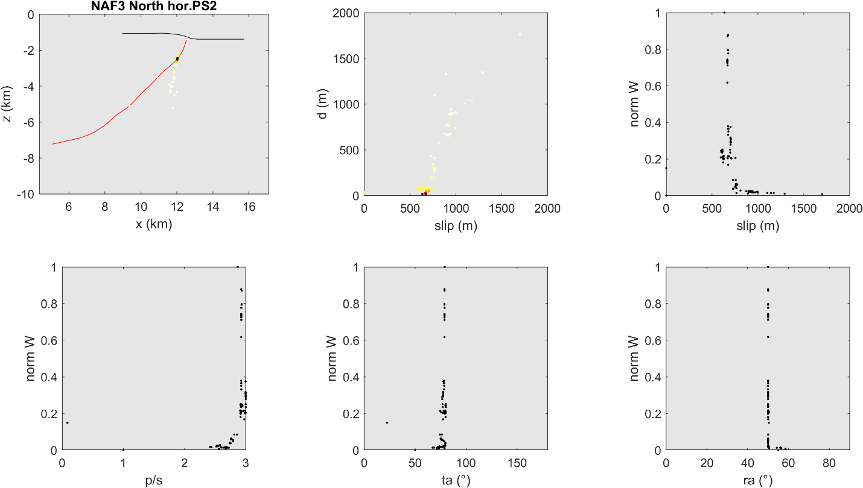
j
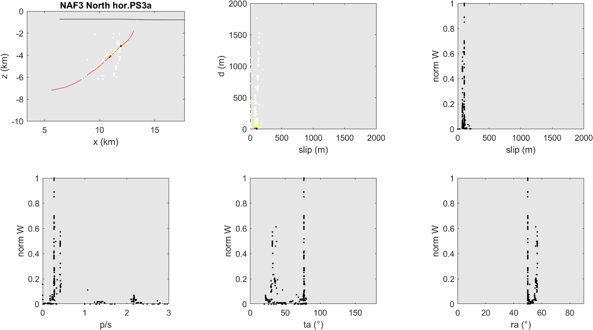

k
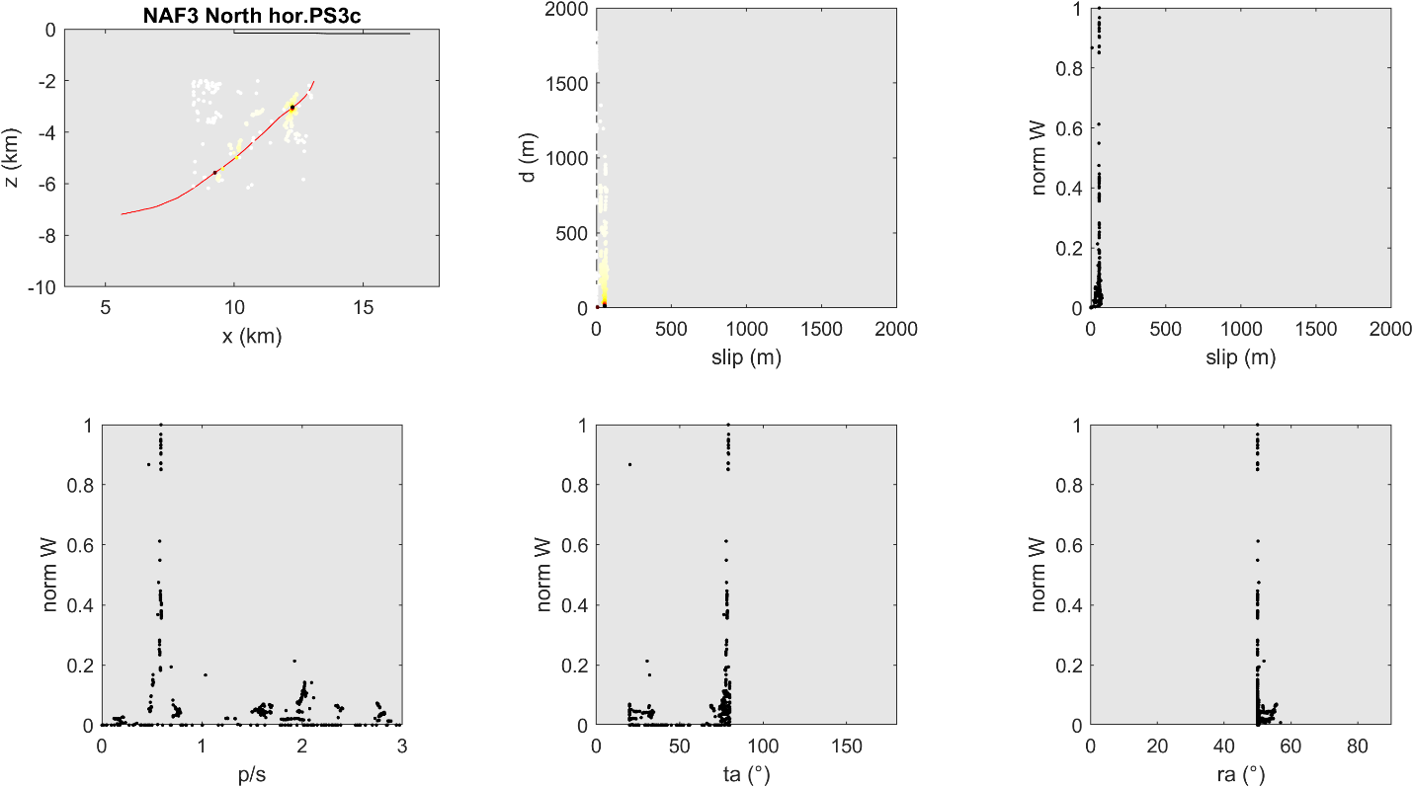
l
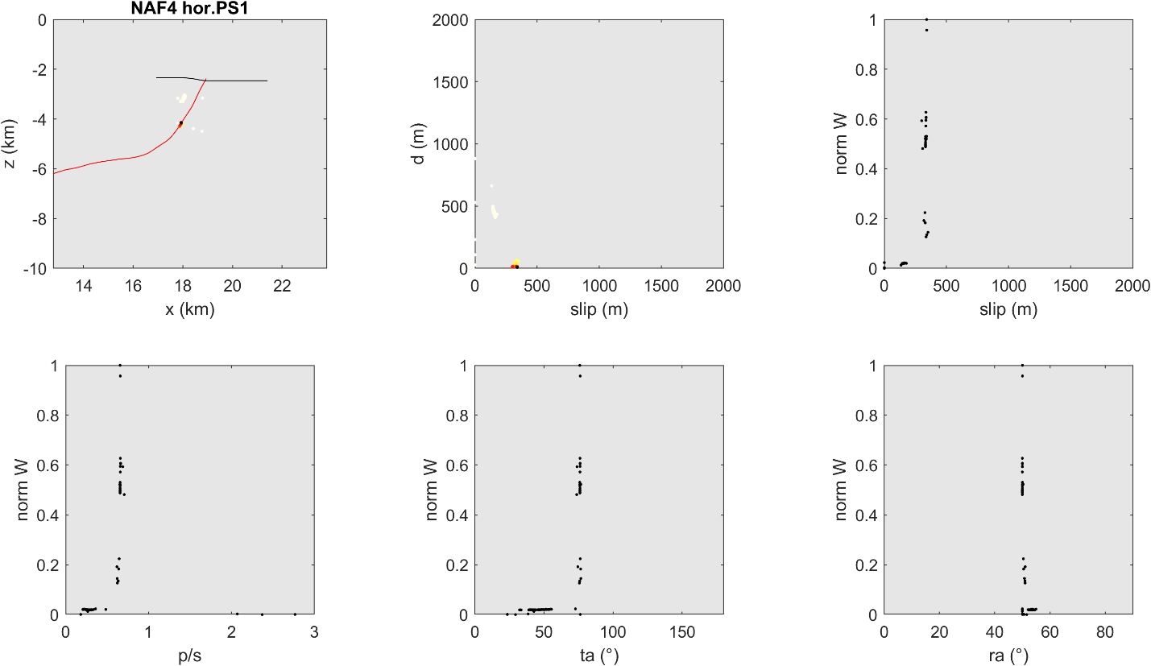

m
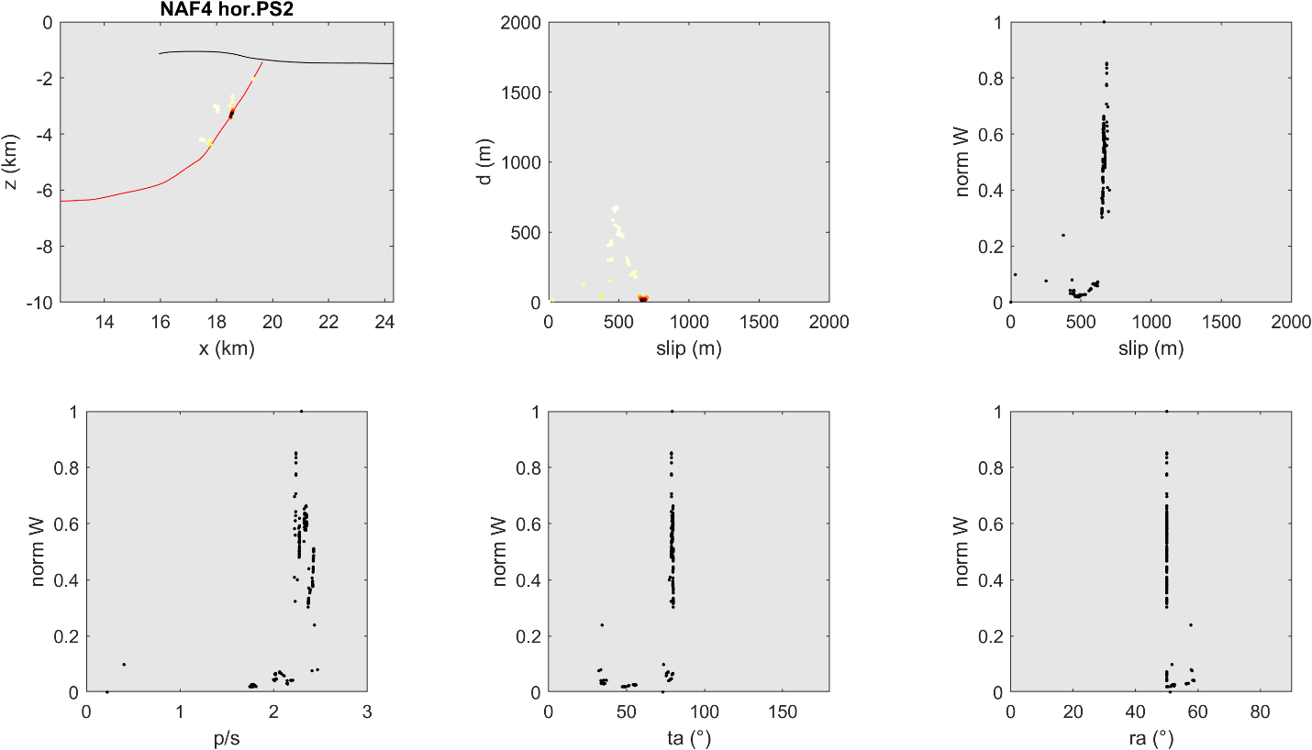
n
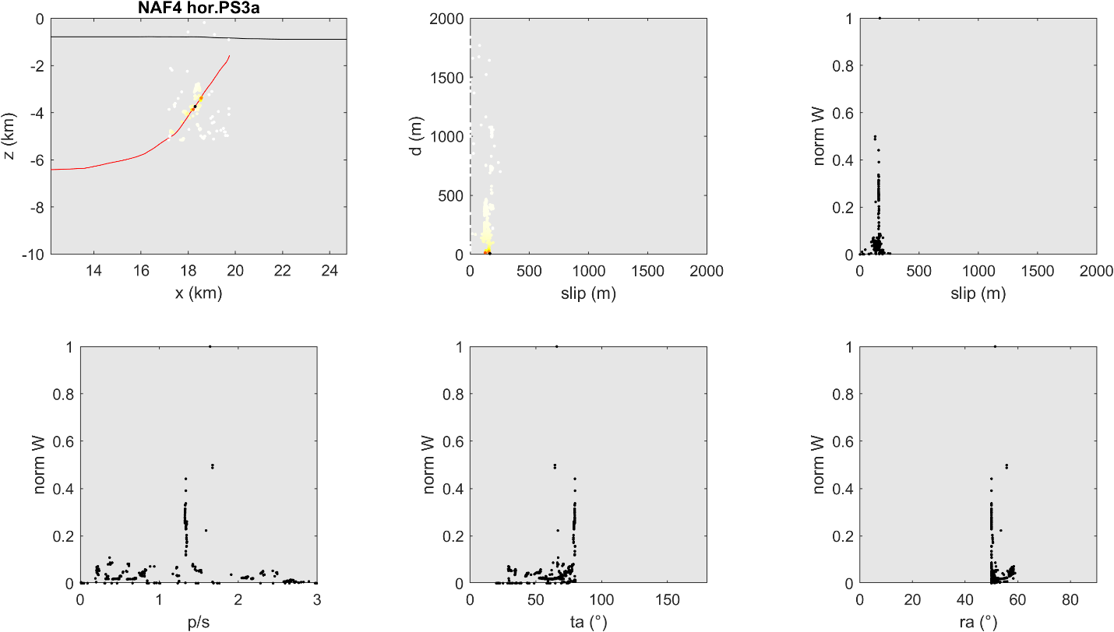

o
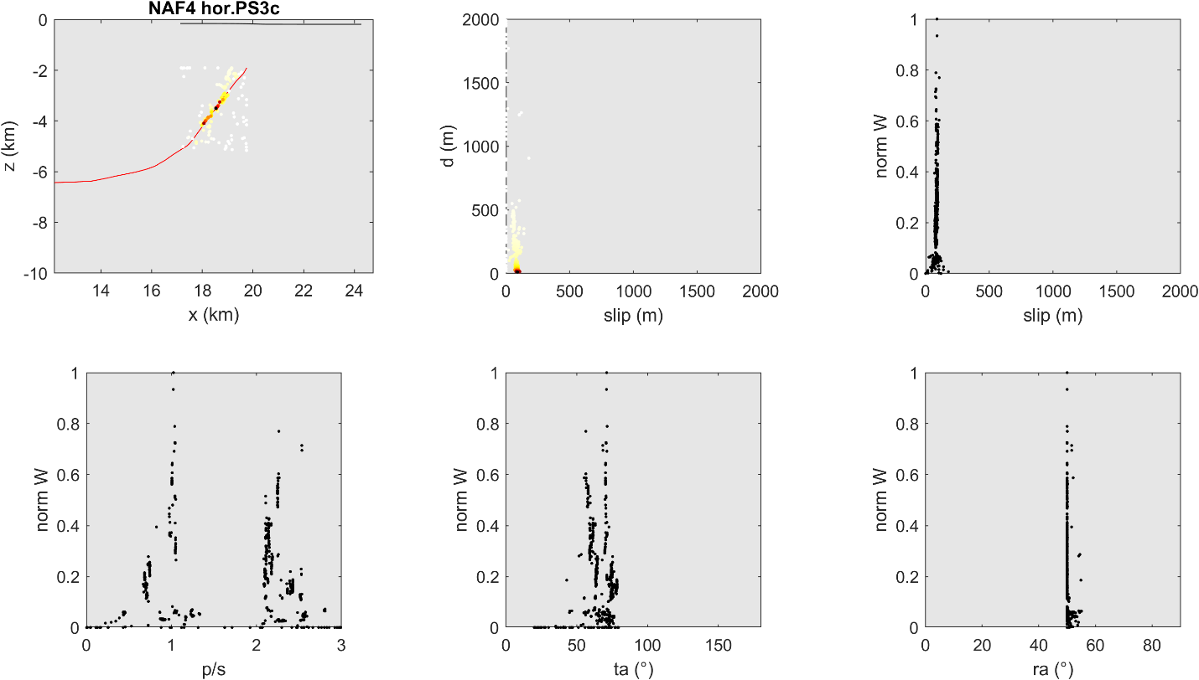
Supplementary Figure 3.
(a-o) Plots of trishear inversion for Northern Section. Legend: d (m): distance from fault; norm W: normalized weight (1-fval)*(1/d); fval is the normalized value of the regression function (Cardozo et al., 2011); p/s: ratio of fault propagation (p) versus slip on fault (s); ta (°): trishear angle; ra (°): ramp dip angle.

a
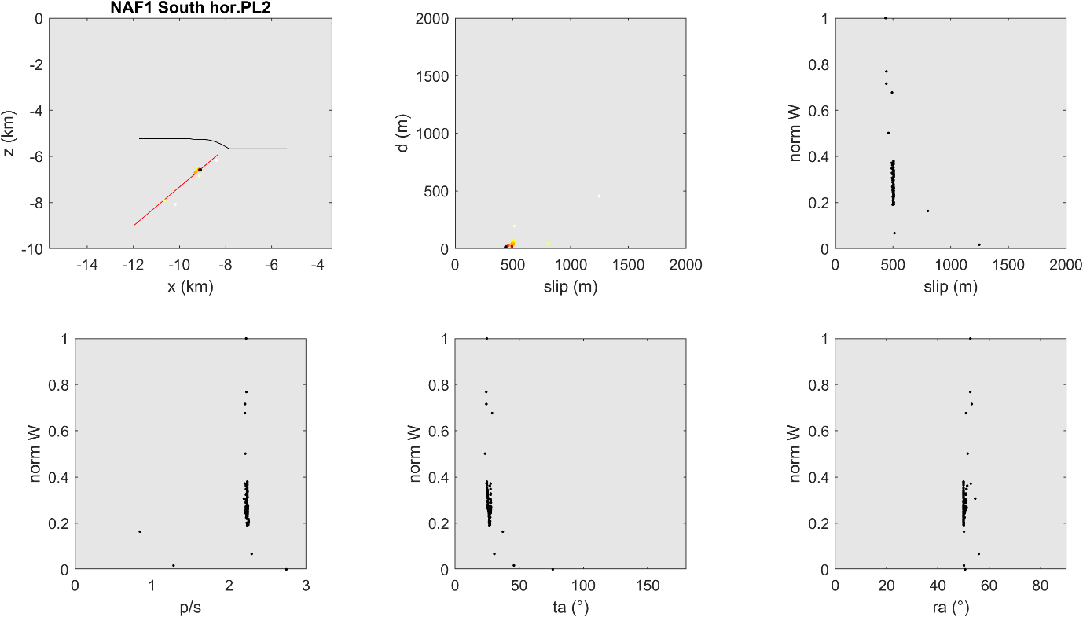
b
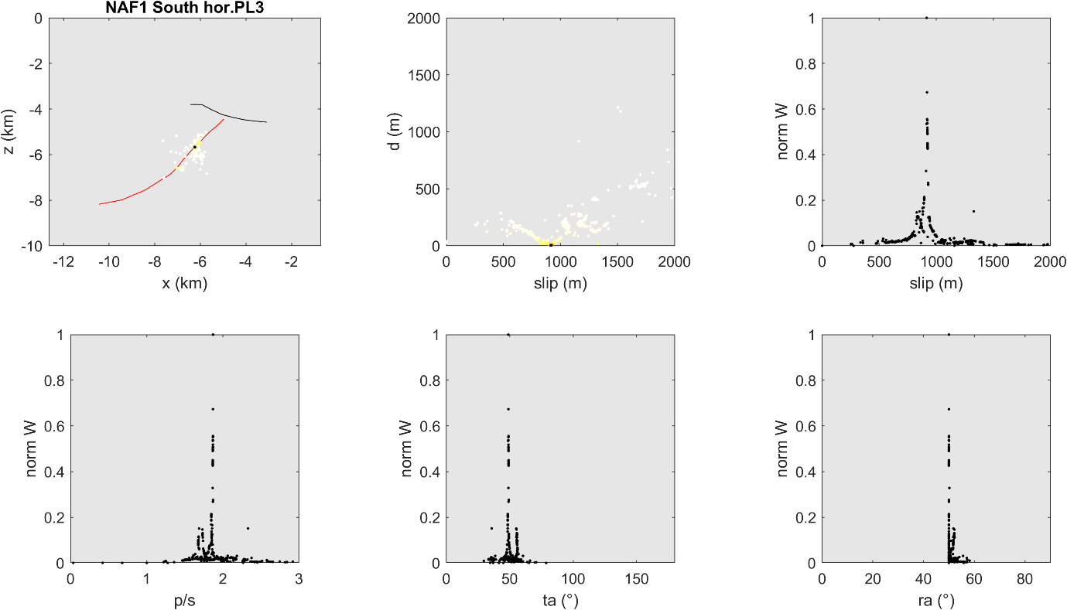

c
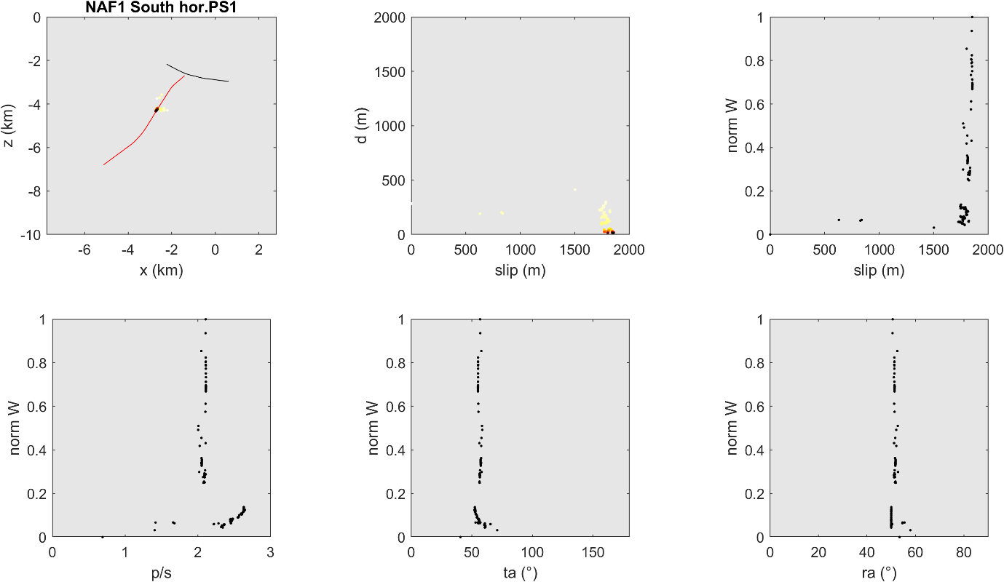
d
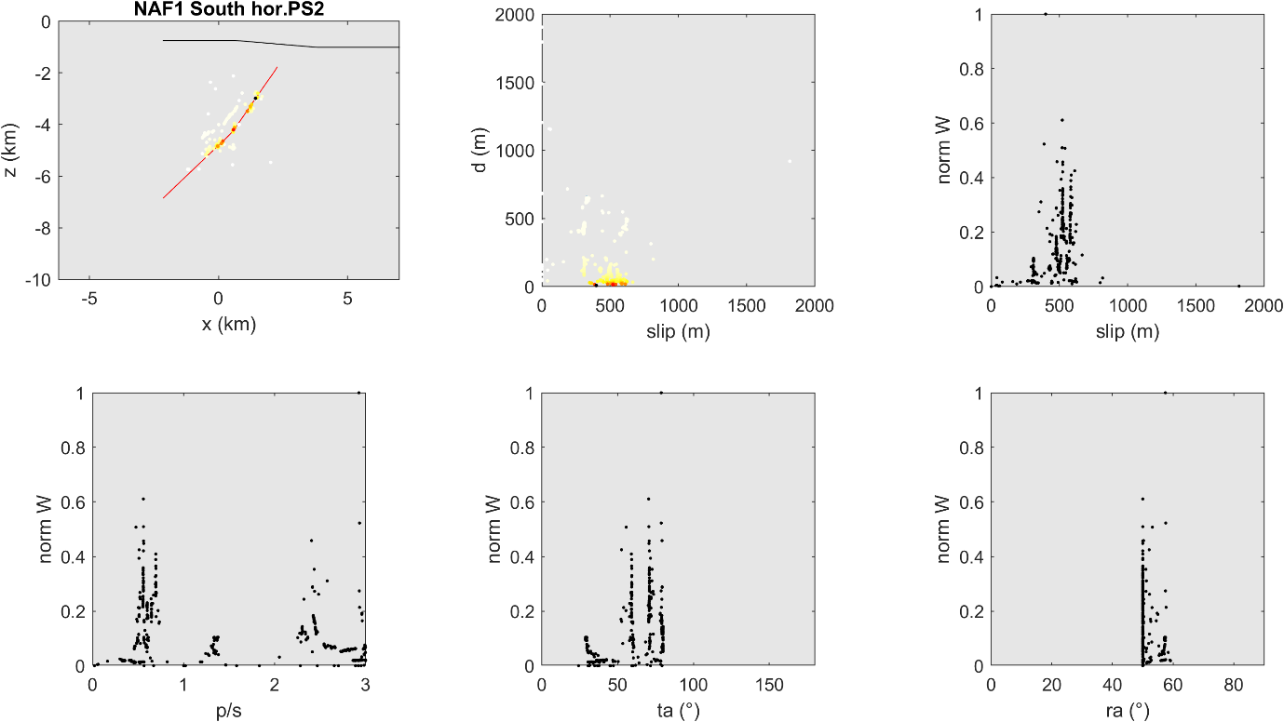

e
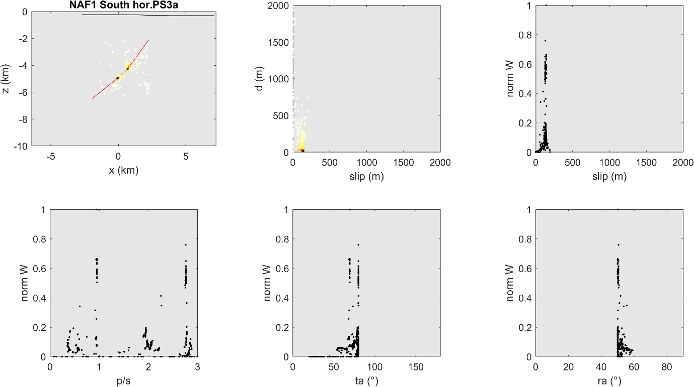
f
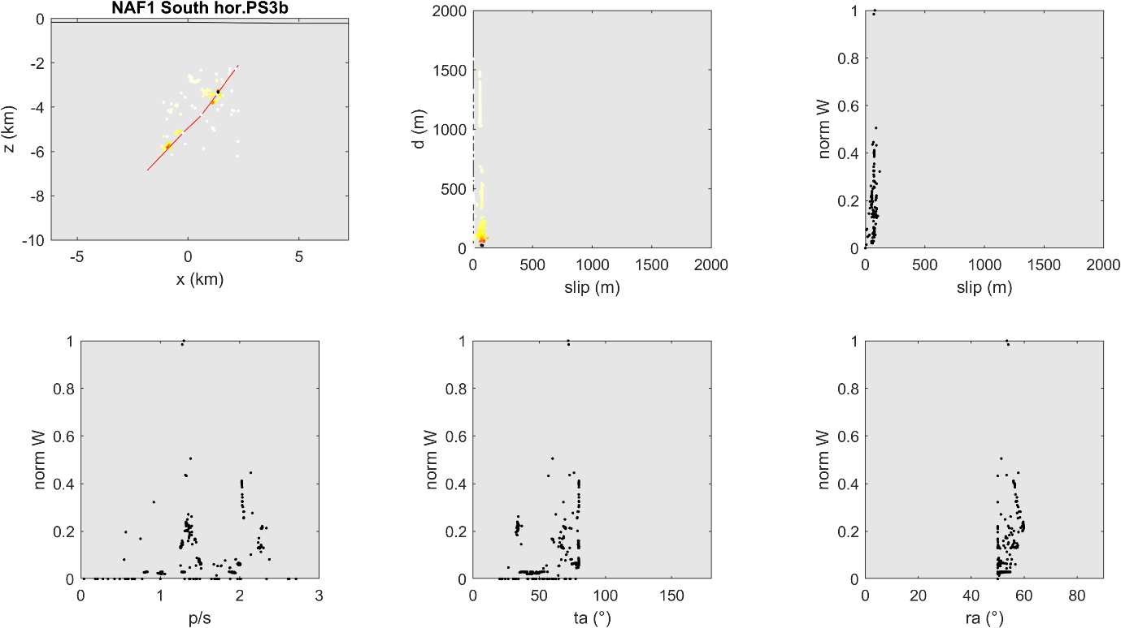

g
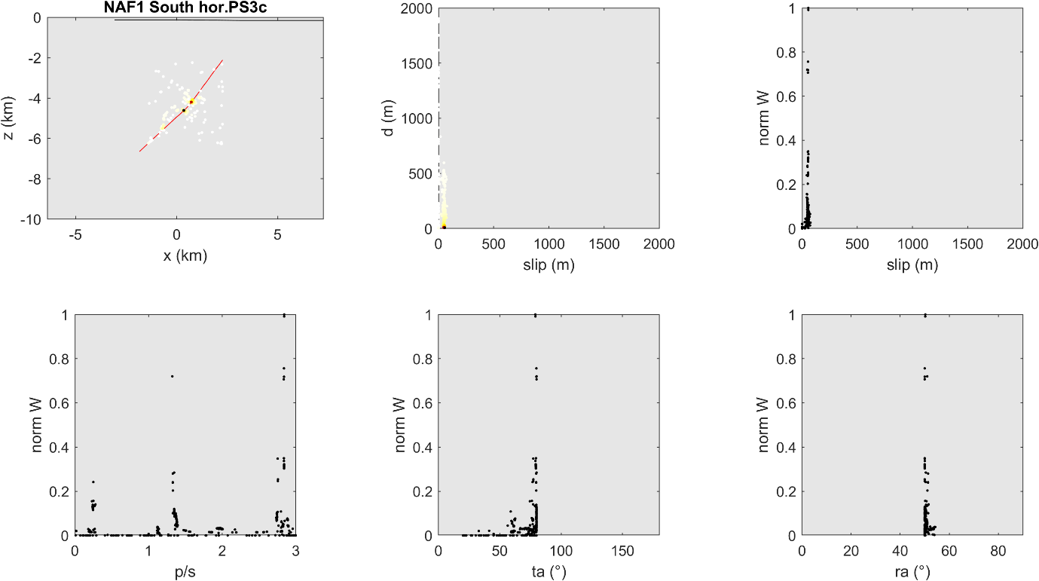
h
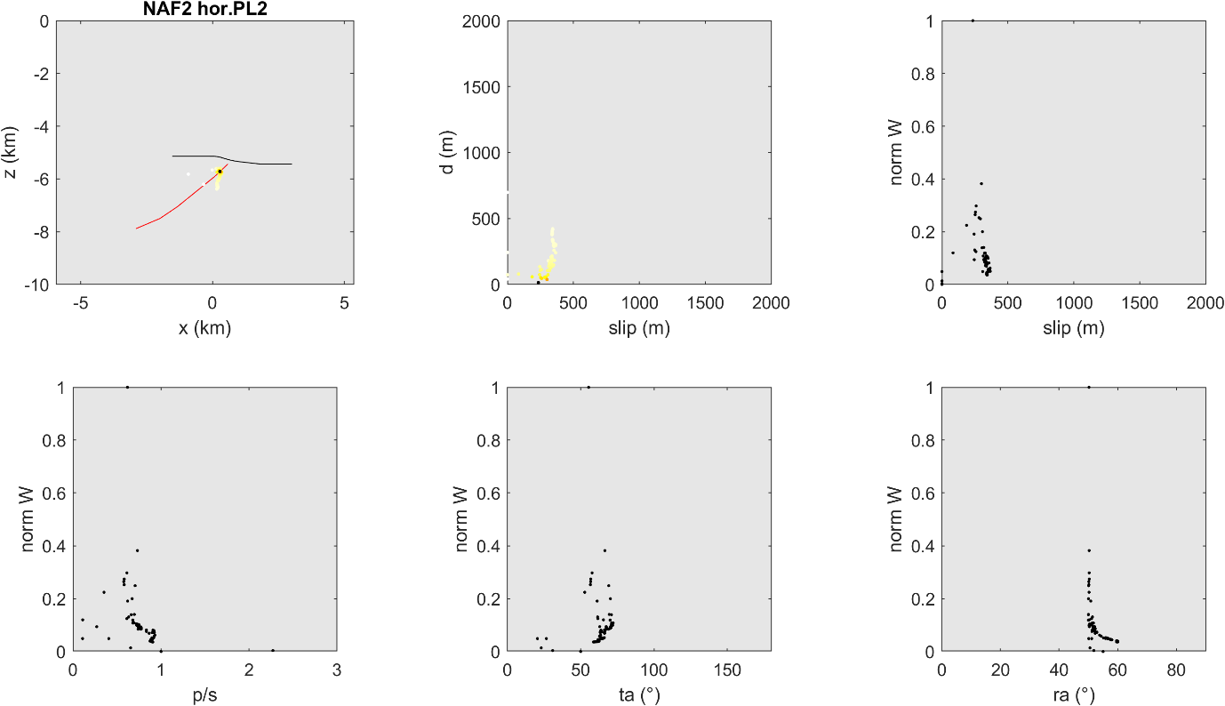

i
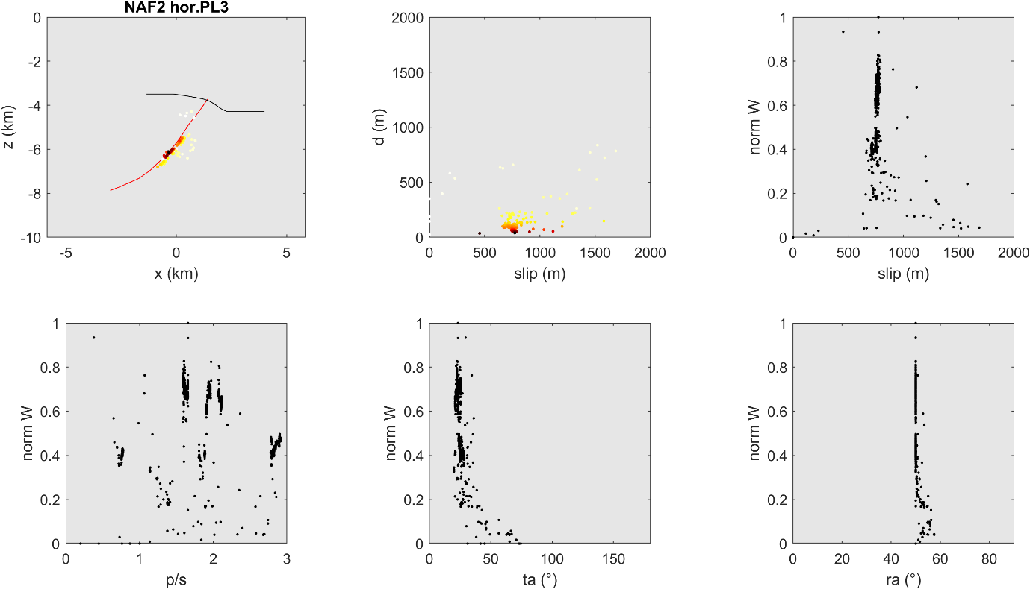
j
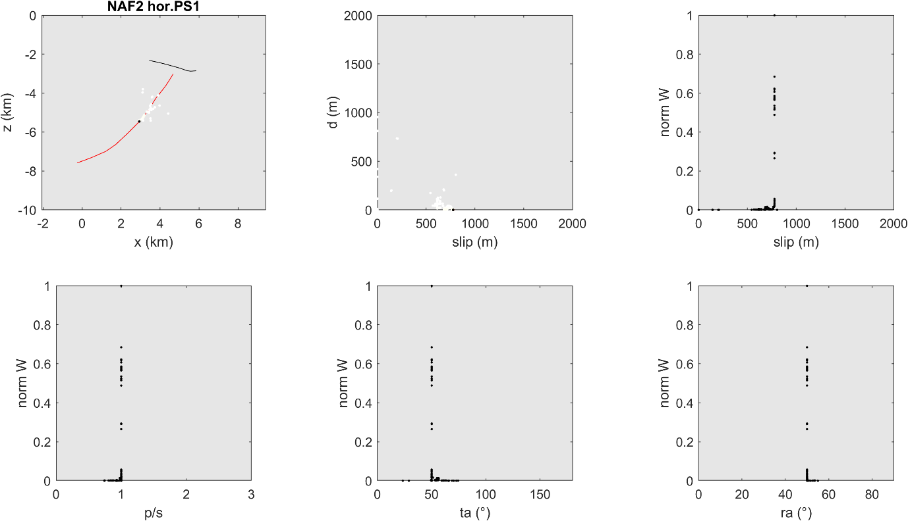

k
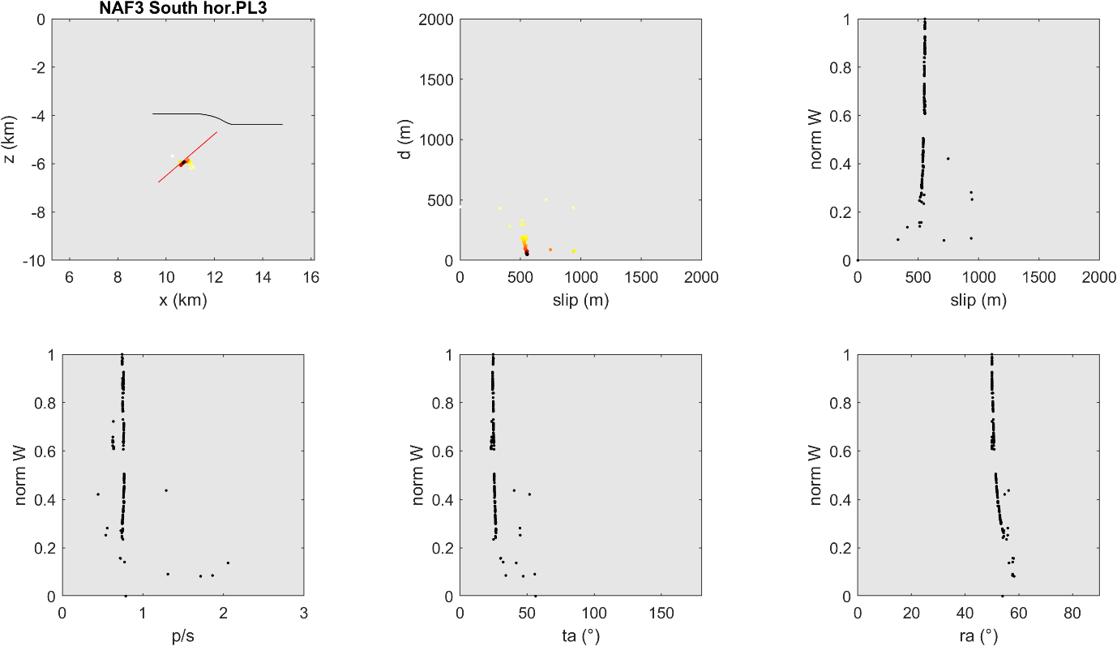
l
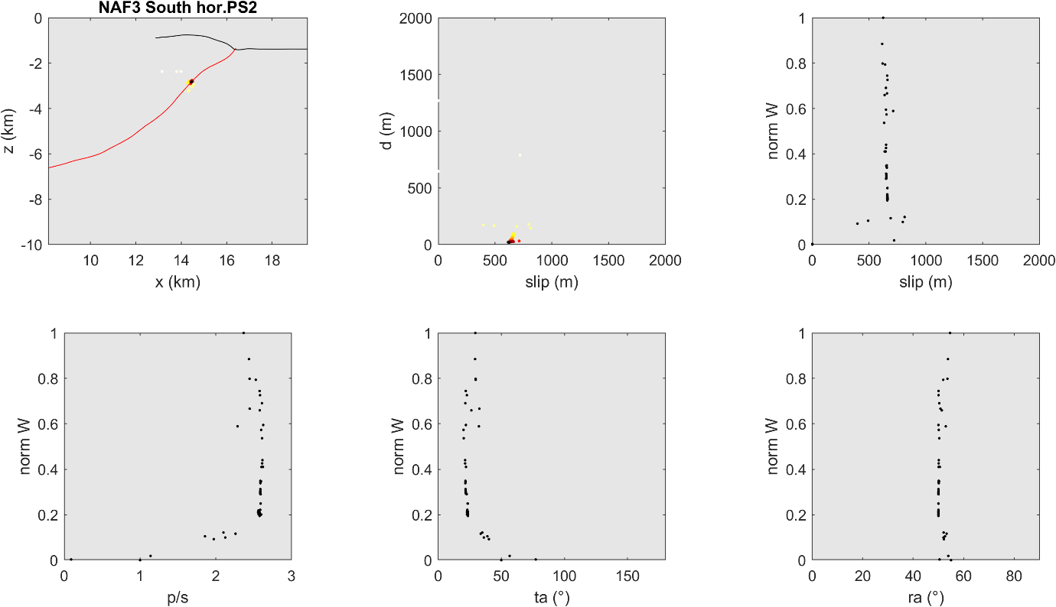

m
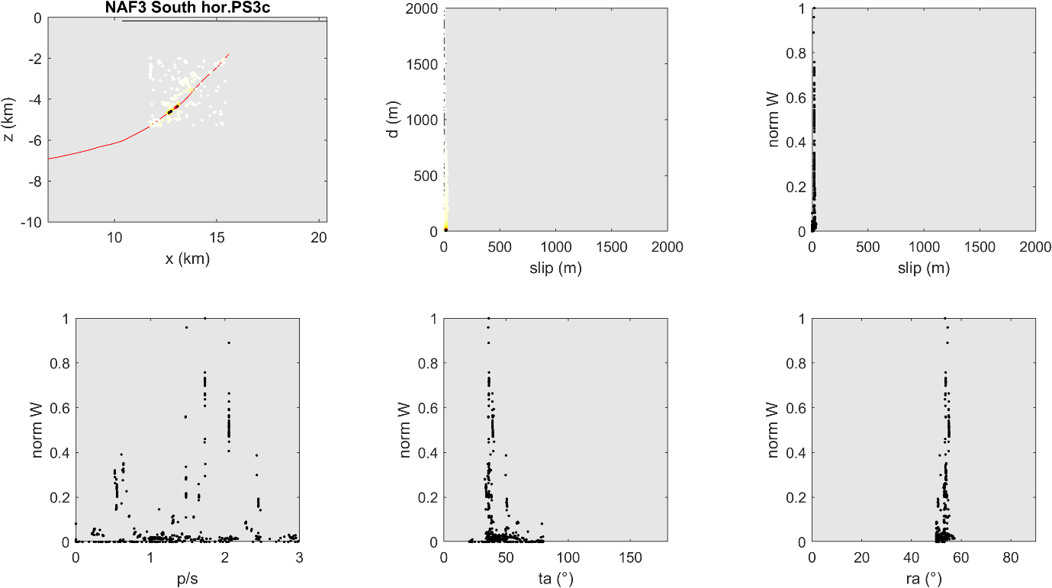

Supplementary Figure 4.
(a-m) Plots of trishear inversion for Southern Section. Legend: d (m): distance from fault; norm W: normalized weight (1-fval)*(1/d); fval is the normalized value of the regression function (Cardozo et al., 2011); p/s: ratio of fault propagation (p) versus slip on fault (s); ta (°): trishear angle; ra (°): ramp dip angle.

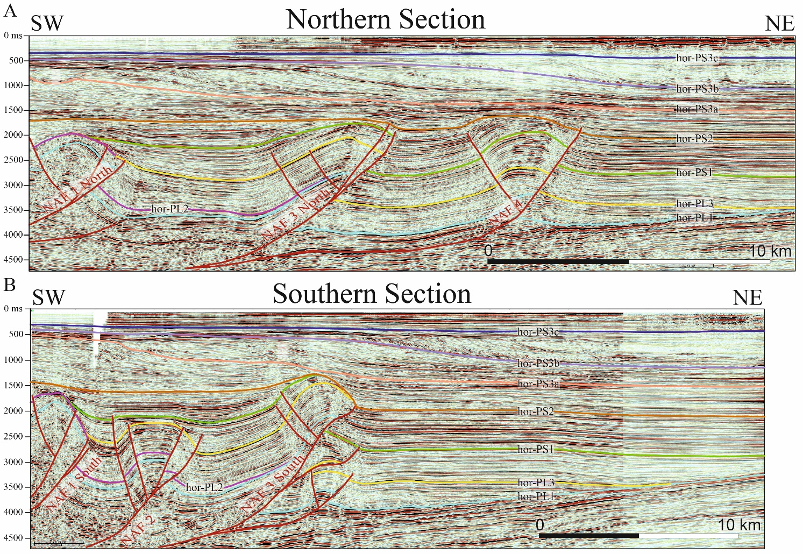
Supplementary Figure 5.
Seismic reflection profiles (see Figure 1 of the paper for location) adopting the interpretation by Ghielmi et al., 2013. (A) Northern Section; (B) Southern Section.

References (for Supplementary Material only)
Benedetti, L. C., Tapponnier, P., Gaudemer, Y., Manighetti, I., and Van der Woerd, J. (2003). Geomorphic evidence for an emergent active thrust along the edge of the Po Plain: The Broni-Stradella fault. J. Geophys. Res. Solid Earth 108. doi:10.1029/2001jb001546.
Benedetti, L., Tapponnier, P., King, G. C. P., Meyer, B., and Manighetti, I. (2000). Growth folding and active thrusting in the Montello region, Veneto, northern Italy. J. Geophys. Res. Solid Earth 105, 739–766. doi:10.1029/1999jb900222.
Boccaletti, M., Corti, G., and Martelli, L. (2011). Recent and active tectonics of the external zone of the Northern Apennines (Italy). Int. J. Earth Sci. 100, 1331–1348. doi:10.1007/s00531-010-0545-y.
Bresciani, I., and Perotti, C. R. (2014). An active deformation structure in the Po Plain (N Italy): The Romanengo anticline. Tectonics 33, 2059–2076. doi:10.1002/2013TC003422.
Bruno, P. P. G., Pazzaglia, F. J., and Picotti, V. (2011). Evidence for active folding and faulting at the northern Apennines mountain front near Bologna, Italy from high resolution seismic reflection profiling. Geophys. Res. Lett. 38. doi:10.1029/2011GL047828.
Cardozo, N., Jackson, C.A.-L., Whipp, P.S. (2011) Determining the uniqueness of best-fit trishear models. Journal of Structural Geology, 33(6), 1063-1078, doi:10.1016/j.jsg.2011.04.001.
D’Agostino, N., Cheloni, D., Mantenuto, S., Selvaggi, G., Michelini, A., and Zuliani, D. (2005). Strain accumulation in the southern Alps (NE Italy) and deformation at the northeastern boundary of Adria observed by CGPS measurements. Geophys. Res. Lett. 32, 1–4. doi:10.1029/2005GL024266.
Gunderson, K. L., Anastasio, D. J., Pazzaglia, F. J., and Picotti, V. (2013). Fault slip rate variability on 104-105yr timescales for the Salsomaggiore blind thrust fault, Northern Apennines, Italy. Tectonophysics 608, 356–365. doi:10.1016/j.tecto.2013.09.018.
Livio, F., Michetti, A. M., Sileo, G., Carcano, C., Mueller, K., Rogledi, S., et al. (2009). Quaternary capable folds and seismic hazard in lombardia (Northern Italy): The castenedolo structure near brescia. Boll. della Soc. Geol. Ital. 128, 191–200.
Livio, F. A., Berlusconi, A., Michetti, A. M., Sileo, G., Zerboni, A., Trombino, L., et al. (2009). Active fault-related folding in the epicentral area of the December 25, 1222 (Io=IX MCS) Brescia earthquake (Northern Italy): Seismotectonic implications. Tectonophysics 476, 320–335. doi:10.1016/j.tecto.2009.03.019.
Maesano, F. E., and D’Ambrogi, C. (2016). Coupling sedimentation and tectonic control: Pleistocene evolution of the central Po Basin. Ital. J. Geosci. 135, 394–407. doi:10.3301/IJG.2015.17.
Maesano, F. E., D’Ambrogi, C., Burrato, P., and Toscani, G. (2015). Slip-rates of blind thrusts in slow deforming areas: Examples from the Po Plain (Italy). Tectonophysics 643, 8–25. doi:10.1016/j.tecto.2014.12.007.
Maesano, F. E., Toscani, G., Burrato, P., Mirabella, F., D’Ambrogi, C., and Basili, R. (2013). Deriving thrust fault slip rates from geological modeling: Examples from the Marche coastal and offshore contraction belt, Northern Apennines, Italy. Mar. Pet. Geol. 42, 122–134. doi:10.1016/j.marpetgeo.2012.10.008.
Michetti, A. M., Giardina, F., Livio, F., Mueller, K., Serva, L., Sileo, G., et al. (2012). Active compressional tectonics, quaternary capable faults, and the seismic landscape of the po plain (northern Italy). Ann. Geophys. 55, 969–1001. doi:10.4401/ag-5462.
Ponza, A., Pazzaglia, F. J., and Picotti, V. (2010). Thrust-fold activity at the mountain front of the Northern Apennines (Italy) from quantitative landscape analysis. Geomorphology 123, 211–231. doi:10.1016/j.geomorph.2010.06.008.
Scrocca, D., Carminati, E., Doglioni, C., and Marcantoni, D. (2007). “Slab Retreat and Active Shortening along the Central-Northern Apennines,” in, 471–487. doi:10.1007/978-3-540-69426-7_25.
Sileo, G., Giardina, F., Livio, F., Michetti, A. M., Mueller, K., and Vittori, E. (2007). Remarks on the Quaternary tectonics of the Insubria Region (Lombardia, NW Italy, and Ticino, SE Switzerland). in Bollettino della Societa Geologica Italiana, 411–425.
Vannoli, P., Basili, R., and Valensise, G. (2004). New geomorphic evidence for anticlinal growth driven by blind-thrust faulting along the northern Marche coastal belt (central Italy). J. Seismol. 8, 297–312. doi:10.1023/B:JOSE.0000038456.00574.e3.
Wegmann, K. W., and Pazzaglia, F. J. (2009). Late Quaternary fluvial terraces of the Romagna and Marche Apennines, Italy: Climatic, lithologic, and tectonic controls on terrace genesis in an active orogen. Quat. Sci. Rev. 28, 137–165. doi:10.1016/j.quascirev.2008.10.006.
Wilson, L. F., Pazzaglia, F. J., and Anastasio, D. J. (2009). A Fluvial record of active fault-propagation folding, salsomaggiore anticline, northern Apennines, Italy. J. Geophys. Res. Solid Earth 114. doi:10.1029/2008JB005984.
Zechar, J. D., and Frankel, K. L. (2009). Incorporating and reporting uncertainties in fault slip rates. J. Geophys. Res. Solid Earth 114. doi:10.1029/2009JB006325.

