SUPPLEMENTARY MATERIAL
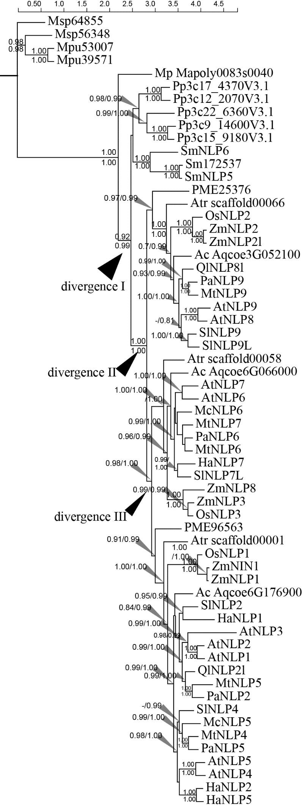
Supplementary Figure 1. Phylogram of Green plant NLP genes. Numbers along branches are BI and ML approximate likelihood value (aLRT). (-) indicates branch support value lower than 0.7 either obtaining from BI or aLRT algorithm. Sequences codes are identical to corresponding species declared in Figure 2.

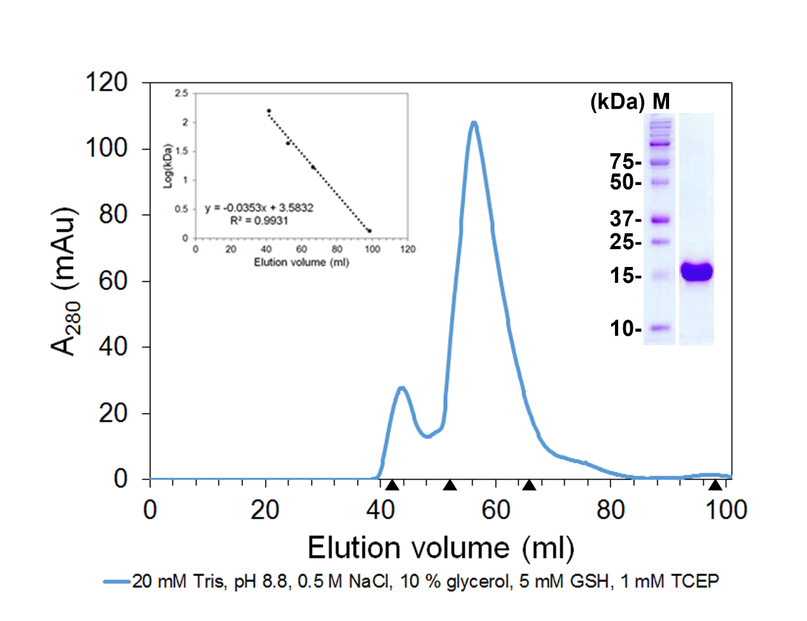
Supplementary Figure 2. SDS-PAGE of purified 6xHis-tagged NLP7 PB1 domain. SDS-PAGE reveals that the molecular weight of purified 6xHis-tagged NLP7 PB1 domain is 15.6 kDa.

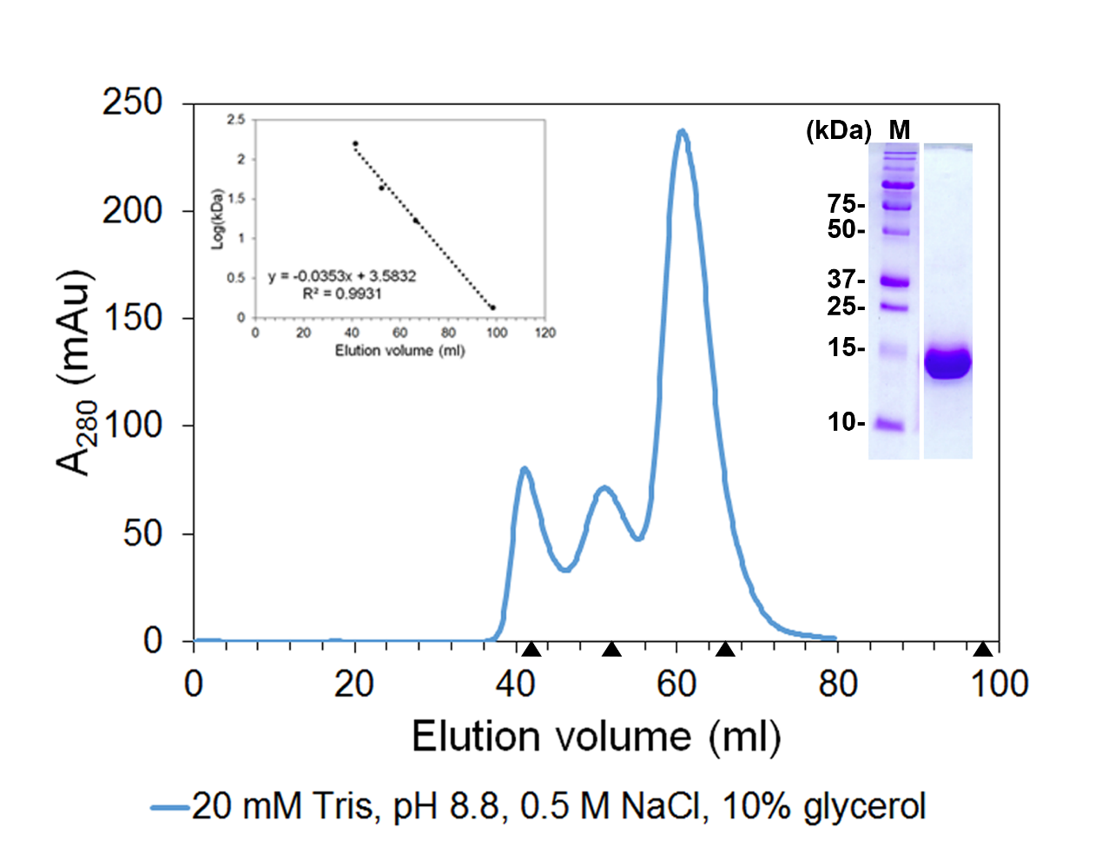
Supplementary Figure 3. SDS-PAGE of purified 6xHis-tagged NLP7 PB1m1 domain. SDS-PAGE reveals that the molecular weight of purified 6xHis-tagged NLP7 PB1m1 domain is 15.6 kDa.

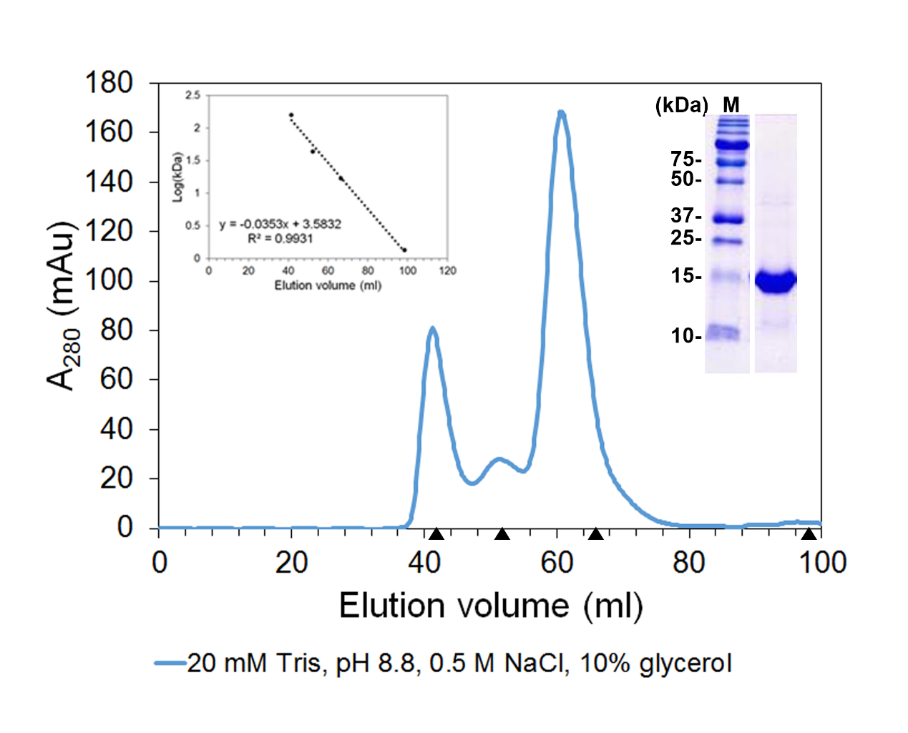
Supplementary Figure 4. SDS-PAGE of purified 6xHis-tagged NLP7 PB1m2 domain. SDS-PAGE reveals that the molecular weight of purified 6xHis-tagged NLP7 PB1m2 domain is 15.6 kDa.

