A
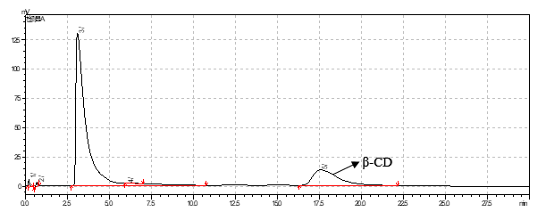
B
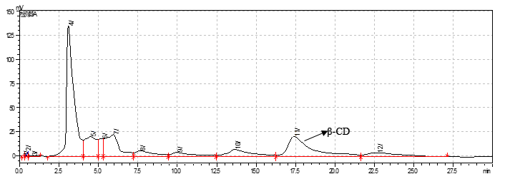
C
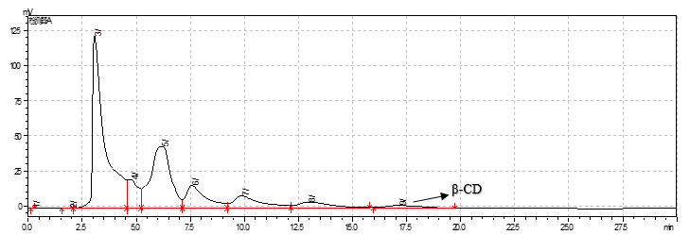
Fjgure 1: Detection of β – CD. (A): Analysis of β-CD standard by HPLC; (B): HPLC analysis of β-CD for 2 h reaction; (C): HPLC analysis of β-CD for 24 h reaction.

