Supplementary Figure 1. Community Stakeholder Engagement Adaptation Feedback Form: (A) cover page with instructions to document stakeholder demographics, summary of adaptation recommendations, and documentation of Adaptation Team’s review and approval of modifications; and collection pages 2-4 documenting stakeholder responses and adaptation recommendations to open-ended questions for (B) clarity, (C) feasibility and acceptability, (D) barriers to understanding the manuals, and (E) barriers to delivering the group sessions.

(A)
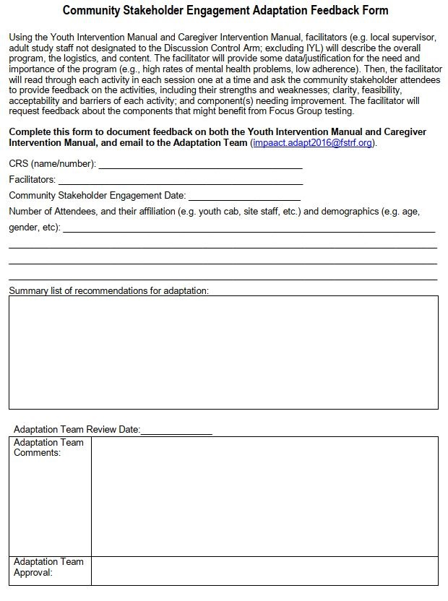

(B)
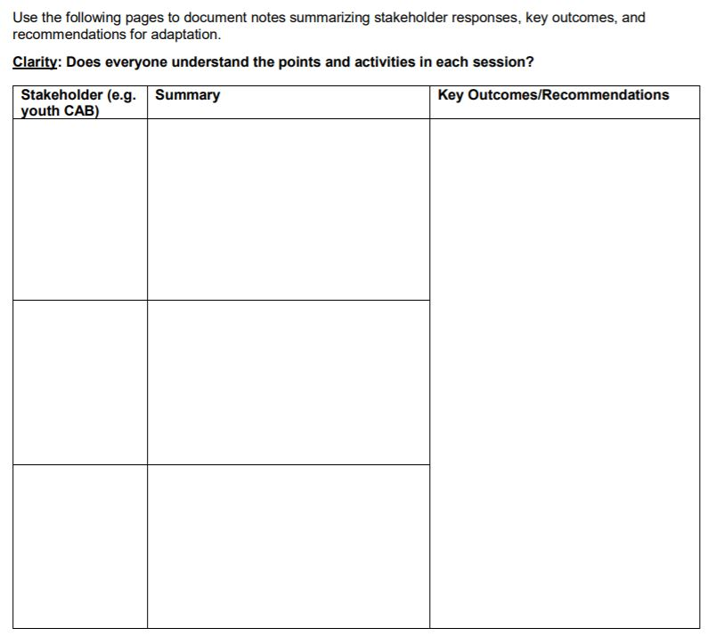

(C)
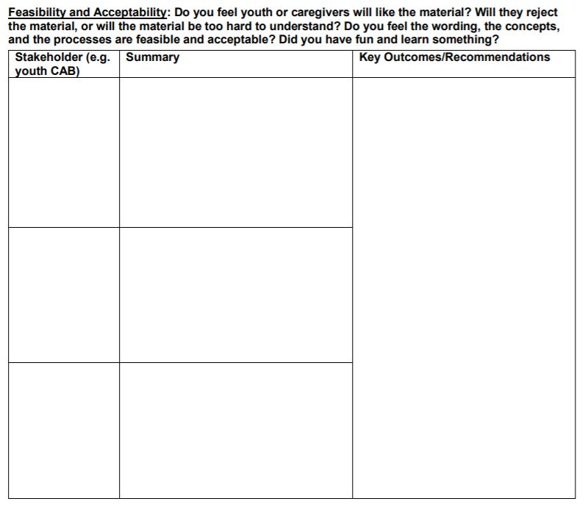

(D)
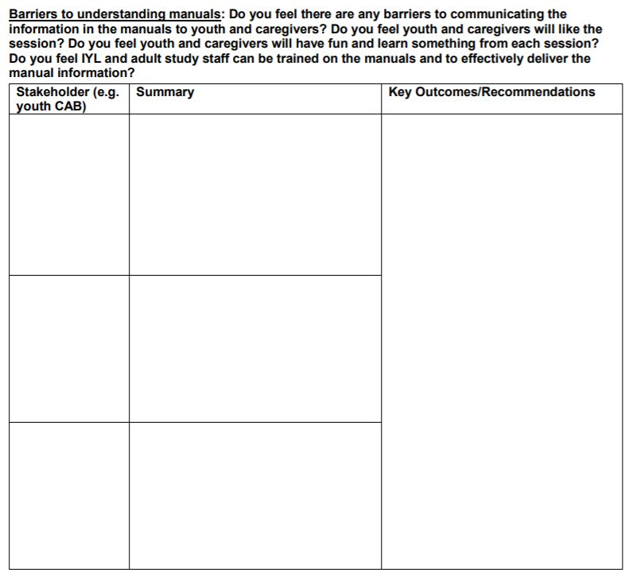

(E)
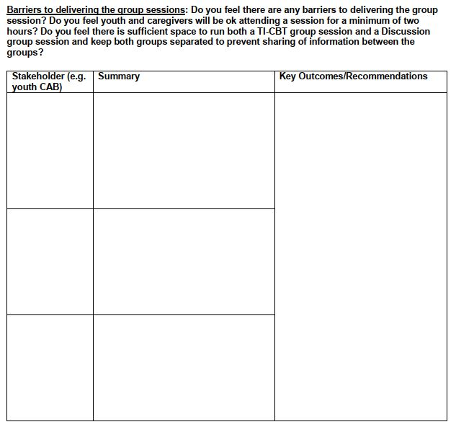

Supplementary Figure 2. Focus Group Adaptation Feedback Form: (A) cover page providing facilitators instructions and documenting stakeholder demographics, summary of adaptation recommendations, and documentation of Adaptation Team’s review and approval of modifications; and collection pages 2-3 documenting youth or caregiver responses and adaptation recommendations to open-ended questions for (B) acceptability and relevance and (C) other questions facilitators may have depending on the session delivered to participants.
(A)
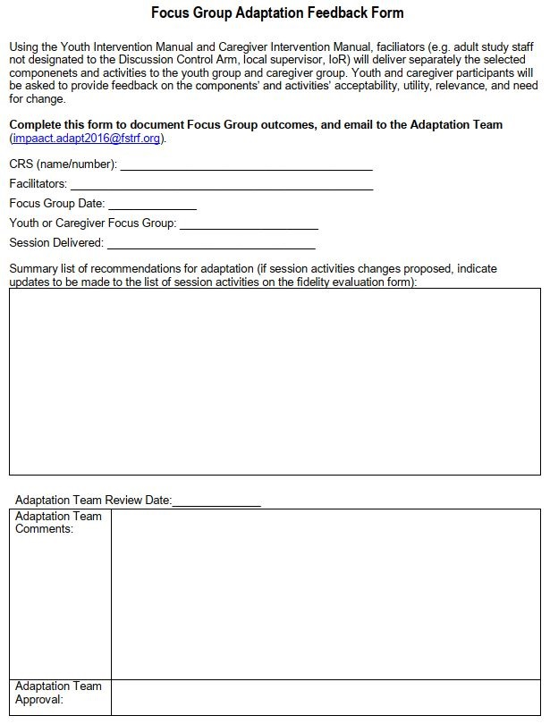

(B)
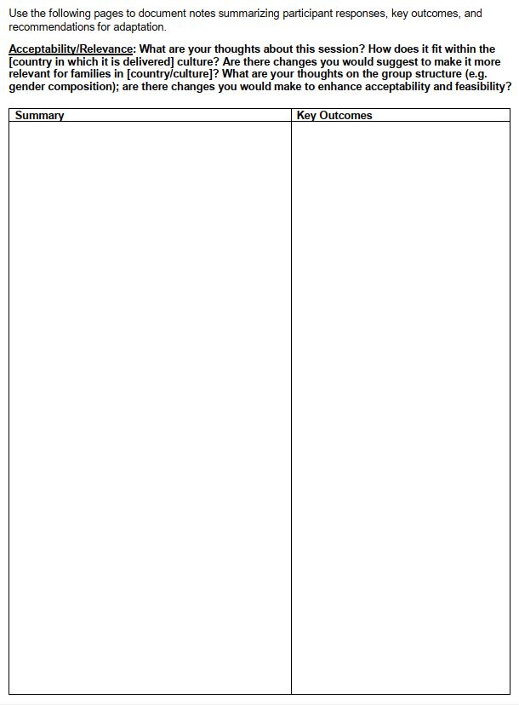

(C)

