Characterization and mapping of spot blotch in Triticum durum - Aegilopes speltoides introgression lines using SNP markers

Jashanpreet Kaur¹*, Jaspal Kaur², Guriqbal Singh Dhillon³, Harmandeep Kaur², Jasvir Singh², Ritu Bala², Puja Srivastava², Satinder Kaur³, Achla Sharma², Parveen Chhuneja³

- Department of Plant Pathology, Punjab Agricultural University, Ludhiana, India
- Department of Plant Breeding and Genetics, Punjab Agricultural University, Ludhiana,
- School of Agricultural Biotechnology, Punjab Agricultural University, Ludhiana, India

*Corresponding author email: jashanpreet-coa@pau.edu
Orcid ID
GSD: 0000-0001-6766-810X
SK: 0000-0003-3704-3074
PC: 0000-0002-8599-9479
JK: 0000-0002-5628-7325

Supplementary Tables
Table S1: Double digit scale (00-99) used for phenotyping germplasm against spot blotch of wheat (Eyal et al 1987)

Code | Scale for severity of infection
0 | No blight
1 | Up to 10 % leaf area blighted
2 | 11-20 %
3 | 21-30 %
4 | 31-40 %
5 | 41-50 %
6 | 51-60 %
7 | 61-70 %
8 | 71-80 %
9 | >80 % leaf area blighted

Table S2: Phenotypic evaluation for spot blotch disease severity of DSBILs along with recurrent parent (RP) and susceptible check across different environments
Env | Stage | RP | Check | Population
 |  | PDW274 | Raj4015 | Range | Median | Mean | Std.Dev | CV | Skewness | Kurtosis
BLUEs | FS | 14.50 | 38.00 | 0.25-39.00 | 11.25 | 12.71 | 8.42 | 0.66 | 0.96 | 0.54
 | DS | 62.00 | 70.25 | 8.75-70.50 | 42.50 | 41.02 | 13.83 | 0.34 | -0.20 | -0.86
 | HDS | 77.75 | 89.00 | 35.00-83.75 | 72.25 | 69.17 | 10.76 | 0.16 | -1.07 | 0.93
 | AUDPC | 1081.25 | 1337.50 | 302.50-1228.75 | 828.75 | 819.55 | 213.24 | 0.26 | -0.23 | -0.73
BLUPs | FS | 13.61 | 24.20 | 7.18-24.65 | 12.14 | 12.81 | 3.79 | 0.30 | 0.96 | 0.56
 | DS | 52.92 | 57.58 | 22.82-57.73 | 41.90 | 41.09 | 7.76 | 0.19 | -0.21 | -0.83
 | HDS | 75.00 | 82.81 | 45.32-79.17 | 71.18 | 69.06 | 7.43 | 0.11 | -1.09 | 1.01
 | AUDPC | 985.25 | 1147.62 | 491.81-1078.71 | 825.26 | 819.86 | 134.52 | 0.16 | -0.24 | -0.70
E1 | FS | 11 | 35 | 00-33 | 1 | 5.63 | 5.96 | 1.06 | 1.15 | 2.60
 | DS | 55 | 57 | 00-68 | 24 | 28.99 | 17.45 | 0.60 | 0.54 | -0.64
 | HDS | 55 | 89 | 00-89 | 47 | 43.75 | 20.83 | 0.48 | -0.40 | -0.93
 | AUDPC | 880 | 1190 | 0-1175 | 530 | 536.80 | 269.56 | 0.50 | 0.32 | -0.49
E2 | FS | 12 | 23 | 00-35 | 1 | 5.92 | 8.68 | 1.47 | 1.45 | 1.40
 | DS | 67 | 78 | 11-78 | 35 | 37.28 | 20.39 | 0.55 | 0.36 | -0.94
 | HDS | 89 | 99 | 37-89 | 89 | 83.74 | 8.23 | 0.10 | -2.44 | 9.73
 | AUDPC | 1175 | 1390 | 445-1400 | 795 | 821.12 | 259.35 | 0.32 | 0.40 | -0.83
E3 | FS | 13 | 37 | 00-48 | 12 | 21.25 | 21.27 | 1.00 | 1.36 | 0.95
 | DS | 47 | 68 | 01-78 | 57 | 50.97 | 25.27 | 0.50 | -0.29 | -1.45
 | HDS | 78 | 79 | 11-99 | 78 | 72.43 | 17.49 | 0.24 | -1.49 | 1.97
 | AUDPC | 925 | 1260 | 135-1665 | 970 | 981.46 | 396.99 | 0.40 | -0.16 | -1.04
E4 | FS | 22 | 57 | 00-57 | 13 | 17.99 | 15.14 | 0.84 | 0.88 | -0.10
 | DS | 79 | 78 | 04-89 | 47 | 46.52 | 23.12 | 0.50 | -0.11 | -1.26
 | HDS | 89 | 89 | 16-99 | 79 | 76.96 | 16.14 | 0.21 | -1.31 | 1.80
 | AUDPC | 1345 | 1510 | 210-1655 | 980 | 941.52 | 357.82 | 0.38 | -0.11 | -0.95
# Standard deviation (Std.Dev), co-efficient of variation (CV), Skewness (Skew.), kurtosis (Kurt.), best linear unbiased predictions (BLUPs), best linear unbiased estimates (BLUEs), environment 1/season 2016-17 (E1), environment 2/season 2017-18 (E2), environment 3/season 2018-19 (E3), environment 3/season 2019-20 (E4), flowering stage (FS), dough stage (DS), hard dough stage (HDS), area under disease progression curve (AUDPC)
## Donor parent Aegilops speltoides (#pau3809) showed score 00 across all stages.

Table S3: QTLs along with SNPs and corresponding proteins and functional gene annotation elucidated based on the high confidence genes from wheat reference sequence (RefSeq V1.0) annotation database.
QTL | SNP | Chr | GeneID | Dist. (in kb) | Gene Annotation
Q.Sb.pau-2A | S2A_755774702 | 2A | TraesCS2A01G546600 | 439.059 | Cytochrome P450 family protein, expressed
 |  |  | TraesCS2A01G546700 | 435.192 | Cysteine proteinase
 |  |  | TraesCS2A01G546800 | 418.04 | Zinc finger MYM-type-like protein
 |  |  | TraesCS2A01G546900 | 411.553 | Phytol kinase
 |  |  | TraesCS2A01G547000 | 409.541 | Exostosin family protein
 |  |  | TraesCS2A01G547100 | 317.21 | RNA-directed DNA polymerase (reverse transcriptase)-related family protein
 |  |  | TraesCS2A01G547200 | 295.145 | ATP synthase subunit alpha
 |  |  | TraesCS2A01G547300 | 95.506 | Polyadenylate-binding protein 1-B-binding protein
 |  |  | TraesCS2A01G547400 | 81.978 | FBD, F-box and Leucine Rich Repeat domains containing protein
 |  |  | TraesCS2A01G547500 | 71.745 | Serine/threonine-protein kinase
 |  |  | TraesCS2A01G547600 | 37.854 | Cytochrome P450, putative
 |  |  | TraesCS2A01G547700 | 33.721 | Peptidyl-tRNA hydrolase
 |  |  | TraesCS2A01G547800 | 5.678 | Auxin response factor
 |  |  | TraesCS2A01G547900 | -11.024 | Zinc finger CCCH domain-containing protein 32
 |  |  | TraesCS2A01G548000 | -15.993 | Phosphoribosylformylglycinamidine synthase subunit PurQ
 |  |  | TraesCS2A01G548100 | -152.331 | Amine oxidase family protein
 |  |  | TraesCS2A01G548200 | -199.456 | Amine oxidase family protein
 |  |  | TraesCS2A01G548300 | -204.738 | Adenylate kinase
 |  |  | TraesCS2A01G548400 | -225.895 | DUF594 family protein
 |  |  | TraesCS2A01G548500 | -253.227 | Alpha-glucosidase
 |  |  | TraesCS2A01G548600 | -282.781 | Alpha-glucosidase
 |  |  | TraesCS2A01G548700 | -356.782 | Alpha-glucosidase
 |  |  | TraesCS2A01G548800 | -390.864 | Gag-Pol polyprotein
Q.Sb.pau-2B | S2B_673595704 | 2B | TraesCS2B01G476400 | 425.139 | senescence-associated family protein (DUF581)
 |  |  | TraesCS2B01G476500 | 353.761 | senescence-associated family protein (DUF581)
 |  |  | TraesCS2B01G476600 | -32.658 | senescence-associated family protein (DUF581)
 |  |  | TraesCS2B01G476700 | -112.168 | senescence-associated family protein (DUF581)
 |  |  | TraesCS2B01G476800 | -115.776 | senescence-associated family protein (DUF581)
 |  |  | TraesCS2B01G476900 | -329.07 | senescence-associated family protein (DUF581)
 |  |  | TraesCS2B01G477000 | -363.566 | zinc finger matrin-type protein
 |  |  | TraesCS2B01G477100 | -431.149 | Glycosyltransferase
 |  |  | TraesCS2B01G477200 | -434.456 | Nucleolar complex protein 4-like protein
 |  |  | TraesCS2B01G477300 | -442.486 | Glutamate receptor
Q.Sb.pau-3B | S3B_104700839 | 3B | TraesCS3B01G127000 | 375.807 | Protein FAR1-RELATED SEQUENCE 3
 |  |  | TraesCS3B01G127100 | -269.633 | IQ domain-containing protein
Q.Sb.pau-5B | S5B_703858864 | 5B | TraesCS5B01G553200 | 370.394 | F-box family protein
 |  |  | TraesCS5B01G553300 | 361.335 | F-box domain containing protein
 |  |  | TraesCS5B01G553400 | 358.507 | F-box and associated interaction domains-containing protein
 |  |  | TraesCS5B01G553500 | 329.318 | F-box domain containing protein, expressed
 |  |  | TraesCS5B01G553600 | 304.847 | DNA topoisomerase
 |  |  | TraesCS5B01G553700 | 214.322 | F-box family protein
 |  |  | TraesCS5B01G553800 | 75.682 | Phytoene synthase, chloroplastic
 |  |  | TraesCS5B01G553900 | 1.689 | F-box family protein
 |  |  | TraesCS5B01G554000 | -214.708 | ATP-dependent Clp protease ATP-binding subunit
 |  |  | TraesCS5B01G554100 | -232.54 | F-box family protein
 |  |  | TraesCS5B01G554200 | -250.728 | Disease resistance protein RPM1
 |  |  | TraesCS5B01G554300 | -276.34 | Disease resistance protein (NBS-LRR class) family
 |  |  | TraesCS5B01G554400 | -308.147 | Protein BCCIP homolog
 |  |  | TraesCS5B01G554500 | -368.461 | AIG2-like (Avirulence induced gene) family protein
 |  |  | TraesCS5B01G554600 | -380.912 | ADP-ribosylation factor GTPase-activating protein
 |  |  | TraesCS5B01G554700 | -417.622 | 30S ribosomal protein S9
 |  |  | TraesCS5B01G554800 | -435.991 | Polynucleotidyl transferase, ribonuclease H-like superfamily protein
 |  |  | TraesCS5B01G554900 | -442.454 | Protein kinase
 |  |  | TraesCS5B01G555000 | -451.294 | Protein kinase
Q.Sb.pau-6A | S6A_131743987 | 6A | TraesCS6A01G149400 | 300.685 | Tubby protein, putative
 |  |  | TraesCS6A01G149500 | 297.87 | Ubiquitin family protein
 |  |  | TraesCS6A01G149600 | -436.076 | Uricase
# Distance from SNP (dist.) represent distance of start site of gene to SNP linked with QTL, where (+) sign represent that gene was found downstream of the SNP and (–) sign represent that gene was found upstream

Table S4: Primer sequences of SNP markers for validation in wheat lines by KASP assay.

QTL | SNP | Allele Specific Primer-I (FAM) | Allele Specific Primer-II (HEX) | Common Primer
Q.Sb.pau-2A | S2A_755774702 | GAAGGTGACCAAGTTCATGCT  agcttatcaagacacgttctagatt | GAAGGTCGGAGTCAACGGATT  agcttatcaagacacgttctagatc | tcaattaggcaccgggtacta
Q.Sb.pau-2B | S2B_673595704 | GAAGGTGACCAAGTTCATGCT  cagctcgacgctatctgctcc | GAAGGTCGGAGTCAACGGATT  cagctcgacgctatctgctct | ttcccggagtcttgatgcca
Q.Sb.pau-3B | S3B_104700872 | GAAGGTGACCAAGTTCATGCT  gtcaggccaggagacaca | GAAGGTCGGAGTCAACGGATT  gtcaggccaggagacacg | ctggtccgttccgttccc
Q.Sb.pau-5B | S5B_703858864 | GAAGGTGACCAAGTTCATGCT  gcttaggcacctcaccctc | GAAGGTCGGAGTCAACGGATT  gcttaggcacctcaccctg | cgatcttgagcgaggagtcc
Q.Sb.pau-6A | S6A_131743987 | GAAGGTGACCAAGTTCATGCT  ggtcgcgggttcgaAtcC | GAAGGTCGGAGTCAACGGATT  ggtcgcgggttcgaAtcT | aaaccgccattgagagggac

Supplementary figures
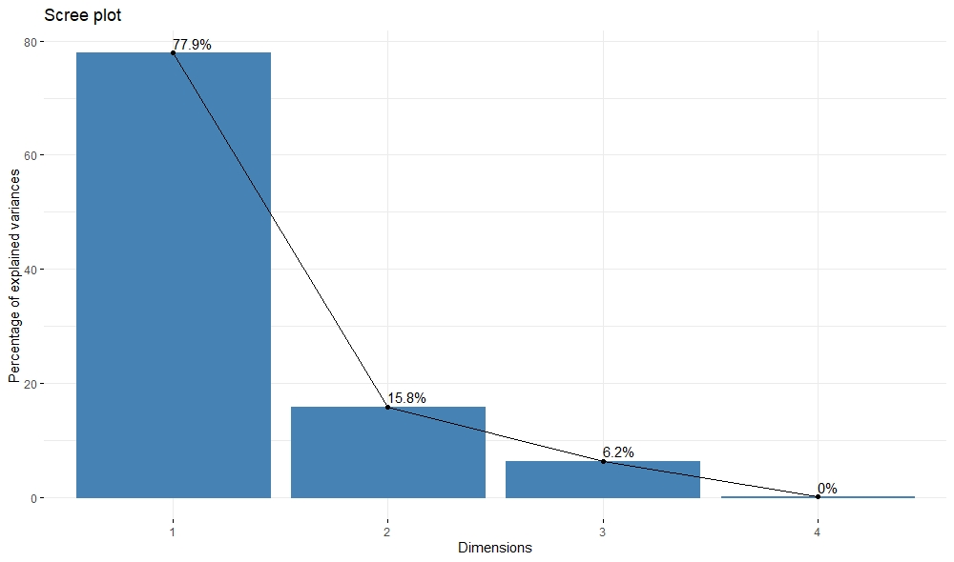
Figure S1: Scree plot for of percentage of variance explained by different dimensions of principal components.

