Supplementary information
4DEMON: integrating 40 years of data on PCB and metal contamination in marine sediments of the Belgian Part of the North Sea.
H.M. Le¹ , K. Bekaert², R. Lagring¹, B. Ampe², A. Ruttens³, K. De Cauwer¹, K. Hostens^{2†}, B. De Witte^{2†*}

¹ Royal Belgian Institute of Natural Sciences, OD Nature, rue Vautier 29, 1000 Brussels, Belgium
² Flanders Research Institute for Agriculture, Fisheries, and Food, Animal Sciences Unit - Aquatic Environment and Quality, Ankerstraat 1, 8400 Ostend, Belgium
³ Sciensano, Unit Trace Elements, Leuvensesteenweg 17, 3080 Tervuren, Belgium
*Corresponding author: bavo.dewitte@ilvo.vlaanderen.be
† These authors share last authorship

- Data collection
Table S1. Overview of projects, period and number of records used for PCB and metal trend analyses in this study (DS1)
 |  | Number of records per grain size class (µm)
Project | Period | 0-37 | 0-63 | 0-500 | 0-2000 | 0-10000
PMPZ | 1971-1975 | 737
MMP_NS | 1978-1983 |  |  |  | 88
MONIT_SED | 1979-2015 |  | 7154 | 84 | 3118
PhD Van Alsenoy | 1987-1988 |  | 157 |  |  | 257
MONIT_Sludge | 2004-2015 |  | 11947

- Normalization
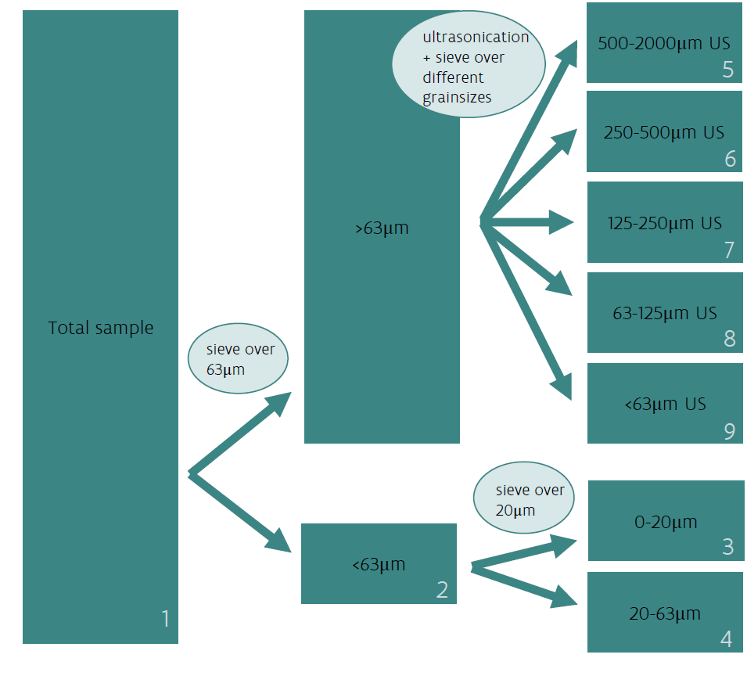Figure S1. Sample fractionation scheme, based on Smedes & Nummerdor (2003)

- Time trend models
All time trend plots for metals and PCBs are provided below. Data points represent the derived concentrations, after normalization. Coloured regression lines represent the fitted time trend within each cluster, scaled to the first quadrimester and to the most recent analytical method. A single regression is visible when there is no significant difference between cluster zones.
(A)  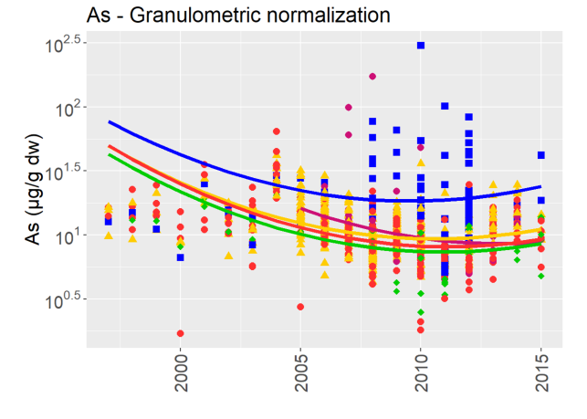 | (B)  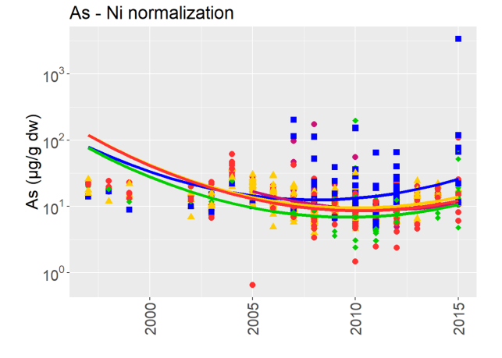
(C)  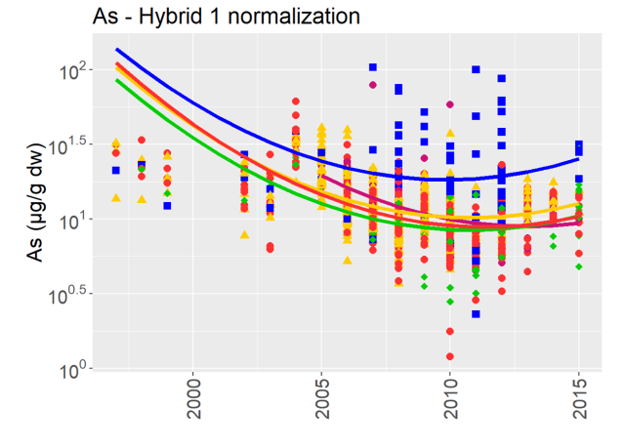 | (D)  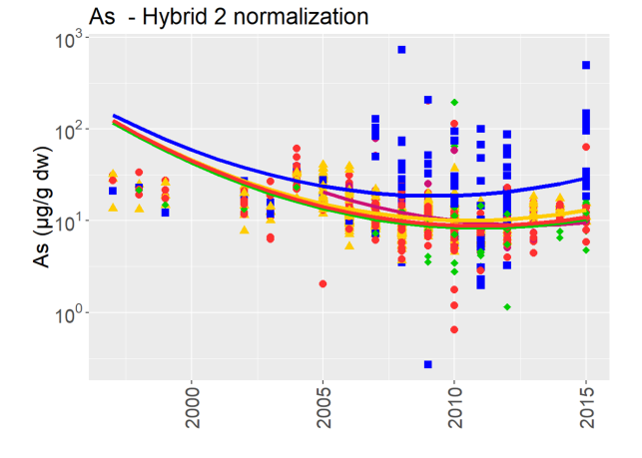
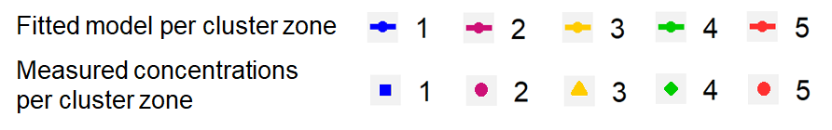
Fig. S2. Trends in As at the BPNS, applying (A) granulometric normalization (<63 µm, 1997-2015)), (B) Ni normalization (1997-2015), (C) Hybrid method 1 (1997-2015) and (D) Hybrid method 2 (1997-2015).

(A)  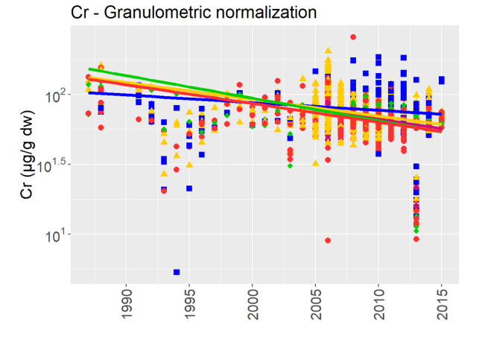 | (B)  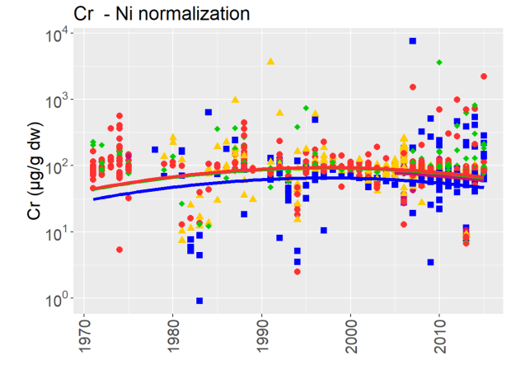
(C)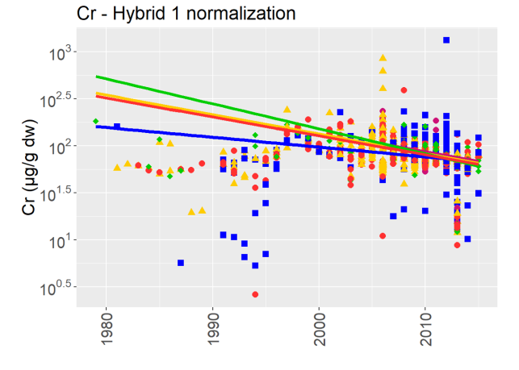 | (D)  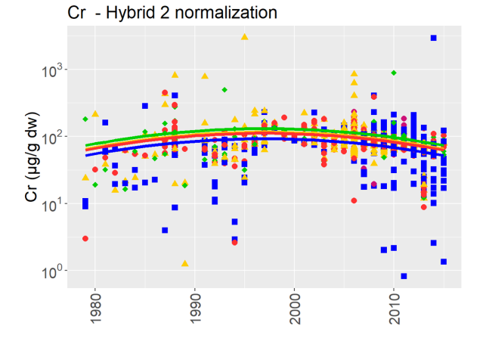
Fig. S3. Trends in Cr at the BPNS, applying (A) granulometric normalization (<63 µm, 1987-2015)), (B) Ni normalization (1971-2015), (C) Hybrid method 1 (1979-2015) and (D) Hybrid method 2 (1979-2015).

(A)  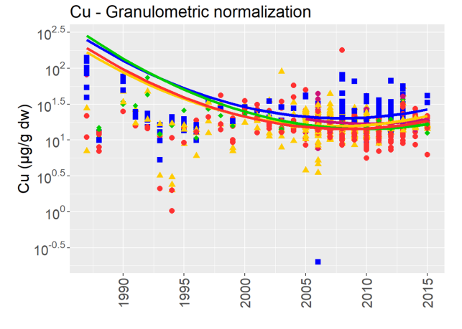 | (B)  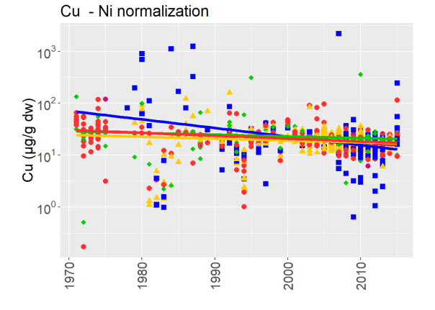
(C)  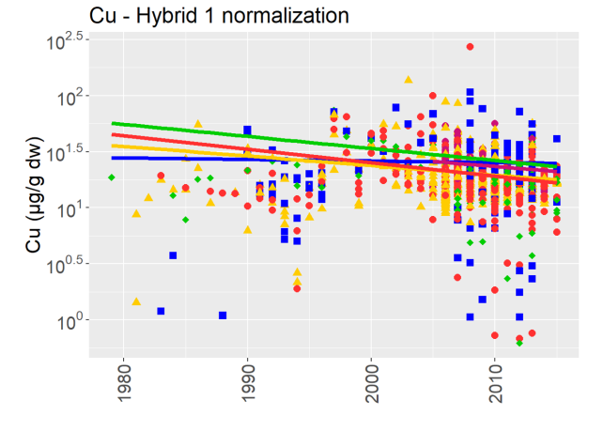 | (D)  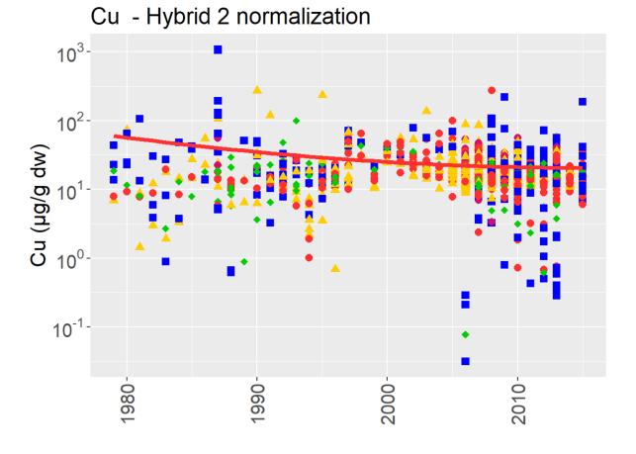
Fig. S4. Trends in Cu at the BPNS, applying (A) granulometric normalization (<63 µm, 1987-2015)), (B) Ni normalization (1971-2015), (C) Hybrid method 1 (1979-2015) and (D) Hybrid method 2 (1979-2015).

(A)  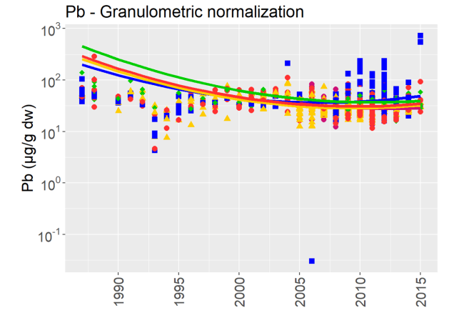 | (B)  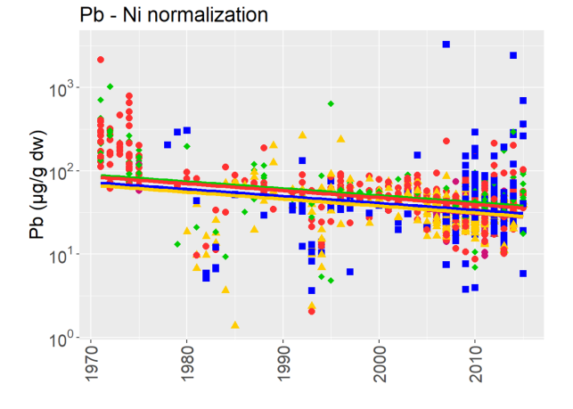
(C)  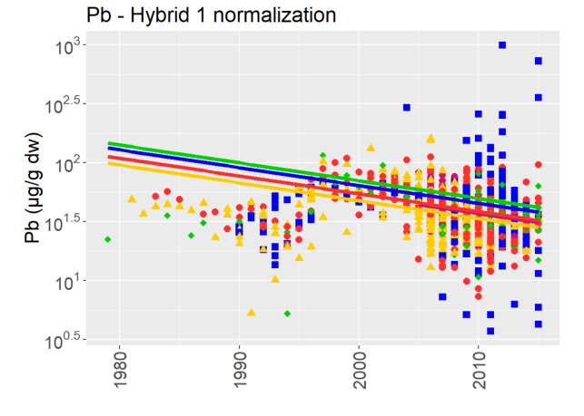 | (D)  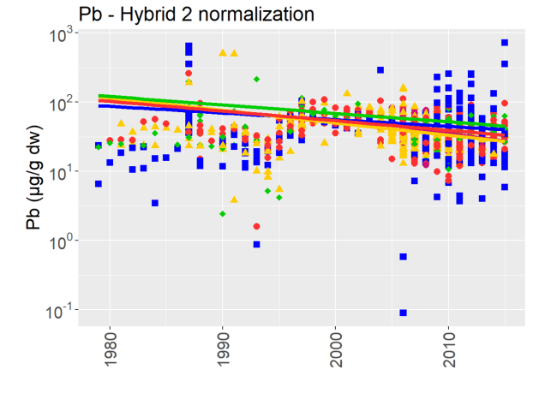
Fig. S5. Trends in Pb at the BPNS, applying (A) granulometric normalization (<63 µm, 1987-2015)), (B) Ni normalization (1971-2015), (C) Hybrid method 1 (1979-2015) and (D) Hybrid method 2 (1979-2015).

(A)  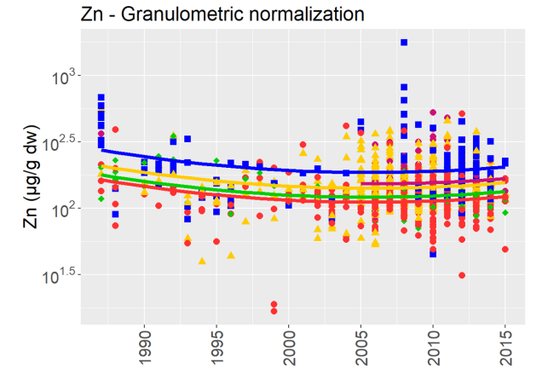 | (B)  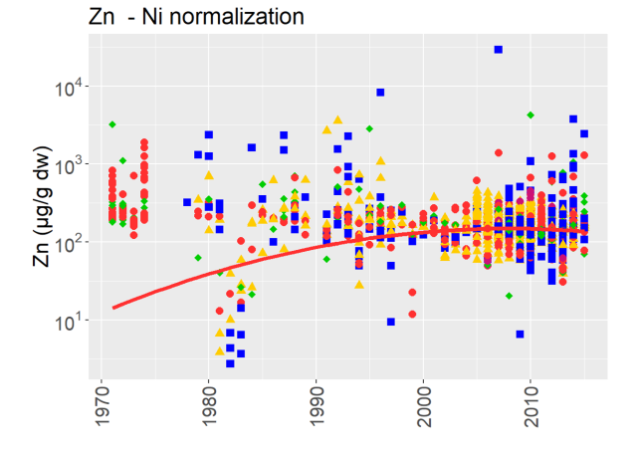
(C)  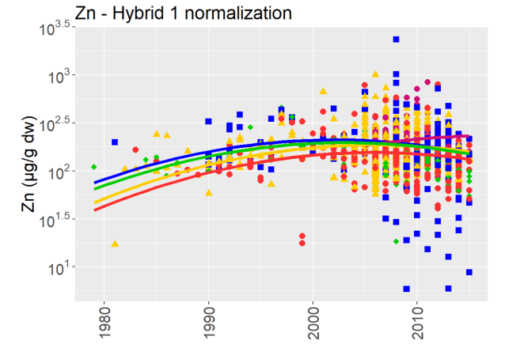 | (D)  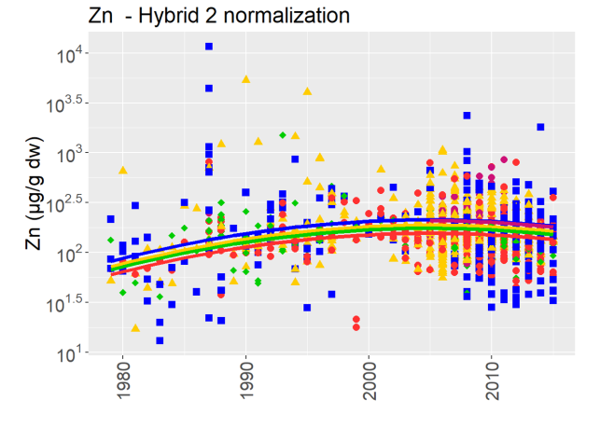
Fig. S6. Trends in Zn at the BPNS, applying (A) granulometric normalization (<63 µm, 1987-2015)), (B) Ni normalization (1971-2015), (C) Hybrid method 1 (1979-2015) and (D) Hybrid method 2 (1979-2015).

(A)  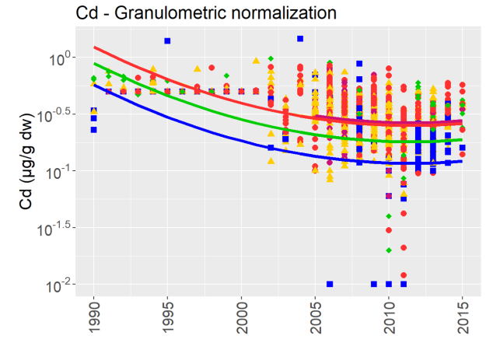 | (B)  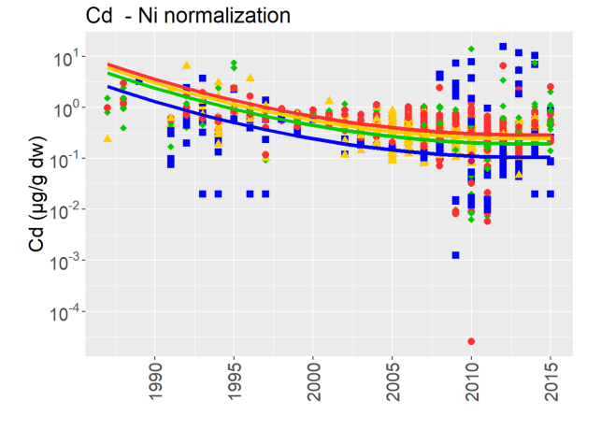
(C)  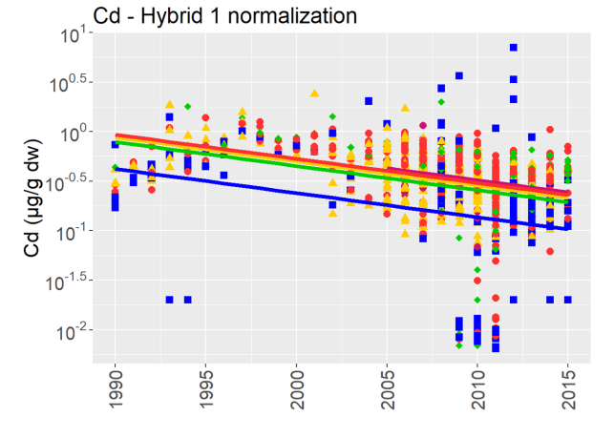 | (D)  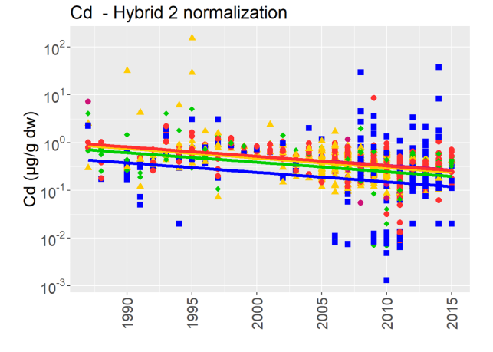
Fig. S7. Trends in Cd at the BPNS, applying (A) granulometric normalization (<63 µm, 1990 – 2015)), (B) Ni normalization (1987-2015), (C) Hybrid method 1 (1990 – 2015) and (D) Hybrid method 2 (1990 – 2015).

(A)  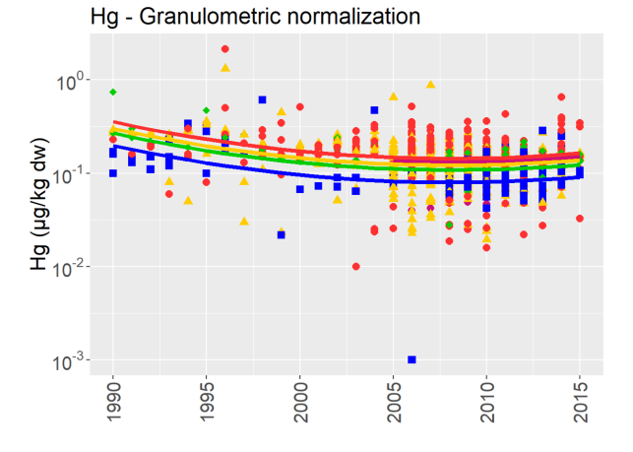 | (B)  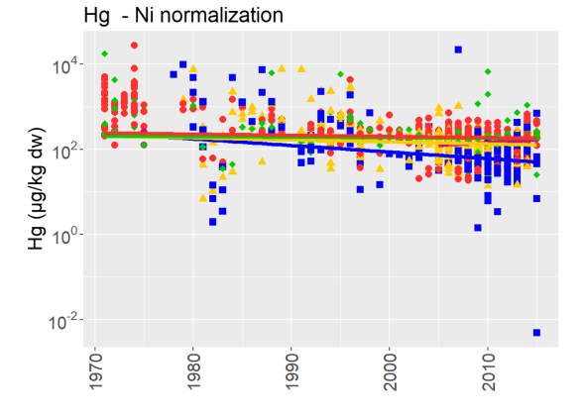
(C)  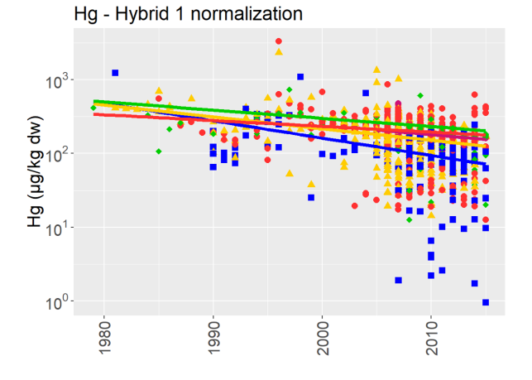 | (D)  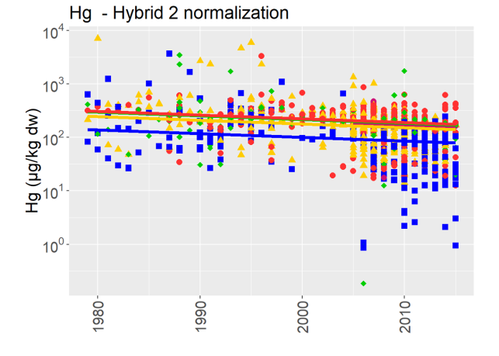
Fig. S8. Trends in Hg at the BPNS, applying (A) granulometric normalization (<63 µm, 1990 – 2015)), (B) Ni normalization (1971 – 2015), (C) Hybrid method 1 (1979 – 2015) and (D) Hybrid method 2 (1979 – 2015).

(A)  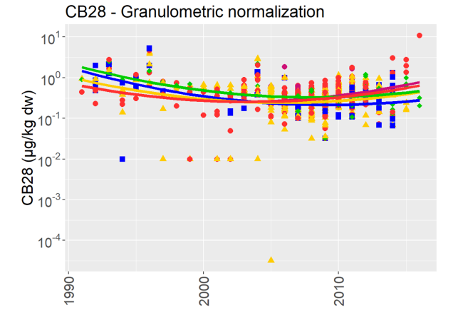 | (B)  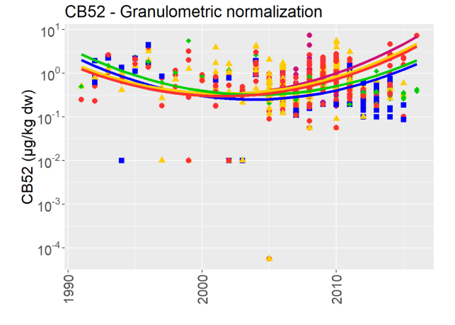
(C)  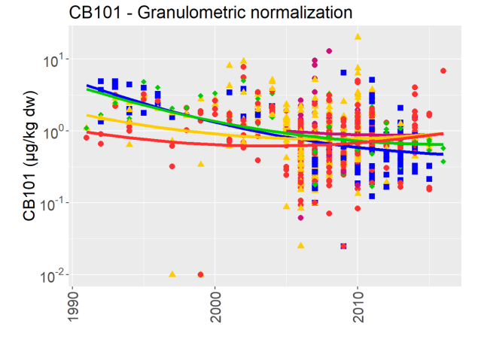 | (D)  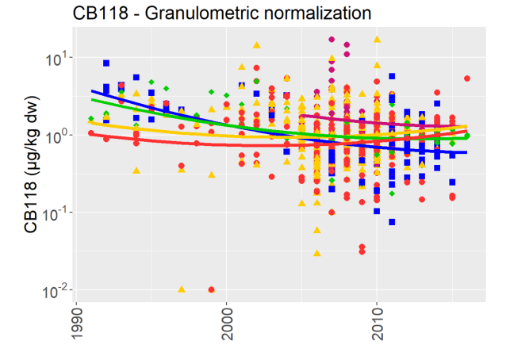
(E)  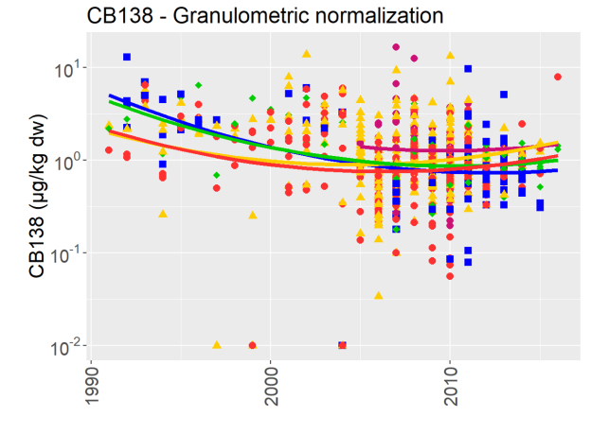 | (F)  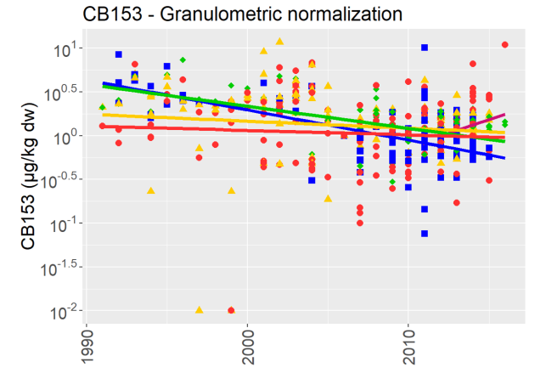
(G)
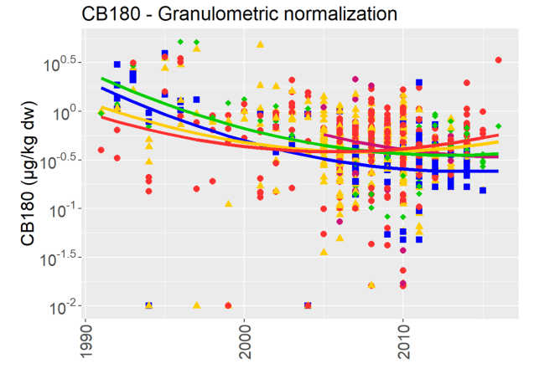
Fig. S9. Trends in PCBs (1991-2016) at the BPNS, granulometric normalization (< 63µm). (A) CB28, (B) CB52, (C) CB101, (D) CB118, (E) CB138, (F) CB153, (G) CB180.

Table S2. Summary of metals and PCBs trend models.
 | Data count | Removed outliers |  | Time effect | Zone effect | Interaction time-zone | Analytical method effect | Season effect
Granulometric
Al | 1129 | 1 | Yes |  | yes - zone 1 higher | Yes | Yes | Yes - season 3 higher
Fe | 1149 | 4 | Yes |  | Yes | Yes | No | Yes - season 3 higher
Ni | 1143 | 0 | Yes |  | Yes | Yes | Yes | No
As | 1009 | 0 | Yes |  | Yes | Yes | Yes | No
Cd | 1124 | 0 | Yes |  | Yes | No | Yes | No
Cr | 1143 | 2 | Yes |  | Yes - zone 1 higher | Yes | Yes | No
Cu | 1131 | 0 | Yes |  | yes - zone 1 lower | Yes | Yes | No
Pb | 1153 | 3 | Yes |  | yes - zone 1 lower | Yes | Yes | No
Zn | 1155 | 0 | Yes |  | Yes | No | No | Yes - season 3 higher
Cd | 1124 | 0 | Yes |  | No | No | Yes | No
Hg | 1124 | 0 | Yes |  | Yes | no | no | no
CB28 | 935 | 0 | Yes |  | Yes | Yes | No | Yes - season 3 higher
CB52¹ | 935 | 0 | No |  | Yes | No | No | Yes - season 3 higher
CB101 | 956 | 0 | Yes |  | Yes | Yes | No | Yes - season 3 higher
CB118 | 969 | 1 | Yes |  | Yes | Yes | No | No
CB138 | 967 | 0 | Yes |  | yes - zone 1 higher | Yes | No | No
CB153 | 450 | 0 | Yes |  | Yes | Yes | Yes | No
CB180 | 952 | 0 | Yes |  | Yes | Yes | No | No
Hybrid 1
As | 994 | 1 | Yes |  | Yes - zone 1 higher | Yes | Yes | Yes - season 3 higher
Cd | 1188 | 0 | Yes |  | yes - zone 1 lower | No | Yes | No
Cr | 1198 | 0 | Yes |  | Yes | Yes | Yes | Yes - season 2 higher
Cu | 1176 | 2 | Yes |  | Yes | Yes | Yes | Yes - season 1 higher
Hg | 1199 | 0 | Yes |  | Yes | Yes | Yes | Yes - season 1 higher
Ni | 1212 | 1 | Yes |  | Yes - zone 1 and 4 higher, zone 3 and 5 lower | No | Yes | Yes - season 2 higher
Pb | 1228 | 1 | Yes |  | Yes - zone 1 and 4 higher, zone 3 and 5 lower | No | Yes | Yes - season 2 higher
Zn | 1204 | 1 | Yes |  | Yes - zone 5 lower | Yes | Yes | Yes
Hybrid 2
As | 1069 | 0 | Yes |  | Yes - zone 1 higher with stronger increase | Yes | Yes | Yes
Cd | 1318 | 2 | Yes |  | Yes - zone 1 lower | No | Yes | Yes - season 2 lower
Cr | 1400 | 0 | Yes |  | Yes - zone 1 lower | No | Yes | Yes
Cu | 1344 | 3 | Yes |  | No | No | Yes | Yes - season 3 lower
Hg | 1386 | 1 | Yes |  | Yes - zone 1 lower | No | Yes | Yes
Ni | 1390 | 0 | Yes |  | Yes | No | Yes | Yes
Pb | 1373 | 1 | Yes |  | Yes | Yes | Yes | Yes
Zn | 1420 | 2 | Yes |  | Yes | No | Yes | Yes
Ni normalized
As | 1036 | 2 | Yes |  | Yes - zone 4 lower | Yes | Yes | No
Cd | 1270 | 0 | Yes |  | yes - zone 1 lower | No | Yes | Yes - season 2 lower
Cr | 1469 | 1 | Yes |  | Yes - zone 1 lower | No | Yes | No
Cu | 1379 | 0 | Yes |  | Yes | Yes | Yes | No
Hg | 1439 | 0 | Yes |  | Yes | Yes | Yes | No
Pb | 1415 | 0 | Yes |  | Yes | No | Yes | No
Zn | 1435 | 0 | Yes |  | No | No | Yes | Yes
¹ CB52 model with AR-1 auto-correlation
² Model zone 2 fitted on 10 year

