Supplement S1. Survival outcome analysis based on CT slice thickness and tumor size
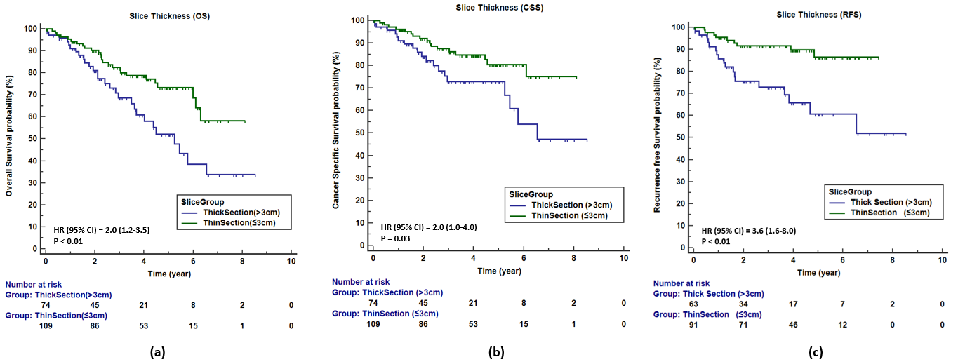
Supplementary Figure 1. (a) (b) and (c) are Kaplan–Meier curves displaying the association between slice thickness and patients’ OS, CSS and RFS, respectively.

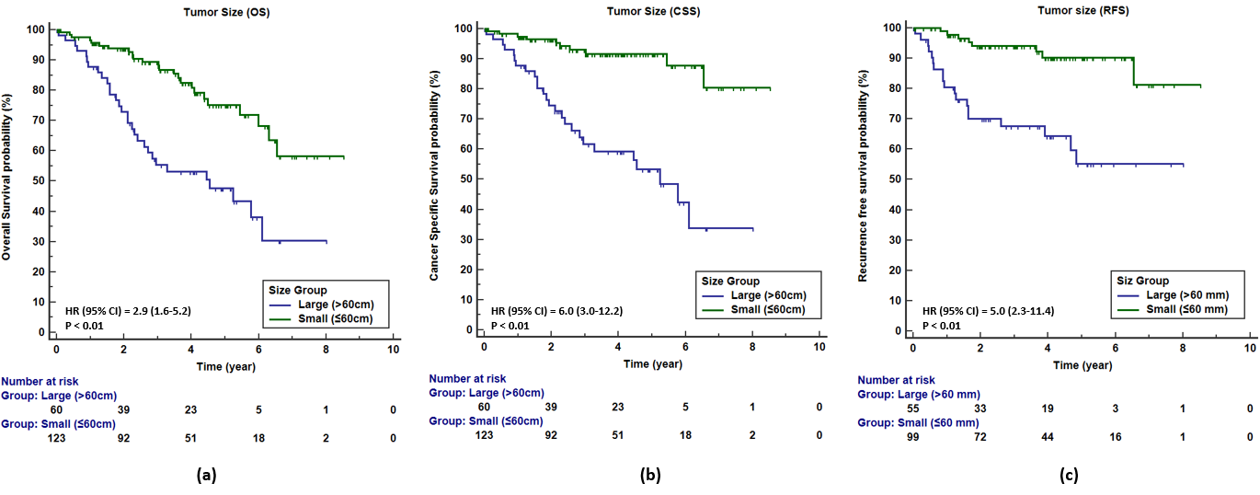
Supplementary Figure 2. (a) (b) and (c) are Kaplan–Meier curves displaying the association between tumor size and patients’ OS, CSS and RFS, respectively.
Supplement S2. CT scan characteristics based on data source cites.
