Figure captions
Fig. S1. Phylogenetic reconstruction of alvinellids based on the COI gene using BI and ML analyses, imposed on the consensus ML tree. Node supports are shown as Bayesian posterior probabilities and ML bootstrap values (PP/BS). Paralvinella mira n. sp. from the Indian Ocean is indicated with red color. "-" indicates nodes which are not supported in the BI analysis. Abbreviations: A., Alvinella; Am., Amphisamytha; G., Grubianella; P., Paralvinella; P. p., Paralvinella pandorae. Accession numbers of the sequences used are provided in Supplementary Table S1.

Fig. S2. Phylogenetic reconstruction of alvinellids based on the 16S gene (with Gblock) using BI and ML analyses, imposed on the consensus ML tree. Node supports are shown as Bayesian posterior probabilities and ML bootstrap values (PP/BS). Paralvinella mira n. sp. from the Indian Ocean is indicated with red color. "-" indicates nodes which are not supported in the BI analysis. Abbreviations: A., Alvinella; Am., Amphisamytha; G., Grubianella; P., Paralvinella; P. p., Paralvinella pandorae. Accession numbers of the sequences used are provided in Supplementary Table S1.

Fig. S3. Phylogenetic reconstruction of alvinellids based on the 18S gene (with Gblock) using BI and ML analyses, imposed on the consensus ML tree. Node supports are shown as Bayesian posterior probabilities and ML bootstrap values (PP/BS). Paralvinella mira n. sp. from the Indian Ocean is indicated with red color. "-" indicates nodes which are not supported in the BI analysis. Abbreviations: A., Alvinella; Am., Amphisamytha; G., Grubianella; P., Paralvinella; P. p., Paralvinella pandorae. Accession numbers of the sequences used are provided in Supplementary Table S1.

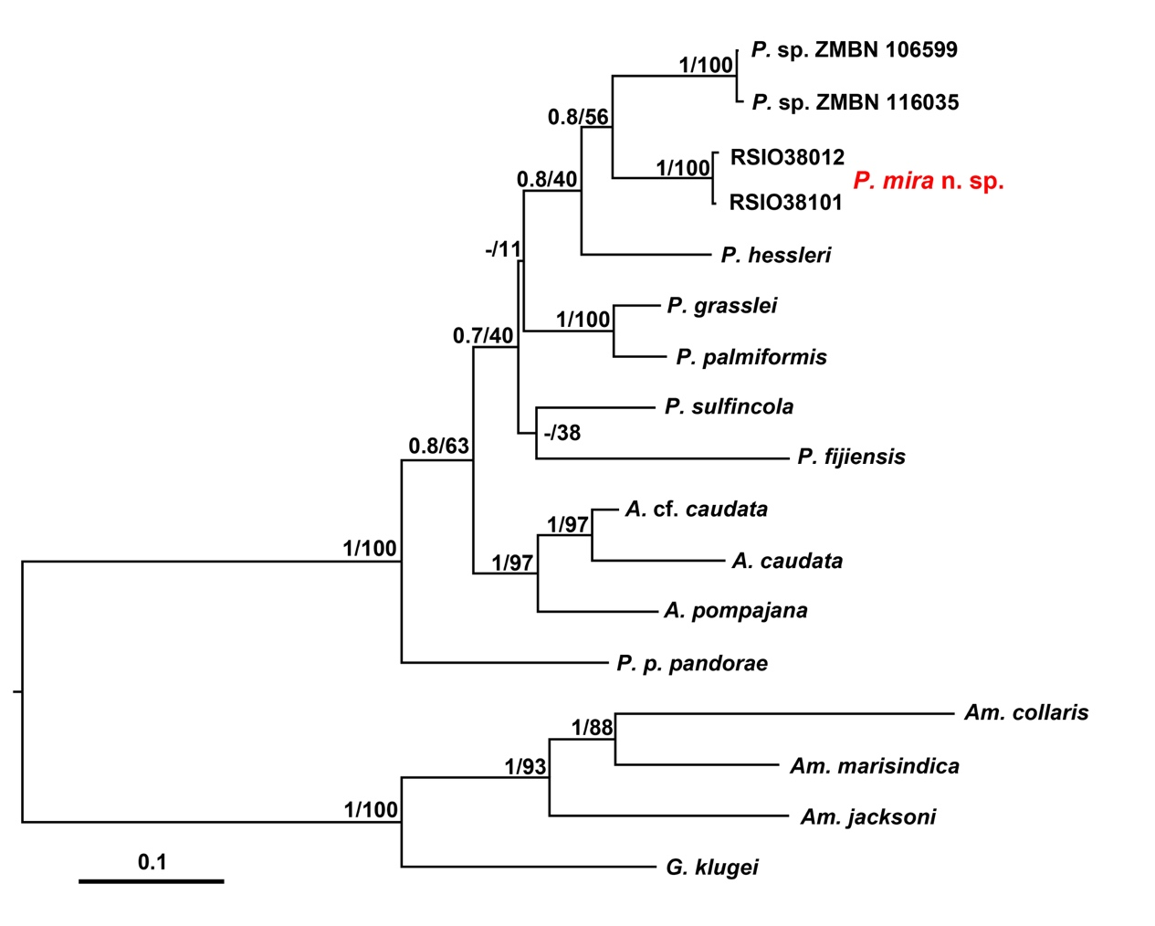
Fig. S1

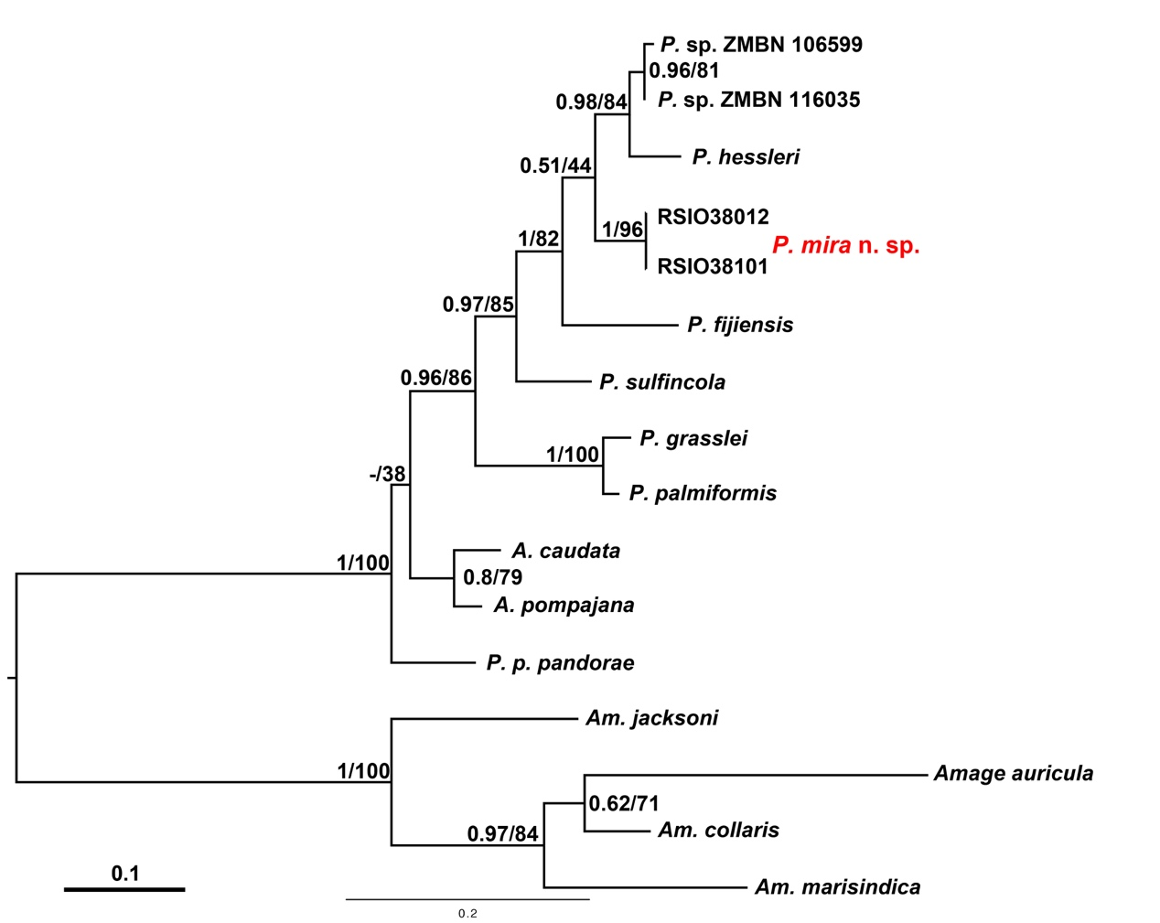
Fig. S2

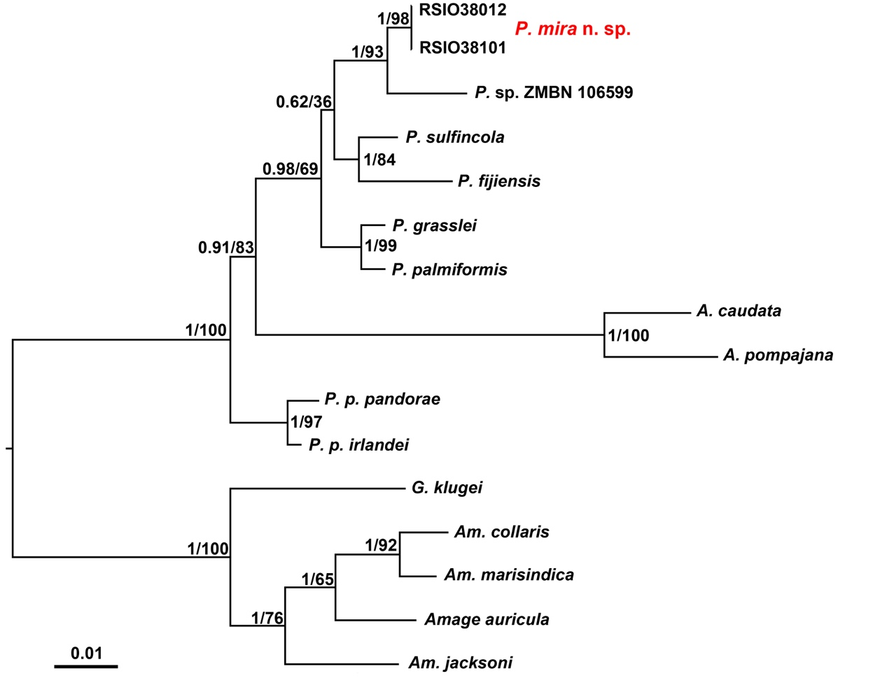
Fig. S3

