**Supplementary Material**

1. **Correlation analysis of miRNAs-lipid reduction**



**Figure S1.** Correlation analysis of 10 miRNAs and lipid reductions percentages following a 20 mg/day atorvastatin dose treatment in hypercholesterolemic patients.

1. **Interaction network of deregulated miRNAs.**

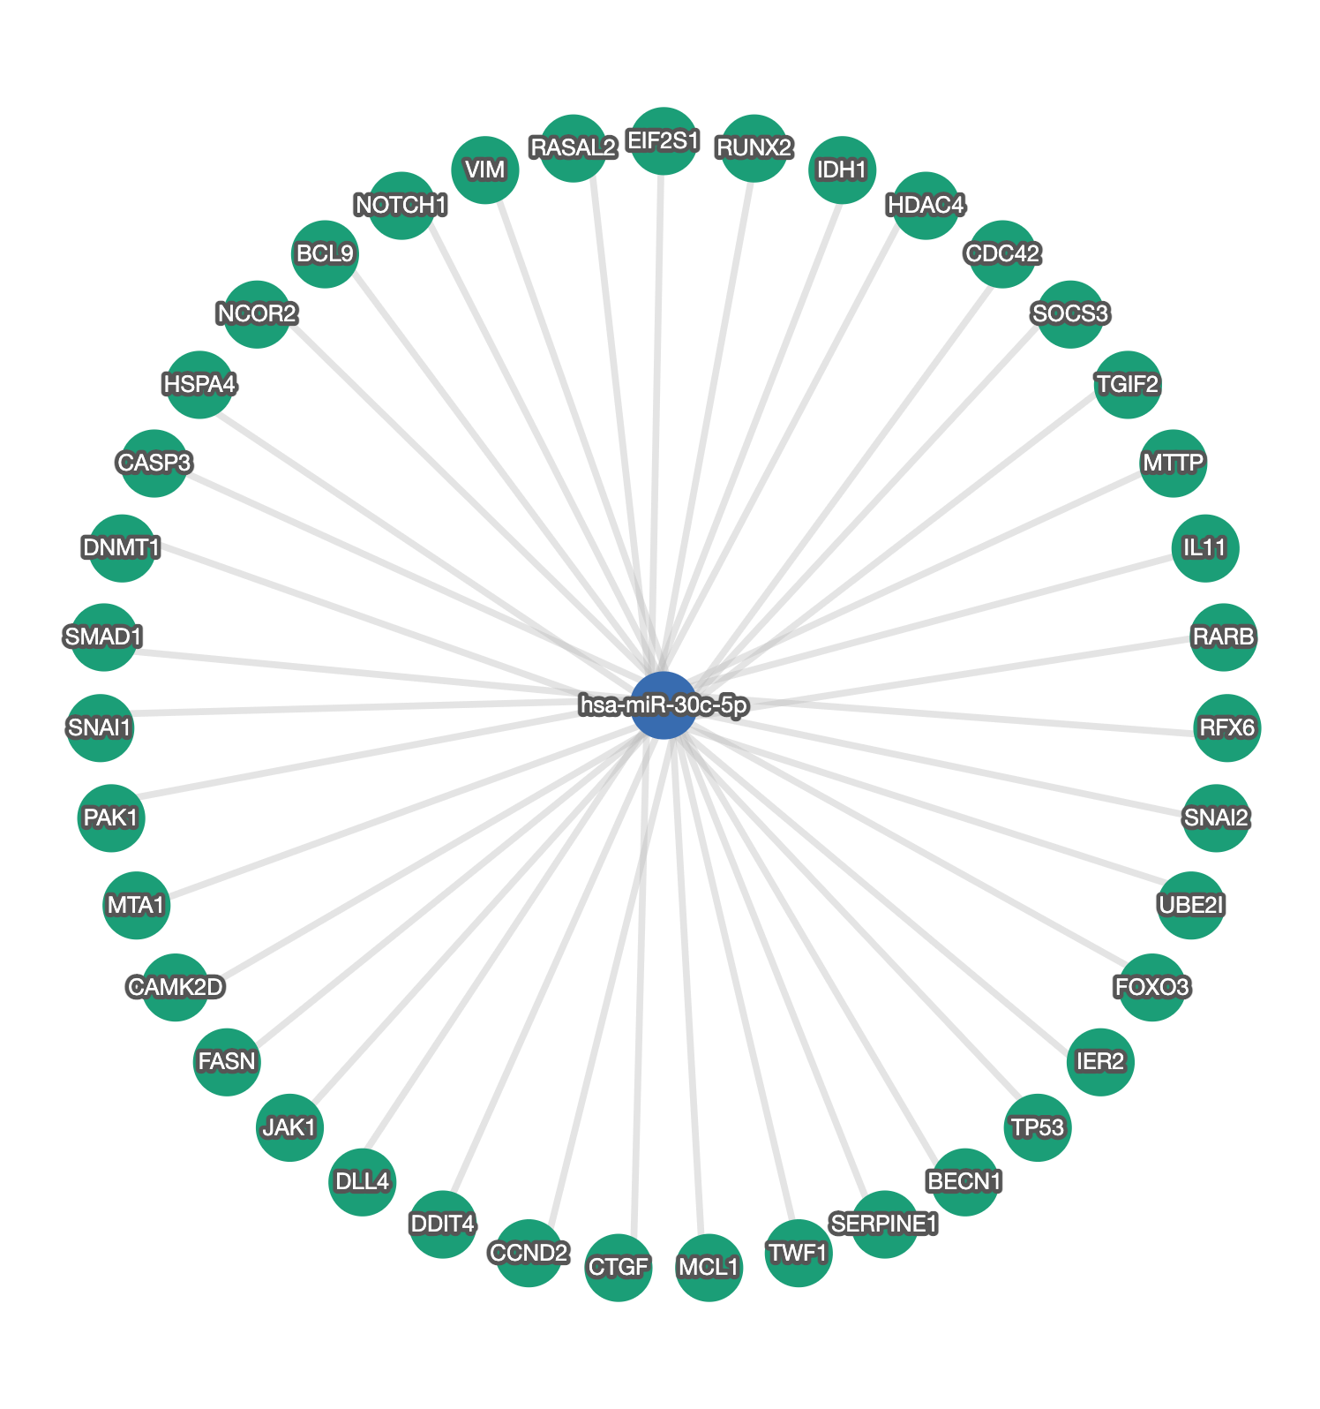

**Figure S2.** Interaction network of miRNA-30c-5p and its validated target genes. Data was retrieved using miRTargetLink 2.0. (https://ccb-compute.cs.uni-saarland.de/mirtargetlink2/).

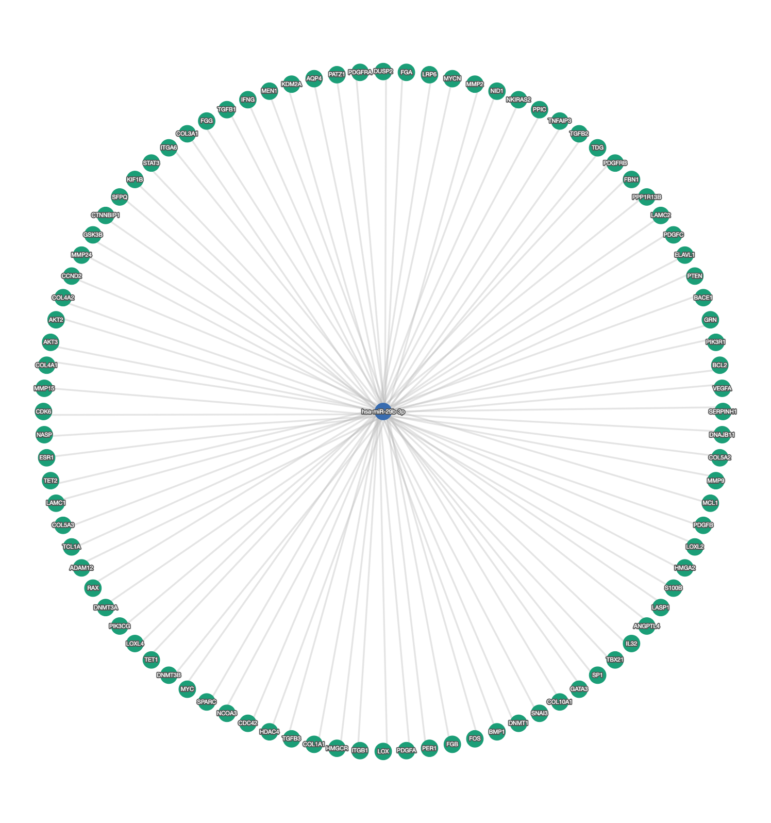

**Figure S3.** Interaction network of miRNA-29b-3p and its validated target genes. Data was retrieved using miRTargetLink 2.0. (https://ccb-compute.cs.uni-saarland.de/mirtargetlink2/).

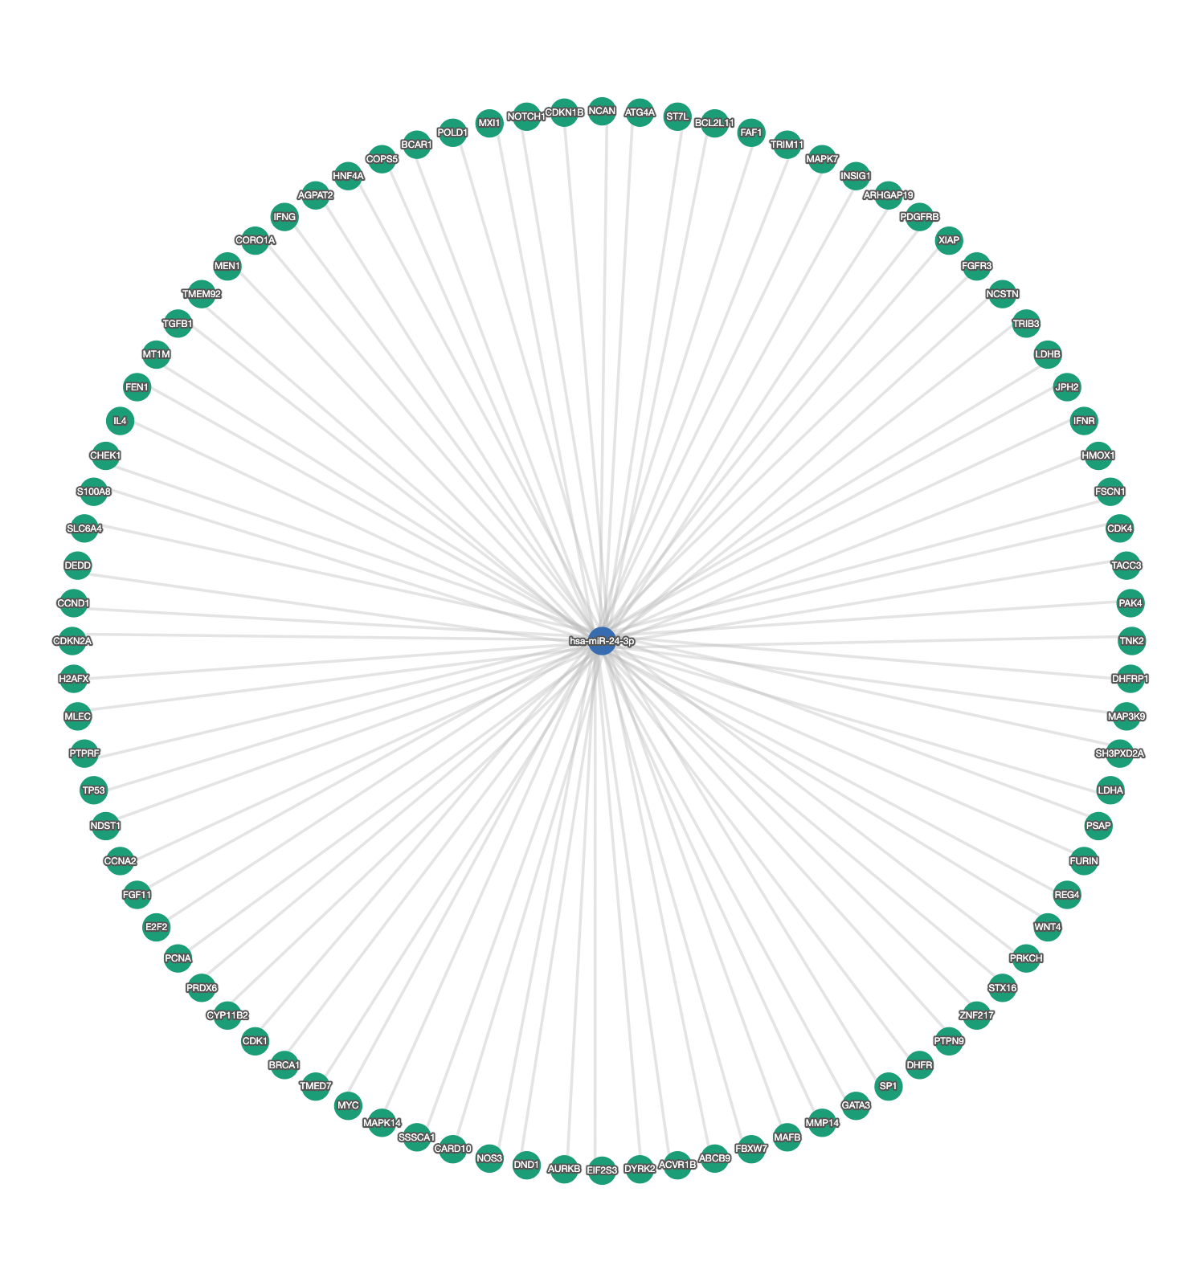

**Figure S4.** Interaction network of miRNA-24-3p and its validated target genes. Data was retrieved using miRTargetLink 2.0. (https://ccb-compute.cs.uni-saarland.de/mirtargetlink2/).

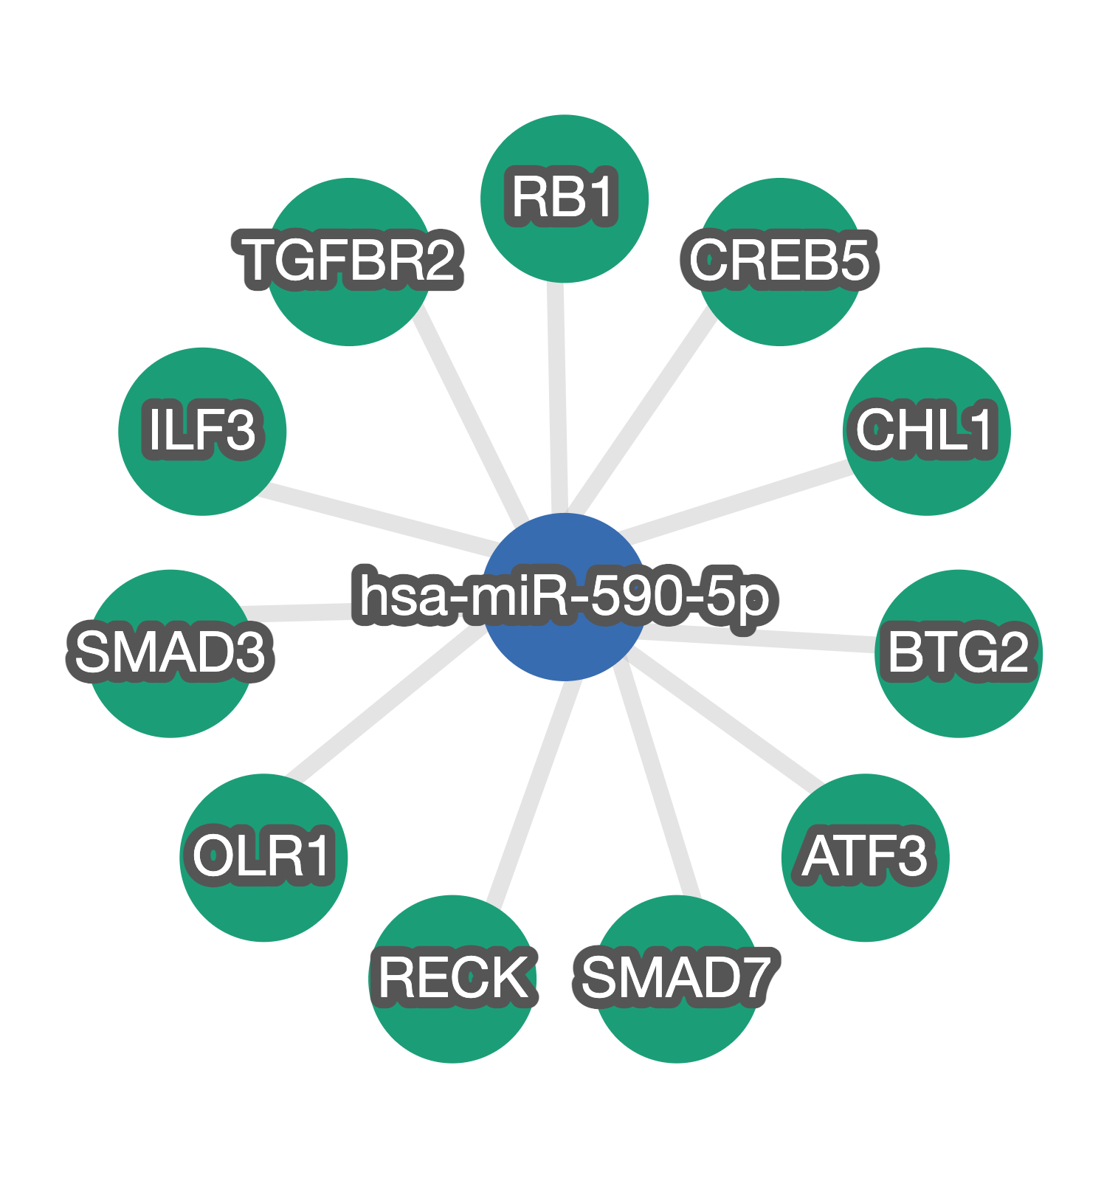

**Figure S5.** Interaction network of miRNA-590-5p and its validated target genes. Data was retrieved using miRTargetLink 2.0. (https://ccb-compute.cs.uni-saarland.de/mirtargetlink2/).