Supplementary materials

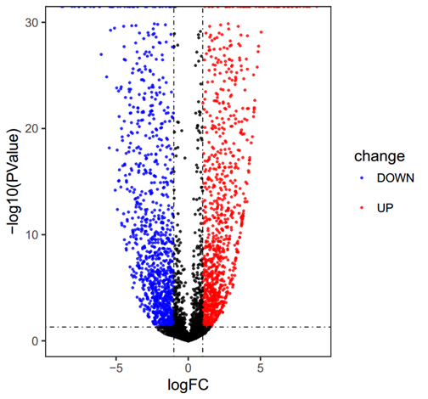
Supplemental figure legends
Figure S1. Volcano plot showing differentially expressed lncRNAs in HONE-1 compared with normal nasopharynx cells. A change is considered significantly if the change is >2-fold with a p-value <0.05.

Figure S2. The expression levels of IL6 and LncRNA MIAT in xenograft tumors were detected by qPCR, ** P ˂ 0.01.
qRT-PCR primer sequences (all sequences from 5′to 3′)
RT-PCR Primers | Forward | Reverse
IL-1 alpha | GACGCACTTGTAGCCACGTA | GGCCATCTTGACTTCTTTGCT
IL-2 | CCAAGAAGGCCACAGAACTGA | TTGGGAAGAAGGTTTGTGTTCC
IL-3 | CACCCACGCGACATCCAAT | AGAGAACGAGCTGGACGTTG
IL-5 | TACGTGTATGCCATCCCCAC | TCCTCAGAGTCTCATTGGCT
IL-6 | GGAGAGGGAGCGATAAACACA | CTCAGACATCTCCAGTCCTCT
IL-7 | GCATCGATCAATTATTGGACAGC | TGCGAGCAGCACGGAATAA
IL-8 | TCAGAGACAGCAGAGCACAC | CTTGGCAAAACTGCACCTTCA
IL-10 | TACGGCGCTGTCATCGATTT | ACTCATGGCTTTGTAGATGCCT
IL-15 | GCCAGGACTCGATGGAGAATC | CGATCTTGTATGGGCTGGCT
IFN-γ | GGCTTTTCAGCTCTGCATCG | TCTGTCACTCTCCTCTTTCCAA
CCL2 | TCTCAAACTGAAGCTCGCACT | TGGGGCATTGATTGCATCTGG
CCL8 | CCCAAGGAAGCTGTGATCTTCA | TGGAATCCCTGACCCATCTCT
CCL7 | TCTCATGTGGAAGCCCATGC | GTATTAATCCCAACTGGCTGAGCA
CXCL9 | AGTGCAAGGAACCCCAGTAG | AGGGCTTGGGGCAAATTGTT
CCL5 | CAGTCGTCCACAGGTCAAGG | CTTGTTCAGCCGGGAGTCAT
TGFβ | GGAAATTGAGGGCTTTCGCC | CCGGTAGTGAACCCGTTGAT
TNFα | CCCATGTTGTAGCAAACCCT | TTATCTCTCAGCTCCACGCC
LINC01238 | TAACCTCAAAGCAGAGGCCG | CTGGGCAGCACTGAACTACA
TCL6 | TGTCTCATTCGCCTCTGGAT | GTCTCCCTCCTTCTGCCTTT
LINC01006 | GTCGAGGGCAGTTTTCTGGG | AACACAACCCGCAACGAGAA
TNRC6C-AS1 | GGGTCTAGCCCACCCAATC | ATGGGCTCAACAGGTCACAA
MMP25-AS1 | GAGGCCTGAAGAGACCAAGAC | AGTGCACCGGAAGTTACAGA
LINC00954 | CATGATGGCCACAGACCCTT | GCTGGTGACGTCAAGTCAGA
A1BG-AS1 | CATCCTCTGCCCAAACTCCTT | GGAGGATACAGGGGGCATGA
MIAT | GAGGGAAGTTCTGAGCTTGG | CCTTTCTTCTGGGCTGAGAC
LINC00173 | GCCAGCTCTCGGTACCTGGA | GGATCGCAACATTCCTGCCAAG
LINC00342 | CCCAAAGCAGTCCTTCACTACA | GCAGTTCACTCTGCTGCTT
CD27-AS1 | GGACCCCATAGGGCACATCT | GTACTCCCCACTCCTACCCC
TSPOAP1-AS1 | TGTCTGCATCCCACAACAGG | CAAGCAGATTGCTGCCTTGC
Actin | CACCATTGGCAATGAGCGGTTC | AGGTCTTTGCGGATGTCCACGT
U6 | GCTTCGGCAGCACATATACTAAAAT | CGCTTCACGAATTTGCGTGTCAT
Supplemental table.
qRT-PCR primer sequences.

