High-frequency nutrient monitoring identifies multiple frequencies of nitrogen and carbon mass balance dynamics in a headwater stream
Phillip J Blaen^{1,2,3}, Kieran Khamis^{1,2}, Sophie Comer-Warner¹, David Hannah¹, A Rob MacKenzie^{1,2} and Stefan Krause^{1,2}

1. School of Geography, Earth and Environmental Sciences, University of Birmingham, Edgbaston, Birmingham, B15 2TT
2. Birmingham Institute of Forest Research (BIFoR), University of Birmingham, Edgbaston, Birmingham, B15 2TT
3. Yorkshire Water, Halifax Road, Bradford, BD6 2SZ

Contents of this file

Supplementary Figures S1 to S8
Supplementary Table S1

Introduction
The following figures provide supporting information for the manuscript entitled High-frequency nutrient monitoring using paired in situ sensors identifies multiple frequencies of nitrogen and carbon uptake dynamics in a headwater stream by Blaen, Khamis, MacKenzie and Krause. Most figures present detailed field data to support our interpretations and conclusions in the primary manuscript. However, Table S1 and Figures S5 & S8 support the statistical methods we employed to analyze the data.
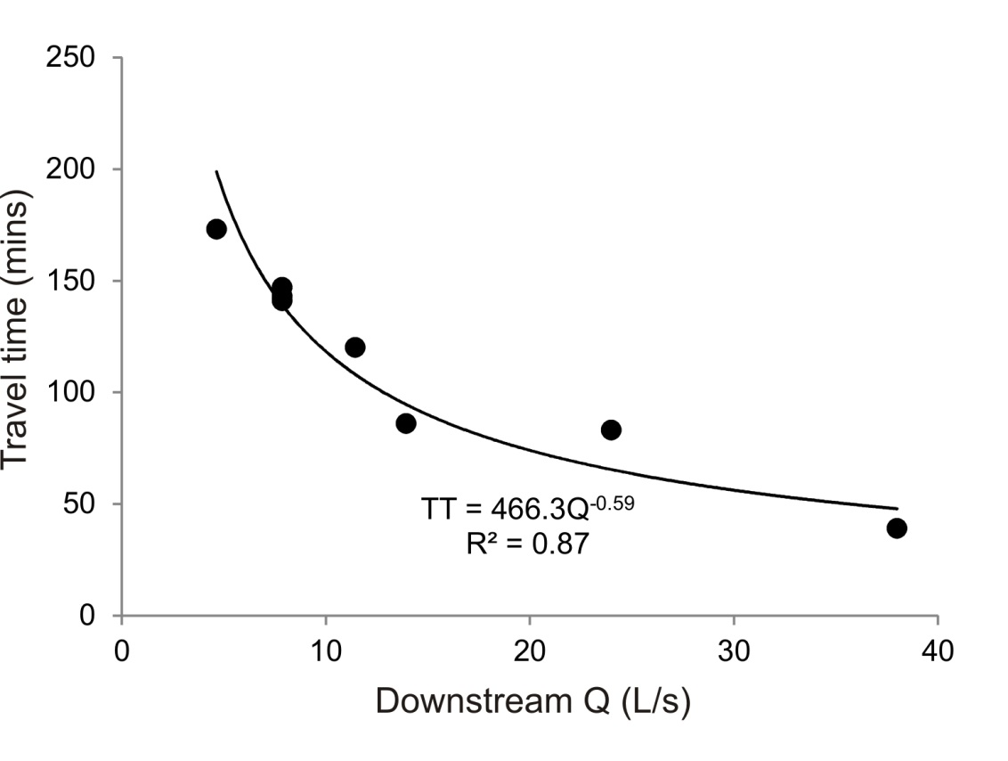
Supplementary Figure S1. Travel time through the reach as a function of discharge at the downstream monitoring station determined from conservative solute (salt and fluorescein) tracer tests conducted over a range of flow conditions.

Supplementary Figure S2. Groundwater level in three boreholes adjacent to the study reach relative to the stream level in 2016. Data from 2017 are not available but the hydroclimatological conditions were similar between the two years. See Blaen et al. (2017) for details of the location of each borehole.

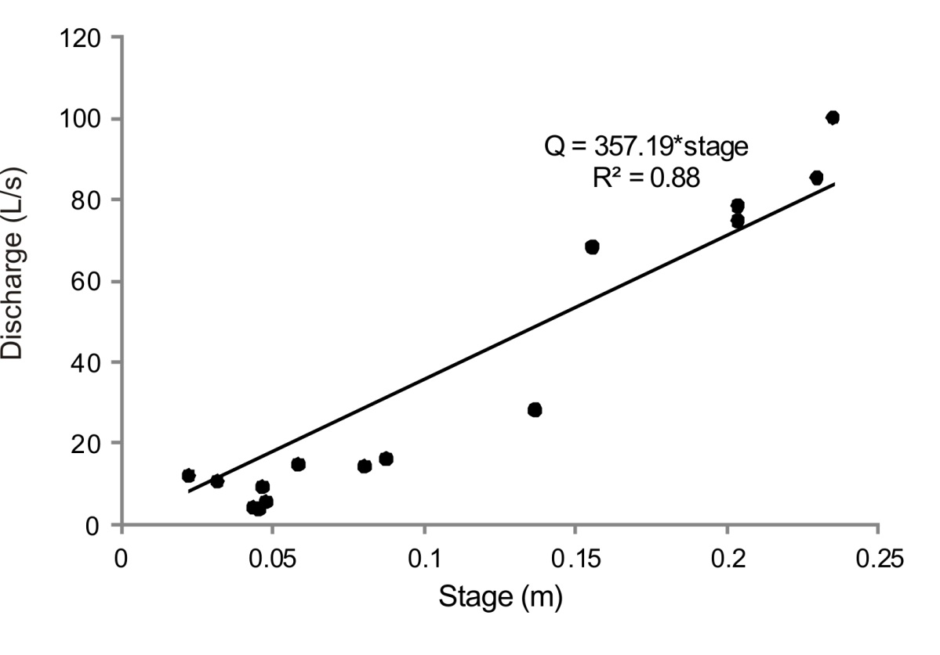

Supplementary Figure S3. Stage-discharge rating curve for the downstream monitoring station as determined by salt dilution gauging.

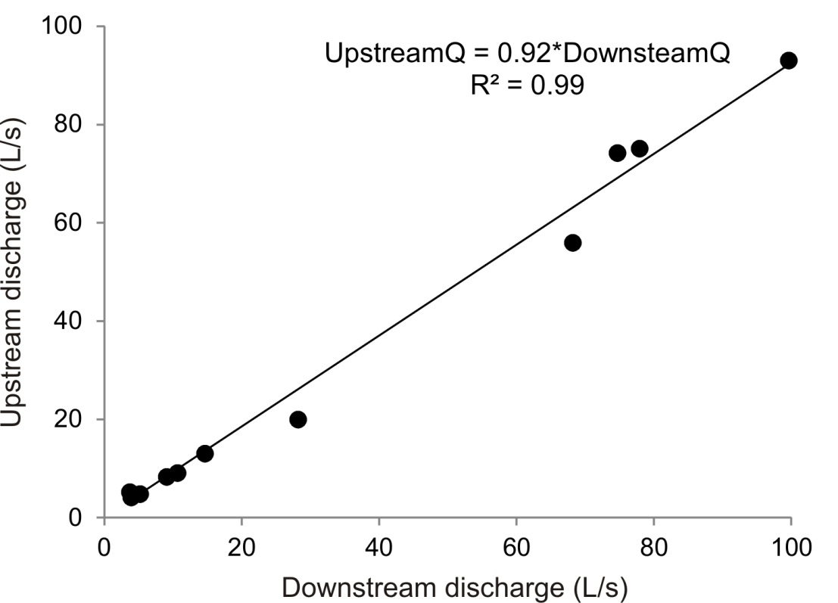

Supplementary Figure S4. Relationship between discharge at the Upstream and Downstream monitoring stations as measured by periodic dilution gauging throughout the study period.

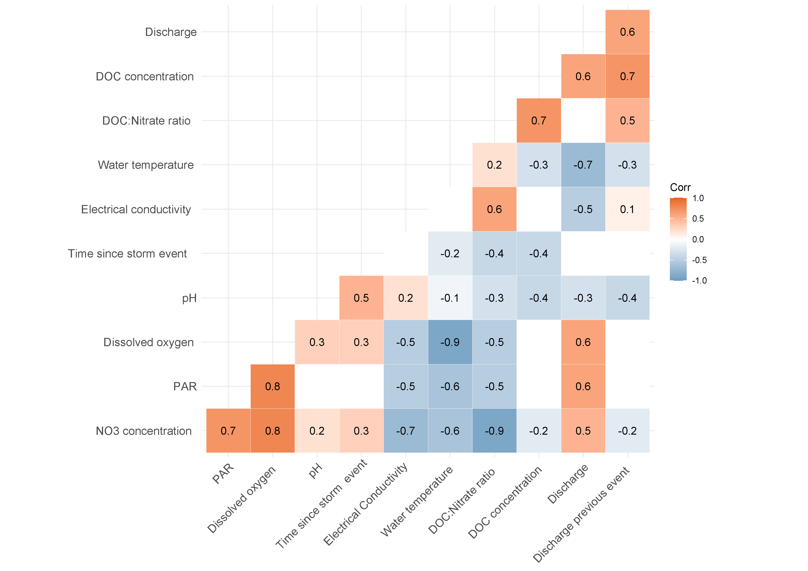

Supplementary Figure S5. Correlation matrix of explanatory variables considered for model development. All variables are daily means except time since storm event and discharge of previous storm event. All values represent Pearson’s correlation coefficients with only significant correlations displayed.

Supplementary Figure S6. Times series of discharge (Q), NO₃⁻-N and DOC throughout selected storm events. Note that isolated single-peak events are rare and multi-peak events spanning more than one day are representative of normal hydroclimatological conditions for this study site.

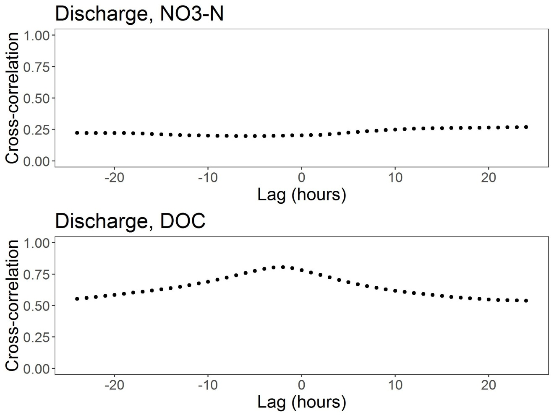

Supplementary Figure S7. Cross-correlation plot of stream discharge against NO₃⁻-N and DOC concentrations.

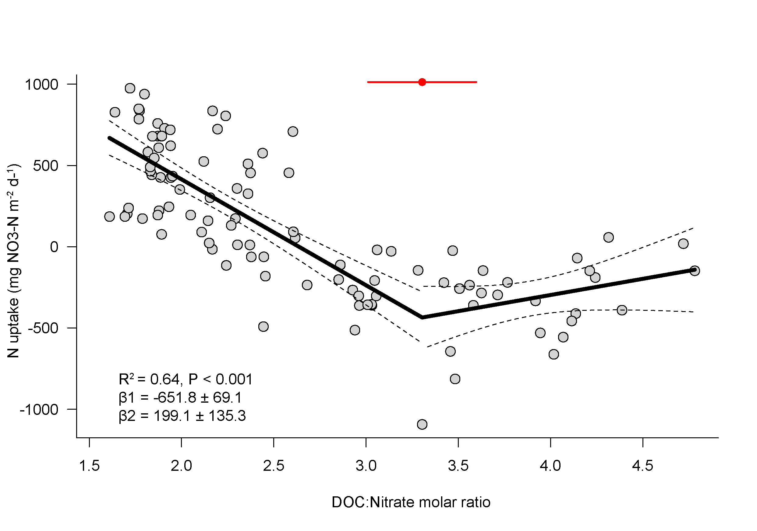
Supplementary Figure S8. Relationship between DOC : nitrate molar ratio and N uptake. The line of best fit represents a fitted segmented regression models (Davies test; P < 0.001). The dashed line represents the 95% confidence interval for the fitted model.The red circle marks the position of the breakpoint and the horizontal bar the 95% confidence interval. β1 is the slope to the left of the beakpoint and β2 the slope to the right.

Supplementary Table S1. Results of the model selection process for daily mean data. Time since the previous storm event (ΔT Event) and magnitude of the previous event (ΔQ Event), water temperature (Tw). Model coefficients are standardized and can be interpreted as effect sizes. Models are ranked in order of increasing AIC differences (ΔAIC). Model-averaged regression coefficients (β) are averages weighted by Akaike weights. Variables with 95% confidence intervals that do not encompass zero are highlighted in bold. Relative variable importance (w_{ip}) is the sum of w_{i} across all models including that variable (Burnham & Anderson 2003). Note uptake rates have been reflected so positive coefficients are positively related to net removal of the nutrient of interest.

Response |  | Predictor | Model rank |  |  |  |  | Model Av.
Variable |  | Variable | 1 | 2 | 3 | 4 |  | β | 2.5% | 97.5% | w_{ip}
N | All seasons | Ratio | 0.63 | 0.61 | 0.63 |  |  | 0.64 | 0.43 | 0.81 | 1
uptake |  | Tw |  | 0.32 | 0.22 |  |  | 0.17 | 0.06 | 0.5 | 0.61
 |  | Q | -0.32 |  | -0.22 |  |  | -0.18 | -0.04 | -0.52 | 0.62
 |  | Δ_{AIC} | 0 | 0.06 | 1.09
 | Spring | Ratio | 1.35 | 1.58 |  |  |  | 1.42 | 0.79 | 2.04 | 1
 |  | PAR | 0.22 | 0.2 |  |  |  | 0.21 | 0.05 | 0.38 | 1
 |  | Q |  | -0.11 |  |  |  | -0.03 | -0.32 | 0.11 | 0.3
 |  | ΔQ Event | -0.57 | -0.51 |  |  |  | -0.55 | -0.87 | -0.23 | 1
 |  | Δ_{AIC} | 0 | 1.74
 | Summer | Ratio | 0.89 | 0.84 |  |  |  | 0.87 | 0.59 | 1.16 | 1
 |  | Q | 0.59 | 0.55 |  |  |  | 0.58 | 0.04 | 1.11 | 1
 |  | ΔQ Event |  | 0.13 |  |  |  | 0.04 | -0.11 | 0.37 | 0.32
 |  | Δ_{AIC} | 0 | 1.49
 | Autumn | Ratio | 0.15 | 0.12 | 0.17 | 0.17 |  | 0.14 | 0.03 | 0.26 | 1
 |  | PAR |  |  | -0.4 | -0.28 |  | -0.14 | -0.83 | 0.1 | 0.39
 |  | Q | -0.41 |  | -0.38 | -0.41 |  | -0.25 | -0.82 | 0.04 | 0.64
 |  | ΔT Event | 0.24 | 0.4 | 0.28 | 0.24 |  | 0.32 | 0.08 | 0.56 | 1
 |  | Tw | 0.15 | 0.14 |  | 0.12 |  | 0.08 | -0.01 | 0.29 | 0.53
 |  | Δ_{AIC} | 0 | 1.11 | 1.15 | 1.51
C | All season | PAR | 0.32 | 0.28 | 0.29 | 0.33 |  | 0.31 | 0.06 | 0.55 | 1
uptake |  | Tw |  | -0.32 | -0.17 |  |  | -0.13 | -0.62 | 0.1 | 0.5
 |  | Q | -0.27 | -0.48 | -0.35 | -0.31 |  | -0.35 | -0.65 | -0.06 | 1
 |  | ΔQ Event | 0.32 | 0.29 | 0.34 | 0.28 |  | 0.31 | 0.06 | 0.56 | 1
 |  | ΔT Event |  | -0.2 |  | -0.1 |  | -0.08 | -0.39 | 0.07 | 0.47
 |  | Δ_{AIC} | 0 | 0.19 | 1 | 1.24
 | Spring | PAR | 0.21 | 0.2 |  |  |  | 0.21 | 0.05 | 0.36 | 1
 |  | Q | -0.47 | -0.49 |  |  |  | -0.48 | -0.64 | -0.31 | 1
 |  | ΔT Event | -0.17 | -0.17 |  |  |  | -0.17 | -0.33 | -0.02 | 1
 |  | ΔQ Event |  | 0.08 |  |  |  | 0.02 | -0.21 | 0.36 | 0.22
 |  | Δ_{AIC} | 0 | 1.75
 | Summer | Q | -1.8 | -1.47 |  |  |  | -1.67 | -3.01 | -0.32 | 1
 |  | ΔT Event | 1.7 | 1.78 |  |  |  | 1.72 | 1.02 | 2.42 | 1
 |  | ΔQ Event | -1.34 | -1.31 |  |  |  | -1.32 | -1.91 | -0.74 | 1
 |  | Tw | -1.43 |  |  |  |  | -0.84 | -3.02 | 0.15 | 0.59
 |  | Δ_{AIC} | 0 | 0.73
 | Autumn | ΔQ Event | 0.18 | 0.12 |  |  |  | 0.12 | 0.01 | 0.32 | 0.73
 |  | ΔT Event | 0.18 |  |  |  |  | 0.07 | 0.02 | 0.37 | 0.42
 |  | Tw | 0.27 | 0.34 | 0.29 |  |  | 0.29 | 0.05 | 0.54 | 1
 |  | Δ_{AIC} | 0 | 1.11 | 1.15 | 1.51

