Supplementary Information

Title
Economics of Southern Pines with and without Payments for Environmental Amenities in the Southern United States

Authors
Karuna Paudel¹, Puneet Dwivedi¹ and David Dickens¹
¹ Warnell School of Forestry and Natural Resources, University of Georgia, Athens, GA 30602

Corresponding Author
Karuna Paudel, Ph.D.
Warnell School of Forestry and Natural Resources
University of Georgia
180 E Green St, Athens, GA 30602
Email: karunapaudel@uga.edu

Figure S1: Breakup of land expectation value (LEV) for loblolly, slash, and longleaf pines at the optimal rotation age with no income from pine straw raking.
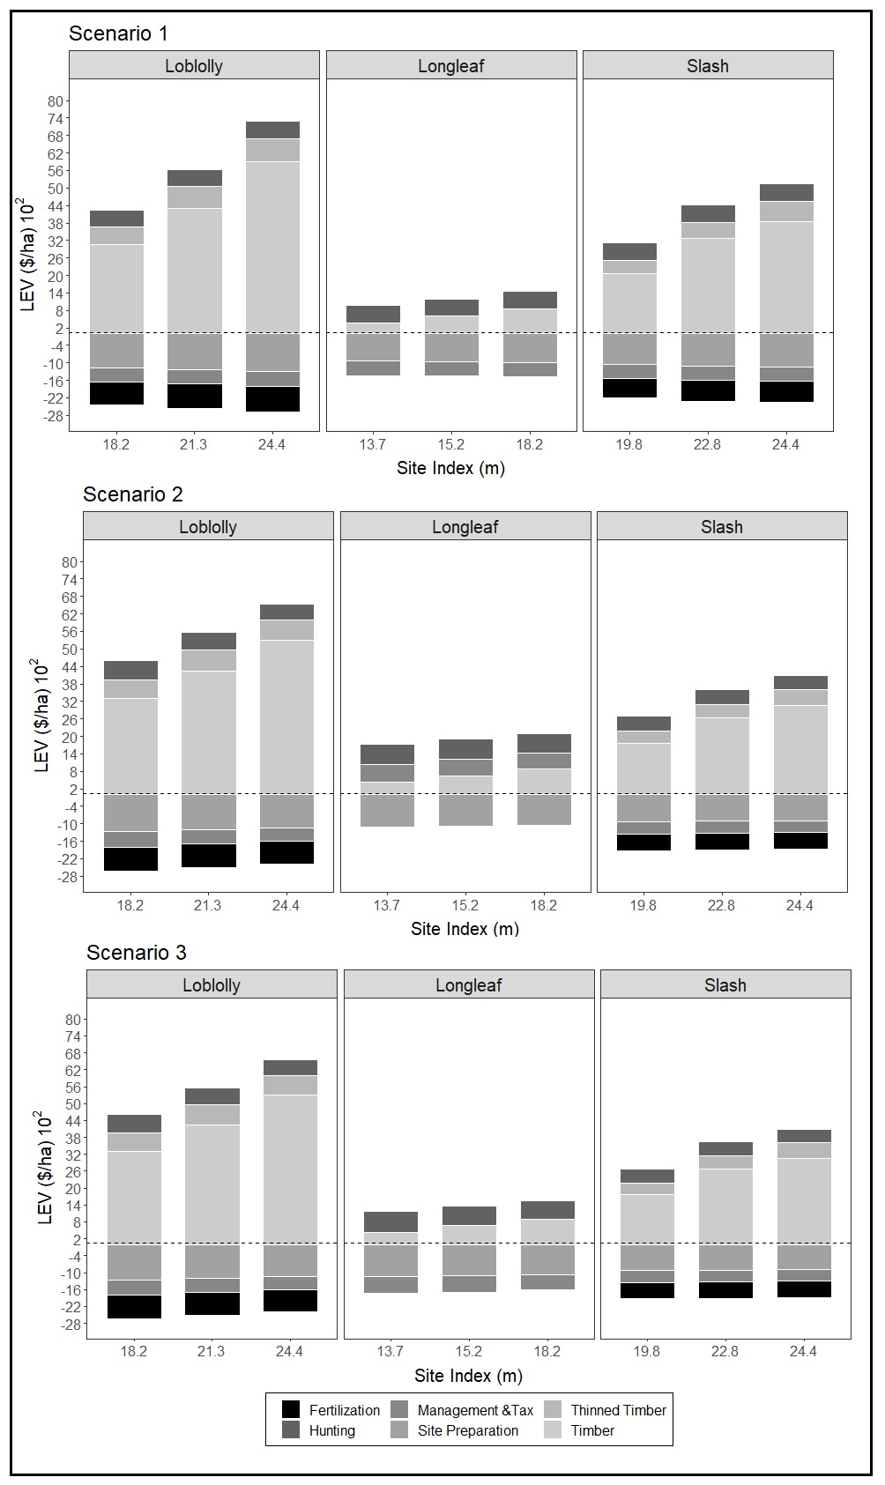

Figure S2: Breakup of land expectation value (LEV) of income and costs for slash, and longleaf pines at the optimal rotation age with income from pine straw raking.
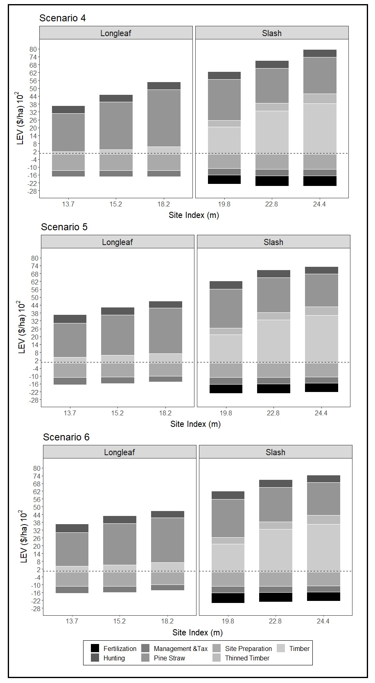

Table S1: Carbon and Water yield for loblolly, slash and longleaf pines across site indices without income from pine straw raking.
 |  | Scenario 1 |  | Scenario 2 |  | Scenario 3
Species | SI (m) | Carbon (t/ha) | Water Yield (mm) | Carbon (t/ha) | Water Yield (mm) | Carbon (t/ha) | Water Yield (mm)
Loblolly | 24.4 | 195.8 | 487.8 | 203.6 | 485.1 | 203.6 | 485.1
 | 21.3 | 173.4 | 494.7 | 179.3 | 492.9 | 179.3 | 492.9
 | 18.2 | 149.4 | 504.8 | 153.8 | 504.0 | 153.8 | 504.0
Slash | 24.4 | 463.4 | 484.9 | 509.5 | 478.1 | 495.0 | 480.1
 | 22.8 | 449.0 | 485.8 | 490.2 | 480.8 | 477.3 | 482.2
 | 19.8 | 393.7 | 501.0 | 427.2 | 498.0 | 416.7 | 498.8
Longleaf | 18.2 | 174.8 | 383.2 | 199.6 | 376.9 | 205.7 | 374.7
 | 15.2 | 133.5 | 409.0 | 159.0 | 403.3 | 152.2 | 404.1
 | 13.7 | 108.2 | 432.8 | 121.0 | 429.9 | 121.0 | 429.9

Table S2: Carbon and Water yield for slash and longleaf pines across site indices with income from pine straw raking.
 |  | Scenario 4 |  | Scenario 5 |  | Scenario 6
Species | SI (m) | Carbon (t/ha) | Water Yield (mm) | Carbon (t/ha) | Water Yield (mm) | Carbon (t/ha) | Water Yield (mm)
Slash | 24.4 | 428.2 | 491.3 | 482.3 | 482.3 | 479.7 | 482.3
 | 22.8 | 400.0 | 493.8 | 485.8 | 485.8 | 449.0 | 485.8
 | 19.8 | 353.8 | 506.0 | 501.0 | 501.0 | 381.1 | 502.4
Longleaf | 18.2 | 52.4 | 470.5 | 418.5 | 418.5 | 80.7 | 443.7
 | 15.2 | 52.4 | 470.5 | 432.8 | 432.8 | 80.7 | 443.7
 | 13.7 | 36.9 | 489.8 | 444.1 | 444.1 | 87.1 | 444.1

