Supplementary File

Histograms for the odds of using specific coping strategies at distinct clusters.

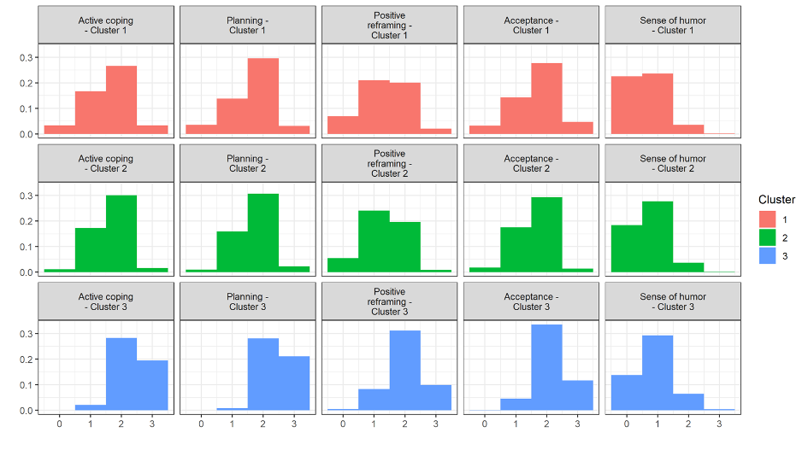

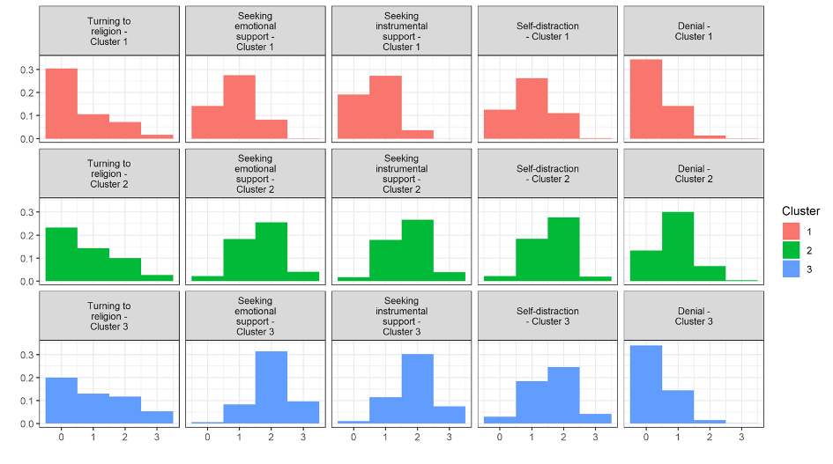

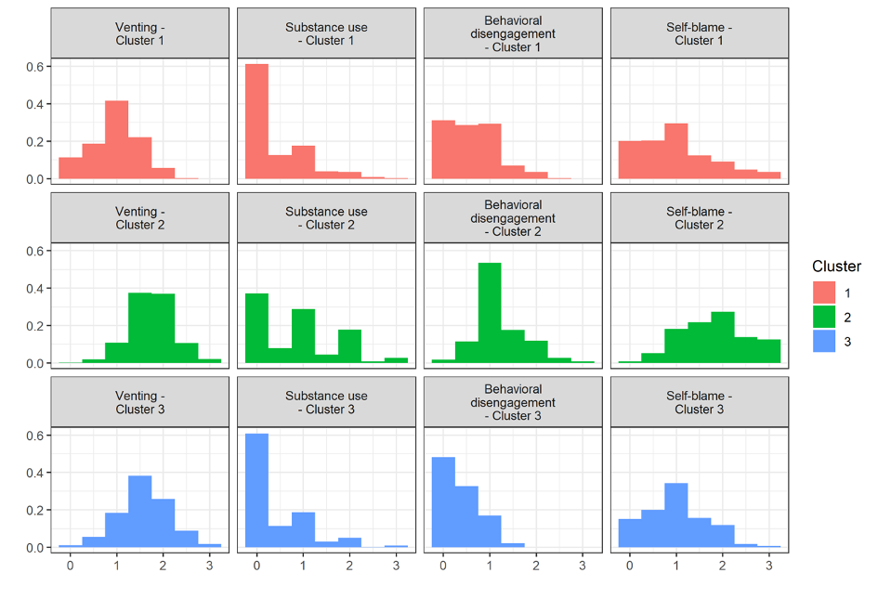

Histograms of the GHQ-28 and the IES-R scores at distinct clusters in medical professionals.

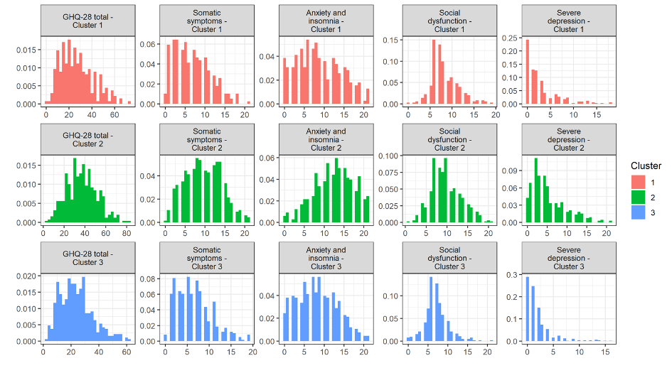

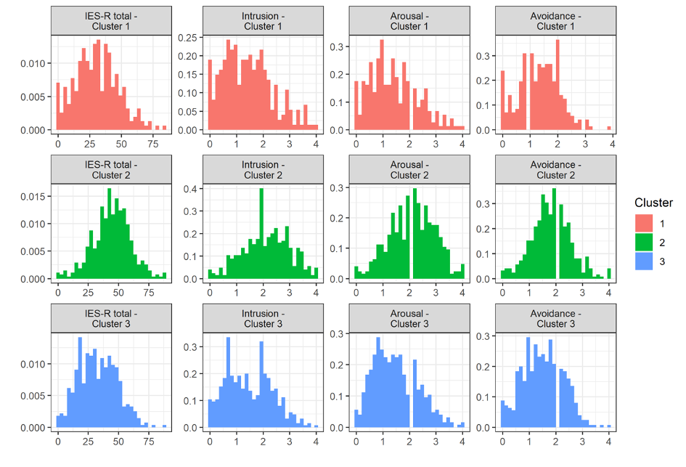

Histograms of the GHQ-28 and the IES-R scores at distinct clusters in non-medical professionals.

