Supplementary Material

Supplementary Data

Supplementary Figures and Tables

Supplementary Figures
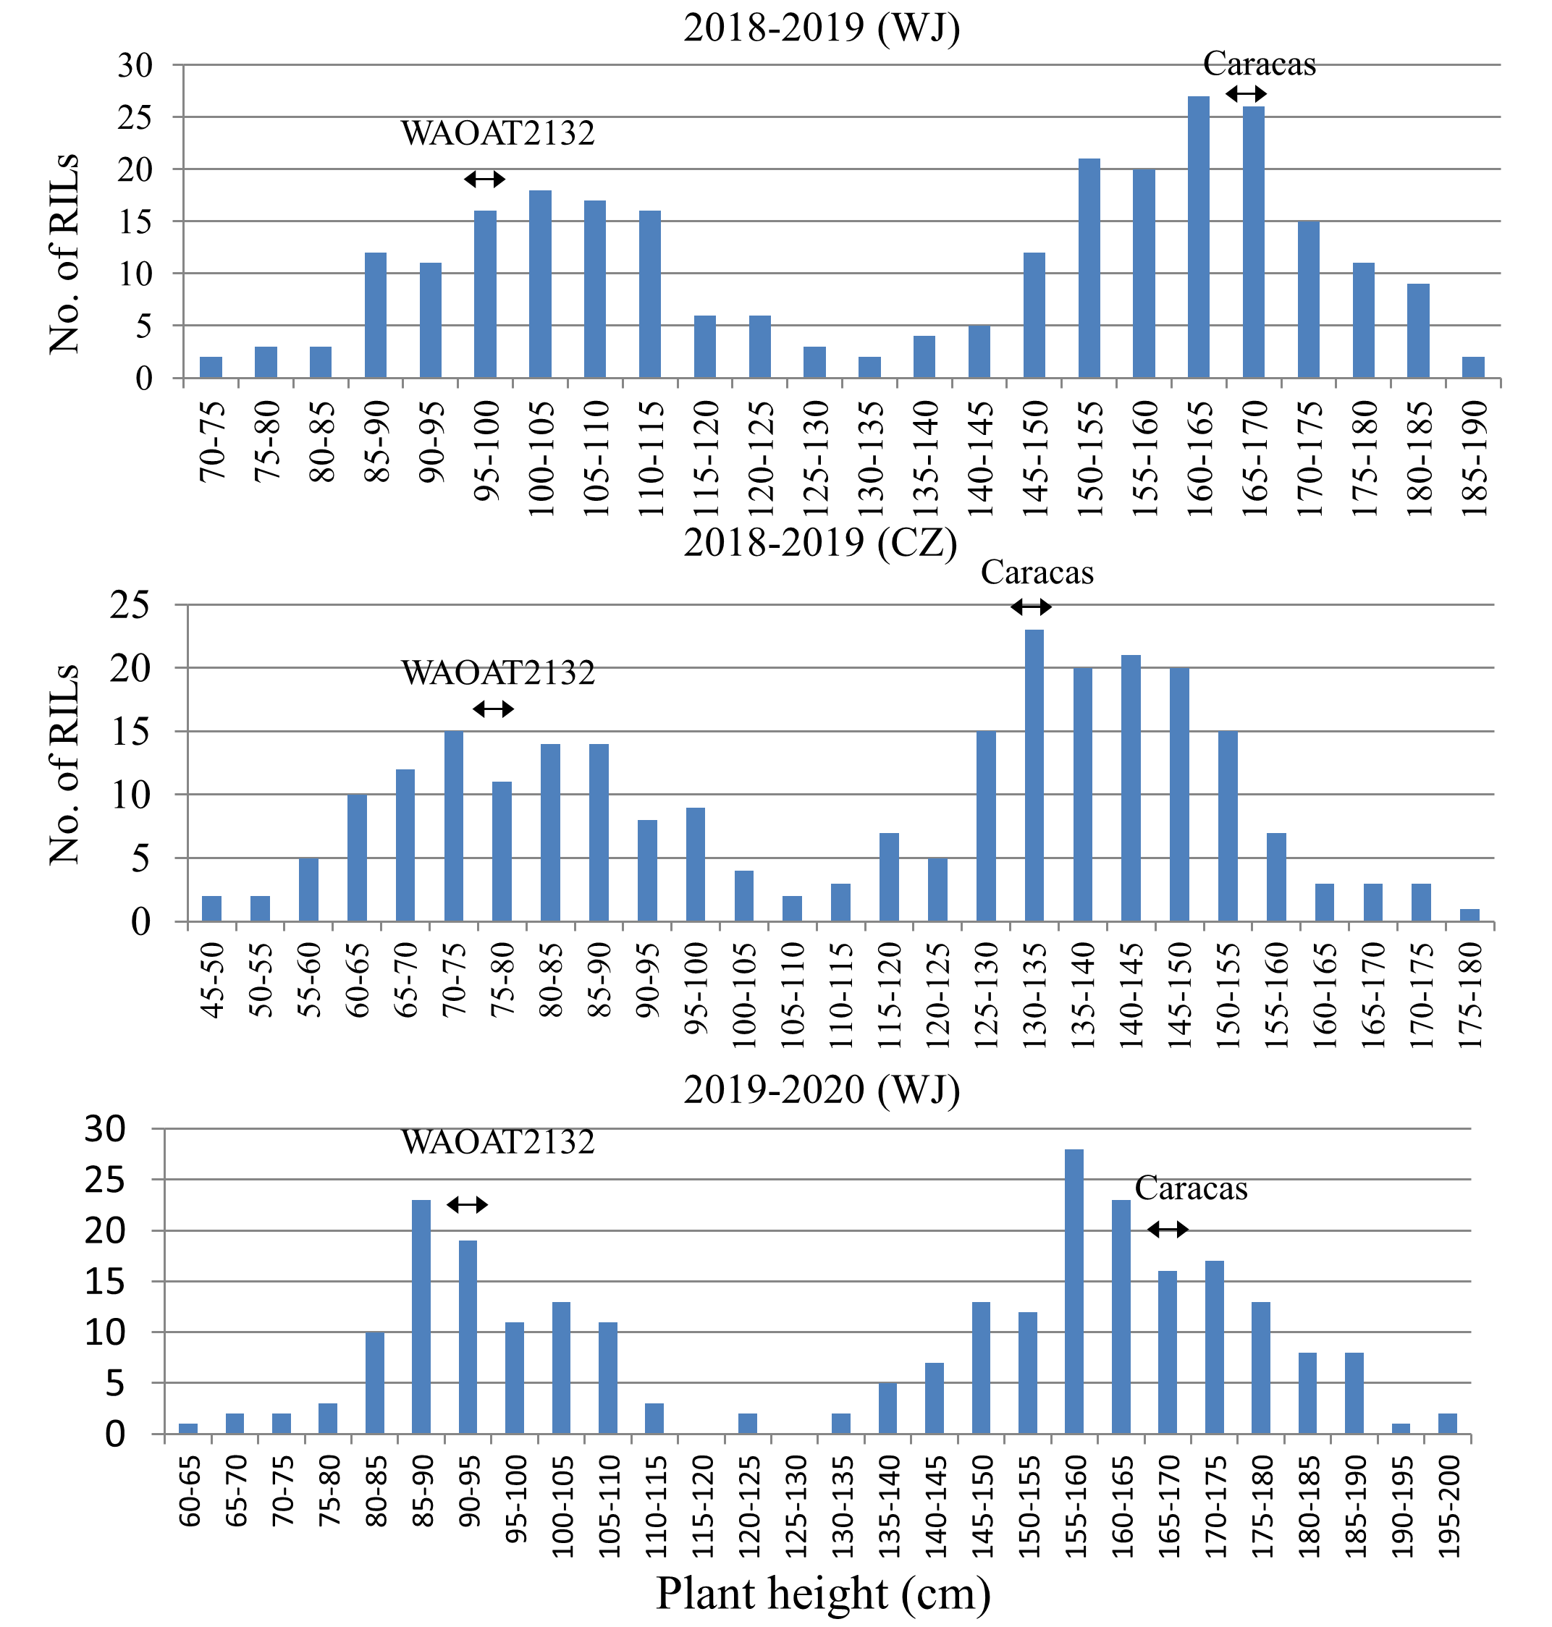
Supplementary Figure 1. Frequency distribution of plant heights in the WAOAT2132/Caracas RIL population across the three environments of testing.
Supplementary Figure 2. Scatter plots displaying the relationships between plant height and other agronomic traits in the WAOAT2132/Caracas RIL population. Note, each line was colored according to the allele state of marker SSR120.
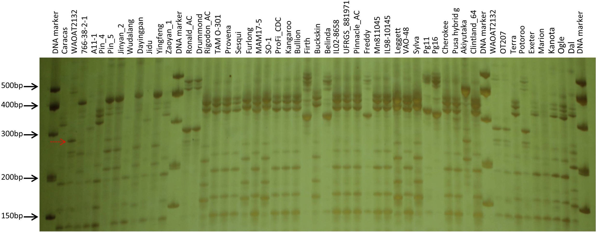
Supplementary Figure 3. Allele state of marker SSR120 in a set of diverse oat accessions. The red dotted arrow indicates the Dw6 allele.

Supplementary Tables
Table S1. List of the recombinant inbred lines and the parents used in this study and their allelic information of five polymorphic SSR markers and raw agronomic data in each of environment of testing.
Table S2. Allelic variation of marker SSR120 in 48 diverse oat accessions and 14 near-isogenic lines contrasting for Dw6.
Table S3. Primer information for microsatellite markers used in this study.

