Supplementary Material

Supplementary Table 1.
Table S1: Raw scores to the cognitive tests at baseline, year 1 and year 5.
Cognitive test | Baseline |  | 1 year |  | 5 years
 | Patients | Controls | Patients | Controls | Patients | Controls
SRT-LTS | 59.594 (8.210) | 60 (10.832) | 60.094 (9.074) | 62 (7.067) | 61.065 (9.313) | 64 (9.191)
SRT-CLTR | 53.031 (13.015) | 53 (15.556) | 53.969 (12.212) | 54 (14.621) | 56.065 (13.706) | 62 (11.549)
SRT-DR | 11.188 (1.693) | 11 (1.229) | 11.031 (1.231) | 11 (0.966) | 11.226 (1.309) | 12 (0.948)
BVMTR-learning | 27.594 (5.797) | 30 (6.074) | 30.156 (4.608) | 30 (5.461) | 29.097 (5.394) | 30 (4.575)
BVMTR-DR | 10.219 (1.996) | 11 (1.686) | 10.969 (1.636) | 11 (1.646) | 11 (1.461) | 11 (1.154)

The data are provided as mean (standard deviation) at each time point. SRT=Selective Reminding Test; LTS=long-term storage; CLTR=consistent long-term retrieval; SRT-DR=delayed recall; BVMTR= Brief Visual Memory Test Revised; BVMTR-DR=delayed recall.
Supplementary Figure 1.
Figure S1: Structural connectome matrices for patients at baseline, year 1 and year 5.
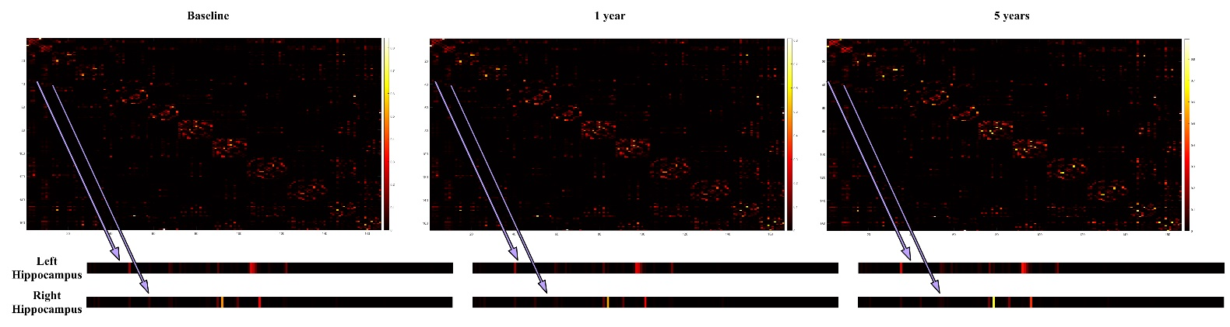
Supplementary Figure 2.
Figure S2: Functional connectome matrices for patients at baseline, year 1 and year 5.
