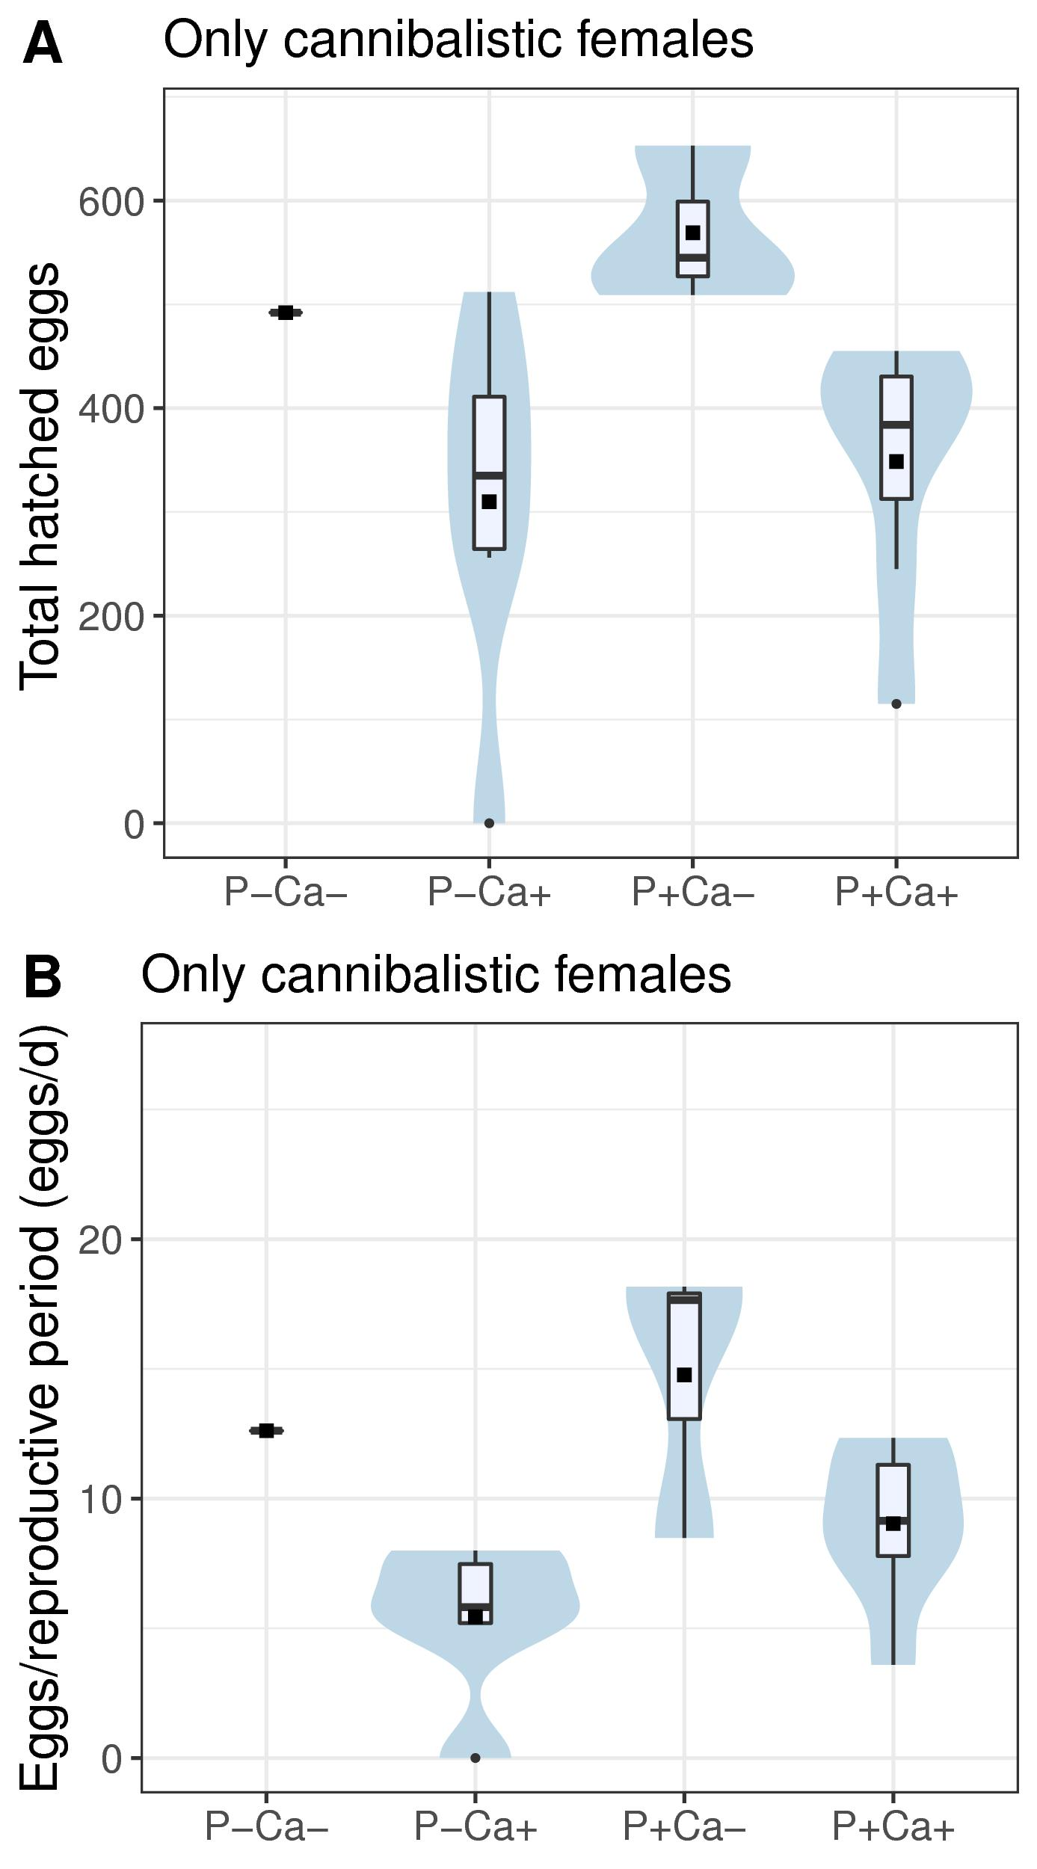
Fig. SI 3 Box-violin plots of Gryllus campestris reproductive success of cannibalistic subjects only. A: Total number of hatched eggs. B: female daily reproduction (hatched eggs/reproductive period (eggs/day)) for different food treatment types. Bars represent bootstrapped 95% CI intervals, with group means as horizontal cross-bar. P+/P- : P treatment contrasts; Ca+/Ca-: lime treatment contrasts. n= 16. Violins indicate data distribution. Boxes indicate 25%, 50% and 75% quantiles, whiskers indicate all data within 1.5*interquantile range, dots represent outliers, squares indicate group mean. P+/P- : P treatment contrasts; Ca+/Ca-: lime treatment contrasts.

