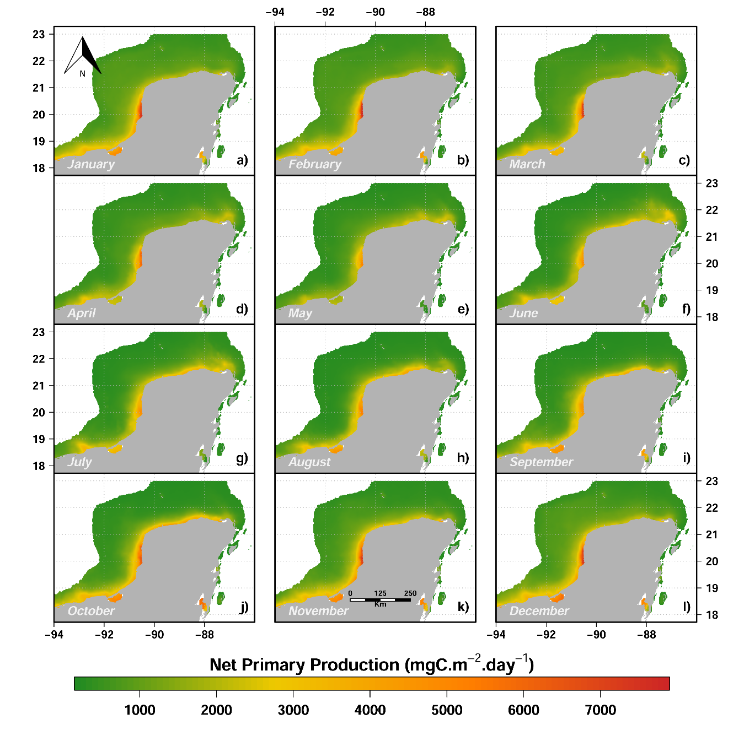
Figure S1. Average monthly values of Net primary production in the study region for the period 2010-2014. These layers were used to elaborate the predicted fishing grounds for the small-scale vessels.
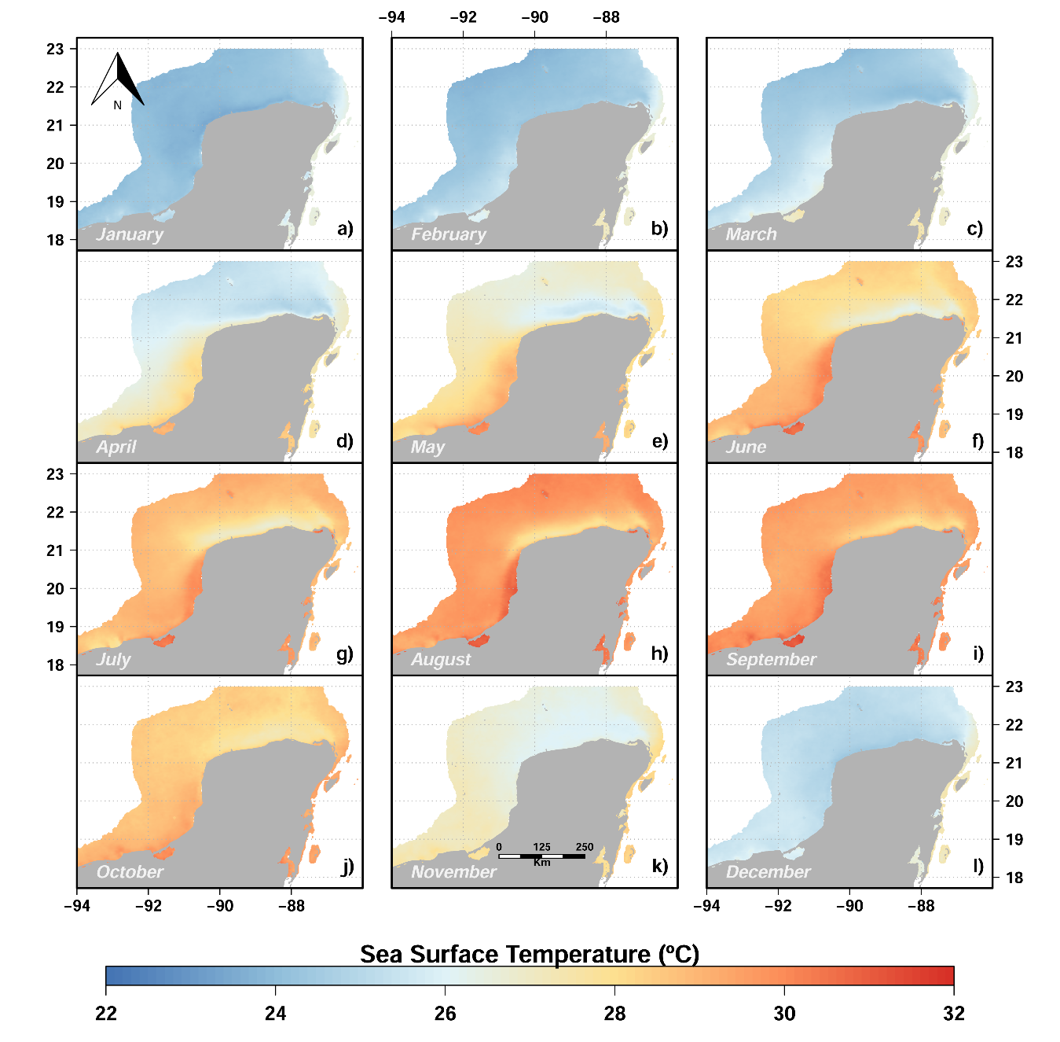

Figure S2. Average monthly values of Sea surface temperature in the study region for the period 2010-2014. These layers were used to elaborate the predicted fishing grounds for the small-scale vessels.

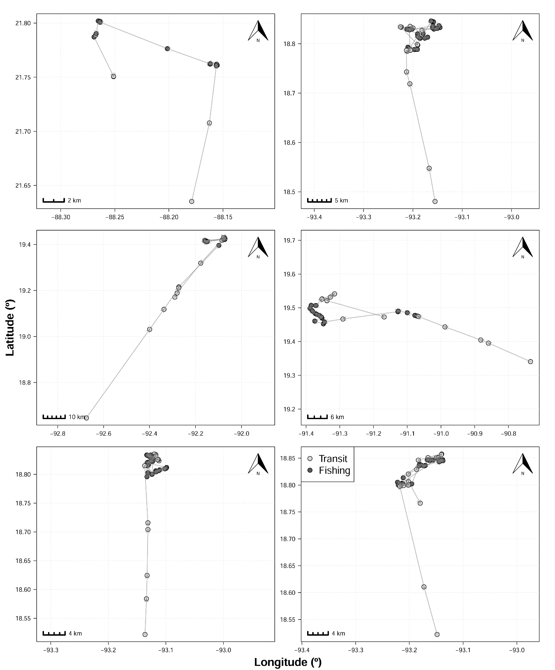
Figure S3. Examples of VMS trajectories classified by the Random forest model trained with observers’ data to differentiate between transit and fishing activities.

