ANNEX 2. Radial plot for small study bias. The radial plots display point estimates (y-axis) with different standard errors (x-axis). According to Galbraith et al 1990, if there is no small-study effects, individual studies are expected to scatter randomly around the regression line through the origin. Radial plots were specifically calculated for the whole of data (Panel a); for the case-control studies (Panel b), and for cross sectional studies (Panel c), including only laboratory-based studies (Panel d). In all cases, estimated were substantially scattered on the both sides of the regression lines, suggesting no significant small study effect.
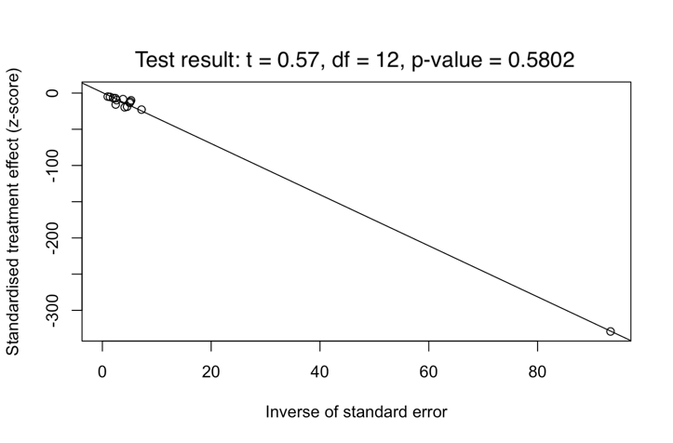 | 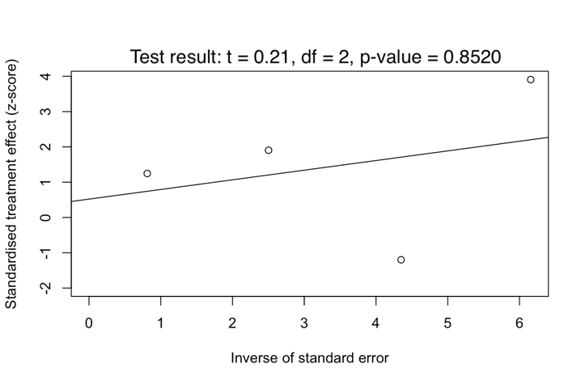
a) | b)
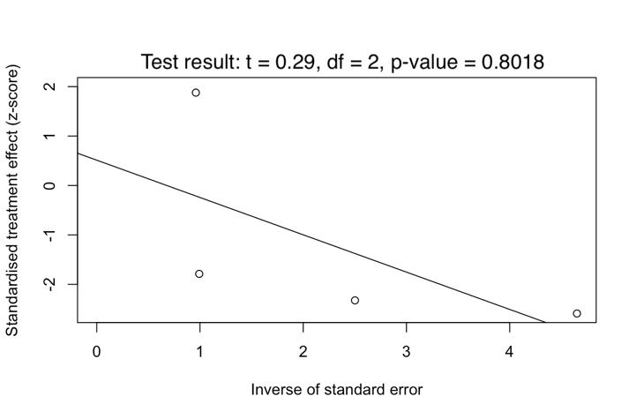 | 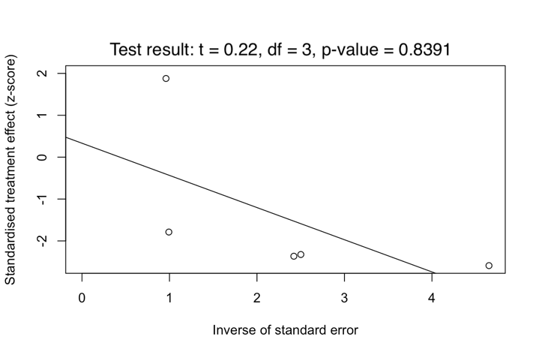
c) | d)

