Supplementary Material

Indirect effects of microplastic-contaminated soils on adjacent soil layers: Vertical changes of soil physical structure and water flow

Shin Woong Kim*, Yun Liang, Tingting Zhao, Matthias C. Rillig

†Institute of Biology, Freie Universität Berlin, 14195 Berlin, Germany
‡Berlin-Brandenburg Institute of Advanced Biodiversity Research. 14195 Berlin, Germany

* Corresponding author: swkim@zedat.fu-berlin.de

11 pages

7 figures

1 table

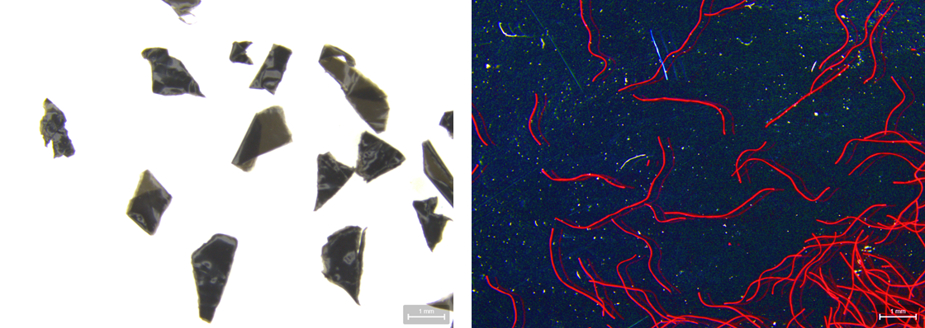
Figure S1. Target microplastics used in this study: low-density polyethylene (LDPE) films (left) and polyacrylonitrile (PAN) fibers (right).

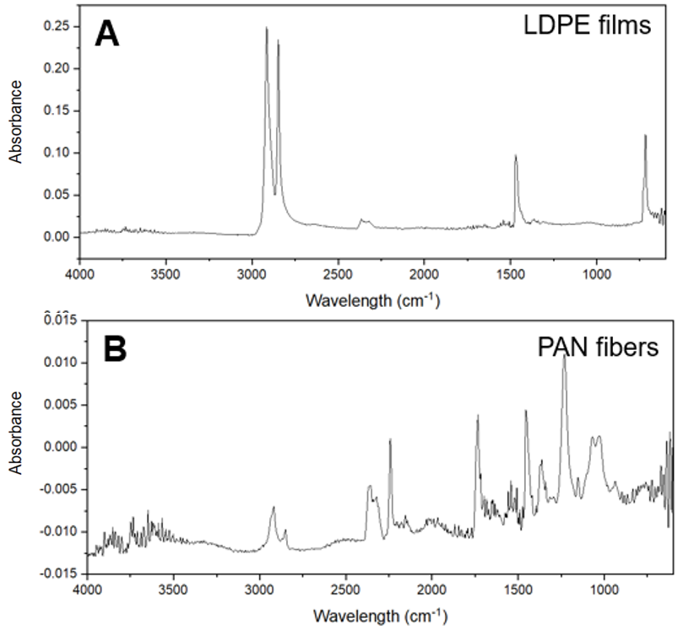
Figure S2. FTIR spectra, ATR mode, of all polymers tested in this paper: (A) Low-Density Polyethylene (LDPE) and (B) Polyacrylonitrile (PAN).

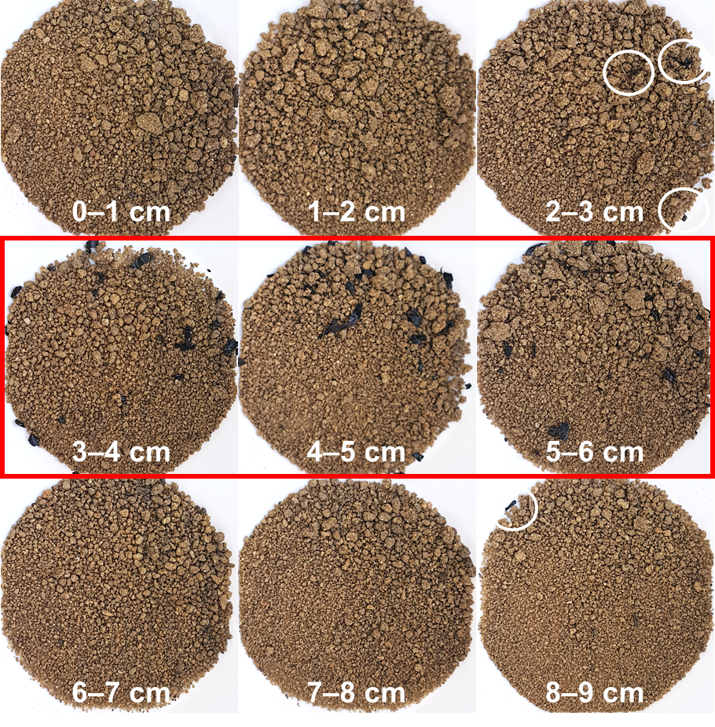
Figure S3. The close-up photographs of soil samples in each depth (0–9 cm) of LDPE film treatment (60 days, low-level irrigation). The red border indicates microplastic-containing soil layer (3–6 cm), and LDPE films observed in the top (0–3 cm) and bottom (6–9 cm) layers were marked in the white circles.

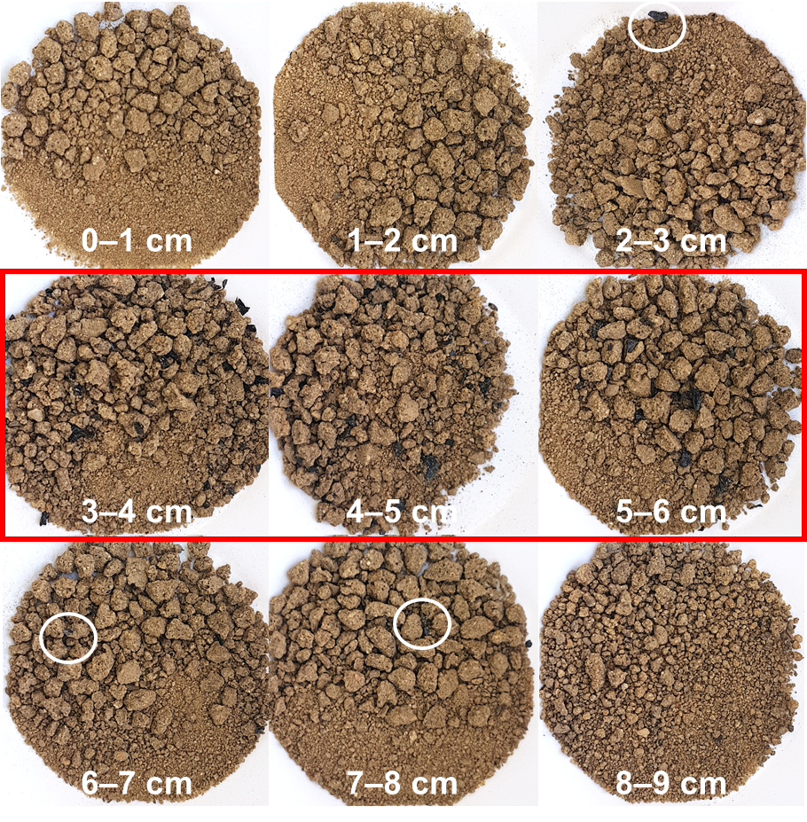
Figure S4. The close-up photographs of soil samples in each depth (0–9 cm) of LDPE film treatment (60 days, high-level irrigation). The red border indicates microplastic-containing soil layer (3–6 cm), and LDPE films observed in the top (0–3 cm) and bottom (6–9 cm) layers were marked in the white circles.

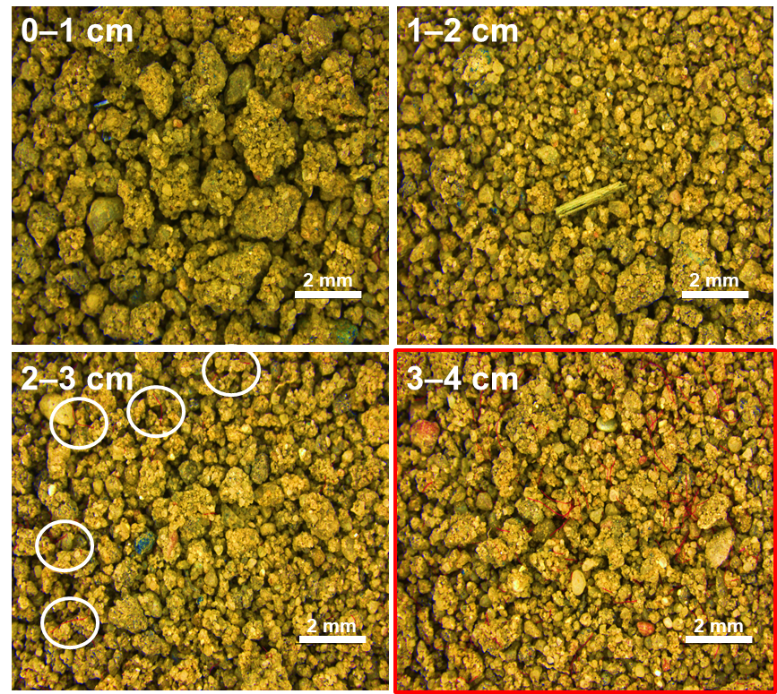
Figure S5. The close-up photographs of soil samples in each depth (0–9 cm) of PAN fiber treatment (60 days, low-level irrigation). The red borders indicate microplastic-soil layer (3–6 cm), and PAN fibers observed in the top (0–3 cm) and bottom (6–9 cm) layers were marked in the white circles.

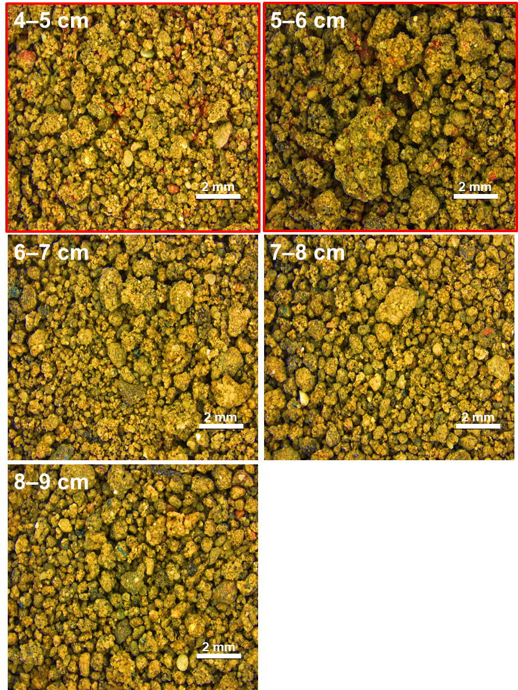
Figure S5. Continued

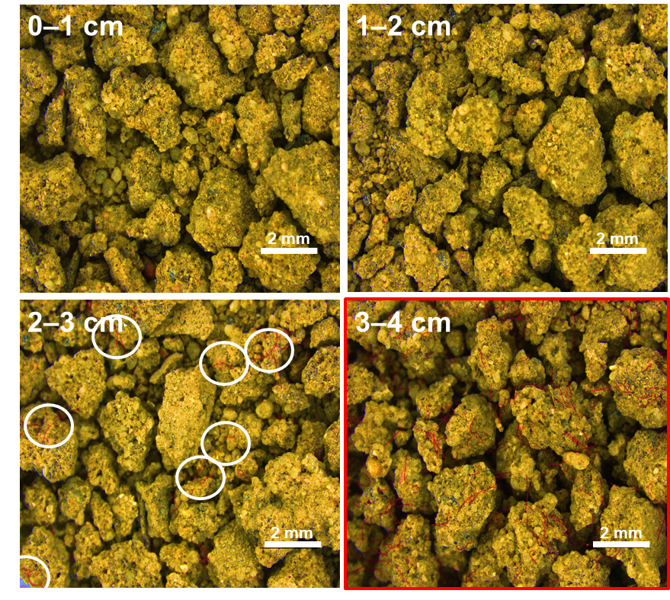
Figure S6. The close-up photographs of soil samples in each depth (0–9 cm) of PAN fiber treatment (60 days, high-level irrigation). The red borders indicate microplastic-soil layer (3–6 cm), and PAN fibers observed in the top (0–3 cm) and bottom (6–9 cm) layers were marked in the white circles.

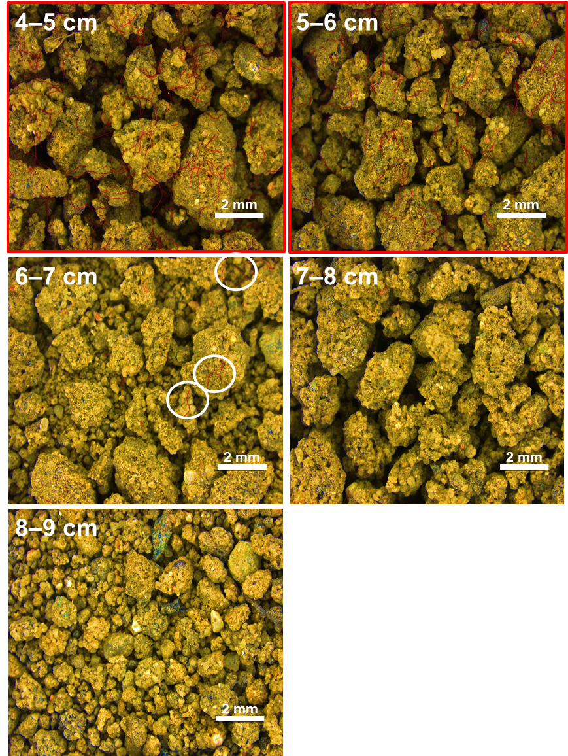
Figure S6. Continued

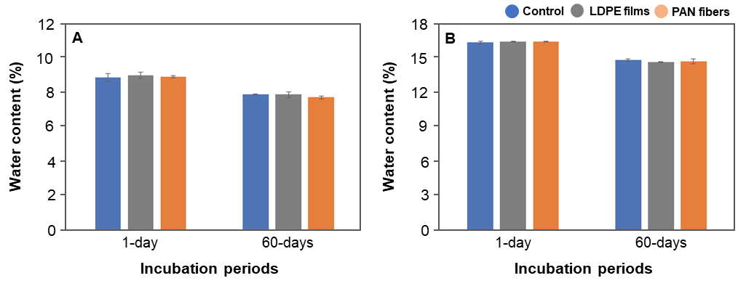
Figure S7. Total water contents in each soil column (control, LDPE films, and PAN fibers) after (A) low- and (B) high-level irrigations.

Table S1. Results for soil respirations and enzyme activities (acid phosphatase and β-D-glucosidase). Asterisk represents significance at the level of 5% (p = 0.05) between control and microplastic-containing soil layer treatments.

Soil depth | Top (0–3 cm) |  |  | Middle (3–6 cm) |  |  | Bottom (6–9 cm)
Treatment | Control | LDPE | PAN | Control | LDPE | PAN | Control | LDPE | PAN
Low-level irrigation
Soil respiration  (ppm h⁻¹) | 5.22  ±1.09 | 5.25  ±0.43 | 5.10  ±0.18 | 4.45  ±0.69 | 4.07  ±0.36 | 3.78  ±0.18 | 3.27  ±0.45 | 2.54  ±0.12* | 2.75  ±0.36*
Acid phosphatase  (µmol mg⁻¹ h⁻¹) | 5.41  ±2.72 | 5.14  ±0.79 | 4.35  ±1.29 | 3.44  ±0.19 | 5.64  ±1.02 | 4.13  ±0.73 | 5.40  ±3.05 | 4.79  ±0.55 | 8.90  ±5.02
β-D-glucosidase  (µmol mg⁻¹ h⁻¹) | NC | NC | NC | NC | NC | NC | 2.96  ±1.44 | 1.92  ±0.48 | 3.68  ±2.30
High-level irrigation
Soil respiration  (ppm h⁻¹) | 3.77  ±0.58 | 4.33  ±0.37 | 2.63  ±0.78 | 4.60  ±1.43 | 5.12  ±1.81 | 3.73  ±0.30 | 6.26  ±0.80 | 7.64  ±0.79* | 7.86  ±0.38*
Acid phosphatase  (µmol mg⁻¹ h⁻¹) | 5.60  ±1.86 | 6.26  ±1.74 | 24.02  ±19.07 | 4.87  ±0.68 | 5.67  ±0.27 | 11.37  ±11.67 | 4.09  ±0.35 | 5.12  ±0.98 | 8.32  ±6.06
β-D-glucosidase  (µmol mg⁻¹ h⁻¹) | NC | NC | NC | NC | NC | NC | 2.10  ±0.24 | 2.52  ±0.36 | 3.08  ±1.67

