Supplementary Materials

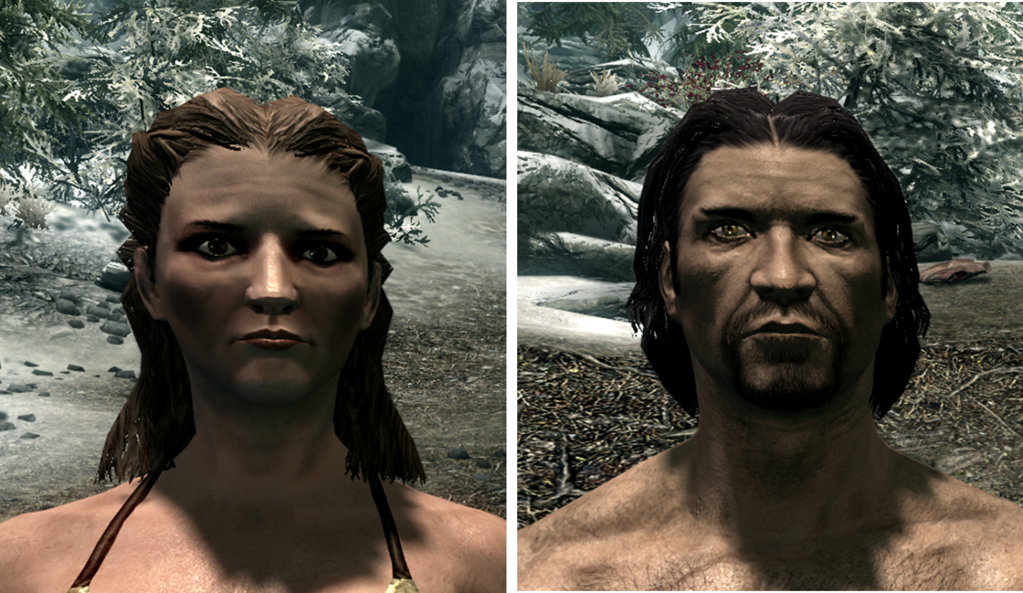

Supplementary Figure 1. Default avatars. This figure presents screenshots of the default female (left) and male (right) avatars for the Imperial race in The Elder Scrolls V: Skyrim.

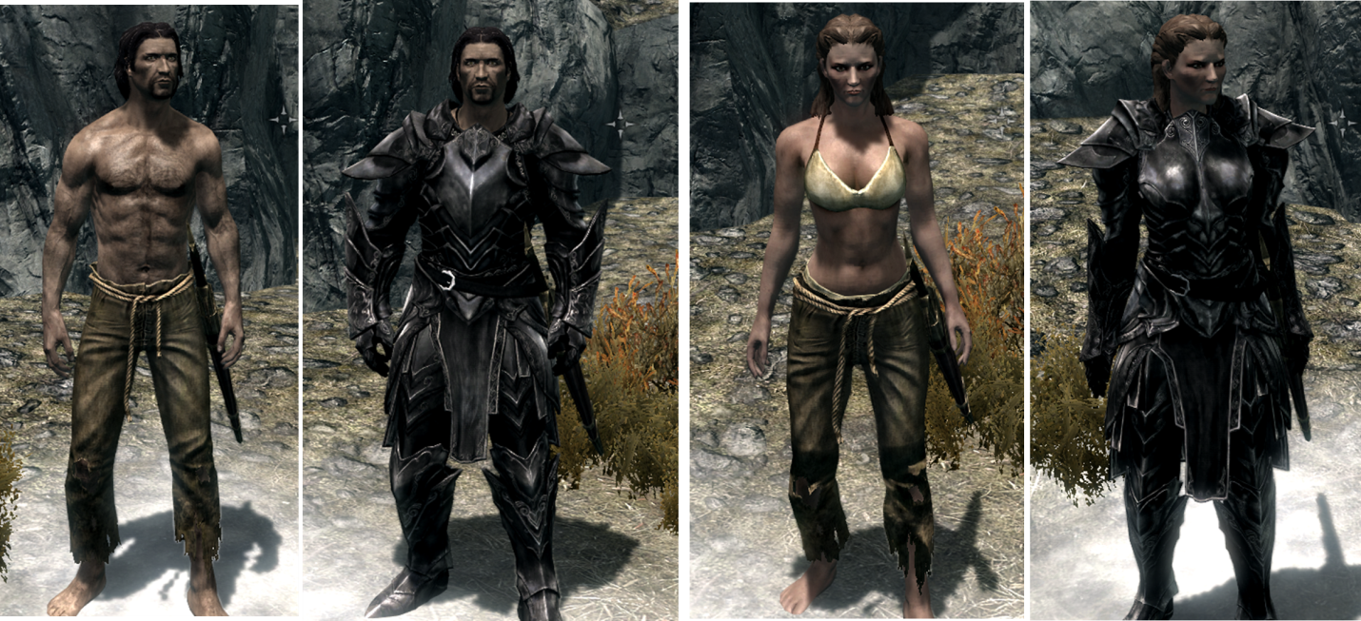

Supplementary Figure 2. Avatar attire. This figure presents screenshots of the ragged trousers and ebony armor items as they appear on the default male (left) and default female (right) avatars for the Imperial race in The Elder Scrolls V: Skyrim.

Supplementary Table 1. Estimated Marginal Means and Standard Error for the Main Effect of Avatar Sex on Skin Conductance and Corrugator Activity in the Low Salience Condition

 | SC |  | Corrugator Activity
Condition | EMM | SE |  | EMM | SE
Male Avatar | 1.018 | 0.624 |  | 31.194 | 7.137
Female Avatar | 1.035 | 0.642 |  | 33.212 | 5.817

Supplementary Table 2. Estimated Marginal Means and Standard Error for the Main Effect of Sex-type on Skin Conductance and Corrugator Activity in the Low Salience Condition
 | SC |  |  | Corrugator Activity
Condition | EMM | SE |  | EMM | SE
Sex-typed | 0.184 | 0.484 |  | 33.963 | 7.290
Non-sex-typed | 1.869 | 0.631 |  | 30.442 | 9.505

Supplementary Table 3. Estimated Marginal Means and Standard Error for the Main Effect of Avatar Sex on Skin Conductance and Corrugator Activity for Sex-typed Participants in the High Salience Condition

 | SC |  |  | Corrugator Activity
Condition | EMM | SE |  | EMM | SE
Same-sex Avatar | 1.151 | 0.778 |  | 16.405 | 10.069
Opposite-sex Avatar | 0.643 | 0.756 |  | 20.933 | 11.117

Supplementary Table 4. Estimated Marginal Means and Standard Error for the Main Effect of Avatar Sex on Skin Conductance for Non-sex-typed Participants in the High Salience Condition

 | SC |  |  | Corrugator Activity
Condition | EMM | SE |  | EMM | SE
Male Avatar | 0.004 | 0.697 |  | 38.922 | 12.118
Female Avatar | 1.324 | 0.605 |  | 30.844 | 9.533

