Supplementary Material

Supplementary Figures and Tables

Supplementary Figures
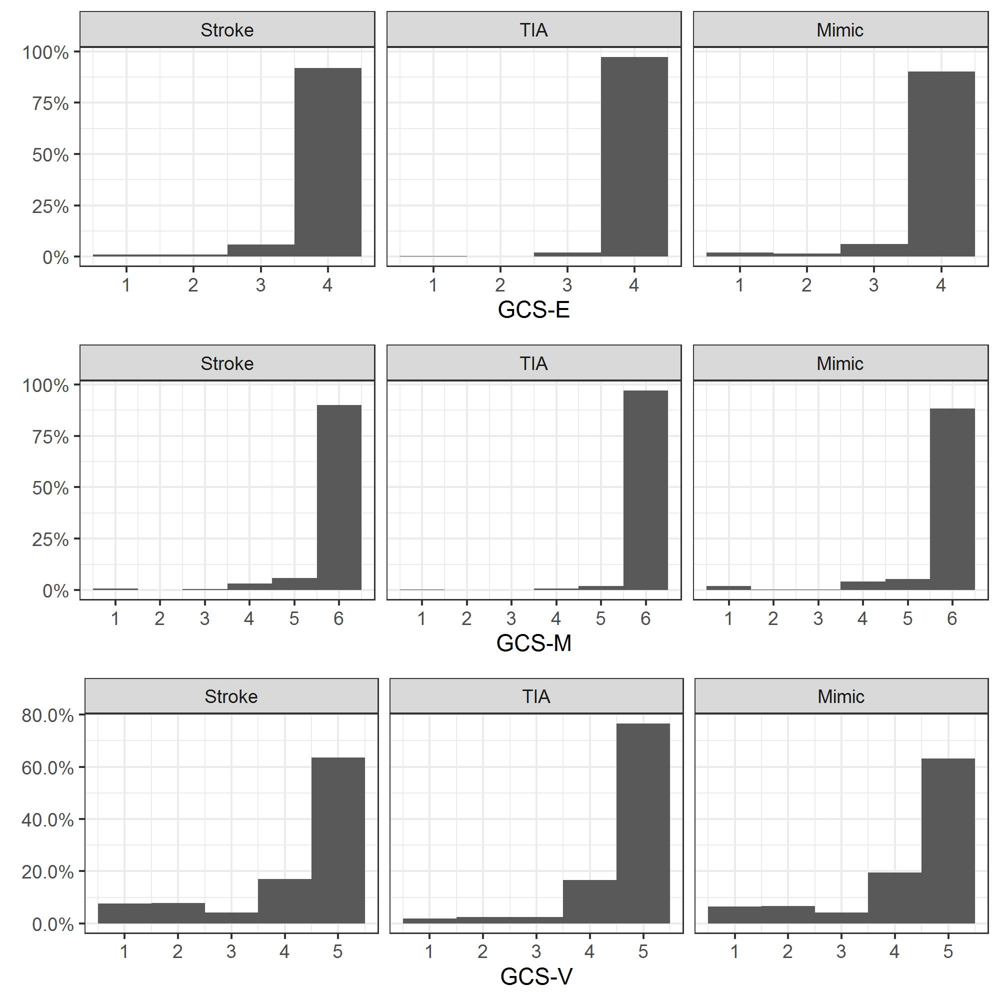
Supplementary Figure S1. Distribution of elements of GCS recorded prehospital for suspected strokes, categorized by final diagnosis of stroke, TIA and mimics.

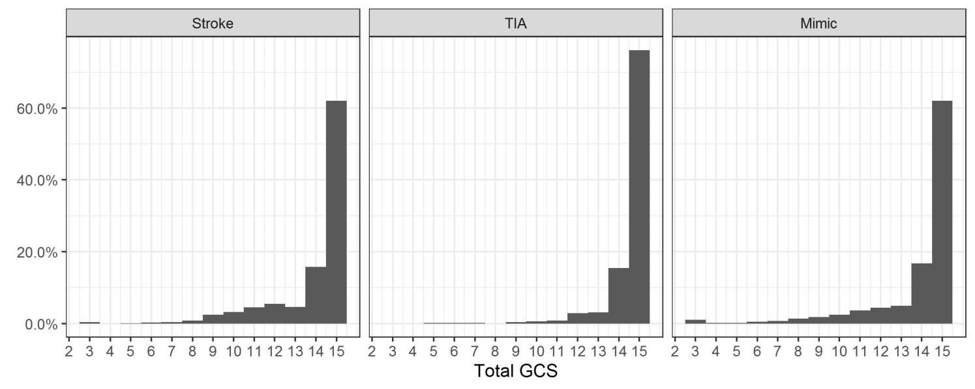
Supplementary Figure S2. Distribution of total GCS recorded prehospital for suspected strokes, categorized by final diagnosis of stroke, TIA and mimics.
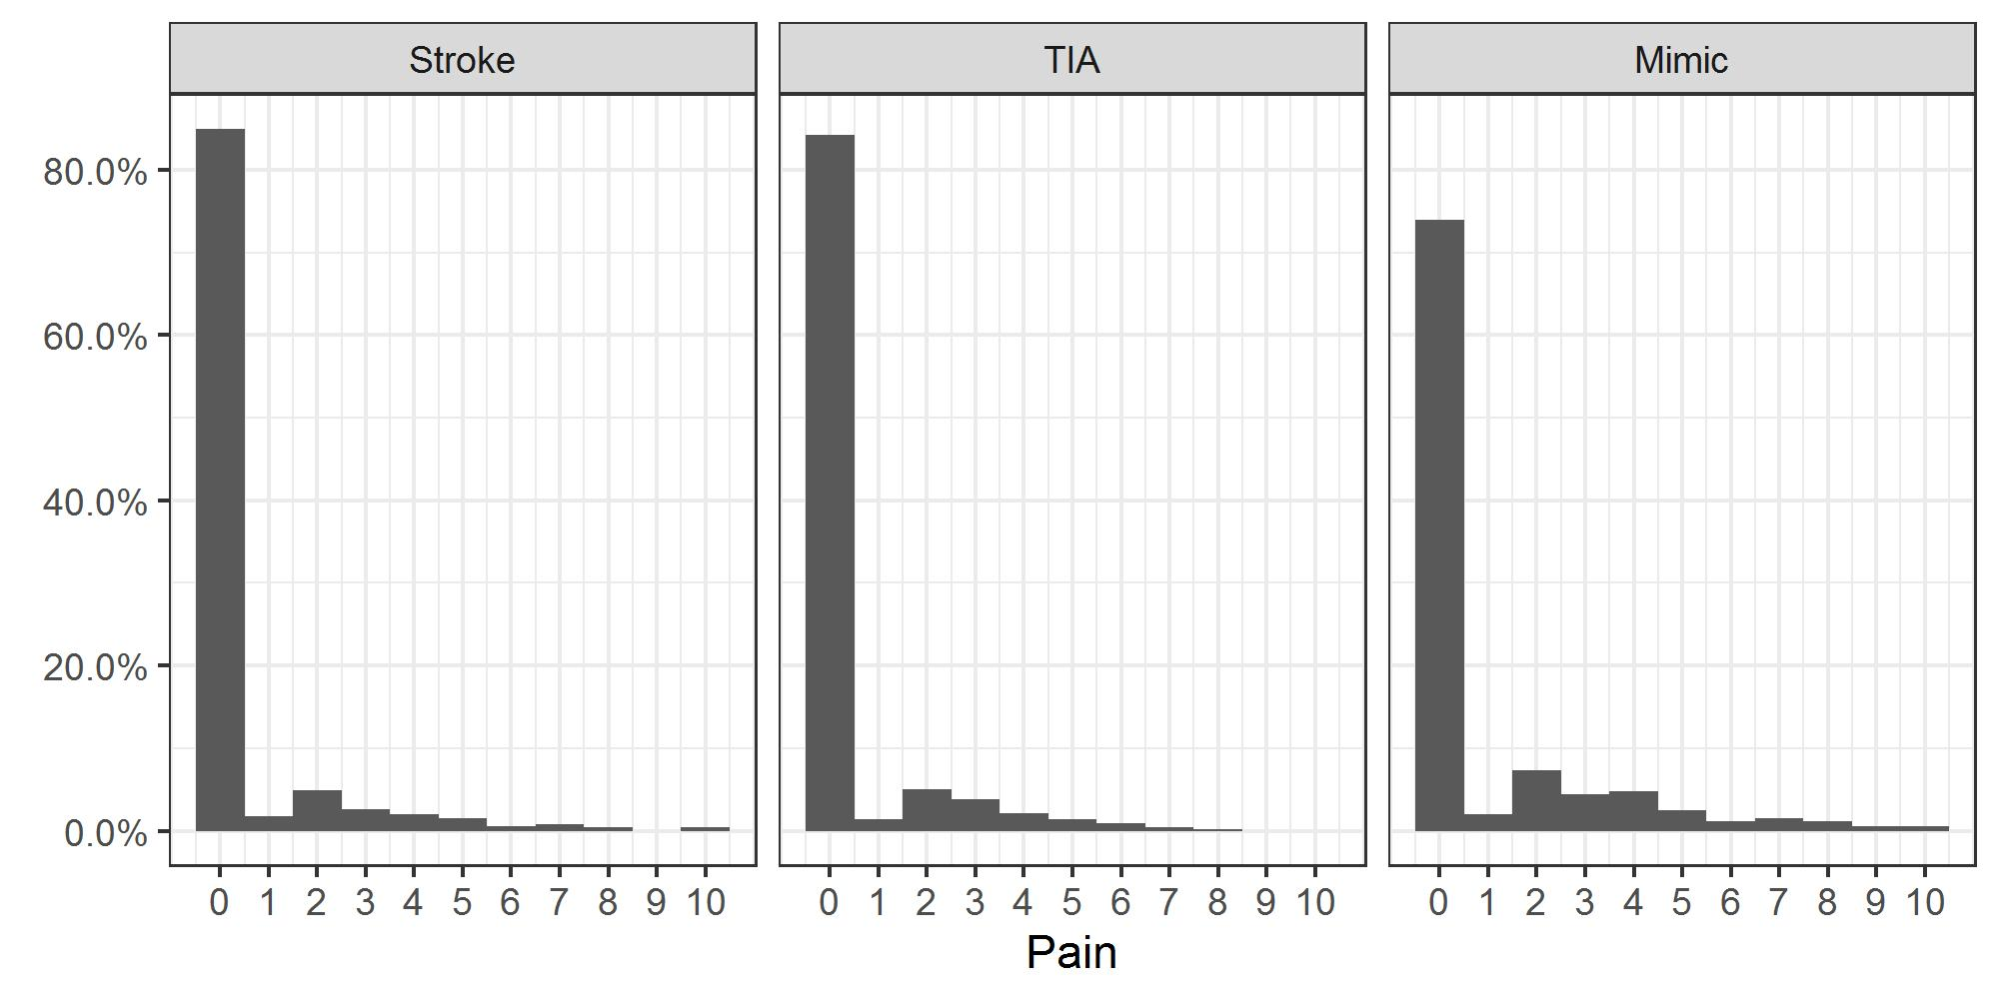
Supplementary Figure S3. Distribution of pain score recorded prehospital for suspected strokes, categorized by final diagnosis of stroke, TIA and mimics.

Supplementary Tables
Supplementary Table S1: Full description of variables recorded in the patient record form
Category | Field | Notes
Previous History | PMH ischemic heart disease | Include angina, previous MI
 | PMH atrial fibrillation or flutter | Prior history of atrial fibrillation, atrial flutter. Includes permanent and paroxysmal
 | PMH hypertension | Documented as high blood pressure or hypertension
 | PMH diabetes | Documented as type 1 or 2 diabetes mellitus
 | PMH Epilepsy | Prior history of epilepsy. Include any patient with a prior history of seizures. Do not include if incident is first ever seizure.
 | PMH Stroke or TIA | Prior history of stroke or TIA, do not include current incident
 | PMH Migraine | Prior history of migraine, with or without aura. Do not include if only says ‘headaches’
 | PMH Dementia | Prior history of any type of dementia
 | PMH Mental health | Prior history of any mental health condition eg: depression, anxiety, psychosis, schizophrenia but NOT dementia
 | Substance misuse | Mark yes if any prior or incident related drug abuse
 | Alcohol misuse | History of any prior or incident related excessive or problematic alcohol use
Other symptoms:  as part of presenting incident (include things that patient reports but have resolved or not objectively seen by the paramedic) | Unilateral leg weakness | Unilateral leg weakness or drift downwards with gravity
 | Reduced mobility/ Unable to mobilise | Documented inability or difficulty with standing or walking whatever the reason, including unilateral leg weakness
 | Unsteadiness/ ataxia | Documented to be unsteady, have poor balance or be ataxia which may be leading to reduced mobility or immobility
 | Visual disturbance/ changes | Any disturbance of vision including double vision / diplopia, visual field loss, loss of vision in one or both eyes. Do not include gaze deviation noted on examination.
 | Gaze deviation | Gaze deviation gaze deviation’, ‘staring/looking/gazing to left/right’ ‘eyes fixed to left/ noted on examination’
 | Seizures | Include if documented seizure(s) as part of the incident. Include if described as ‘seizure’, ‘fit’, or if loss or altered consciousness with limb shaking.
 | Vomiting | Any vomiting as part of incident, record as no if nausea only
 | Difficulty swallowing | Coughing or choking on eating or drinking, or any other change in swallowing
 | Dizziness | Dizziness or vertigo
 | Leaning to one side | Noted to be leaning or slumped to one side as main complaint
 | Fall | Any fall from sitting or standing
 | Headache | Headache as part of current incident, regardless of prior history
 | Loss of consciousness | Complete loss of consciousness as part of current incident, regardless of whether recovered before paramedics arrive or en route to hospital
 | Generalised weakness | General weakness of all 4 limbs, if worse on one side mark ‘N’ and record as arm and/or leg weakness
 | Memory loss | Any amnesia around time of incident, either prompting the call or noted by paramedics
 | Behavioral changes | Any noted alteration in behavior not meeting other symptoms in list
 | Confusion | Clear new onset confusion, clouding of consciousness, lack of attention
 | Loss/ change in sensation | Loss of/ change in feeling anywhere in body as part of current incident eg numbness, paraesthesia

Supplementary Table S2: Patients that died within 30 days of admission, broken down by ambulance pathway adherence, area and final diagnosis
 | OOA suspected strokes |  |  | Local suspected strokes |  |  | All local strokes and TIAs  (n=886)
 | Stroke  (n=1697) | TIA  (n=334) | Mimic  (n=1072) | Stroke  (n=494) | TIA  (n=149) | Mimic  (n=426)
FAST- | <5 (<0.2%) | <5 (<1.5%) | <5 (<0.4%) | <5 (<1.0%) | <5  (<3.4%) | 0  (0.0%) | 7  (0.8%)
Pathway exclusion | 22  (1.3%) | 0 (0.0%) | 8  (0.7%) | 13  (2.6%) | 0  (0.0%) | 10  (2.3%) | 18  (2.0%)
Total | 204 (12.0%) | 7 (2.1%) | 63  (5.9%) | 71  (14.4%) | <5  (<3.4%) | 30  (7.0%) | 91  (10.3%)

