Supplementary Material (Supplement 1)

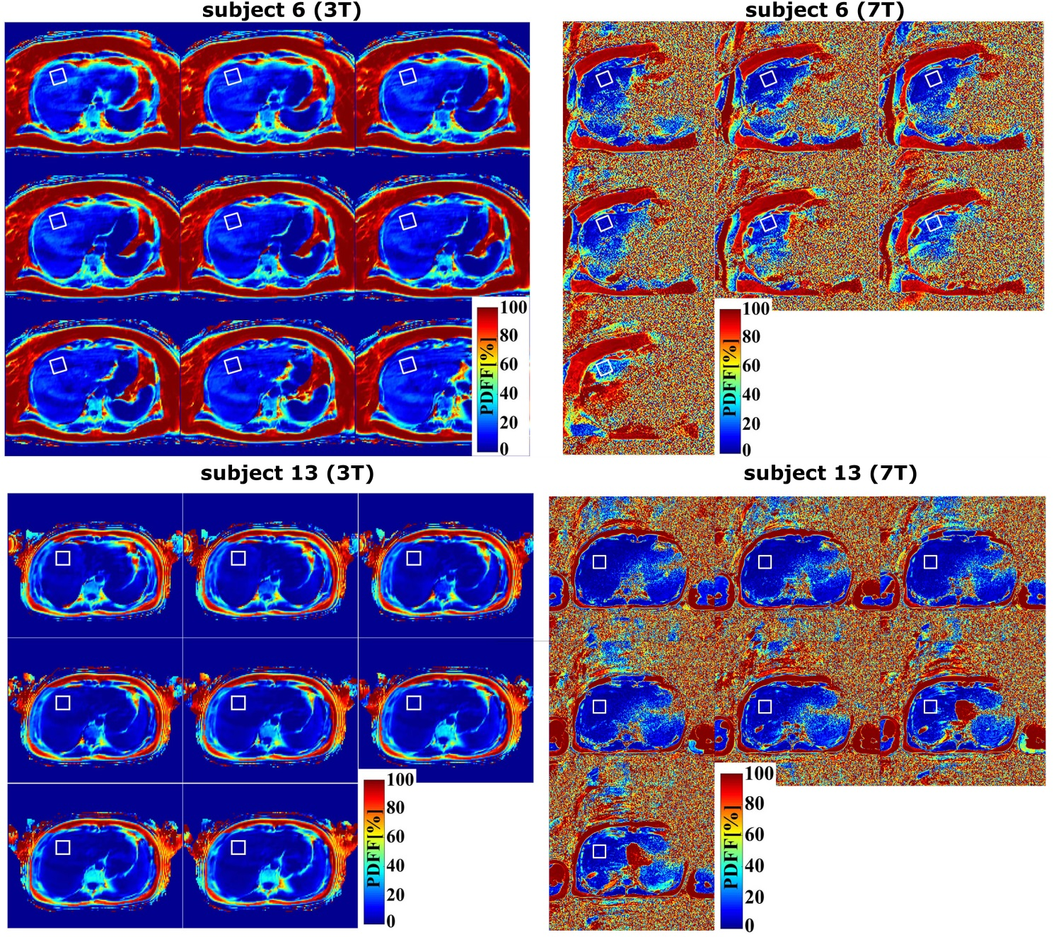
Figure Supp1-1. Examples (subjects S6 and S13) of MRI-PDFF maps of slices cutting the investigated volume of interest (VOI) at 3T and 7T fields. The position of the investigated volume that corresponds to the largest axial cross-section in the cranial section of the liver (same/similar as MRS) is depicted by white solid boxes in MRI-PDFF maps.

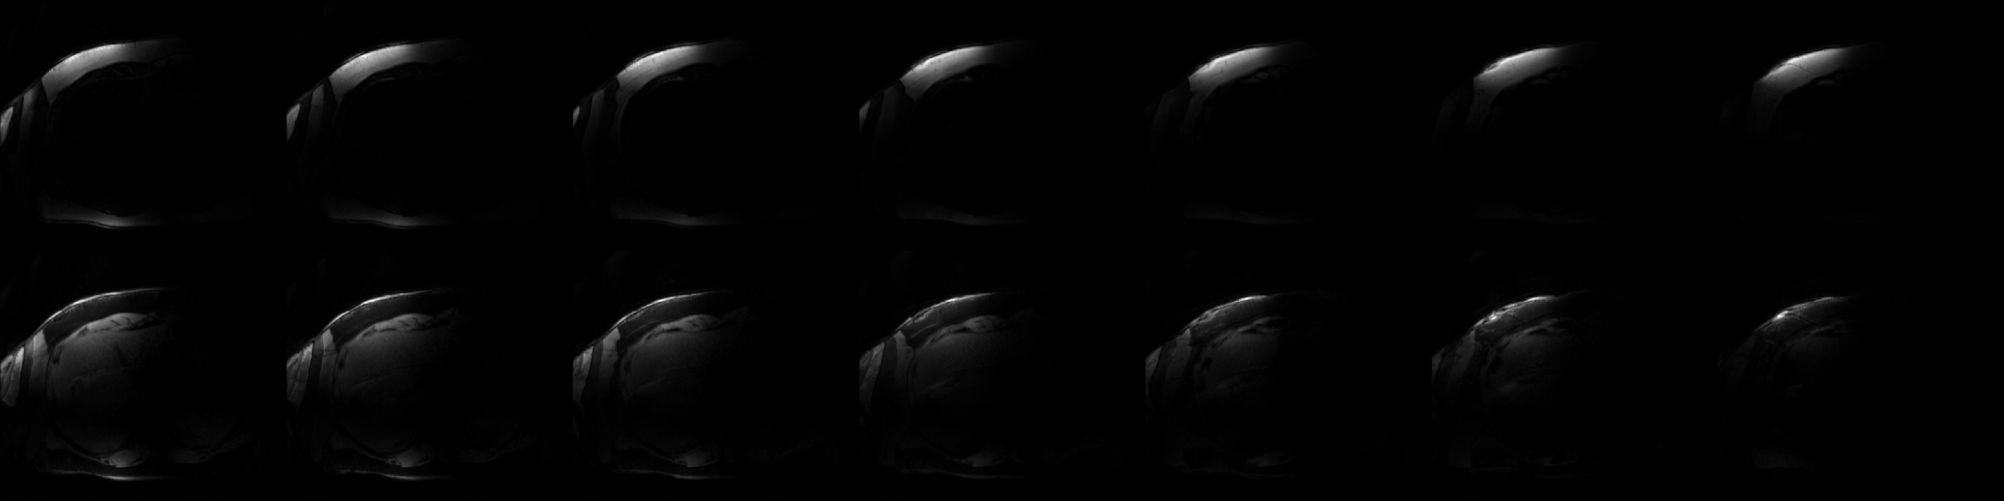
Figure Supp1-2. The anatomical reconstructed fat and water images of subject S6 at 7T field (related PDFF maps in Figure Supp1-1.).
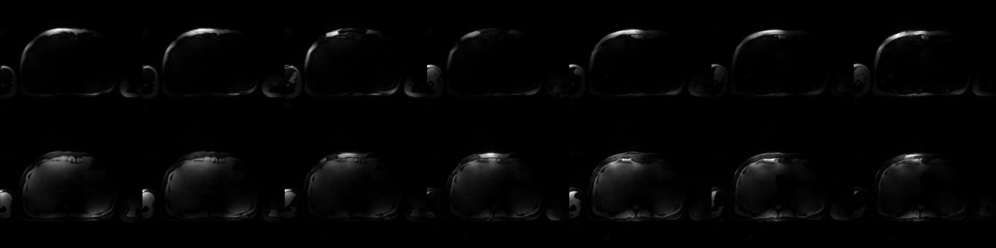
Figure Supp1-3. The anatomical reconstructed fat and water images of subject S13 at 7T field (related PDFF maps in Figure Supp1-1.).

