Total flavonoids of Glycyrrhiza uralensis alleviates irinotecan-induced colitis via modification of gut microbiota and fecal metabolism
Shi-Jun Yue^{1†}, Yi-Feng Qin^{2,3†}, An Kang², Hui-Juan Tao², Gui-Sheng Zhou², Yan-Yan Chen¹, Jian-Qin Jiang³, Yu-Ping Tang^{1*}, Jin-Ao Duan²
Corresponding author: yupingtang@sntcm.edu.cn
† These authors contribute equally to the paper.

Supplementary Table 1. Mass spectral data for identification of the 27 compounds in the total flavonoids of Glycyrrhiza uralensis analyzed by UPLC–Q-TOF-MS/MS.
Peak | RT (min) | [M-H]⁻ | MS² ions | Identification | Molecular Formula
 |  | Mean measured mass (Da)
F1 | 9.134 | 433.1047 | 271.0546; 150.9994; 119.0473 | Unknown | C₂₈H₁₈O₅
F2 | 9.501 | 417.1104 | 255.0594; 135.0051; 119.0473; 91.0175 | Isoliquiritin | C₂₁H₂₂O₉
F3 | 9.896 | 417.1099 | 255.0601; 135.0063; 119.0487; 91.0191 | Liquiritin | C₂₁H₂₂O₉
F4 | 10.284 | 549.1494 | 417.1101; 255.0594; 135.0052; 119.0472 | Liquiritin apioside | C₂₆H₃₀O₁₃
F5 | 13.673 | 654.1683 | 591.1576; 531.1403; 255.0594; 135.0056; 61.9898 | Unkown | C₃₃H₂₄O₇
F6 | 15.013 | 549.1501 | 417.1150; 255.0596; 135.0052; 119.0472; 91.0190 | Isoliquiritin apioside | C₂₆H₃₀O₁₃
F7 | 15.338 | 255.0583 | 135.0050; 119.0469; 91.0170 | Liquiritigenin | C₁₅H₁₂O₄
F8 | 15.474 | 549.1615 | 417.1193; 255.0671 | Neolicuraside | C₂₆H₃₀O₁₃
F9 | 15.482 | 255.0586 | 135.0051; 119.0475; 91.0179 | Isoliquiritigenin | C₁₅H₁₂O₄
F10 | 15.534 | 549.1498 | 429.0951; 255.0595; 135.0048 | Licuraside | C₂₆H₃₀O₁₃
F11 | 15.936 | 669.1728 | 549.1542; 531.1393; 255.0592; 135.0055 | Unkown | C₂₁H₂₂O₉
F12 | 16.885 | 433.1388 | 271.0921; 135.0422 | 5-Hydroxyl liquiritin | C₂₁H₂₁O₁₀
F13 | 17.036 | 725.1974 | 549.1511; 531.1395; 399.0981; 255.0594; 193.0447; 135.0049 | Licorice glycoside A | C₃₆H₃₈O₁₆
F14 | 19.761 | 725.1890 | 549.1453; 531.1375; 399.0940; 255.0578; 193.0464; 135.0060 | Licorice glycoside C2/C1 | C₃₆H₃₈O₁₆
F15 | 20.068 | 429.0738 | 269.0738; 160.8379 | Unkown | —
F16 | 22.991 | 255.0601 | 135.0053; 119.0476; 91.0181 | Neoisoliquiritin | C₁₅H₁₂O₄
F17 | 23.401 | 401.0787 | 313.0642; 269.0758; 225.0498; 121.0263 | Unkown | C₁₉H₁₆O₇
F18 | 27.800 | 323.1687 | 203.0659; 119.0475; 61.9900 | Glabridin | C₂₀H₁₉O₄
F19 | 30.067 | 353.0850 | 323.0378; 284.0646; 176.0392 | Licoiso flavanone A | C₂₀H₁₇O₆
F20 | 30.315 | 337.1003 | 293.0309; 281.0387; 117.0318 | Unkown | C₂₀H₂₀O₂
F21 | 31.644 | 337.1366 | 305.1110; 187.0709; 93.0340 | Unkown | —
F22 | 31.910 | 353.0954 | 227.0652; 125.0213; 57.0372 | Unkown | —
F23 | 32.353 | 337.1374 | 305.1119; 279.0597; 173.0194; 93.0341 | Licochalcone B | C₂₁H₂₁O₄
F24 | 32.700 | 337.1378 | 305.1122; 243.0976; 187.0718; 93.0339 | Licochalcone A | C₂₁H₂₁O₄
F25 | 33.847 | 335.0847 | 291.0961; 199.0715; 135.0061 | Unkown | C₂₀H₁₅O₅
F26 | 35.635 | 351.0791 | 283.0907; 199.0710 | Licoiso flavone B | C₂₀H₁₅O₆
F27 | 36.194 | 337.0641 | 201.0503; 162.9990; 135.0052; 91.0179 | Unkown | C₁₉H₁₃O₆

Supplementary Figure 1. The extraction process (yellow line) of the total flavonoids from Glycyrrhiza uralensis.

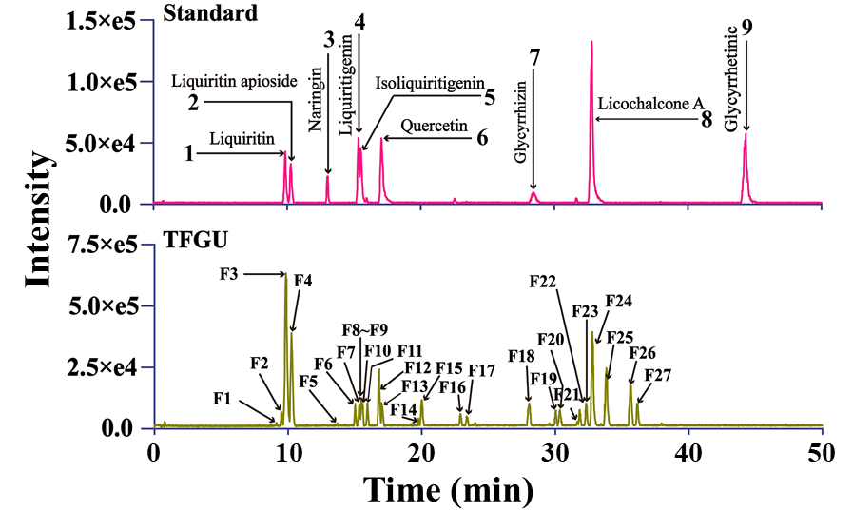
Supplementary Figure 2. BPI chromatograms of the standards and the total flavonoids of Glycyrrhiza uralensis (TFGU) under the negative ion mode (ESI⁻). Shimadzu LC-20A: Shim-pack XR-ODS column (2.0 mm i.d.×100 mm), column temperature 40°C, injection volume 2 μL, flow rate 0.4 mL/min, 0.1% formic acid aqueous (A) and acetonitrile (B): 10% B at 0-4 min, 10%~30% B at 4-20 min, 30%~35% B at 20-35 min, 35%~60% B at 35-50 min. AB SCIEX Triple TOF 5600: ESI⁻, m/z 50-1200 Da, spray voltage -4500 V, curtain gas 40°C, turbo spray temperature 550°C, collision energy -40 V, declustering potential -100 V.

Supplementary Figure 3. Venn diagram showing the overlap of OTUs in each group. 181 OTUs were present in all groups, while 18, 7, 17, 7 OTUs uniquely present in Con group, Mod group, CIF group, TFGU group, respectively.

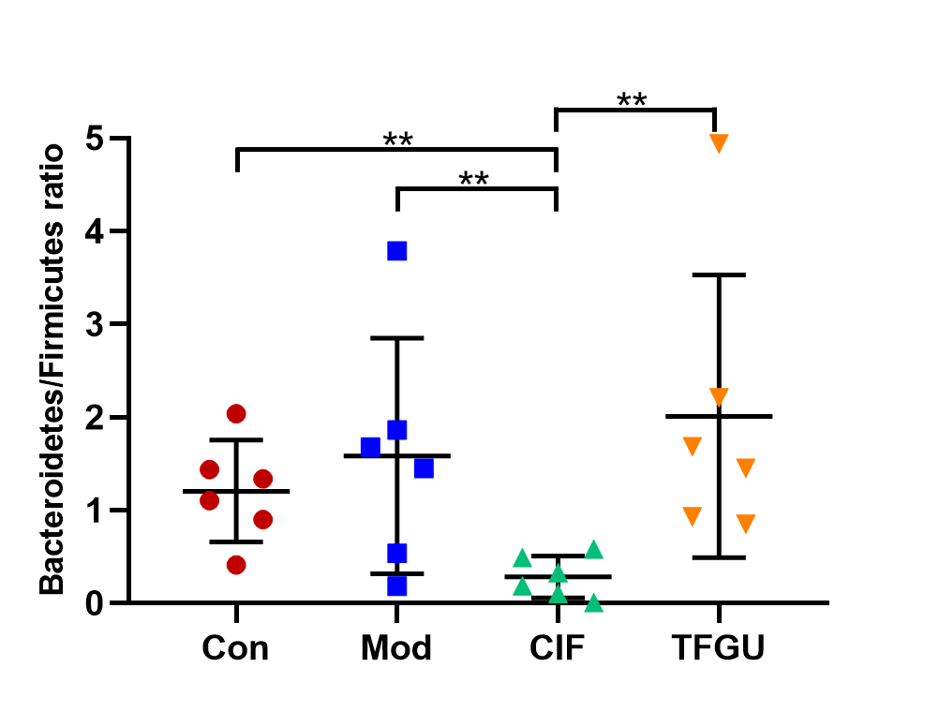
Supplementary Figure 4. Effects of TFGU on the Bacteroidetes/Firmicutes ratio of the gut microbiota in CPT-11-induced colitis mice. n = 6 mice/group, P < 0.05, P < 0.01.

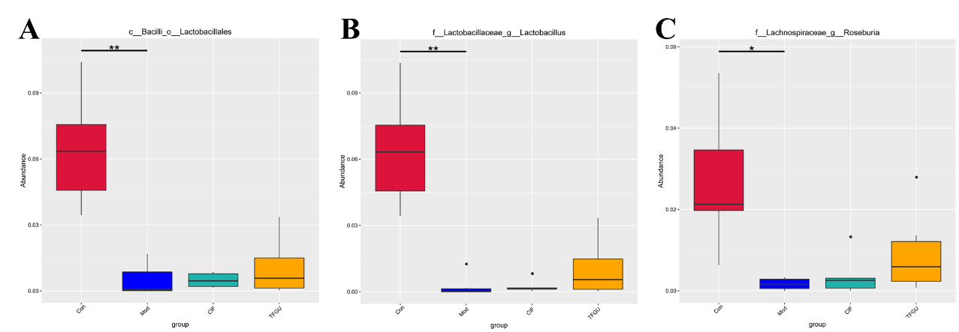
Supplementary Figure 5. The relative abundance of Lactobacillales, Lactobacillus and Roseburia in each group. n = 6 mice/group, P < 0.05, P < 0.01.

Supplementary Figure 6. The heatmap of the gut microbiota of all samples at the genus level on CPT-11-induced experimental colitis in fecal samples of mice (n = 6 mice/group).

Supplementary Figure 7. The linear discriminant analysis effect size (LEfSe) cladogram shows that brown dots are unimportant bacteria in any groups; other colored dots are important bacteria in the group labeled with the same color. The circles from the outside to the inside indicate genus, family, order, class, phylum, and kingdom. The diameter of each circle is proportional to its abundance.

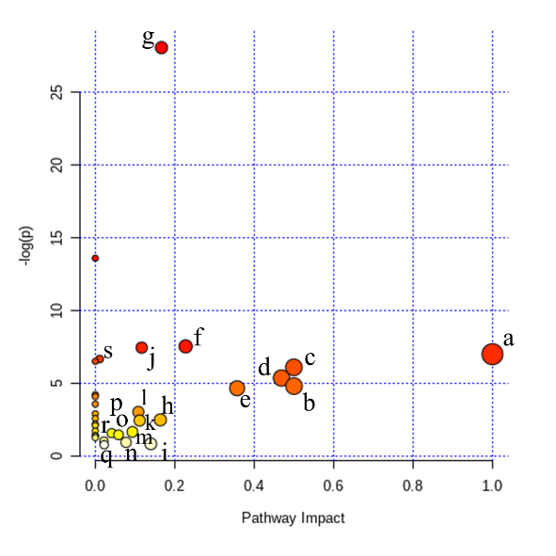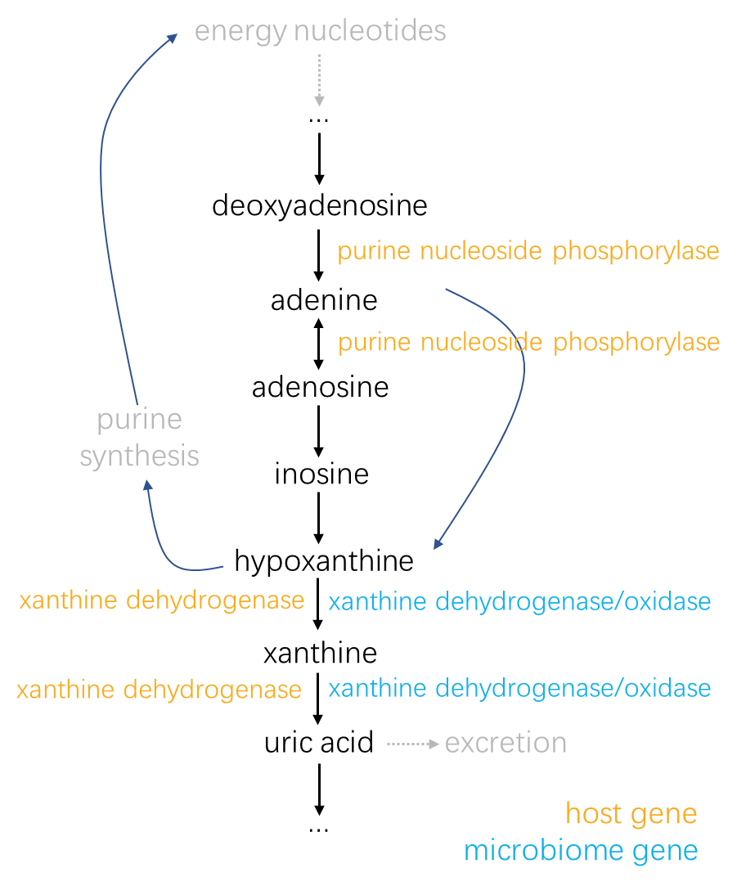
Supplementary Figure 8. The pathway analysis of the CPT-11-induced colitis mice by MetaboAnalyst (A) and the simplified human-microbiome purine metabolism (B). a: Phenylalanine, tyrosine and tryptophan biosynthesis; b: Glycine, serine and threonine metabolism; c: D-Glutamine and D-glutamate metabolism; d: Alanine, aspartate and glutamate metabolism; e: Phenylalanine metabolism; f: Glyoxylate and dicarboxylate metabolism; g: Aminoacyl-tRNA biosynthesis; h: Arginine and proline metabolism; i: Tyrosine metabolism; j: Arginine biosynthesis; k: Pyrimidine metabolism; l: Glutathione metabolism; m: Glycerolipid metabolism; n: Amino sugar and nucleotide sugar metabolism; o: Citrate cycle (TCA cycle); p: Purine metabolism; q: Primary bile acid biosynthesis; r: Cysteine and methionine metabolism; s: Valine, leucine and isoleucine degradation.

