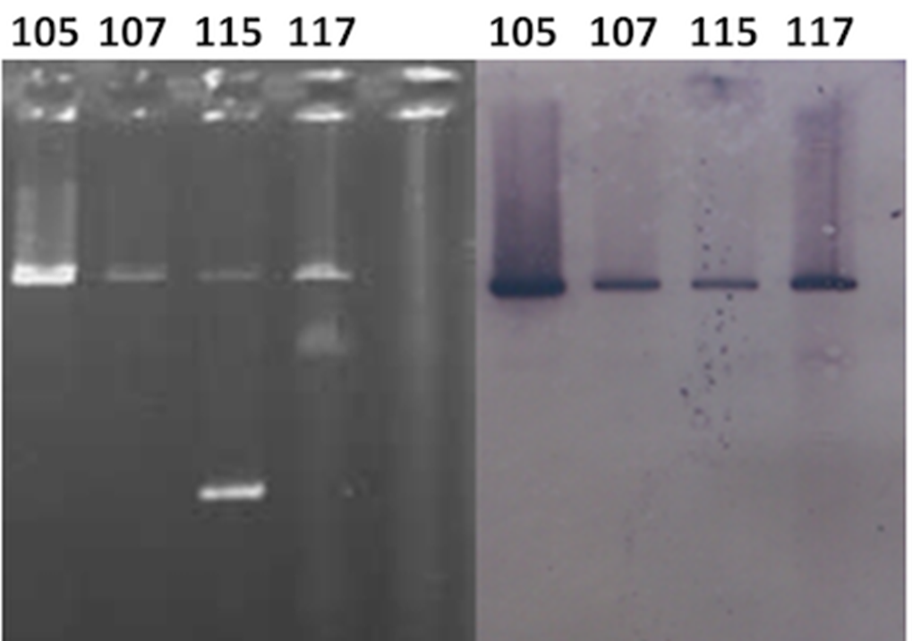Supplementary Figure 1. Gel presenting plasmids extracted from transconjugants obtained from conjugation between ESBL-producing K. oxytoca strains and the recipient E. coli ML1410 strain (Left panel) and Southern blot hybridization of these plasmids with bla_{CTX-M-2} gene probe (Right panel). Lanes 105, 107, 115, and 117: transconjugants received plasmids from strains Ko105, Ko107, Ko115, and Ko117, respectively.

