Supporting information
Stem photosynthesis in Mikania micrantha
A Li6800 portable photosynthesis system was use measured stem photosynthesis in M. micrantha. Net photosynthesis of the stems were expressed on a half surface area basis. From Figure S1, it can be seen that stem photosynthesis was an eighteenth of leaf photosynthesis. Due to the small effective area and the limited accuracy of the instrument, the stem photosynthesis showed a larger fluctuation than leaf photosynthesis. The maximum fluctuation range stem photosynthesis reached 0.5 μmol m^{–2} s^{–1}, which was significant larger than the fluctuation level of the leaves (0.1 μmol m^{–2} s^{–1}).
FIGURE S1| Changes of net photosynthetic rate in leaves and stems of Mikania micrantha when PPFD was switched off (A). Net photosynthetic rate and respiration rate in stems of Mikania micrantha was plotted together in one figure (B). Gas exchange in leaves and stems of Mikania micrantha were measured in the intervals of 5 seconds using a LI-6800 Portable Photosynthesis System (Li-Cor, Lincoln, NE, USA).

Stem surface characteristics of Mikania micrantha and the native species
According to the microscopic image of the stems (Figure S2), we can clearly see that the stem surface characteristics of the invasive species M. micrantha was different from the native species. The stem surface of M. micrantha was smooth and glabrous, whereas those of the three native species had abundant trichomes. Pueraria lobata had the longest trichome length, which was followed by that of Pharbitis nil and Paederia scandens. Under normal growth conditions, M. micrantha, P. nil and P. scandens accumulated anthocyanins leading to a characteristic red of the stems. They turn into green during defoliation treatment. By contrast, Pueraria lobata did not accumulate anthocyanins in the stems, and had no visible change during defoliation treatment.
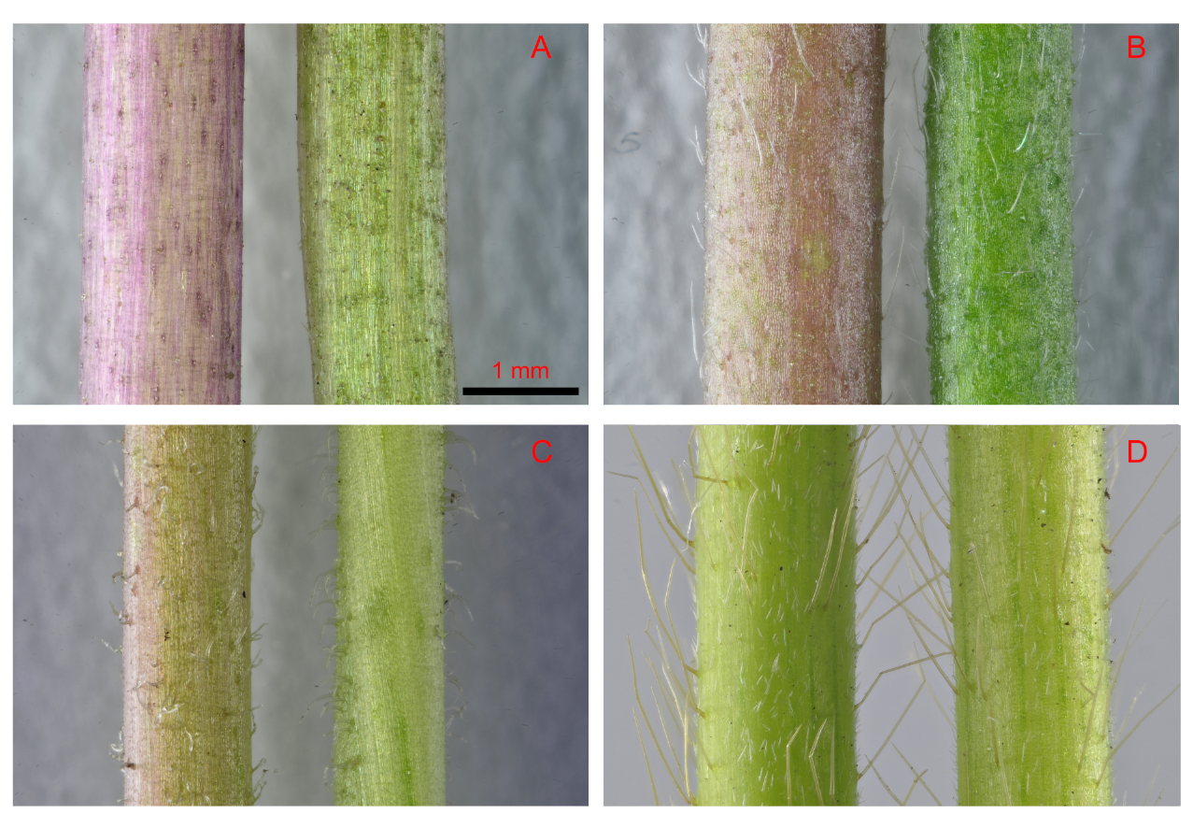
FIGURE S2| Stem external features of invasive plant Mikania micrantha (A) and three native plants, Pharbitis nil (B), Paederia scandens (C) and Pueraria lobata (D) on after removal of leaves for 20 days. In each panel, the stem on the left and right were the non-defoliation group and defoliation group, respectively.

Changes of Φ_{PSII} and NPQ in the stems of Mikania micrantha after removal of leaves
On day 20 after removal of leaves, the effective quantum yield (Φ_{PSII}) in stems of M. micrantha increased to the levels of its leaves (Figure S3). Similarly, non-photochemical quenching (NPQ) was shifted toward the levels of leaves. Therefore, chlorophyll fluorescence characteristics in the stems become more similar as in leaves of non-defoliation plants after removal of leaves.
FIGURE S3| Change of effective quantum yield (Φ_{PSII}) (A) and non-photochemical quenching (NPQ) (B) in stems of Mikania micrantha after removal of leaves for 20 days. Leaves of the non-defoliation group were also used the object to be compared.

