Supporting information for the manuscript entitled
Depth-dependent diversity patterns of rocky subtidal macrobenthic communities along a temperate fjord in Northern Chilean Patagonia
Supplementary figures
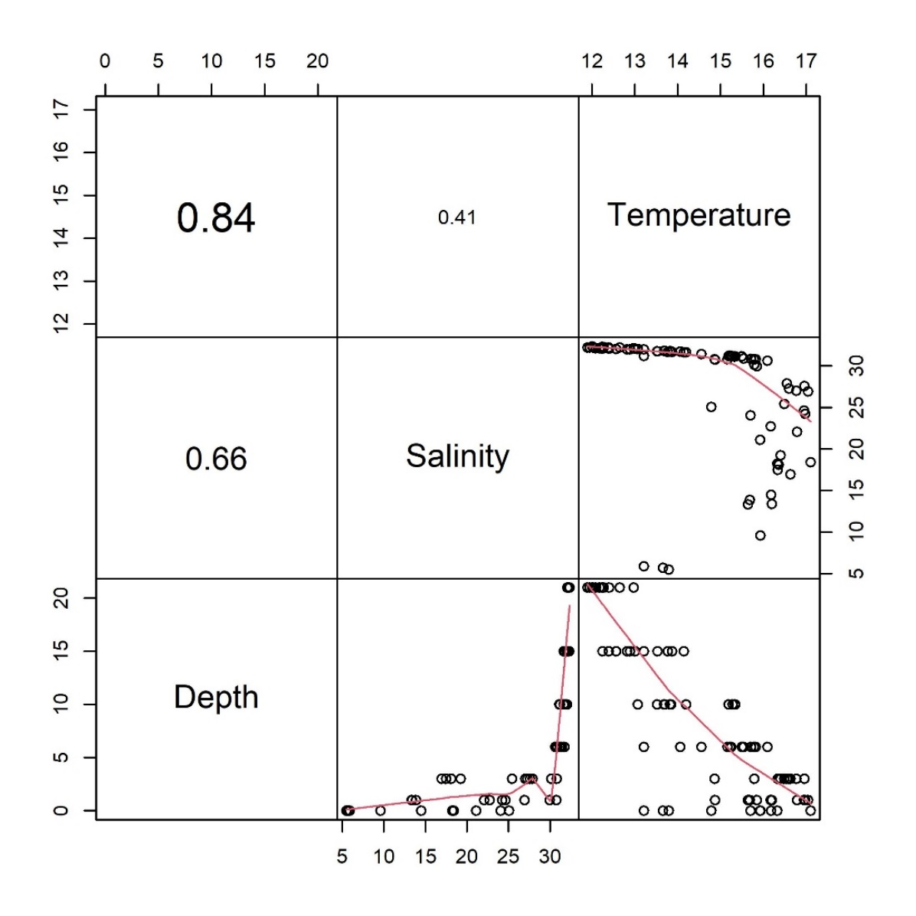
Supplementary Figure 1. Pearson correlations between environmental variables and depth. Scatterplot showing temperature (C°), salinity (psu) and depth (m) correlations. The axes present respectively “raw” data. To aid visual interpretation a LOWESS smother is added (red lines).

Supplementary Figure 2. Distribution of species richness along depth at three sites for the head sections of Comau fjord. Mean species richness expressed as the total number of taxa in each OUs are shown. The error bars represent the 95% confidence intervals.

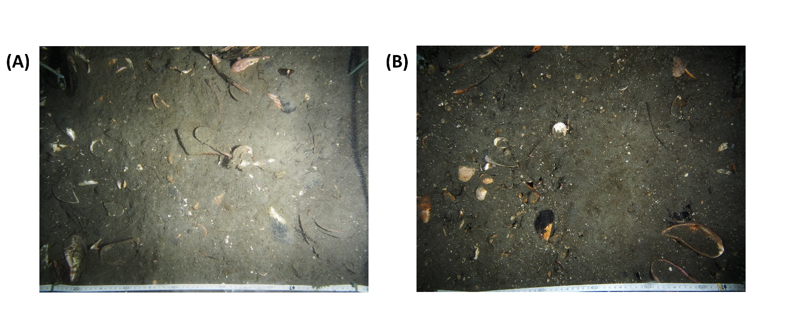
Supplementary Figure 3. Representative observational units (28 m²) of the 21-meter stratum at the head section of the Comau fjord. A random chosen replicate of (A) site N°9 and (B) site N°11 are shown.

Supplementary Figure 4. Benthic representatives’ taxa of Comau fjord. Scheme with the subdominant species at each depth range along the fjord sections. Generally, Lithothamnion sp. and Aulacomya atra was the most dominant taxa in all depth-section groups.

Supplementary tables
Supplementary Table 1. List of taxonomic identities identified between 0 and 21 m depth range at three sections of Comau fjord, Northern Patagonia. The occurrence of each taxon with its corresponding phylum for each area is shown.
Taxon | Phylum | Head | Middle | Mouth
Rhynchonellata class
Magellania venosa (Dixon, 1789) | Brachiopoda | X | X | X
Anthozoa class
Swiftia spp. | Cnidaria | X
Anthothoe chilensis (Lesson, 1830) | Cnidaria | X | X | X
Boloceropsis/Bolocera sp. | Cnidaria |  | X
Bunodactis hermafroditica Carlgren, 1959 | Cnidaria | X |  | X
Caryophyllia huinayensis Cairns, Häussermann & Försterra, 2005 | Cnidaria | X | X | X
Cereus herpetodes (McMurrich, 1904) | Cnidaria | X | X | X
Clavulariidae Hickson, 1894 | Cnidaria | X | X | X
Corynactis sp. | Cnidaria |  | X | X
Desmophyllum dianthus (Esper, 1794) | Cnidaria | X | X | X
Epizoanthus fiordicus Sinniger & Häussermann, 2009 | Cnidaria | X | X | X
Gonactinia prolifera (Sars, 1983) | Cnidaria | X | X | X
Halcurias pilatus McMurrich, 1893 | Cnidaria | X | X | X
Hormathia pectinata (Hertwig, 1882) | Cnidaria | X | X
Mesozoanthus fossii Sinniger & Häussermann, 2009 | Cnidaria |  |  | X
Metridium senile (Linnaeus, 1761) | Cnidaria | X | X | X
Paranthus niveus (Lesson, 1830) | Cnidaria |  | X
Parazoanthus elongatus McMurrich, 1904 | Cnidaria |  | X | X
Primnoella chilensis (Philippi, 1894) | Cnidaria |  | X | X
Swiftia comauensis Breedy, Cairns & Haussermann, 2015 | Cnidaria |  |  | X
Tethocyathus endesa Cairns, Häussermann & Försterra, 2005 | Cnidaria | X | X
Hydrozoa class
Unid. hydroid (morpho 1) | Cnidaria | X | X | X
Unid. hydroid (morpho 2) | Cnidaria | X | X
Unid. hydroid (morpho 3) | Cnidaria | X | X | X
Hybocodon chilensis Hartlaub, 1905 | Cnidaria |  | X | X
Hydractinia pacifica Hartlaub, 1905 | Cnidaria | X |  | X
Obelia dichotoma (Linnaeus, 1758) | Cnidaria | X | X | X
Obelia geniculata (Linnaeus, 1758) | Cnidaria |  | X
Plumularia spp. | Cnidaria | X | X | X
Sertularella spp. | Cnidaria |  |  | X
Ascidiacea class
Aplidium spp. | Chordata |  |  | X
Unid. ascidian (morpho 1) | Chordata | X |  | X
Corella eumyota Traustedt, 1882 | Chordata | X
Didemnum studeri Hartmeyer, 1911 | Chordata | X | X | X
Polychaeta class
Apomatus sp. | Annelida |  | X
Chaetopterus variopedatus (Reiner, 1804) | Annelida | X | X | X
Cirratulus sp. | Annelida |  |  | X
Hypsicomus sp. | Annelida | X | X | X
Unid. polychaete (morpho 1) | Annelida | X | X | X
Spiochaetopterus patagonicus Kingberg, 1866 | Annelida | X | X | X
Spirorbis sp. | Annelida | X | X | X
Gymnolaemata class
Adeonella sp. | Bryozoa |  |  | X
Beania magellanica (Busk, 1852) | Bryozoa | X | X | X
Unid. bryozoan (morpho 1) | Bryozoa | X | X
Unid. bryozoan (morpho 2) | Bryozoa | X |  | X
Unid. bryozoan (morpho 3) | Bryozoa | X | X | X
Cellaria malvinensis (Busk, 1852) | Bryozoa | X | X | X
Chaperiopsis sp. | Bryozoa | X | X
Fenestrulina sp. | Bryozoa | X | X
Membranipora isabelleana (d’Orbigny, 1842) | Bryozoa |  | X
Gastropoda class
Acanthina sp. | Mollusca |  | X | X
Crepipatella spp. | Mollusca | X | X | X
Fissurella oriens G. B. Sowerby I, 1834 | Mollusca |  | X | X
Fissurella picta (Gmelin, 1791) | Mollusca |  | X | X
Fissurellidea patagonica (Strebel, 1907) | Mollusca |  | X | X
Fusitriton magellanicus (Röding, 1798) | Mollusca | X | X | X
Nacella magellanica (Gmelin, 1791) | Mollusca | X | X | X
Nassarius gayii (Kiener, 1834) | Mollusca | X | X | X
Unid. nudibranch (morpho 1) | Mollusca |  | X
Unid. nudibranch (morpho 2) | Mollusca
Unid. egg strand (morpho 1) | Mollusca |  | X
Unid. egg strand (morpho 2) | Mollusca | X
Unid. egg strand (morpho 3) | Mollusca |  |  | X
Tegula atra (Lesson, 1830) | Mollusca |  | X | X
Tritonia challengeriana Bergh, 1884 | Mollusca |  | X
Trophon spp. | Mollusca | X | X | X
Bivalvia class
Aulacomya atra (Molina, 1782) | Mollusca | X | X | X
Ameghinomya antiqua (P. P. King, 1832) | Mollusca |  |  | X
Polyplacophora class
Chiton spp. | Mollusca | X | X | X
Tonicia spp. | Mollusca | X | X | X
Calcarea class
Clathrina fjordica Azevedo, Hajdu, Willenz & Klautau, 2009 | Porifera | X | X
Leucosolenia sp. | Porifera | X | X | X
Demospongiae class
Amphilectus americanus (Ridley & Dendy, 1887) | Porifera |  | X | X
Caballeraxine sp. | Porifera | X | X | X
Cliona chilensis Thiele, 1905 | Porifera | X |  | X
Crambe chilensis Esteves, Lôbo-Hajdu & Hajdu, 2007 | Porifera |  |  | X
Desmapsamma spp. | Porifera |  |  | X
Unid. sponge (morpho 1) | Porifera |  | X | X
Unid. sponge (morpho 2) | Porifera | X |  | X
Unid. sponge (morpho 3) | Porifera | X | X | X
Unid. sponge (morpho 4) | Porifera | X | X | X
Unid. sponge (morpho 5) | Porifera | X | X | X
Haliclona sp. | Porifera | X | X | X
Hamigera sp. | Porifera | X | X | X
Hymenancora sp. | Porifera | X | X | X
Myxilla (Burtonanchora) araucana Hajdu, Desqueyroux-Faúndez, Carvalho, Lôbo-Hajdu & Willenz, 2013 | Porifera |  |  | X
Scopalina sp. | Porifera | X | X | X
Tedania (Tedaniopsis) mucosa Thiele, 1905 | Porifera |  |  | X
Tethya spp. | Porifera | X | X | X
Trachytedania spinata Ridley, 1881 | Porifera | X | X | X
Clase Asteroidea class
Anasterias antarctica (Lütken, 1857) | Echinodermata | X | X
Cosmasterias lurida (Philippi, 1858) | Echinodermata | X | X | X
Diplodontias singularis (Müller & Troschel, 1843) | Echinodermata |  | X | X
Henricia sp. | Echinodermata | X | X | X
Odontaster penicillatus (Philippi, 1870) | Echinodermata |  |  | X
Poraniopsis echinaster Perrier, 1891 | Echinodermata |  | X | X
Echinoidea class
Arbacia dufresnii (Blainville, 1825) | Echinodermata | X | X | X
Loxechinus albus (Molina, 1782) | Echinodermata | X | X | X
Holothuroidea class
Heterocucumis spp. | Echinodermata | X | X | X
Heterocucumis godeffroyi (Semper, 1867) | Echinodermata | X | X | X
Unid. holothuroid (morpho 1) | Echinodermata |  | X
Pentamera chiloensis (Ludwig, 1886) | Echinodermata | X | X | X
Psolidium disciformis (Théel, 1886) | Echinodermata | X | X | X
Psolus sp. | Echinodermata |  |  | X
Psolus squamatus segregatus Perrier, 1905 | Echinodermata | X | X | X
Trachythyone lechleri (Lampert, 1885) | Echinodermata | X
Ophiuroidea class
Gorgonocephalus chilensis (Philippi, 1858) | Echinodermata |  |  | X
Ophiocten amitinum Lyman, 1878 | Echinodermata | X | X
Hexanauplia class
Arossia henryae (Newman, 1982) | Arthropoda | X |  | X
Austromegabalanus psittacus (Molina, 1788) | Arthropoda |  | X | X
Unid. barnacle (morpho 1) | Arthropoda | X | X | X
Malacostraca class
Unid. brachyuran (morpho 1) | Arthropoda | X
Phaeophyceae class
Desmarestia sp. | Ochrophyta |  | X
Ectocarpales spp. | Ochrophyta | X | X | X
Ectocarpus sp. | Ochrophyta | X | X | X
Halopteris sp. | Ochrophyta |  |  | X
Macrocystis pyrifera (Linnaeus) C.Agardh, 1820 | Ochrophyta | X | X | X
Ralfsia sp. | Ochrophyta | X | X | X
Scytosiphon sp. | Ochrophyta |  | X
Florideophyceae class
Ceramiales sp. | Rhodophyta | X | X | X
Unid. coralline (morpho 1) | Rhodophyta | X | X | X
Unid. coralline (morpho 2) | Rhodophyta |  | X | X
Delesseriaceae sp. | Rhodophyta | X |  | X
Hydrolithon sp. | Rhodophyta | X | X | X
Lithothamnion sp. | Rhodophyta | X | X | X
Sarcodiotheca sp. | Rhodophyta | X | X
Ulvophyceae class
Acrosiphonia spp. | Chlorophyta | X | X | X
Chaetomorpha sp. | Chlorophyta |  |  | X
Ulva sp. | Chlorophyta | X | X
Unid. ulvoid (morpho 1) | Chlorophyta | X | X
Supplementary Table 2. Generalized additive mixed models (GAMMs) for the interactive effect of depth, salinity and fjord sections on richness, Shannon’s diversity, and Pielou’s evenness. The between-site variability is shown as the random effect of fjord sites nested in each fjord section. The adjusted R-squared for each individual model are shown. This model was selected as the best model using an information theory-based model selection (See Materials and Methods).
 | Estimated effect of depth |  |  |  |  |  | Estimated effect of salinity |  |  |  |  |  | Estimated interactive effect of depth and salinity |  |  |  |  |  | Random effect of sites
 | Head |  | Middle |  | Mouth |  | Head |  | Middle |  | Mouth |  | Head |  | Middle |  | Mouth
 | edf | Ref.df | edf | Ref.df | edf | Ref.df | edf | Ref.df | edf | Ref.df | edf | Ref.df | edf | Ref.df | edf | Ref.df | edf | Ref.df | edf | Ref.df
S | 1 | 1 | 1 | 1 | 1 | 1 | 1 | 1 | 1 | 1 | 1 | 1 | 5.5 | 8 | 6.6 | 15 | 7.5 | 14 | 7.2 | 8
H’ | 1 | 1 | 1 | 1 | 1 | 1 | 1 | 1 | 1 | 1 | 1 | 1 | 6.5 | 8 | 5 | 15 | 9.2 | 14 | 7.3 | 8
J’ | 1 | 1 | 1 | 1 | 1 | 1 | 1 | 1 | 1 | 1 | 1 | 1 | 5.7 | 8 | .9 | 14 | 9.1 | 14 | 7.1 | 8

Supplementary Table 3. Summary of PERMANOVA results for benthic community composition trends of Comau fjord measured as Bray-Curtis dissimilarities between pair of observations. The separate and interactive effect of depth ranges, salinity, and fjord sections are shown.
Multivariate test
 | df | F. Model | R-sq. | p-value
Depth | 3 | 40.9 | .12 | < .001***
Section | 2 | 33.1 | .06 | < .001***
Salinity | 1 | 21 | .02 | < .001***
Depth : Section | 6 | 7.6 | .04 | < .001***
Section : Salinity | 2 | 4.5 | .01 | .125
Depth : Section : Salinity | 3 | 6.1 | .03 | < .001***
Depth ranges | 6 | 5.1 | .12 | < .001***
Residuals | 715 |  | .69
‘***’ p < .001

