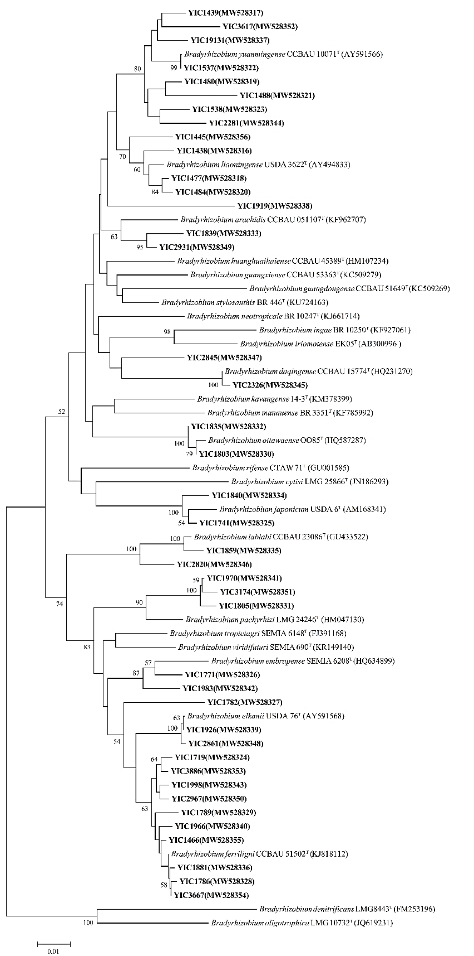
Fig. S1. Phylogenetic tree of recA sequences showing the relationships between the representative strains isolated in this study (in boldface) and the related species. The Neighbor-joining tree was reconstructed using MEGA 7.0, and Kimura 2-parameter model was selected as the nucleotide substitution model. Bootstrap confidence levels of ≥ 50% are indicated at the internodes. The bar indicates 1% nucleotide divergence.
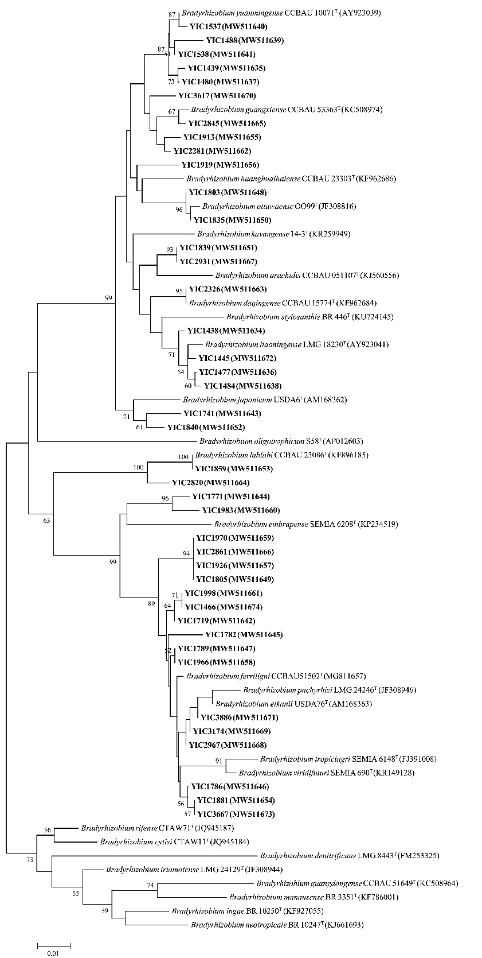
Fig. S2. Phylogenetic tree of dnaK sequences showing the relationships between the representative strains isolated in this study (in boldface) and the related species. The Neighbor-joining tree was reconstructed using MEGA 7.0, and Kimura 2-parameter model was selected as the nucleotide substitution model. Bootstrap confidence levels of ≥ 50% are indicated at the internodes. The bar indicates 1% nucleotide divergence.
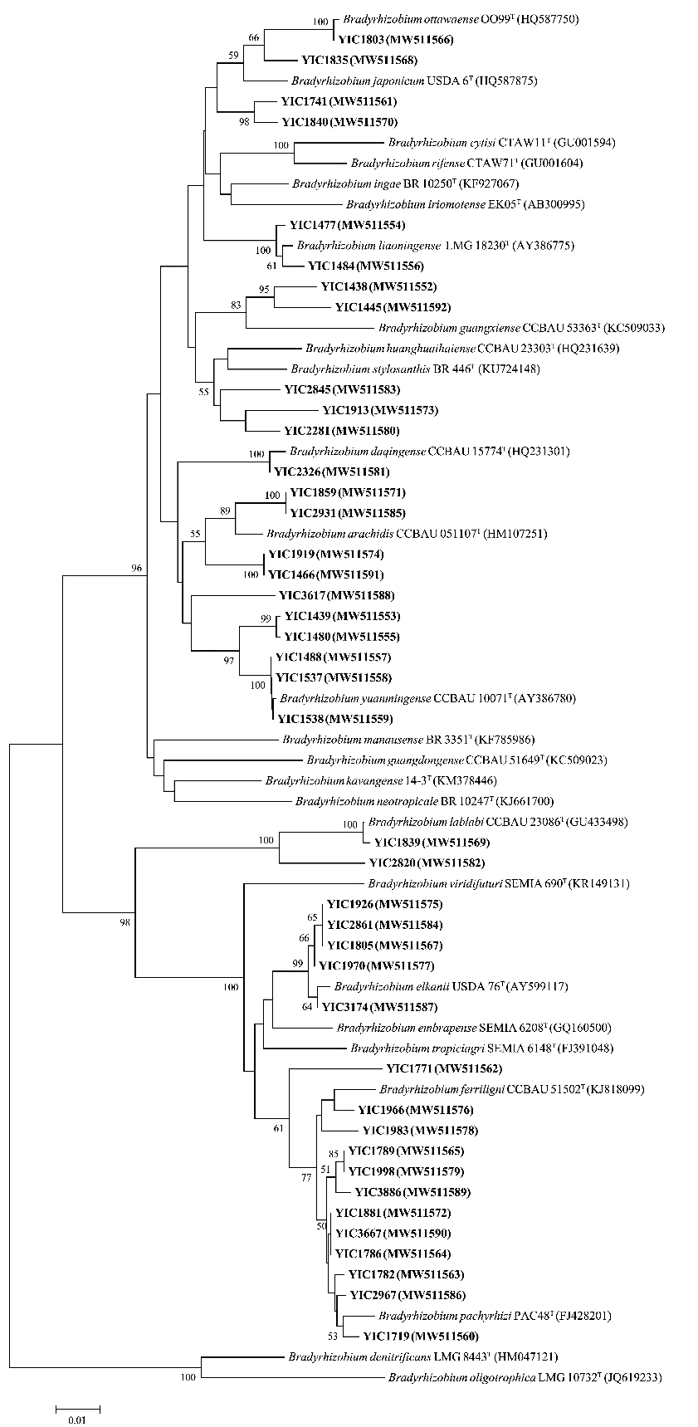
Fig. S3. Phylogenetic tree of glnII sequences showing the relationships between the representative strains isolated in this study (in boldface) and the related species. The Neighbor-joining tree was reconstructed using MEGA 7.0, and Kimura 2-parameter model was selected as the nucleotide substitution model. Bootstrap confidence levels of ≥ 50% are indicated at the internodes. The bar indicates 1% nucleotide divergence.
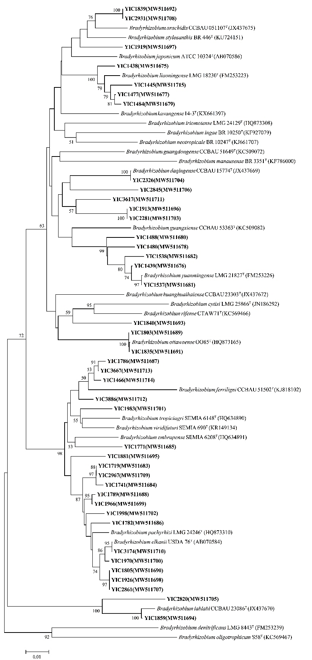
Fig. S4. Phylogenetic tree of gyrB sequences showing the relationships between the representative strains isolated in this study (in boldface) and the related species. The Neighbor-joining tree was reconstructed using MEGA 7.0, and Kimura 2-parameter model was selected as the nucleotide substitution model. Bootstrap confidence levels of ≥ 50% are indicated at the internodes. The bar indicates 1% nucleotide divergence.
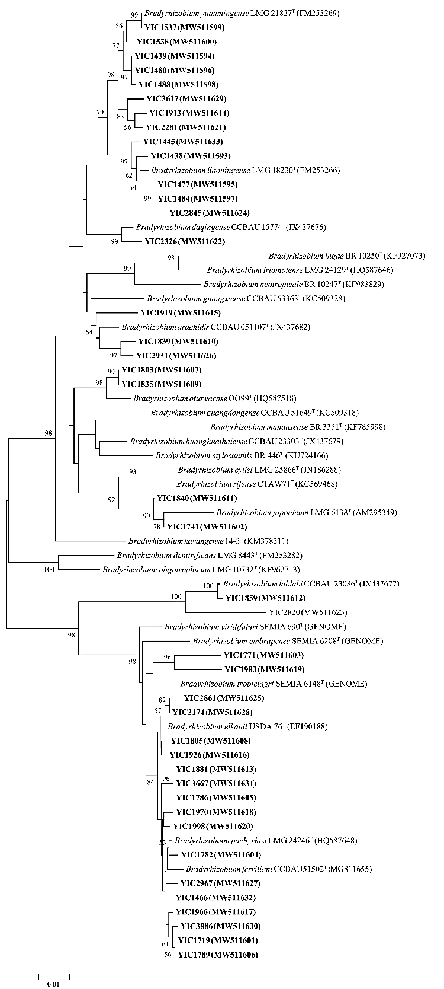
Fig. S5. Phylogenetic tree of rpoB sequences showing the relationships between the representative strains isolated in this study (in boldface) and the related species. The Neighbor-joining tree was reconstructed using MEGA 7.0, and Kimura 2-parameter model was selected as the nucleotide substitution model. Bootstrap confidence levels of ≥ 50% are indicated at the internodes. The bar indicates 1% nucleotide divergence.
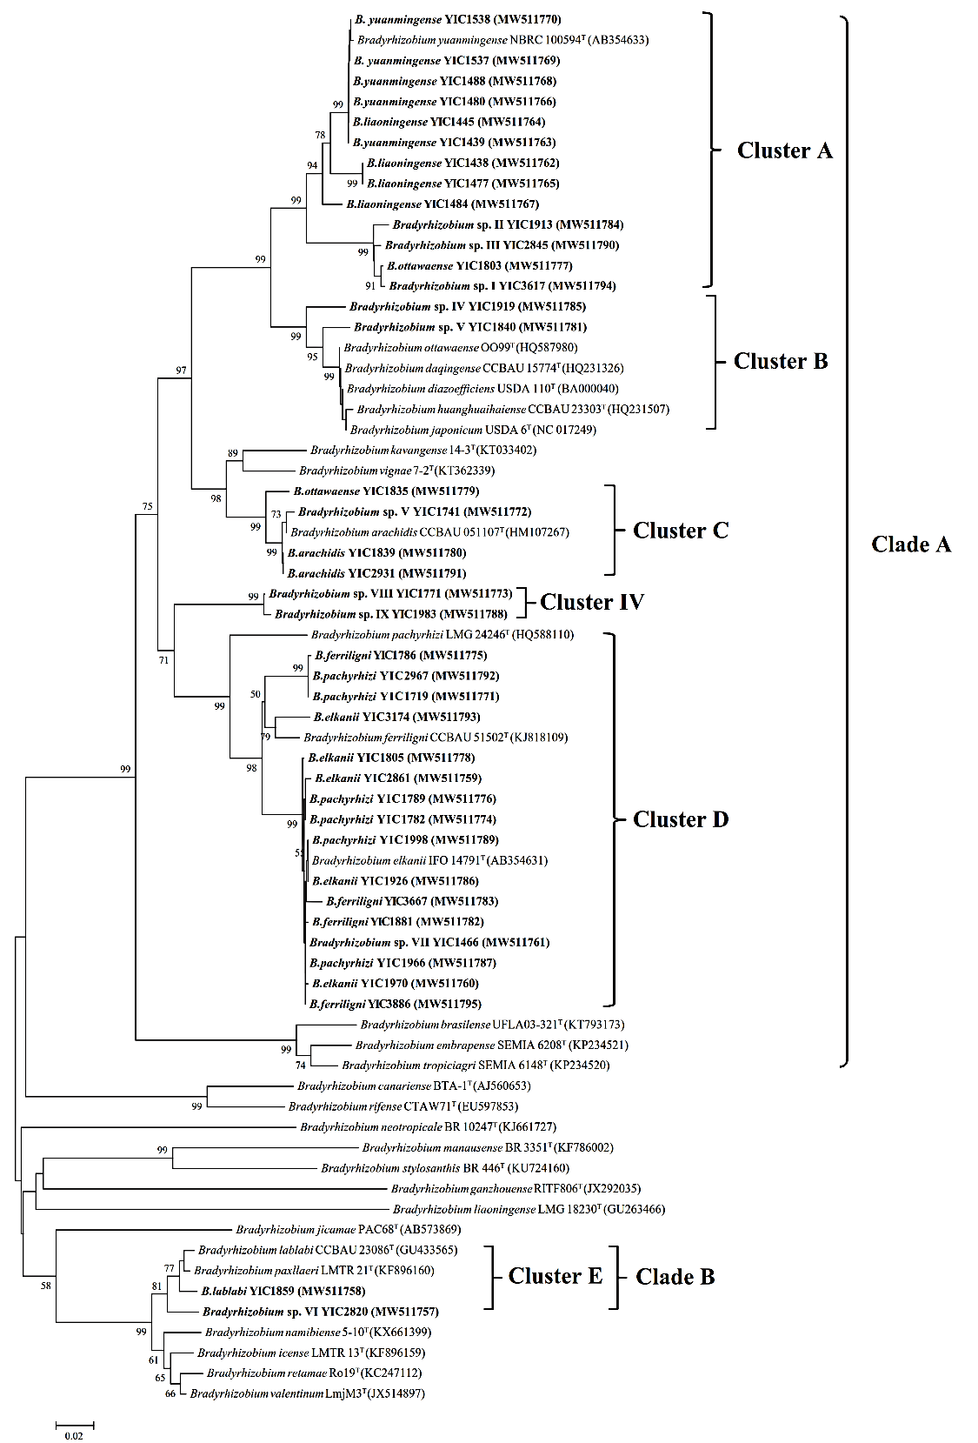
Fig. S6. Phylogenetic tree of nodC sequences showing the relationships between the representative strains isolated in this study (in boldface) and the related species. The Neighbor-joining tree was reconstructed using MEGA 7.0, and Kimura 2-parameter model was selected as the nucleotide substitution model. Bootstrap confidence levels of ≥ 50% are indicated at the internodes. The bar indicates 1% nucleotide divergence.

Table S1. The list of recA haplotypes classification of V. minima nodulating rhizobia isolated in this study.
Classification | Haplotypes No. | Representative strain | Number of Isolates | Distribution (number of strains) in sampling site
B. yuanmingense  (15 isolates) | H1 | YIC1537 | 6 | Haiyang (5), Qingdao (1)
 | H2 | YIC1439 | 1 | Haiyang (1)
 | H3 | YIC1488 | 3 | Haiyang (3)
 | H4 | YIC1538 | 3 | Haiyang (1), Qingdao (2)
 | H5 | YIC1480 | 2 | Haiyang (1), Laoshan (1)
Bradyrhizobium sp. I | H6 | YIC3617 | 1 | Weihai (1)
Bradyrhizobium sp. II  (31 isolates) | H7 | YIC1913 | 30 | Weihai (7), Rongcheng 1 (3), Rongcheng 2 (1), Haiyang (1), Laoshan (6), Qingdao (2), Yantai (10)
 | H8 | YIC2281 | 1 | Yantai(1)
Bradyrhizobium sp. III | H9 | YIC2845 | 2 | Rongcheng 1 (1), Rongcheng 2 (1)
B. daqingense | H10 | YIC2326 | 2 | Laoshan (1), Yantai (1)
B. liaoningense  (13 isolates) | H11 | YIC1438 | 2 | Haiyang (1), Yantai (1)
 | H12 | YIC1445 | 3 | Haiyang (1), Rongcheng 1 (1), Yantai (1)
 | H13 | YIC1477 | 1 | Haiyang (1)
 | H14 | YIC1484 | 7 | Haiyang (7)M
Bradyrhizobium sp. IV | H15 | YIC1919 | 14 | Jimo (8), Laoshan (1), Weihai (2), Rongcheg 2 (3)
B. arachidis (4 isolates) | H16 | YIC1839 | 3 | Rushan (3)
 | H17 | YIC2931 | 1 | Rongcheng 1 (1)
B. ottawaense  (16 isolates) | H18 | YIC1803 | 14 | Rongcheng 2 (4), Laoshan (1), Penglai (8), Weihai (1)
 | H19 | YIC1835 | 2 | Rongcheng 2 (2)
Bradyrhizobium sp. V  (3 isolates) | H20 | YIC1741 | 2 | Rushan (2)
 | H21 | YIC1840 | 1 | Rushan (1)
Bradyrhizobium sp. VI | H22 | YIC2820 | 1 | Penglai (1)
B. lablabi | H23 | YIC1859 | 3 | Laohan (3)
Bradyrhizobium sp. VII | H24 | YIC1466 | 26 | Laoshan (1), Yantai (9), Rongcheng 1 (4), Rongcheng 2 (6), Rushan (2), Haoyang (4)
Bradyrhizobium sp. VIII | H25 | YIC1771 | 2 | Laoshan (2)
Bradyrhizobium sp. IX | H26 | YIC1983 | 1 | Weihai (1)
B. elkanii (433 isolates) | H27 | YIC1805 | 108 | Weihai (21), Rongcheng 1 (4), Rongcheng 2 (13), Rushan (4), Haiyang (4), Jimo (15), Qingdao (11), Penglai (3), Yantai (33)
 | H28 | YIC1970 | 53 | Weihai (25), Rongcheng 1 (7), Rongcheng 2 (4), Rushan (10), Jimo (3), Yantai (4)
 | H29 | YIC3174 | 2 | Jimo (1), Rizhao (1)
 | H30 | YIC1926 | 238 | Weihai (5), Rongcheng 1 (28), Rongcheng 2 (28), Rushan (19), Haiyang (1), Jimo (21), Laoshan (26), Qingdao (14), Rizhao (57), Penglai (6), Yantai (33)
 | H31 | YIC2861 | 32 | Weihai (2), Rongcheng 1 (8), Rongcheng 2 (1), Rushan (5), Jimo (4), Laoshan (6), Qingdao (1), Penglai (2), Yantai (3)
B. ferriligni (226 isolates) | H32 | YIC1786 | 17 | Rongcheng 1 (3), Rongcheng 2 (1), Jimo (2), Laoshan (9), Yantai (2)
 | H33 | YIC3667 | 116 | Weihai (2), Rongcheng 1 (6), Rongcheng 2 (26), Rushan (5), Haiyang (24), Laoshan (10), Qingdao (15), Penglai (21), Yantai (7)
 | H34 | YIC1881 | 79 | Weihai (2), Rongcheng 1 (15), Rongcheng 2 (7), Rushan (10), Haiyang (1), Jimo (9), Laoshan (12), Qingdao (3), Penglai (6), Yantai (14)
 | H35 | YIC3886 | 14 | Rongcheng 1 (1), Rushan (2), Jimo (5), Laoshan (1), Qingdao (1), Penglai (2), Yantai (2)
B. pachyrhizi (81 isolates) | H36  H37  H38  H39  H40  H41 | YIC1782  YIC1998  YIC1719  YIC2967  YIC1789  YIC1966 | 12  9  38  1  10  11 | Rongcheng 2 (9), Rushan (2), Yantai (1)  Penglai (1), Rongcheng1 (1), Rongcheng2 (3),Rushan (1), Jimo (1),Rizhao (2)  Weihai (2), Rongcheng1 (2), Rongcheng2 (7),  Rushan (6), Haiyang (4), Jimo (2), Laoshan (12), Qingdao (3)  Laoshan (1)  Yantai (3), Rongcheng1 (3), Rushan (1), Jimo (2), Laoshan (1)  Yantai (2), Rongcheng2 (3), Rushan (2), Jimo (1), Laoshan (3)

Table S2. Distribution of rhizobia in different sampling sites and rhizobial haplotype classification
Isolates (YIC code) | recA haplotype | Species affiliation
Isolates from Penglai
1803, 1804, 1816, 1872, 1873, 1876, 1944, 1945 | H18 | B. ottawaense
2820 | H22 | Bradyrhizobium sp. VI
1805, 1948, 2862 | H27 | B. elkanii
1808, 1997, 2344, 2345, 2577, 2841 | H30
1878, 1879 | H31
1810, 1812, 1814, 1815, 1870, 1871, 1877, 1990, 2343, 2414, 2415, 2422, 2529, 2531, 2561, 2793, 2811, 2821, 2842, 2865, 2960 | H33 | B. ferriligni
1807, 1813, 1874, 1875, 1880, 2501 | H34
1999, 2789 | H35
2840 | H37 | B. pachyrhizi
Isolates from Yantai
1796, 1797, 1892, 1893, 1820, 1823, 2266, 2267, 2350, 2535 | H7 | Bradyrhizobium sp. II
2281 | H8
1074 | H10 | B. daqingense
1123 | H11 | B. liaoningense
1081 | H12
1053, 1059, 1061, 1054, 1055, 1060, 1080, 1134, 1157 | H24 | Bradyrhizobium sp. VII
1781, 1821, 1827, 1968, 1969, 1971, 1973, 1974, 1975, 2268, 2279, 2280, 2300, 2363, 2364, 2365, 2370, 2377, 2533, 2536, 2541, 2546, 2558, 2571, 2584, 2626, 2629, 2852, 2859, 2860, 3619, 1082, 1151 | H27 | B. elkanii
1970, 2614, 1117, 1120 | H28
1783, 1819, 1882, 1914, 1926, 1930, 1931, 1965, 2272, 2274, 2310, 2319, 2334, 2339, 2346, 2521, 2522, 2523, 2524, 2525, 2528, 2549, 2555, 2838, 1118, 1125, 1136, 1079, 1109, 1119, 1132, 1138, 1156 | H30
2556, 2861, 1154 | H31
1795, 1786 | H32 | B. ferriligni
1972, 2545, 2788, 1058, 1135, 1071, 1078 | H33
1787, 1788, 1790, 1791, 1792, 1794, 1809, 2824, 1780, 1881, 2292, 2544, 1052, 1137 | H34
2582, 2863 | H35
1782 | H36 | B. pachyrhizi
1784, 1785, 1789 | H40
1966, 1967 | H41
Isolates from Weihai
3617 | H6 | Bradyrhizobium sp. I
2342, 2439, 2514, 2785, 2855, 3526, 3928 | H7 | Bradyrhizobium sp. II
2465, 2512 | H15 | Bradyrhizobium sp. IV
3320 | H18 | B. ottawaense
1983 | H26 | Bradyrhizobium sp. IX
1700, 1701, 1703, 1704, 1749, 1752, 1754, 1755, 1756, 1757, 1940, 2311, 2325, 2331, 2332, 2340, 2353, 2354, 2392, 2500, 2835 | H27 | B. elkanii
1689, 1690, 1691, 1692, 1694, 1695, 1698, 1699, 1751, 1759, 1760, 2366, 2436, 2464, 2570, 2589, 2813, 2814, 2816, 2839, 2959, 3312, 3321, 3659, 3925 | H28
1696, 1750, 2352, 2445, 2466 | H30
1753, 1758 | H31
1688, 2823 | H33 | B. ferriligni
2367, 2369 | H34
1693, 1697 | H38 | B. pachyrhizi
Isolates from Rongcheng 1
2579, 3578, 3946 | H7 | Bradyrhizobium sp. II
2845 | H9 | Bradyrhizobium sp. III
2607 | H12 | B. liaoningense
2931 | H17 | B. arachidis
3587, 1982, 2409, 2413 | H24 | Bradyrhizobium sp. VII
1730, 2324, 1908, 2400 | H27 | B. elkanii
2263, 2484, 2818, 2828, 2864, 2866, 3603 | H28
1731, 2273, 2318, 2388, 2402, 2617, 1923, 1981, 1985, 2261, 2270, 2271, 2276, 2378, 2405, 2408, 2410, 2481, 2483, 2486, 2487, 2491, 2494, 2853, 2856, 2889, 2951, 2964 | H30
2312, 2313, 2613, 1906, 2488, 2504, 2518, 2822 | H31
2306, 2519, 2825 | H32 | B. ferriligni
1733, 2316, 2317, 2349, 2262, 2440 | H33
1732, 1910, 1911, 1912, 1915, 1922, 1929, 1984, 2335, 2336, 2616, 2832, 2892, 1907, 2509 | H34
2393 | H35
2963 | H37 | B. pachyrhizi
1909, 2817 | H38
2401, 2482, 2808 | H40
Isolates from Rongcheng 2
2068 | H7 | Bradyrhizobium sp. II
2166 | H9 | Bradyrhizobium sp. III
2168, 2180, 2576 | H15 | Bradyrhizobium sp. IV
2164, 2210, 2550, 2567 | H18 | B. ottawaense
2235, 1835 | H19
2044, 2403, 2538, 2568, 2620, 2624 | H24 | Bradyrhizobium sp. VII
2067, 2189, 2193, 2211, 2212, 2224, 2226, 2227, 2228, 2229, 2239, 2240, 2251 | H27 | B. elkanii
2223, 1799, 2283, 2621 | H28
2066, 64285, 64316, 2081, 2083, 69399, 69430, 2091, 2092, 2169, 2170, 2187, 2188, 2230, 2231, 2256, 2258, 1798, 1833, 1834, 2285, 2347, 2411, 2511, 2517, 2787, 2831, 2945 | H30
2099 | H31
2165 | H32 | B. ferriligni
2138, 2139, 2141, 2142, 2181, 2182, 2190, 2192, 2195, 2201, 2204, 2205, 2209, 2225, 2232, 2233, 2234, 2237, 2241, 2250, 2257, 1836, 1837, 2275, 2348, 3667 | H33
2191, 2206, 1800, 1832, 2291, 2562, 2802 | H34
2074-1, 63586, 2202, 2203, 2207, 2208, 2213, 2238, 2249 | H36 | B. pachyrhizi
2252, 2253, 1998 | H37
2167, 2186, 2236, 2284, 2553, 2575, 2956 | H38
1811, 1830, 2559 | H41
Isolates from Rushan
1839, 2471, 2472 | H16 | B. arachidis
1740, 1741 | H20 | Bradyrhizobium sp. V
1840 | H21
1838, 1847 | H24 | Bradyrhizobium sp. VII
1738, 1848, 2278, 2470 | H27 | B. elkanii
1745, 1746, 1747, 1900, 1901, 1902, 2441, 2548, 2583, 2623 | H28
1736, 1743, 1748, 1844, 1896, 2259, 2265, 2391, 2397, 2398, 2399, 2406, 2407, 2469, 2551, 2569, 2585, 2882, 3947 | H30
1735, 1737, 1843, 1895, 2473 | H31
1845, 1897, 2327, 2438, 2883 | H33 | B. ferriligni
1828, 1829, 1842, 1846, 1894, 1899, 1925, 2351, 2396, 2586 | H34
2404, 3669 | H35
1744, 2394 | H36 | B. pachyrhizi
1898 | H37
1739, 1841, 2277, 2479, 2796, 3576 | H38
1742 | H40
2395, 2792 | H41
Isolates from Haiyang
1441, 1443, 1444, 1490, 1537 | H1 | B. yuanmingense
1439 | H2
1482, 1486, 1488 | H3
1538 | H4
1480 | H5
1514 | H7 | Bradyrhizobium sp. II
1438 | H11 | B. liaoningense
1445 | H12
1477 | H13
1442, 1481, 1484, 1505, 1509, 1518, 1535 | H14
1465, 1466, 1470, 1473 | H24 | Bradyrhizobium sp. VII
1479, 1483, 1536, 1539 | H27 | B. elkanii
1507 | H30
1471, 1472, 1475, 1476, 1478, 1487, 1489, 1491, 1502, 1504, 1506, 1508, 1510, 1511, 1512, 1513, 1515, 1516, 1517, 1519, 1520, 1521, 1534, 1545 | H33 | B. ferriligni
1503 | H34
1485, 1500, 1501, 1540 | H38 | B. pachyrhizi
Isolates from Jimo
1904, 1918, 1919, 1946, 2515, 2526, 2539, 2580 | H15 | Bradyrhizobium sp. IV
1947, 1949, 1950, 1951, 2289, 2437, 2442, 2443, 2458, 2497, 2520, 2578, 2610, 2625, 2628 | H27 | B. elkanii
2587, 2611, 2827 | H28
2506 | H29
1987, 1988, 2450, 2451, 2452, 2454, 2457, 2460, 2463, 2496, 2543, 2547, 2552, 2630, 2631, 2884, 2927, 2929, 2944, 2950, 2977 | H30
1986, 2480, 2887, 2888 | H31
2456, 2554 | H32 | B. ferriligni
1905, 1917, 1920, 1921, 2453, 2462, 2493, 2588, 2930 | H34
2459, 2461, 2495, 2786, 3886 | H35
2455 | H37 | B. pachyrhizi
2846, 2962 | H38
1933, 2527 | H40
2948 | H41
Isolates from Laoshan
1718 | H5 | B. yuanmingense
1851, 1856, 1913, 1941, 2290, 2320 | H7 | Bradyrhizobium sp. II
2326 | H10 | B. daqingense
2314 | H15 | Bradyrhizobium sp. IV
1705 | H18 | B. ottawaense
1773, 1824, 1859 | H23 | B. lablabi
1854 | H24 | Bradyrhizobium sp. VII
1771, 2502 | H25 | Bradyrhizobium sp. VIII
1707, 1710, 1712, 1715, 1716, 1717, 1724, 1725, 1727, 1857, 1858, 1916, 1924, 1932, 2260, 2269, 2282, 2293, 2315, 2322, 2337, 2376, 2485, 2498, 2507, 2815 | H30 | B. elkanii
1706, 1723, 1726, 1927, 1928, 1903 | H31
1852, 1761, 1762, 1763, 1825, 1863, 1864, 1869, 2321 | H32
1708, 1713, 1714, 1722, 1729, 1853, 2287, 2323, 2341, 2797 | H33
1850, 1855, 1942, 1765, 1770, 1774, 1775, 1779, 1861, 1868, 2328, 2355 | H34 | B. ferriligni
1777 | H35
1711, 1719, 1764, 1768, 1776, 1778, 1822, 1860, 1866, 2826, 2849, 2885 | H38 | B. pachyrhizi
2967 | H39
1709 | H40
1728, 1943, 1867 | H41
Isolates from Qingdao
3100 | H1 | B. yuanmingense
3200, 3201 | H4
3118, 3283 | H7 | Bradyrhizobium sp. II
3117, 3127, 3184, 3191, 3194, 3199, 3208, 3210, 3211, 3252, 3293 | H27 | B. elkanii
3121, 3122, 3123, 3188, 3192, 3193, 3195, 3197, 3198, 3202, 3204, 3206, 3251, 3285 | H30
3288 | H31
3101, 3102, 3103, 3105, 3106, 3185, 3186, 3189, 3190, 3205, 3212, 3282, 3289, 3290, 3292 | H33 | B. ferriligni
3203, 3286, 3305 | H34
3287 | H35
3099, 3209, 3253 | H38 | B. pachyrhizi
Isolates from Rizhao
3174 | H29 | B. elkanii
3137, 3138, 3139, 3140, 3141, 3142, 3143, 3144, 3145, 3146, 3148, 3149, 3150, 3151, 3152, 3153, 3154, 3155, 3156, 3157, 3158, 3159, 3160, 3161, 3162, 3163, 3164, 3165, 3166, 3167, 3168, 3169, 3170, 3171, 3172, 3173, 3175, 3176, 3177, 3178, 3179, 3232, 3233, 3234, 3235, 3236, 3237, 3238, 3239, 3240, 3241, 3242, 3243, 3275, 3276, 3303, 3304 | H30
3147, 3302 | H37 | B. pachyrhizi

Table S3. List of the accession numbers obtained in this study.
Strains | dnaK | glnII | gyrB | recA | ropB | nifH | nodC
YIC1438 | MW511634 | MW511552 | MW511675 | MW528316 | MW511593 | MW511718 | MW511762
YIC1439 | MW511635 | MW511553 | MW511676 | MW528317 | MW511594 | MW511719 | MW511763
YIC1445 | MW511672 | MW511592 | MW511715 | MW528356 | MW511633 | MW511720 | MW511764
YIC1466 | MW511674 | MW511591 | MW511714 | MW528355 | MW511632 | MW511738 | MW511761
YIC1477 | MW511636 | MW511554 | MW511677 | MW528318 | MW511595 | MW511721 | MW511765
YIC1480 | MW511637 | MW511555 | MW511678 | MW528319 | MW511596 | MW511722 | MW511766
YIC1484 | MW511638 | MW511556 | MW511679 | MW528320 | MW511597 | MW511723 | MW511767
YIC1488 | MW511639 | MW511557 | MW511680 | MW528321 | MW511598 | MW511724 | MW511768
YIC1537 | MW511640 | MW511558 | MW511681 | MW528322 | MW511599 | MW511725 | MW511769
YIC1538 | MW511641 | MW511559 | MW511682 | MW528323 | MW511600 | MW511726 | MW511770
YIC1719 | MW511642 | MW511560 | MW511683 | MW528324 | MW511601 | MW511727 | MW511771
YIC1741 | MW511643 | MW511561 | MW511684 | MW528325 | MW511602 | MW511728 | MW511772
YIC1771 | MW511644 | MW511562 | MW511685 | MW528326 | MW511603 | MW511729 | MW511773
YIC1782 | MW511645 | MW511563 | MW511686 | MW528327 | MW511604 | MW511730 | MW511774
YIC1786 | MW511646 | MW511564 | MW511687 | MW528328 | MW511605 | MW511731 | MW511775
YIC1789 | MW511647 | MW511565 | MW511688 | MW528329 | MW511606 | MW511732 | MW511776
YIC1803 | MW511648 | MW511566 | MW511689 | MW528330 | MW511607 | MW511733 | MW511777
YIC1805 | MW511649 | MW511567 | MW511690 | MW528331 | MW511608 | MW511734 | MW511778
YIC1835 | MW511650 | MW511568 | MW511691 | MW528332 | MW511609 | MW511735 | MW511779
YIC1839 | MW511651 | MW511569 | MW511692 | MW528333 | MW511610 | MW511736 | MW511780
YIC1840 | MW511652 | MW511570 | MW511693 | MW528334 | MW511611 | MW511737 | MW511781
YIC1859 | MW511653 | MW511571 | MW511694 | MW528335 | MW511612 | MW511716 | MW511758
YIC1881 | MW511654 | MW511572 | MW511695 | MW528336 | MW511613 | MW511739 | MW511782
YIC1913 | MW511655 | MW511573 | MW511696 | MW528337 | MW511614 | MW511717 | MW511784
YIC1919 | MW511656 | MW511574 | MW511697 | MW528338 | MW511615 | MW511740 | MW511785
YIC1926 | MW511657 | MW511575 | MW511698 | MW528339 | MW511616 | MW511741 | MW511786
YIC1966 | MW511658 | MW511576 | MW511699 | MW528340 | MW511617 | MW511742 | MW511787
YIC1970 | MW511659 | MW511577 | MW511700 | MW528341 | MW511618 | MW511743 | MW511760
YIC1983 | MW511660 | MW511578 | MW511701 | MW528342 | MW511619 | MW511744 | MW511788
YIC1998 | MW511661 | MW511579 | MW511702 | MW528343 | MW511620 | MW511745 | MW511789
YIC2281 | MW511662 | MW511580 | MW511703 | MW528344 | MW511621 | MW511746 | --
YIC2326 | MW511663 | MW511581 | MW511704 | MW528345 | MW511622 | MW511747 | --
YIC2820 | MW511664 | MW511582 | MW511705 | MW528346 | MW511623 | MW511748 | MW511757
YIC2845 | MW511665 | MW511583 | MW511706 | MW528347 | MW511624 | MW511749 | MW511790
YIC2861 | MW511666 | MW511584 | MW511707 | MW528348 | MW511625 | MW511750 | MW511759
YIC2931 | MW511667 | MW511585 | MW511708 | MW528349 | MW511626 | MW511751 | MW511791
YIC2967 | MW511668 | MW511586 | MW511709 | MW528350 | MW511627 | MW511752 | MW511792
YIC3174 | MW511669 | MW511587 | MW511710 | MW528351 | MW511628 | MW511753 | MW511793
YIC3617 | MW511670 | MW511588 | MW511711 | MW528352 | MW511629 | MW511754 | MW511794
YIC3667 | MW511673 | MW511590 | MW511713 | MW528354 | MW511631 | MW511755 | MW511783
YIC3886 | MW511671 | MW511589 | MW511712 | MW528353 | MW511630 | MW511756 | MW511795

Table S4. Taxonomy and recA, dnaK, gyrB, rpoB, glnII and MLSA similarities of intra-genospecies isolated in this study, and MLSA similarities between each haplotype with the related published species.
Representative strains | Similarities between haplotypes of intra-genospecies |  |  |  |  |  | MLSA Similarities between haplotypes and related species | Definition of genospecies
 | recA | dnaK | gyrB | rpoB | glnII | MLSA
YIC1439, YIC1480, YIC1488, YIC1537, YIC1538 | 96.1-98.6% | 98.4-99.8% | 96.8-99.5% | 99.0-100% | 98.3-100% | 98.1-98.9% | 98.2-99.8%, B. yuanmingense CCBAU 10071^{T} | B. yuanmingense
YIC3617 |  |  |  |  |  |  | 96.8%, B. yuanmingense CCBAU 10071^{T} | Bradyrhizobium sp. I
YIC1913, YIC2281 | 97.6% | 99.3% | 100.0% | 99.4% | 97.6% | 98.8% | 96.3%, B. yuanmingense CCBAU 10071^{T} | Bradyrhizobium sp. II
YIC2845 |  |  |  |  |  |  | 95.8%, B. yuanmingense CCBAU 10071^{T} | Bradyrhizobium sp. III
YIC2326 |  |  |  |  |  |  | 99.4%, B. daqingense CCBAU 15774^{T} | B. daqingense
YIC1438, YIC1445, YIC1477, YIC1484 | 96.8-99.5% | 99.1-99.8% | 97.9-99.7% | 99.0-100% | 94.5-99.3% | 98.2-99.7% | 97.9-99.0%, B. liaoningense USDA 3622^{T} | B. liaoningense
YIC1919 |  |  |  |  |  |  | 95.6%, B. liaoningense USDA 3622^{T} | Bradyrhizobium sp. IV
YIC1839, YIC2931 | 98.6% | 100.0% | 100.0% | 99.1% | 88.4% | 97.2% | 95.6-97.8%, B. arachidis CCBAU 051107^{T} | B. arachidis
YIC1803, YIC1835 | 99.8% | 100.0% | 100.0% | 100.0% | 97.8% | 99.5% | 99.1-99.7%, B. ottawaense OO85^{T} | B. ottawaense
YIC1741, YIC1840 | 99.1% | 98.4% | 92.4% | 99.1% | 99.0% | 97.6% | 96.8-96.9%, B. japonicum LMG 6138^{T} | Bradyrhizobium sp. V
YIC2820 |  |  |  |  |  |  | 96.3%, B. lablabi CCBAU 23086^{T} | Bradyrhizobium sp. VI
YIC1859 |  |  |  |  |  |  | 97.5%, B. lablabi CCBAU 23086^{T} | B. lablabi
YIC1466 |  |  |  |  |  |  | 96.2%, B. elkanii USDA 76^{T} | Bradyrhizobium sp. VII
YIC1771 |  |  |  |  |  |  | 95.8%, B. embrapense SEMIA 6208^{T} | Bradyrhizobium sp. VIII
YIC1983 |  |  |  |  |  |  | 96.2%, B. embrapense SEMIA 6208^{T} | Bradyrhizobium sp. IX
YIC1805, YIC1970, YIC3174, YIC1926, YIC2861 | 95.5-99.5% | 98.9-100% | 99.0-100% | 98.9-99.6% | 99.5-100% | 98.7-99.7% | 98.8-99.4%, B. elkanii USDA 76^{T} | B. elkanii
YIC1786, YIC3667, YIC1881, YIC3886 | 98.4-99.8% | 99.3-100% | 96.3-99.7% | 99.0-100% | 99.1-100% | 98.6-99.9% | 98.0-98.3%, B. ferriligni CCBAU 51502^{T} | B. ferriligni
YIC1782, YIC1998, YIC1719, YIC2967  YIC1789, YIC1966 | 96.4-99.5% | 98.4-100% | 98.2-100% | 99.3-100% | 98.8-100% | 98.4-99.5% | 98.1-98.3%, B. pachyrhizi LMG 24246^{T} | B. pachyrhizi

Table S5. Different haplotype numbers were observed through analyses using different housekeeping gene sequences of 41 representative strains.
Gene | Haplotype number
recA | 41
dnaK | 34
glnII | 33
gyrB | 35
rpoB | 35

