**Synthesis, biological evaluation and QSAR studies of 3-Iodochromone derivatives as potential fungicides**

Parshant Kaushik1, *, Najam A. Shakil1 and Virendra S. Rana1

*1Division of Agricultural Chemicals, ICAR-Indian Agricultural Research Institute, New Delhi, India*

*Correspondence:parshantagrico@gmail.com, parshant.kaushik@icar.gov.in

**Supporting Information**

**Figure 1:** 1H NMR spectrum of compound **4b**

**Figure 2:** 13C NMR spectrum of compound **4b**

**Figure 3:**1HNMR spectrum of compound **4n**

**Figure 4:** 13C NMR spectrum of compound **4n**

**Figure 5:** 1H NMR spectrum of compound **4r**

**Figure 6:** 13C NMR spectrum of compound **4r**

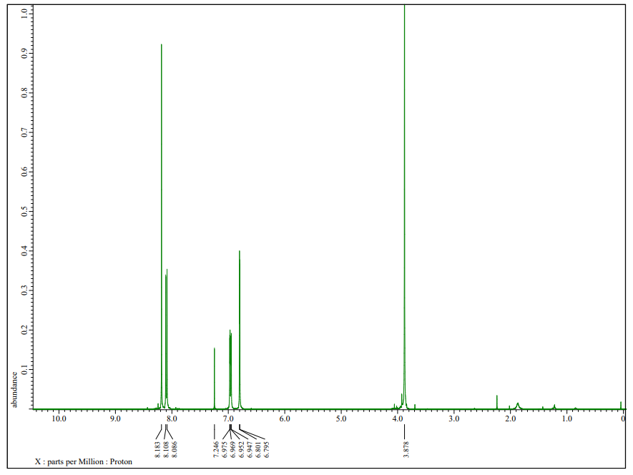

**Figure 1:** 1H NMR (400 MHz, CDCl3)of compound **4b**

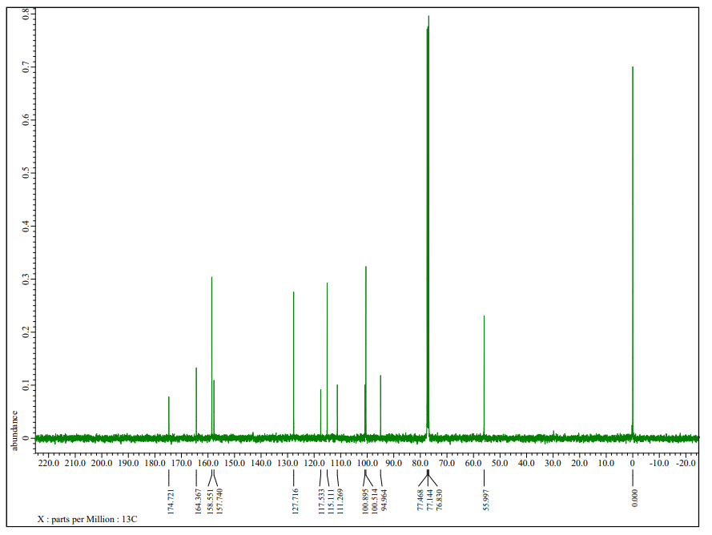

**Figure 2**: 13C NMR (100.6 MHz, CDCl3)of compound **4b**

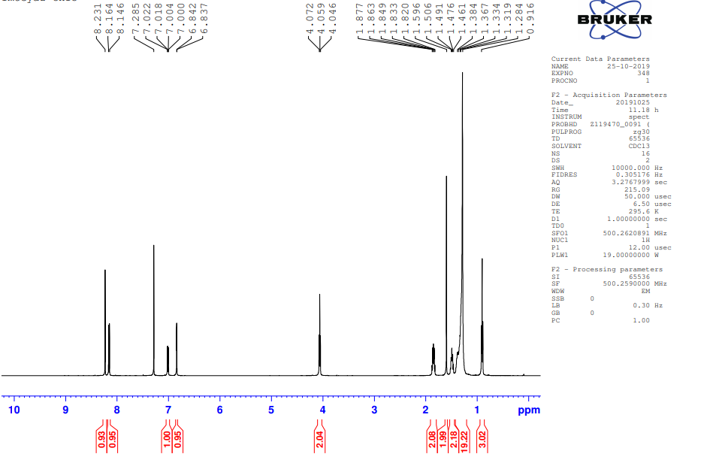

**Figure 3**: 1H NMR (400 MHz, CDCl3)of compound **4n**

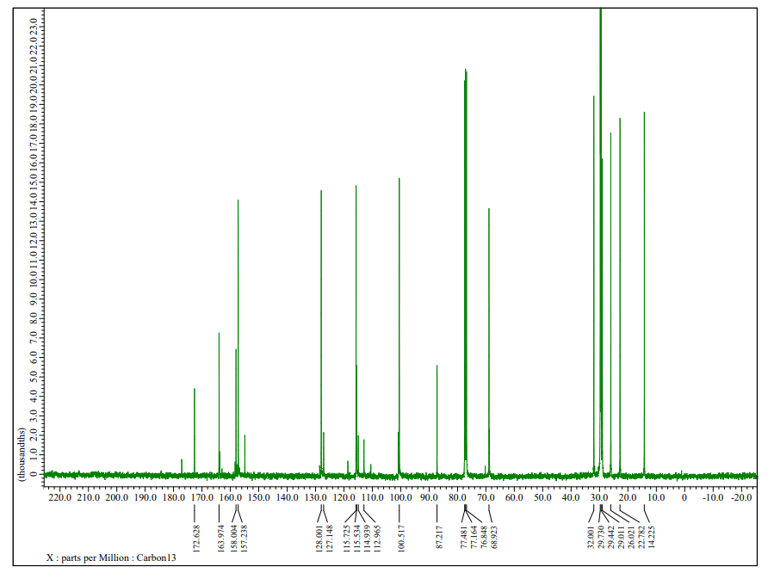

**Figure 4**: 13C NMR (100.6 MHz, CDCl3)of compound **4n**

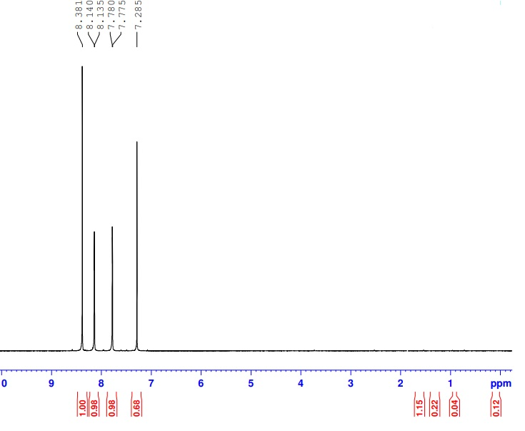

**Figure 5**: 1H NMR (400 MHz, CDCl3)of compound **4r**

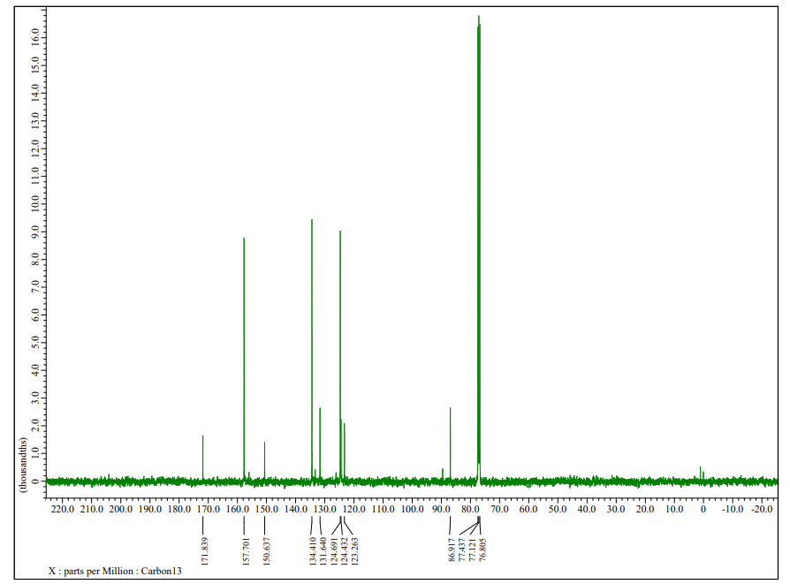

**Figure 4**: 13C NMR (100.6 MHz, CDCl3)of compound **4r**