Supplementary tables & figures
Supplementary table 1: comparison of the patient & tumor characteristics and MET positivity between the early OTSCC included from the LUMC and Erasmus MC (n=102).
 |  | Leiden cohort (n=25) |  | Rotterdam cohort (n=77) |  | p-value
 |  | Number | Percentage | Number | Percentage
Gender
 | Male | 14 | 56.0 | 46 | 59.7
 | Female | 11 | 44.0 | 31 | 40.3 | 0.741
Age at diagnosis (years)
 | Mean (range) | 57.0 (38.0 – 78.0) |  | 60.5 (24.0 – 90.0) |  | 0.283
Tumor diameter (cm)
 | Mean (range) | 1.94 (0.700 – 3.10) |  | 1.81 (0.400 – 4.00) |  | 0.458
pT (8th edition of the AJCC)
 | T1 | 4 | 16.0 | 27 | 35.1
 | T2 | 21 | 84.0 | 50 | 64.9 | 0.072
pN
 | N0 | 16 | 64.0 | 56 | 72.7
 | N≥1 | 9 | 36.0 | 21 | 27.3 | 0.405
Extranodal extension*
 | No | 22 | 88.0 | 72 | 93.5
 | Yes | 3 | 12.0 | 5 | 6.5 | 0.401
Pathological cancer stage** (8th edition of the AJCC)
 | I – II | 16 | 64.0 | 57 | 74.0
 | III – IV | 9 | 36.0 | 20 | 26.0 | 0.334
Resection margins
 | Clear and close | 21 | 84.0 | 60 | 77.9
 | Positive | 4 | 16.0 | 17 | 22.1 | 0.514

MET positive
 | < 10% D1C2 uniform positivity | 10 | 40.0 | 47 | 61.0
 | ≥ 10% D1C2 uniform positivity | 15 | 60.0 | 30 | 39.0 | 0.066
DOI > 4 mm
 | ≤ 4 mm | 5 | 20.0 | 22 | 28.6
 | > 4 mm | 20 | 80.0 | 55 | 71.4 | 0.399
* Here the Fisher’s Exact Test was used as 1 cell has an expected count of less than 5.
** All included patients are assessed as pM=0.

Supplementary table 2: univariable binary logistic regression model investigating the effect of MET positivity on pN+ for all cancers (n=102) and cN0 cancers (n=90).
Variable | All patients (n=102) |  |  | cN0 patient (n=90)
 | Odds ratio | 95% CI | p-value | Odds ratio | 95% CI | p-value
MET positivity | 3.76 | 1.53 – 9.26 | 0.004 | 4.47 | 1.53 – 13.1 | 0.006
Constant | 0.21 |  | 0.000 | 0.13 |  | 0.000
Significance | p-value = 0.003 |  |  | p-value = 0.004

Supplementary table 3: univariable binary logistic regression model investigating the effect of DOI > 4 mm on pN+ for all cancers (n=102) and cN0 cancers (n=90).
Variable | All patients (n=102) |  |  | cN0 patient (n=90)
 | Odds ratio | 95% CI | p-value | Odds ratio | 95% CI | p-value
DOI > 4 mm | 2.20 | 0.75 – 6.50 | 0.154 | 2.43 | 0.64 – 9.18 | 0.191
Constant | 0.23 |  | 0.003 | 0.14 |  | 0.002
Significance | p-value = 0.135 |  |  | p-value = 0.162

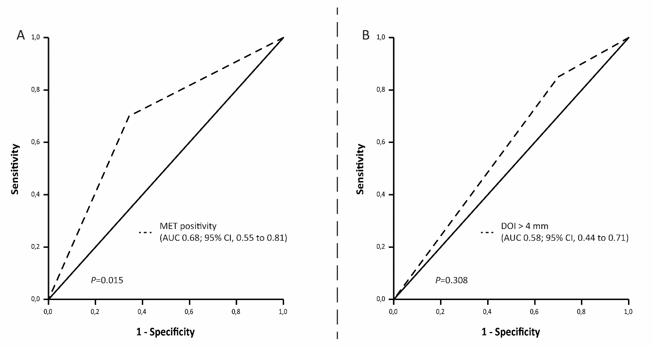
Supplementary figure 1: ROC curve indicating the area under the curve for A. MET positivity and B. Depth of invasion set at > 4 mm and occult LNM (cN0/pN+).

