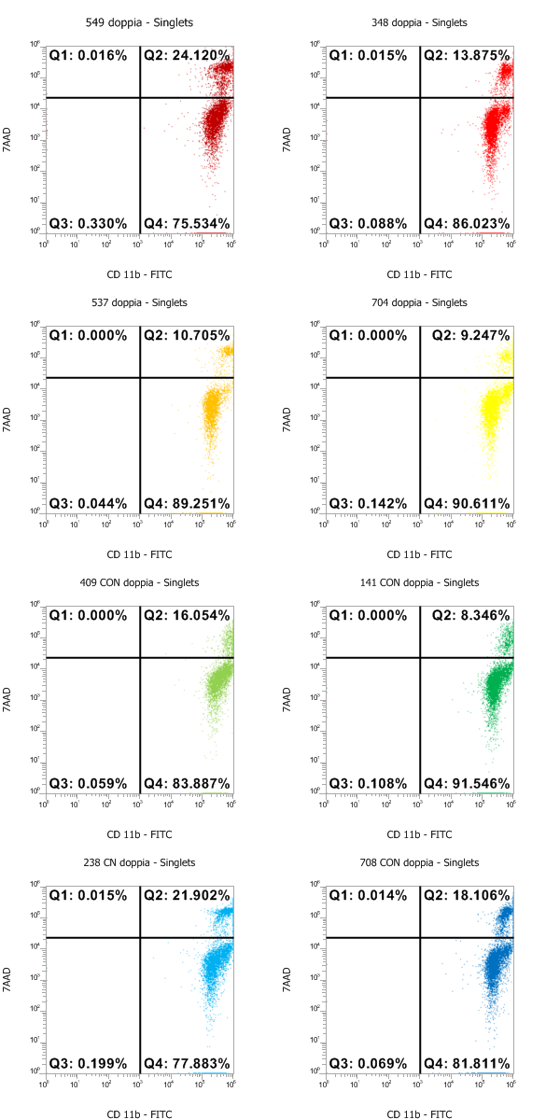
h)
g)
f)
e)
d)
c)
b)
a)
Supplementary Figure 1 Overlay of Dot plot of CD11b and 7-AAD; a,b,c,d for OP group, e,f,g,h for CON group, respectively.

